Flight Report – Graupner Kwik Fly III
Jeff Owens

In a previous column I described some aspects of pattern flying and discussed some of the ARF aircraft which are currently available. Two of these are the Tower Hobbies Kaos 40 and the Graupner Kwik Fly III. The Kwik Fly III was the third in a series of models designed by Phil Kraft, the owner of Kraft Radio back in the 1960-1980 time frame. Phil was the World Champion pattern pilot in 1967 flying a Kwik Fly. He also designed the original Ugly Stik (see https://www.modelaircraft.org/files/Kraft-Phill.pdf). I became interested in the Kwik Fly in a rather unusual manner. The RC club in Prattville, Alabama held an Antique Pattern contest in November 2009. The maneuvers were chosen from those flown in the late 1960s and aircraft from that time period were specified. We were discussing the upcoming contest while flying in the Masters Contest in Atlanta last fall and my wife suggested that we should go to the Antique event. When I replied that I didn’t have a suitable plane her response was “Then go get one!” Not being one to refuse a direct order, I started looking for something I could get in the air in a two week time frame (very very fast for me.) This was when I found the Graupner Kwik Fly which is carried by Hobby-Lobby. It was from the correct time period and the Graupner version was reported to be a good performer. I had an OS 55 AX that wasn’t being used and this seemed to be the perfect engine, so I purchased the kit ($230 – Frank says that he can order them.)
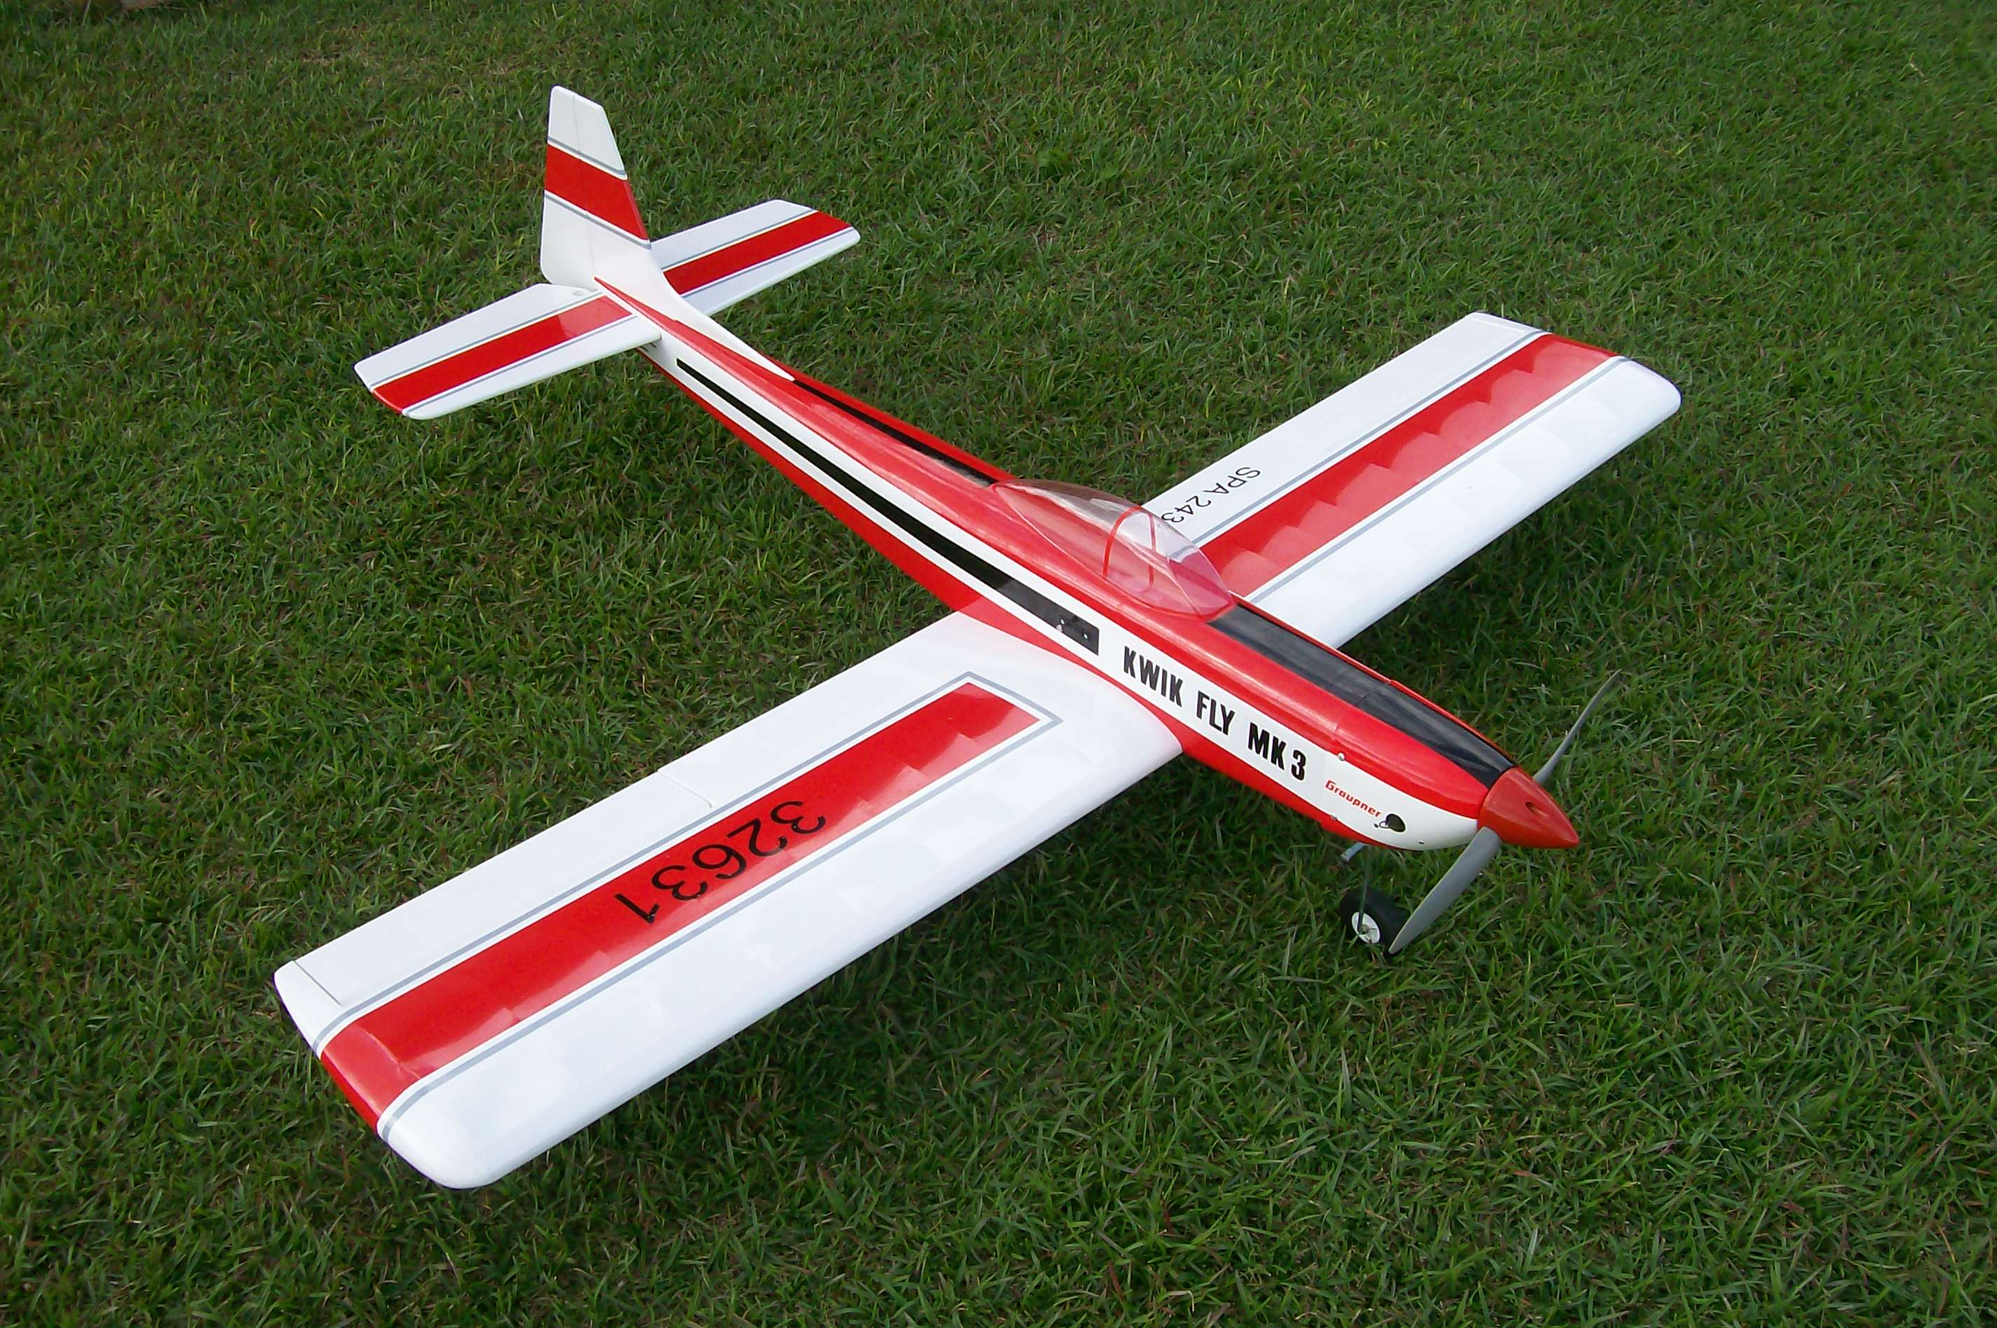

My completed Kwik Fly is shown above. It features an inverted engine installation and the OS 55 AX fits very nicely. The model retains the original “barn door” style of inset ailerons – they are very effective. I encountered no surprises in assembling the kit, which is very complete and features high quality hardware. The covering is also better than that of the usual ARF. It is a heavy duty covering material – slightly thicker than Monokote. There were no wrinkles when I examined all the parts and I haven’t had to do anything in the way of reshrinking or reworking the covering thus far. The plane was very easy to trim for pattern work and it performs all of the required maneuvers quite well. Any sport pilot would feel quite at home with this design. In addition, the ground handling is quite stable and it lands like it is on rails. As expected, the OS 55 AX is an excellent match and the vertical performance is excellent. Loops, rolls, spins, and more can easily be done as one would expect from a design which won the World Championship in its day. There are several Antique contests on the Senior Pattern Association schedule for this year and now I have an excellent plane for them. By the way, the kit comes set up for retracts (sold separately) and also includes mounting plates for fixed gear – you get to choose.
Several pilots at the Prattville contest were impressed with the performance of the Kwik Fly and decided to order their own. One SPA member, Ken Blackwell, posted some pictures and construction notes at the following web site http://www.flickr.com/photos/kenfly/sets/72157623175971478/
If you are looking for a different sport plane with a bit of history, I highly recommend the Kwik Fly. It is a great pattern trainer and just fun to fly. You won’t be disappointed.

