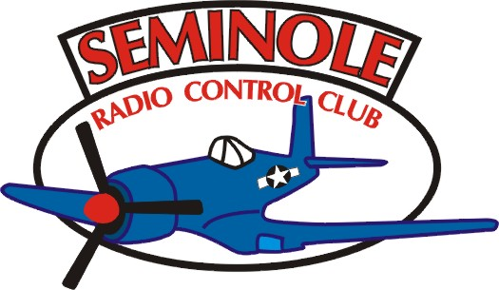
The Seminole Flyer www.seminolerc.com
A chartered member of the Academy of Model Aeronautics

AMA Charter #216, 1969-2005

“The Seminole Flyer” is a publication of the Seminole Radio Control Club of Tallahassee, Florida January 2006

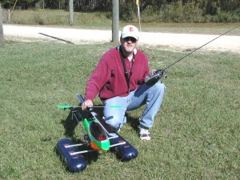
INDEX

Letter from the Editors
- Chief Pilot Report
- Chief Copilot Report
- Chief Treasurer Report
- Chief Scribe Report
- Gadget Corner- Center of Gravity
- Radios- Frequency Management
- Which is Better? PPM or PCM
- After the Crash
- New Member Spotlight
- Safety Notes
- Beginner’s Brief- Engines
- Announcements & Information
Jay Luedecke, SRCC Member of the Year 2005.

Letter from the Editors- Stephen Warmath, Richard Feezel

A New Year and a new slate of Officers will guide the Club in 2006. A big “Thank You” to the Officers who have done a great job over the years. With the cold winter months ahead, you may be thinking about that new bird you plan to build. Send us a photo and we’ll feature it in the “Pilot’s Showcase”. Don’t be shy; we love to show off our aircraft..…er..…tanks.....er…… lawnmowers. This month we delve into the heart of our passion: Engines, a primer on Radios and Frequency Control.

Check out the “Video of the Month” sent in by Geoff Lawrence. It is awesome. Turn up the music and enjoy.
http://www.rcpropbusters.com/video/ ,select “Haute-Voltige”. If your Media Player doesn’t open the file you may need to get a current version of your media player. If you want a copy just right click on the link and download to your hard drive. The file is 19.3 megs. Geoff also has a primer on “Props” in his Copilot Report.

Having difficulty checking your C.G. on that big bird or other aircraft that won’t fit your current set-up? Check the Gadget Corner for a nifty solution. I made one to check the CG on my J-3 floatplane and it works great.

Just plowed the north forty with your prized bird? After the initial anger passes, follow the tips in the “After the Crash” article for good advice on finding the plane and what can be learned about the cause from observations at the crash site.

WANTED- Your contributions. Send us something to print and you’ll receive, absolutely free, credit for your helping with the newsletter. Photos, Tips, Links, Upcoming Events, anything would be appreciated.

Chief Pilot- Mike Atkinson
I want to begin this month by saying ""Thank You" to Richard Wynn for his past years as President of the club. I don't know exactly how many years he served, but it seems like whenever there has been an important situation arise, Richard has always been there to create a solution. A large portion of the club has known no other President. We'll certainly miss Richard's leadership. Also, John Clark has done a great job over the past few years as both secretary and, at times, newsletter editor. When you see these guys at the field, please let them know you appreciate their service.

I've really enjoyed my terms as vice-president over the past few years. Positions such as events coordinator and training coordinator are certainly time consuming, but they are rewarding in themselves. But, time passes on and I guess it's my time to step up. I appreciate the trust placed in me as the new president and will do my best to continue the leadership our past presidents have shown. I look forward to working again with Sam as treasurer, as well as our new vice-president, Geoff Lawrence, and our new secretary, Stephen Warmath.

As far as changes, I do not foresee any major changes in the way things have gone. Membership is growing. The club is moving in a positive direction, and I see no reason to alter that. We have a great relationship with the county administration and solid waste management (landfill) personnel. As long as we maintain our good standing with them, the future of our flying site should be good. John Hall and I are serving on the citizen's advisory committee for the Apalachee Parkway Regional Park. The prospects for our future flying site are very good. The county is going to have another "neighborhood" meeting in late January or early February to do the activities survey again and hear from interested parties. The club officers will be putting together a club representation committee to serve our purposes at events such as these. We can talk more about that at the next meeting. I'll let you know more about the upcoming "neighborhood" meeting whenever the date is finalized.

One of the responsibilities of the president is to appoint a field marshal and safety officer. I'll be working on that over the next couple of weeks. In addition to these positions, I'll be proposing the development of a field committee, overseen by the field marshal, and a safety committee, headed by the safety officer. There is simply too many responsibilities in both these areas to place on one person. We'll discuss this at the next meeting and take recommendations.

Finally, Geoff Lawrence and I are excited about upcoming events. As events coordinator, Geoff will be in charge of lining up events at our field, as well as events such as the EAA Fly-in, Perry swap meet, and various float fly-ins. I look forward to working with Geoff in having even more events this upcoming year. If you have requests for certain events, or have information on events the club may be interested in, please let one of the officers know.

Happy New Year!!! I look forward to seeing all the new Christmas gifts at the field. I know I'll have mine there.

Michael Atkinson

Chief Copilot- Geoff Lawrence

Choosing A Prop for best performance
(Best for .15-1.2 engines!)
Of course you will need a Tach., a spread sheet (or other software for calculating thrust, HP, and speed ) to determine the “holy trinity” of model performance. (Speed, Acceleration, Vertical).
To prop for speed. Choose the highest pitch prop between 6 and 8 pitch that produces at least a 1:1 thrust to weight ratio, and runs at the bottom of the RPM range on the ground. *
To prop for extreme aerobatic performance. Prop for a speed of 65 MPH - 80 MPH. Bias the speed according to your model type and personal preferences. Choose a prop between 4 and 6 pitch that produces maximum thrust within the above speed range, and runs near the upper RPM limit.
To prop for a good compromise. Prop for 10%-15% more thrust than model weight, use the highest pitch prop possible between 5 and 7 pitch. Prop for the middle of the RPM range.
Tips and a few thoughts on prop selection.
- Speed, acceleration, and vertical are the Holy Trinity of performance. All 3 must be in balance.
- A good spreadsheet and Tach are very handy for figuring max performance.
- Knowing the speed, thrust, and HP a motor/ prop combo produce are keys to propping correctly.
- Knowing the model’s weight within 2 or 3 Oz is a key to propping correctly and choosing the right engine.
- It’s a very common mistake to over pitch. This hurts speed, acceleration, and vertical.
- Under propping is not as harmful to an engine as most modelers think.
- There’s no use propping for more than 10 MPH greater than the model’s flutter speed.
- 10-15 MPH speed headroom helps acceleration look impressive. You don't have to use it.
- Acceleration is rarely considered but important. Good acceleration is a must for a fun, responsive model.
- 8 pitch prop are rarely correct for smaller models, but often needed on larger ones.
- 4 pitch props are best for high performance engines. Otherwise they're too slow, and look sluggish in flight.
- HP is a great way to predict performance. It translates directly into speed, acceleration, and vertical.
- Props that extract highest HP always produce the most exciting performance.
- Don’t worry about unloading in the air, etc. Models fly too slowly for this to matter.
- To have pleasing acceleration, your max speed must be at least 65 MPH.
- Accelerating instantly from 20 MPH to 45 MPH is not impressive.
- Unlimited vertical at 5 MPH is not impressive. At 15 MPH, it is!
- A very fast plane is no fun if it has less thrust than weight.
- Always give up 5-6 MPH of top speed in favor of needed acceleration.
- Speed, acceleration, and vertical are a compromise, and can be biased any way you wish.
- Don't totally sell out any of the Holy Trinity. Your performance will suffer badly if you do.
- 4 Pitch props hurt speed and acceleration, but help vertical for heavy models.
- 5 Pitch props are usually a great balance of speed, acceleration, and vertical.
- 6 pitch props are good for speed and acceleration, but vertical suffers somewhat.
- 7 pitch props are good for speed, but acceleration and vertical both suffer.
- 8 pitch props are only useful for larger models or restricted noise situations.
- See suggested RPM envelope for 2 stroke engines below.
Suggested RPM (2 stroke)
.15-.36 14000-18000
.40-.53 13500-16000
.61-.90 9500-13000
1.08-1.20 8000-10000
* If you can’t get this level of performance, the engine is not powerful enough.

Chief Treasurer- Sam Varn
Editor’s Note: The Treasurer’s report is published for Members only. The public version of the Newsletter does not include this information.

Cash:
Checking:
Savings:
CD:
Total funds available:

Happy New Year! Sam

Chief Scribe- Steve Warmath

Business Meeting Minutes 12/01/05
The meeting was called to order at approximately 7:35 pm, December 1, 2005.

Visitor/ New member introductions- Don Coon introduced himself as a visitor to the Club. Don is a Science teacher at Leon High School and heads up the school’s Aerospace Club. He has spent time in Boulder, Colorado and also Huntsville, Alabama. He was involved in the “Aviation Challenge Center” in Huntsville and flew RC aircraft with students wanting to learn about aviation. Don is interested in investigating the possibility of teaming up with SRCC to allow his students a chance to fly at the field with a special dues structure for his students. They would be covered by AMA insurance at a special rate.
With some discussion, the Club was willing to take the matter under advisement. It was also arranged for the students to have some instructor training with the Club trainer on Tuesday afternoon, December 6, 2005 starting around 3:00 pm.

The Treasurer’s Report- Sam summarized our current asset allocations. He also gave a summary of our cash flow for the 11 months of this year as follows:
- Total Income Year to date, Jan1 – Nov 30 $6,393.75
- Total Expenses $4,164.87
- Net Income $2,228.88

Members requesting specific information regarding assets, may contact Sam Varn.
The Treasurer’s report was accepted.

Mike was asked to give a brief update on the County landfill conversion. The County is still going through the process of selecting which activities will be part of the master plan for the park. One contentious issue was the notion that a private Club like SRCC could have exclusive rights to use public property. Mike said that this issue had been tabled and at present was not an issue. One concern was with people flying at other county parks as a resident of that county, unsupervised and possibly without AMA insurance and without frequency control. There is a feeling the County will minimize flying at county parks by directing them to our field. It was mentioned the possibility of a separate dues structure for non-members to use the field, but this idea was not in the foreseeable future. Our lease with the county was through Public Works Department but has since been transferred to the Parks and Recreation Dept. for oversight. For now, we will have to organize activities and police ourselves.
Frank Bastos said that we should contact other municipalities facing this same dilemma to see how they accommodate the different flyers on Public land. He mentioned a Club in Jackson, Mississippi had a public field maintained by the City and that he would contact them about their experience.
Mike said he was not concerned about loosing the field. He reported the County has told him that they would relocate our facilities and move us when they were ready for us.

(Editors note): The proliferation of Park Flyers and people using uncontrolled flying sites without insurance or frequency control is a very hot topic with the AMA right now. This month’s Model Aviation, Letter from the President, talks about this issue in general terms. There is also a rather pointed debate going on in District V, our District, and what recommendations to make to the Executive Committee. This is not just an SRCC issue. It is a nation-wide issue that will surely heat up as we try to figure this one out.

Old Business-

Richard announced that the December elections were upon us and that most of the positions had been covered. John Clark noted the current slate of officers as: Mike Atkinson- President, Geoff Lawrence- Vice President, Sam Varn- Treasurer and Steve Warmath- Secretary. Richard asked if there were any other nominations to be added and there were none. Richard called for a motion to vote on the slate of candidates, seconded and approved.

Jay Luedecke was previously nominated in November and voted Club Member of the Year 2005. Congratulations Jay!

New Business-
- Jeff Owens gave an update on Airfest 2006. he had just come from the Airfest Planning Committee Meeting and reported that we were invited back again for 2006. They are in the process of getting FAA approval. The static demo area would be in the same place. There was a possibility that in the area North of the T-Hangars, they might allow some flying of small electrics and helicopters. There would be a 200’ height limit. Jeff was to meet with airport ATC Ron Fisher on December 15th. One problem in using a “non-movement” area, was as soon as an aircraft became airborne, it was now in controlled airspace. The event is slated for 20th of May 2006. Richard indicated he felt like this was a good thing for the Club to participate in.
- Jeff also said he had been approached to have club members participate in an “Aviation Appreciation Day” at the Challenger Learning Center on Saturday, Dec. 3rd. The consensus was that the notice was too short and that people had other commitments.

Announcements-
- Bob reminded everyone that the last person to leave the field should lock the gate. It had been found unlocked on several occasions.
- John Hall would replace the lock on the wood shed.
- Mike said that Tuesday evening would be set aside for the Aerospace Club from Leon H.S. The trainer would be available. Guest Don Coon asked if the Club would consider a special dues structure for these students. This to be considered by the Club. Members of the Club would only have a pay a dollar a head for AMA insurance and wanted to have access top the field. The Club was on a very limited budget. They had approximately 15 members.
- A “Thank You” was proffered to the outgoing officers for their contributions to the Club.

With no additional business, the meeting was adjourned at approximately 8:30 pm.

Gadget Corner- Center of Gravity Machine- Article from House of Balsa Dust

The 'Vanessa CG Machine' was I believe designed by the late Jim Archer, a modeler in the truest sense of the word "amateur", one who loves the hobby. It is offered here in memoriam to Jim so that others may benefit from his contributions to aero modeling.

Where the C.G. is located on your model aircraft is one of the most important factors in determining how well it flies. It is also one of the most difficult parameters to measure as anyone will attest who has tried to balance a low wing monoplane on a pair of pencils stuck in a 2 x 4.
If you want to know where the C.G. is located on almost any configuration of model plane accurately, and I mean within a sixteenth of an inch, make this device. I've been using it for many years on everything from a 1/2A two channel to a 26 pound 1/4 scale Tiger Moth. It works every time, is fairly simple to use, and it's accurate. It can be made of almost anything kicking around the workshop, a piece of 1 x 2 (or 2 x 2) wood about a foot long; a piece of 1/4 or 3/8 dowel also about a foot long; some flexible but strong rope about 1/8" in diameter; a pulley you can hook up to the ceiling (preferably over a bench where your plane can sit), and a little plumb bob.
Drill a hole parallel to the long dimension near the end of the 1 x 2. It must be snug enough so that you can just turn the dowel by hand. If it is too loose put a saw-cut through the hole and a bit beyond it, and a bolt with a wing nut (as shown in Fig. A) so that it can be adjusted by hand. A hole in the other end for the "hanging rope," a pulley, and two nails in a stud to snub the "hanging rope," and that part is ready.
Next, make two equal loops of soft rope or cord to support the model. The pair I use are 40" in circumference, and they handle most 40 to 60 size models. Cut two pieces of soft cord 40" long and tie the ends together. Pull them taut over your index fingers to make sure that the lengths are equal, and then put a drop of CA on each knot to assure they stay forever.
Now make a small plumb bob. I made one out of a 2" length of 3/8" dia. aluminum rod. I chucked it in a drill press and filed a point on one end. A small axial hole at the other end and a cross-hole made a neat place to tie a piece of string or thread. I discovered later that wallpaper stores sell cute little lead bobs that are perfect. About a foot and a half of thread tied in a slipknot will allow you to adjust the height of the plumb bob.
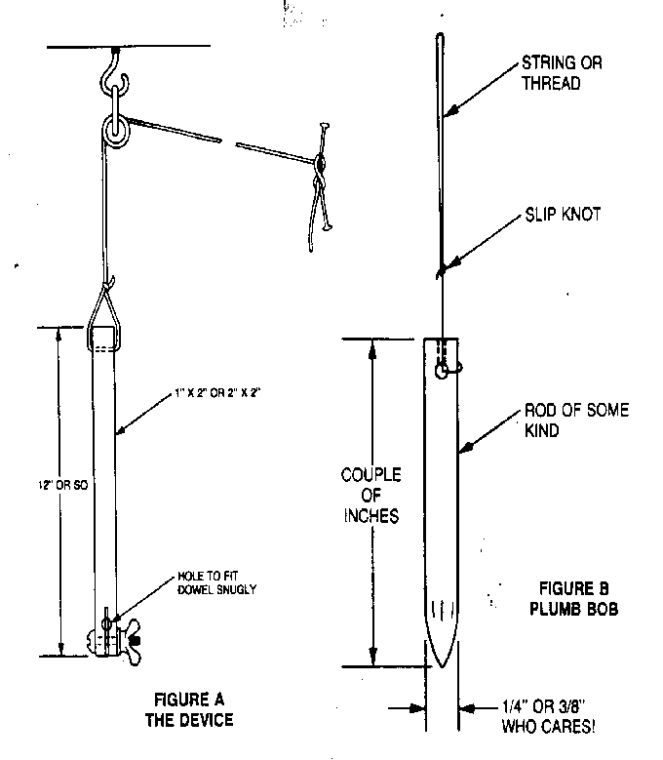
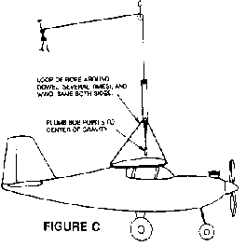

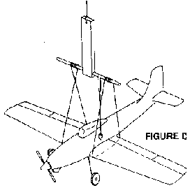
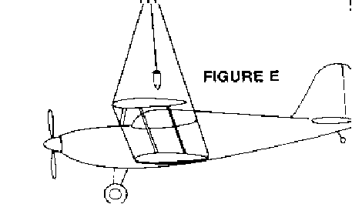

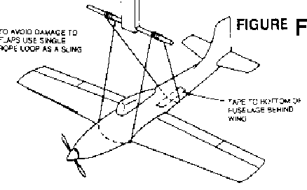

Radios- Frequency Management- Steve Warmath

We’ve all seen it. We’ve all heard it. We’ve all told the stories about it. Airplanes and helicopters crash. This unfortunate ending to a flight can be caused by many factors. There are mechanical failures, structural failures, pilot error, mid-air collisions, radio failure and the topic of this piece, radio interference. Radio interference is caused by the unwanted signal interference between your transmitter and receiver. Stray “noise” or someone transmitting on your frequency while you are airborne or on the ground can cause it. Frequency management is so important to safe operations and the protection of our investments. So what is frequency management? It is the controlled, self-regulated use of frequencies (channels) to preclude the inadvertent transmission of more than one signal on the same channel at a time. If it happens while you are airborne, you will loose control, usually in a rather erratic fashion. Have you every showed up at the field, gotten your stuff out, set it up and turned on your transmitter to check your control throws without verifying someone else is not flying on that channel? It happens. So how do we manage this problem? In practice, a “Frequency Board” is present at the field. This board has a number of clothespins with a distinct channel number on it. You put your AMA card in the slot under the pin with your channel number and attach the pin to your transmitter antenna. Anyone on the same frequency will see who has that frequency “checked out”. Sounds pretty simple. What is hard is the discipline to never turn on your transmitter without a frequency pin. One should also have your highly visible channel number placard on your antenna so others can see at a glance what channels are active.

In strictly enforced frequency management environments at large events, if you don’t have a pin on your transmitter, it is “impounded” in a central location to avoid someone having that lapse of memory by wanting to cycle their landing gear one more time or something and turning on the transmitter. We have an impound shelf at the field but it is not always used by everyone. When you are done flying, put the pin back on the board, pull your AMA card and put your transmitter in the impound area. When you are ready to fly, repeat the process. By the way, if you have more than one transmitter with you, make sure you pull the right pin for the right transmitter!
Refer to your AMA Members Handbook section “Radio Control Operation” , page 17 for AMA specifics on this subject.

The club has purchased a Hobbico Frequency Checker that will show at a glance what frequencies are in use at any given time. It is kept in the wood shed. They are only $49.95 if you want your own. There is also a company I found that is making a Frequency Management database file for use on a computer. I’ve inquired about a release date but have not received a reply. This would be more appropriate for large, structured events, but it looked pretty interesting. Check it out at www.extensioncables.com/rc/

When we experience these unfortunate failures, one is not always positive, initially, the real cause. In our follow up article this month “After the Crash”, you will find some tidbits to examine at the crash scene to help isolate the cause.

Transmitters and receivers are the heart and lifeblood of an airworthy craft. Let’s not create a stroke for the aircraft or the pilot by careless frequency use. Read the roster. Know who flies on your frequency and keep an eye out and remind them you are on the same channel. Update your channel numbers as required with the Treasurer. The plane you save may be someone else’s.

Some exciting news on the technology advancements of transmitters and receivers for aircraft is coming from the Race Car arena. You may have heard about it. It’s called “Digital Spectrum Modulation” or DSM. It is also referred to as “SS” (Spread Spectrum). Our equipment on the low side of the frequency spectrum (27,53,72,75mhz, etc.) is channel specific. If you are on a particular channel, that’s what your receiver listens for. It does not matter the source. This is where frequency control becomes an issue. Most noise such as ignition, noisy motors and speed controllers are below 300Mhz. DSM works at a very high 4.2 Gigahertz. The “Spread Spectrum” concept in simple terms is the transmitter scans 80 different channels looking for an open channel. When it finds one, it locks onto it. No other outside signal can use this channel. The transmitter will stay locked on to this frequency until it is turned off. For aircraft vs. cars, a second channel is locked in as a redundancy. Additionally, each receiver is factory set with a GUID (Globally Unique Identification Code). There are over 4.2 billion possible GUID code combinations. Once a receiver is programmed with its unique code, called “binding”, it’s virtually impossible for a receiver to listen to anything other than its bound transmitter. This is very cool stuff.

Bottom line- With Spread Spectrum technology, you no longer have to wait for the frequency pin or worry about interference. If you see an electric park flyer at the field with no frequency pin, it may be because he’s flying with DSM technology. I’ve only scratched the surface on this subject but wanted to mention it. The AMA Frequency Committee is looking hard at this and there will be a lot more on this in the future.
For additional information, see the July 2005 AMA magazine and also visit www.spektrumrc.com

Which is Better: PPM vs. PCM by Ed Olszewski (AMA “Insider” Newsletter)

Aside from all the other choices when selecting an RC radio system, the terms PPM and PCM comes up. PPM or Pulse Position Modulation is standard FM. The next step up is PCM or Pulse Code Modulation, which seems to be shrouded in mysticism. In a nutshell, it is not what frequency each is on, but how they use their frequencies.
To demystify PCM somewhat you should understand that there is no range increase with PCM. It is not on some special side band or frequency. It shares the exact same FM frequency everyone else on your channel is using, and is susceptible to the same interference. There is, however, improvement in noise reduction and safe performance while the noise is received.
Noise is the undesirable signals on your frequency. They can be caused by anything from sunspots to another transmitter horning in on your frequency. Today's modern radios operate on a narrow band that eliminates most of the random noise.
Basically, the PCM radio takes your FM signal and “codes” it digitally (the “C” in PCM). Then the PCM receiver “decodes” the signal to utilize it.
Since noise is not a normally recognized code, it is ignored by the PCM receiver, and is not sent as servo instructions. In addition PCM does not transmit position signals for each servo in each transmitter pulse. Rather it transmits movement commands as required, and occasional positions confirmation commands. Short periods of interference will simply leave the servo at its last known position, and not show such radio interference as glitches or fluttering.
If your PCM receiver continuously receives interference past the preset time, it then switches into “failsafe mode,” and obeys some preset commands you programmed in the receiver. For example, you may set failsafe to throttle down and move all other surfaces to the neutral position. This is great if you are in level flight, but disastrous if you are exiting a loop. If set to continue the last command, it will often keep your model in the loop. Unfortunately, failsafe settings will put your model in a precarious situation you didn't want it locked into.
A third level of protection may be obtained by using a pilot assist module in combination with preset positions on the failsafe settings. You can help ensure your model will go to level flight at a slow—but safe—airspeed and hopefully safely ride out the interference.
Even though the radio does not glitch, it is not to say the PCM radio was in good contact at all times. If another radio is transmitting on your frequency, it can—and likely will—interfere with your receiver’s ability to receive the proper signal from your transmitter. The CB radio enthusiast in the seventies used to call this being “walked on.” PCM will help keep your receiver from acting on a bad signal, but there is nothing it can do if a good signal can not be received over the interference.
The logic of PCM is that it is better to momentarily do nothing than act on a bad signal. PCM benefits are purely in precise transmitter/receiver communication. PCM does, unfortunately, have a serious weakness. Even minimal atmospheric or external noise can foul up those wonderful intricate binary numbers beyond any correction. In that case, the receiver is up a creek without a paddle. Think of it as if trying to communicate a grocery list via cell phone in a “one bar” area—some things are not going to make it in the grocery cart. With PCM the main purpose is to hide glitches by not transmitting them to a control surface command. As far as the pilot is concerned, there is only an unnoticeable momentary loss of control. If the radio interference is persistent, the pilot will probably be unaware and may lead to total loss of control sending the airplane either into the wild blue yonder or to the ground.
On the other hand, the simple PPM pulses may be corrupted with some information getting through. When things go bad, the choice is between no control (PCM)—and some control (PPM). Most RC pilots would prefer having some control even if erratic. When a model aircraft is suddenly doing the funky chicken, it is normally a signal to land.
Most radio interferences are normally small glitches and are recoverable, giving the PPM pilot a chance to land and find the cause of the problem.
A system sporting PCM is an excellent choice for larger acrobatic and 3-D fliers with quick throws, where a small glitch may send it suddenly into the ground. PCM will of course work on smaller, more docile airplanes. These airplanes will benefit less from the added features, and PPM is probably a good bet.
Remember there is no substitute for a good battery charge and a range check. If another radio on your frequency is turned on, there is little any radio can do to keep you from being “shot down.”

After the Crash -by Clay Ramskill
Let's face it- sometime, some day, one of your wonderfully crafted RC planes may crash. Some RC airplanes may last years, until they're just flat worn out; others have been completely destroyed after only a few tense seconds of flight!
When a crash does occur, there are several things you need to do.
LOCATE- Whether or not you are the unfortunate pilot, if you see a plane go down out in the toolies, establish a line of sight (a bearing line) to the crash. Do this by noting your position at the time, and by sighting to some recognizable landmark; in the absence of anything that stands out, lay your transmitter down, antenna pointing to the crash site. Then, if possible, a search party can just walk out that line to find the wreckage. If two separate lines of bearing have been established, the wreck site may be even more accurately pinpointed.
In a dense forest or swamp, it may be helpful if someone will fly a plane over the bearing line to aid the searchers on the ground. And in those trees, don't forget to look UP, as well as down and around; the plane can very well be perched up in the branches and leaves.
RECOVER- When you find the plane, be sure to pick up everything of importance. If there's any doubt, pick it up! Even some smaller pieces can be of aid in reconstruction. Naturally, you're interested in locating all the expensive stuff- radio, engine and such. The hard part is that heavier items (engine and battery) can travel a long way from the initial impact site; they will often be found some distance off in the direction the plane was traveling at impact. And be sure to count servos- sometimes one may be separated from the fuselage or wing. Also at this time, be sure that any leaking fuel situation is not allowed to continue. Fuel soaked wood is very difficult to repair.
If you should have to leave without all the goodies, be sure that the crash site is marked well enough that you can return to it at a later time for further searching.
ANALYZE- Sometimes the cause of a crash is obvious, sometimes not. If not, do what you can to find out what happened. This is crucial to your peace of mind, and toward preventing future occurrences.
Radio failures are usually the most difficult to sort out, but you can often narrow down any fault to a specific component. If there was a complete loss of control and all the servos went "hard over," then that is definitely a radio or interference problem. But if you were able to cut the throttle, then perhaps only one servo went haywire. And if the plane `went in' with all the controls locked in the last commanded position, then the failure was more likely the battery, switch harness, or associated plugs. Note that on a PCM computer radio, your "failsafe" mode can give you a similar effect. If only one control surface failed, the elevator for instance, you not only need to check out that servo, but also the appropriate control linkages.
RECONSTRUCTION ?- That depends.
It depends on how bad the damage is, of course. But heavily damaged planes CAN BE REPAIRED. It's usually a question of whether you think it's worth it and many factors will influence your decision. But give yourself a chance; take the scraps home and think about it before you make any rash decisions to trash the plane.
And the repairs? -That's another subject..

New Member Spotlight

No new members were in attendance at the December meeting. We are providing a photo of a Mystery Member provided by Bob Burke. Can you guess who it is? Modeler and Businessman by day, Superhero at night.


Safety Notes- A picture is worth a thousand words.
Field- Unknown.
Man on hands and knees- Dumb and Lucky!
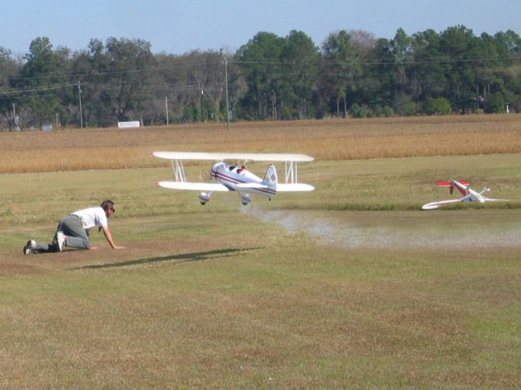

INCOMING!

Beginners Briefing- Engines
This briefing will be a series of articles on very basic information about our hobby for those just trying to figure out what it’s all about. This fourth installment is about the mysterious world of Engines. In future briefings we’ll talk about glow plugs and radios. If you would like to post a question for the newsletter, we’ll be happy to answer you. Just drop us a line.
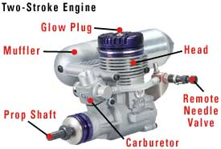
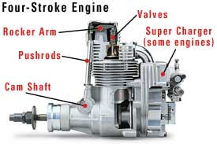

Radio Controlled Engines Made Easy
What is a glow engine?
R/C models are powered in a variety of ways. Sailplanes, for example, need no power source other than nature. But they’re the exception. Nearly all R/C vehicles, aircraft, boats and helicopters require something to propel them into action.
Electric models use small motors, powered by battery cells. Those motors should not be confused with glow engines — which are actual internal combustion power plants that form the heart of any “gas” or “nitro” powered R/C model.
Most gas R/C models use a 2- or 4-stroke glow engine, sized specifically for that model. Typically, they range in displacement from .049 cu. in. to 2.2 cu. in. — a variety that satisfies virtually most model’s power requirements.
Glow engines cannot be operated with the same gasoline you’d get at a filling station pump. They require a special fuel, called “glow fuel.” It contains methanol as the base, with varying amounts of nitromethane to increase the energy that the fuel can provide. Oil, pre-mixed into the fuel, lubricates and protects your tiny engine as it pounds out amazing power.
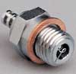Glow Plug
When you get your new engine, first examine it carefully for any obvious defects. Read the operating instructions closely. If the manufacturer suggests a specific procedure for breaking in the engine, by all means, use it!

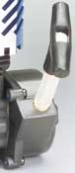
Two-stroke vs. four-stroke
You’ll quickly notice that many R/C models give you the option of installing a 2-stroke OR a 4-stroke glow engine. How do you know which is best?
Two-Stroke simply means that the engine “fires” (ignites the fuel in its combustion chamber) with every revolution of the piston. Generally, they’re a good place for new gas modelers to start. Two-strokes are easier to operate, less vulnerable to problems if misused, and deliver more power for their size and weight.
Four-Stroke engines fire once with every two revolutions. They consume less fuel, sound more realistic, and provide more torque — but cost more, are harder to adjust and require more maintenance.
Recoil
Starter
How does a glow engine work?
Most glow engines have a simple ignition system that uses a glow plug rather than a spark plug — so there’s no coil, magneto or points. The glow plug is heated by a battery-operated glow starter; meanwhile, the modeler uses a recoil starter, electric 12V starter or starter box to turn over the engine. When fuel enters the combustion chamber, it’s ignited by the heated glow plug — and with that, the engine springs to life, instantly gaining the momentum to continue running after all the starter accessories are removed.
 |  | 
Electric 12V Starter |  | Starter Box for Cars
The engine’s carburetor supplies the fuel and air needed for combustion. It has several adjustments. A rotating throttle arm controls the AMOUNT of fuel and air that enters the combustion chamber. The high-speed needle valve controls the MIX or proportions of fuel vs. air at mid- to high-speeds.
The idle mixture screw is similar to the high-speed needle valve, except that it controls the mix of fuel and air when the engine is only idling. When you’ve adjusted the high-speed and idle mixtures properly, your engine should operate smooth and steady throughout its speed range.
Books
There are many books available with helpful information about glow engine operation and maintenance, including the following:
Harry Higley’s All About Engines
Model Airplane News 2-Stroke Glow Engines for Aircraft, Vol. 1
O.S.® Engine/Carburetor Exploded Views Book

How do I care for a glow engine?
If you take good care of your engine from day one, it will reward you with a long life of optimum performance. Proper maintenance is not difficult. Some of the best tips include:
- Keep your engine clean.
- Keep your engine dry.
- Use an after-run engine oil.
- Use a brand-name fuel that contains at least the amount of oil recommended by the engine manufacturer.
- Use fuel with the proper percentage of nitro-methane, as recommended by the engine manufacturer.

Other types of R/C engines
Models designed for first-time R/C hobbyists will not require any power plant other than an electric motor or 2- or 4-stroke glow engine. Other types of engines are used at more advanced levels of the hobby, however. For example, some R/C jets are powered by ducted fan engines, actual turbine engines (jet) and many large-scale aircraft use gasoline engines similar to those found in chainsaws and “weedeater” lawn tools but are made specifically for model aircraft.
Gasoline Powered Engine
What accessories will I need?
For whatever engine that you order (or is included with your model), check the “Accessories Needed” in the manufacturer’s instruction manual. There, you can quickly find out what additional items are required to run it.
All glow engines will require glow fuel, fuel line and spare glow plugs. You may also need a muffler or tuned pipe. Most model airplanes require an engine mount, which may or may not be included with the kit.
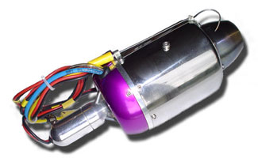

Turbine Engine

Next month we’ll include a detailed article on glow plugs and the different types.

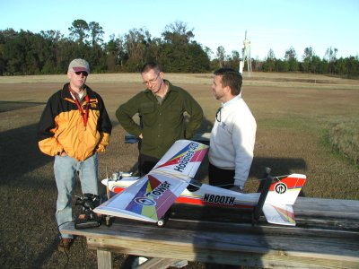
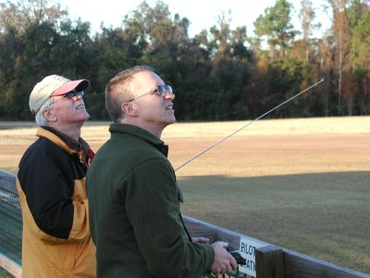

Mike and Geoff check out Don’s Club Trainer.
Geoff & Don getting some “air time” together.

Announcements

T-Shirts For Sale:
Seminole RC Club t-shirts are available for purchase. We have a variety of sizes available. White pocket t-shirts are only $10, while gray and tan pocket t-shirts are $11. I have 2 XL gray shirts with a collar. These are $15. The ordering of the shirts is a benefit for club members. We have priced the shirts low, where we are essentially at a break-even point. So, we need to sell all of the shirts real soon. Shirts will be available at the club meetings and all club sponsored events.

Seminole Radio Control Club
Tallahassee, FL

AMA Charter #216, 1969-2005

SRCC Officers
President – Mike Atkinson
Vice President – Geoff Lawrence
Secretary/ Newsletter Editor – Steve Warmath
Treasurer - Sam Varn
Field Marshall – Appointed in January
Field Safety Officer- Appointed in January

Field Hours
12 Noon till Dark- These hours apply to all aircraft, gas and electric.

Training Notes
To schedule a training time contact Mike Atkinson.

Flight Instructors
Mike Atkinson (Coordinator) 926-4692 (H)
Ed Budzyna Sam Varn
Jeff Owens Bob Burke
Geoff Lawrence John Clark

Club Meeting Location and Time
The regular club meetings are held on the first Thursday of each month at 7:30 PM at the Grace Lutheran Church on Miccosukee Rd. Head out Miccosukee Rd., cross Capital Circle NE, and the entrance will be the first one on your right. Once you park, follow the sidewalk around the left side of the building and go down the hill. We meet in a room on the first level.
Submissions- Submissions are requested to be in M.S. Word format. Photos should be in .jpg or .tif format. Vector art accepted in Corel, Illustrator and AUTOCAD format. We will, however, accept anything to make it easier for those who wish to contribute. Submissions are due no later than the 23rd of the month. We can be contacted at seminoleflyer@feezel.net or by phone, Steve at 509-0672 and Richard at 906-9341.
Editor’s note: Please contact the editors for any reporting contribution assistance and for reporting formatting problems, errors, omissions or corrections at seminoleflyer@feezel.net. The views expressed in the newsletter are of those of the specific authors and do not represent a majority consensus of the club membership unless voted upon at a club meeting.
Hard Copy Printing of the SRCC Newsletter provided by Apogee Signs & Graphics.



