The Seminole Flyer www.seminolerc.com


A chartered member of the Academy of Model Aeronautics

AMA Charter #216, 1969-2007

“The Seminole Flyer” is a publication of the Seminole Radio Control Club of Tallahassee, Florida JANUARY 2007

INDEX

Letter from the Editor
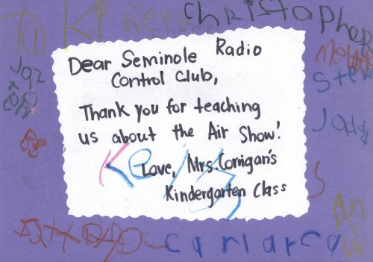
- Float Fly Photo Gallery
- Chief Pilot Report
- Chief Copilot Report
- Chief Treasurer Report
- Chief Scribe Report
- Pilot Briefing (New)
- High Wings vs. Low Wings
- Field Safety Rules
- Classifieds/ For Sale
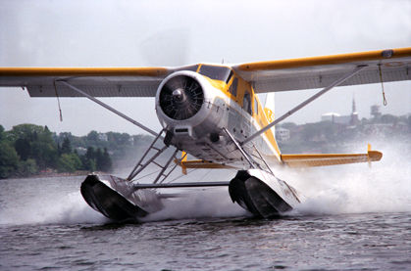

Medart School Certificate of Appreciation for Airshow

Letter from the Editor- Stephen Warmath
Well, Christmas has passed and a New Year is upon us. Another year to build, fly, meet, get to know each other a little better and enjoy the camaraderie of being a member of the Club. One way to enhance that feeling is if we can know each other a little better. A Newsletter addition for this year will be a new offering entitled “Pilot Briefing”. This will spotlight a member of the Club and provide a little information about the member as to where they are from, what do they do, what are their interests, etc. along with a picture of the member. We will start this month and February spotlighting the Officers of the Club. I think the membership should know something about and be able to recognize their Officers. This month we feature John Hall- President and Brad Sharp- Vice President. Next month, Steve and Sam. In March we will randomly spotlight other members of the Club in no special order, just whoever is willing to participate. If interested in being in the spotlight, please e-mail me and I’ll send you a short format to follow. Just fill it out and send a digital picture of yourself and I’ll get it in. Also this month, the December Float Fly Photo Gallery is included. Float flying is a lot of fun. There are several article links on float flying from our web site. Check out the “Do it Yourself” link. High Wings vs. Low Wings. They are different in how they respond in flight. A short primer on how they behave. As we start a new year, it’s a good time to review our Field Rules in that we have a safe and enjoyable flying experience in 2007. Happy New Year!

Photo Gallery- Float Fly December 9, 2006
Photos by Steve Warmath
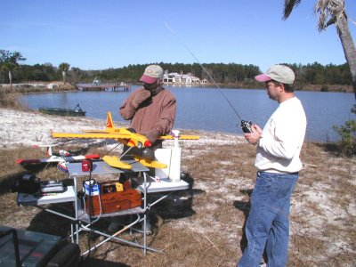
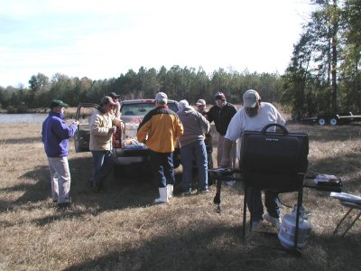

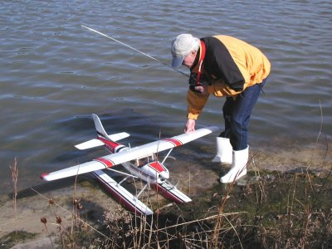
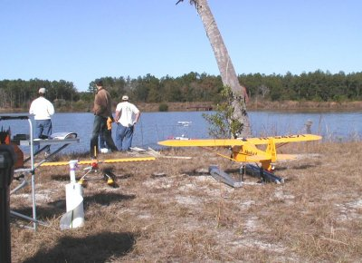

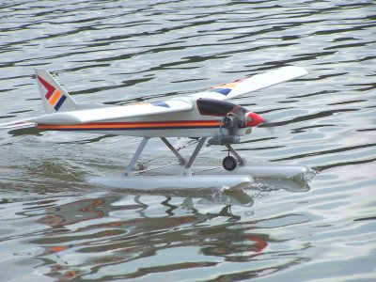
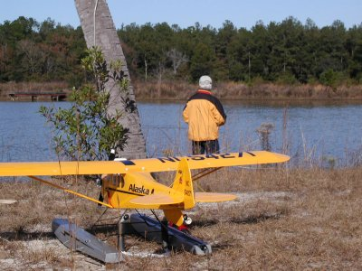

Chief Pilot- John Hall
Wow, 2007 is here! That's hard to believe. So, where are the flying cars the futurists predicted for the 21st century? I think Dr. Mike has one! Hey, at least we have flying boats... those cool little foam, electric, RC hydroplanes that can scream across the water and then, with a little up elevator, lift off the water and fly around like a foamy airplane. I've held off on buying one for myself because I already have too many RC models, or so I've been told.

Thinking about what lies ahead in the year to come, we have our ongoing participation on the Park Use committee. This participation is important in helping the club have input as to the future of our flying site and what kind of facilities we will eventually have. As committee members, Dr. Mike and I will continue to represent the interests of the club and the surrounding community at the monthly meetings.

Another important job will be the planning and execution of our annual club events and our participation in other major events such as the EAA fly in. These events are our best opportunity to expose the general public to our hobby and let people know what our club has to offer. And, of course, we will all be working together to make club membership and flying at the field as safe and fun as possible.

2007 will be my third year as a radio control enthusiast and member of the Seminole Radio Control Club. As the new President of the club, I will do my best to fulfill the duties of the position. I look forward to working with the other club officers and club members to make 2007 a safe and fun year for all of us.

Happy holidays and see ya at the field.

John Hall

Chief Copilot- Brad Sharp
Upcoming Club Events

January 4, 2007- Club Meeting at Grace Lutheran Church. 7:30 pm.

Upcoming AMA Regional Events

Chili Fly and Cook Out
1/06/07 - McDonough, GA (C) Chili Fly and Cook Out. Site: Red Hawk Park. Miles Simmons CD, 315 Tussahaw Tr Locust Grove GA 30248 PH:678-583-4045 email: mes57@bellsouth.net. Visit www.henrycountyrcclub.com. Bring a plane and a dish or chili. Sponsor: HENRY COUNTY RC

First in the South Electric Fly In
FL
01/19/07-01/21/07 - Odessa, FL (C) First in the South Electric Fly In. Site: Club Field. Wilbur Kibbey CD, 6717 Forrest Vale LN Tampa FL 33634 PH:813-885-4292 email: dynomite2034@aol.com. Sponsor: WPMPA

The SE IMAC Season Opener
FL
1/20/07 - 1/21/07 - Port St Lucie, FL (A) The SE IMAC Season Opener for 411, 412, 413, 414, 415(O). Site: Club Field. Peter Jackson CD, 1908 Stillwind Court Orange Park FL 32003 PH:904-269-7260 email: ppajack@aol.com. 8:15am registration ends, 8:30am pilots meeting, 9am wheels up. Landing fees $30 ($25 - IMAC Members) includes meal on Saturday.I-95 Exit 126 East on Midway Rd, Turn right on E Torino , Turn right on Blanton going west. Field is to the north of Blanton. Campsites available no hookups. Sponsor: SUN DANCERS RC CLUB

Warbirds Over Paradise
FL
1/20/07 - Cape Coral, FL (C) Warbirds Over Paradise. Site: Sea Hawk Park. John Niezelski CD, 4334 NW 34 Terr Cape Coral FL 33993 PH:239-282-0635 email: jniezelski4334@earthlink.net. LF $10 RV Park free. Paved runway 60'x500' event limited to all size warbirds in military pain scheme. Electric warbird time available. Turbine warbirds welcome. Visit www.rseahawks.org. Sponsor: CAPE CORAL RC HAWKS

January 2007 Indoor Contest
GA
1/20/07 - Kennesaw, GA (A) January 2007 Indoor Contest for Cat II 202, 203, 206, 212, 215, 217, 218,(JSO), 208, 219, 220(J)(SO). Site: North Cobb HS. John Barker CD, 3406 Creek Valley Dr SE Smyrna GA 30082 PH:770-436-9912 email: jambarker@juno.com. Most popular AMA and some FAC classes. Time available may restrict number of flights. Other classes: Science Olympiad, Hangar Rat, Dime Scale, Butterfly FAC: No-Cal (profile) Scale, Peanut Scale, A-6. Sponsor: TTOMA

FSS #1
FL
1/27/07-1/28/07 - Punta Gorda, FL (A) FSS #1 for 444(JSO). Site: Club Field. George Grier CD, 132 Coral Dr Ft Myers FL 33905 PH:239-694-1990 email: jenbilfla@webtv.net. Start time Sat 10am. Sportsman and Expert classes. Mapquest address for directions 24472 Rio Tagas Rd Punta Gorda FL 33950. Sponsor: SW FL SOARING SOCIETY

Upcoming IMAA Regional Events
None in January

Chief Treasurer- Sam Varn
Editor’s Note: The Treasurer’s report is published for Members only. The public version of the Newsletter does not include this information.

Activity for December was a little slow but far more active than November. We paid for weed killer, meeting snacks and float fly concessions (total for all was $158.45) and had four new members, John Hazlip, Chad Jackson, George Julovich (back after an 18 month hiatus) and J T Sheddan which brought in $220.00 to the treasury. That said here are our balances as we roll into 2007:

Cash - Checking - CD - Savings –
Total -

I hope everyone had a wonderful Christmas (with lots of hobby related gifts under the tree) and a safe New Year!
Sam

Chief Scribe- Steve Warmath
The December 7th Club meeting was called to order at approximately 7:30 pm.

Visitor/ New member Introductions-
New Members Present- Danny Goddard Guests-

The Treasurer’s Report- Sam read off the current account amounts. Mike Kinsey was reimbursed for Weed Killer and Mike Atkinson for meeting dessert sweets. A motion to accept the treasurer’s report was made, seconded and passed.

Old Business-
- Mike was still working on getting the badges and frequency pins. Richard was no longer with the company that would provide them. Sam volunteered to help out if Richard could not do them.
- The December Landfill meeting was cancelled. Three park schemes had been developed and none were acceptable and not well planned. It would be likely that the County would not continue using the current consultant, but would do the planning in-house. Mike said that realistically we were still two years away from moving.
- The Float Fly was coming up this weekend. It would be a cool start, but should be a good day for flying, warming up later in the day with light winds. Mike A. will be bringing his grill. Theo Titus offered to donate his radiant kerosene heater if desired. Bob Burke noted the propane heater and tank had been picked up and was no longer in the shed. Apparently it was picked up by the owner.
- Mike said the MEDART School flight demonstration was a big hit. He had a certificate made by the class and two letters of appreciation. Shadeville Elementary School has mentioned their desire for one in April 2007.
- Ant poison was still needed at the field. Geoff Lawrence said he would pick it up.

New Business-
- Mike Atkinson wanted to address the membership regarding two issues that he felt needed to be discussed and resolved about use of the field.
- An issue came up about 1-1/2 to 2 years ago regarding .90 sized 3D aircraft flying in close to the pilot stations. There was a consensus of opinion that all 3D flying would be conducted on the far side of the runway to comply with AMA safety standards. It appears that with the increase in the number of 3D and helicopter aircraft flying at the field. It is becoming a problem again flying in close to the pilots and pit area.
- The second issue is one of courtesy. When in-close 3D and helicopter flying is going on, no fixed wing conventional flying can take place due to over flying the runway. Also it remains a safety issue and a distraction for pilots flying away from the immediate runway area. Mike said it made him nervous.
Solutions? Mike recommended, again, limiting in-close 3D and heli flying to the far side of the runway. He noted the North heli-pad area was not big enough for 3D flying and suggested that an area to the West of this pad be widened to create a dedicated 3D/heli flight area. He would volunteer the use of his tractor to mow.

Theo Titus noted our lease was for a small area of the field only and we may not be allowed to extend the flying area. He also mentioned this area puts flying closer to the Sharp’s house.

Brad Sharp asked if there were any AMA insurance issues. Mike thought the 25’ separation rule between aircraft and personnel was the only issue he was aware of.

Ken Detzner suggested we get input from all the Heli guys and let them come back with some suggestions. Mike felt this would be a good idea. Mike reiterated that this was not just a helicopter issue but a flying style issue. Our older, long-time pilots have expressed concern about feeling uncomfortable flying conventionally with a lot going on around them on the runway.

Geoff Lawrence said that it is also a courtesy issue. If 3D and heli flying were on the far side of the runway, pilots would be able to share the runway.

Don Coon stated that when he brought his student out to fly, they had a very narrow window of time to fly and could not wait around for an opening to access the field.

It was agreed that the discussion would continue at the next meeting with the recommendations of the helicopter pilots.
- Mike noted that historically, the December meeting was when the cub nominated a person for “Club Member of the Year”. He then asked the members present for any nominations. Three members were nominated. They are as follows:
- Steve Warmath- for his work publishing the Club Newsletter. Nominated by Sam Varn.
- Frank Bastos- for the HobbyTown contributions and support of the club. Nominated by Geoff Lawrence.
- Francis Surovec- for allowing the Club use of his property for the Float Flys’. Nominated by Ken Detzer.

Ballots were handed out and voting was completed with ballots collected in a box. Mike was to tally the votes and make the announcement at the January meeting.
- Don Coon asked for assistance from anyone who could spare some time around 7:45 to 8:15 am for his morning class for teaching flying park foam flyers. He would resolve any safety issues and could be reached at his new extension at Leon High School.. ext. 1950.
- Mike noted the current slate of Officer nominations:

President – John Hall
Vice President – Brad Sharp
Secretary – Stephen Warmath (incumbent)
Treasurer - Sam Varn (incumbent)

Mike opened the floor for additional nominations. None were made. A motion was made to close the nominations, seconded and passed. A motion was made to accept the current, unchallenged nominations by quorum, seconded as passed.
(Secretaries note: In accordance with the Club Constitution, Article VII, paragraph 8., “Officers shall take office at the completion of the regular membership meeting in December.”

Pilot Briefing
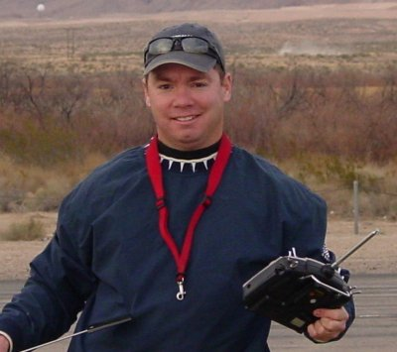
John Hall- President

Where are you from?
I was born in Green Bay, WI and lived in Northern WI until I was about 15 years old. Then my family moved to Ft. Myers, FL where I attended high school. I went to FSU for four years, graduated and got a job in Jacksonville, FL where I lived for 5 years. From there I moved to NYC where I lived for 11 years, and then back to Tallahassee where I've been for the last 4 years or so.

What do you do for a living?
I have a B.S. degree in Computer Science from FSU and currently work as an independent software development consultant.

How did you get started in radio control?
Between the ages of about 5 and 13, my older brother and I built many static, plastic model kits: cars, ships, planes, you name it. I always wanted to fly model aircraft, but never had the means or, as I got older, the time and commitment to get started. I almost got into nitro helicopters about 8 years ago in NYC. Some of the guys I worked with in the office were trying helicopters but kept telling stories of crashing every time they would get off the ground. I looked into buying a helicopter but then decided it was not a good hobby for somebody living in Manhattan.

Then years later, after moving to Tallahassee, I was browsing the web one day and came across an ad for a four rotor helicopter called the DragonFlyer IV. The online videos of this thing flying were incredible and I decided I just had to have one. In hindsight, that was probably not the best way to get started in the hobby because that model was very expensive and hard to fly. But I was determined to be able to hover that model and eventually, after weeks of practice, could do it. That's when I decided I wanted to pursue the hobby more seriously and see if there was a club in town to help me learn.

I emailed then-club-president Richard Wynn and showed up at the field in March of 2003. That first visit I watched Gordie fly his 90 size helis and that's when the RC "hook was set". I asked Gordie for a list of everything I would need to get started with helicopters, which he gladly provided, and off I went to order it all from Heliproz. That was before we had the awesome hobby shop that we have now. While I was waiting for the helicopter stuff to arrive, I bought a NextStar trainer plane to learn fixed wing at the same time. I haven't stopped learning since.

What do you like best about the hobby?
Initially it was the individual challenge of building, setting up, and then flying the models. Now it has become a combination of the individual challenge as well as the fun and friendship that comes from belonging to and participating in a club such as ours. Flying alone is definitely not as fun as flying with a group... regardless of skill level or background. I also enjoy helping new people get started in the hobby. It's a little intimidating to be at the field when you are a beginner; at least it was for me. But those starting out need just remind themselves that everybody, no matter how skilled, started as a beginner.

What models do you have or would like to have? What are your favorites and why?
I love to build and fly all types of aircraft. I have tiny, electric, micro-helicopters on up to the 90 size nitro helis. I also have small, foamy planes on up to 90 size nitro planes. Right now my favorites are the 90 size nitro helis and the smaller electric helis. I also enjoy flying the foamy planes. Eventually I would like to build and fly a giant scale 3D plane, 33% or larger. But that will have to wait until I have more space and I build some of the models I already have that are still in boxes!

Other than just enjoying the hobby, are there any skills or maneuvers you are working on or want to master?
I'm always working on something with the helicopters... there is so much you can do with them. The possibilities are almost endless. I would love to be able to fly 3D like some of the sponsored pilots I see at the fun flies. With airplanes I like flying low and slow, which makes it easier to crash if you screw up. But that's what makes it so exciting to me I suppose.

Is there anyone in particular who has influenced your participation in the hobby?
I mentioned Gordie Meade before because that was the first time I had ever seen what an RC helicopter could do and I was impressed. He helped me get started with the helicopters. For fixed wing, it was the guys who buddy boxed me until I was able to solo: Dr. Mike, Paul and Jeff Lawrence, and Mike Kinsey... thanks guys. Jay Leudeke has been a great help for all things helicopter and tuning engines as well.

Is there anything else you'd like to share?
I'm looking forward to the challenges and constant learning that can be a part of this hobby. I'm also looking forward to more of the friendship and good times I've had so far with the club.

Brad Sharp- Vice President
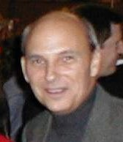
Where are you from? Born 1945, central Indiana, but grew up in northern Illinois. Army, 1965-1968. Moved to Manhattan 1976, and lived there 13 years. Memphis, TN 1987-1989. San Francisco Bay area, 1989-2002. Tallahassee since May 2002.
What do you do for a living? I spent 1968-2002 in information technology, when it was still mostly fun. Have been sort-of 'semi-retired', working at HobbyTown since 2003.
How did you get started in radio control? Frank Bastos gave me a long list of ways I could improve my image at HobbyTown. At my age, I couldn't do much to improve my personality and attitude - besides, flying R/C was at the top of the list, and I've always wanted to fly.
What do you like best about the hobby? I suppose like most real pilots - it's the flying ' The Flying'. With all the choices we have today, I don't think there's ever been a better time to fly R/C.
What models do you have or would like to have? What are your favorites and why? I still have the Airborne Models Skyraider Mach I high-wing trainer that belonged to The Club until I found the wind-sock post with it - Ken Detzner, for one, would probably recognize it when he sees it, if he's close enough. I had a great flying-for-$75-bucks Skyraider Mach II that's still in the back woods somewhere, about 43 degrees off pilot station 4, following a wing separation - I'm hoping to find the remains and reason when more of the leaves fall. Presently, and in spite of at least twenty more planes Frank tells me I 'need', and at least thirty I'd like to have, I have only a flyable Park 480-powered Slo-Stick (heh-heh), and a really nice-flying .46-powered Seagull models Space Walker.
Other than just enjoying the hobby, are there any skills or maneuvers you are working on or want to master? Before I get really crazy, I'd like at least to land nicely and consistently, and have everyone envy my landings. I probably need a tail-hook, but it's a well-known fact that all great pilots should have one and use it as often as possible......
Is there anyone in particular who has influenced your participation in the hobby? Frank Bastos, of course. For flying instruction, the predictable excitement of being on the buddy-box with Frank could only be balanced by Dr. Mike, Geoff Lawrence and Tristin. I'll always remember, "Hey - he just solo-ed, didn't he? Didn't he? One good landing is all he needs, right? - Uh - he didn't crash, right?" And yes, the encouragement from 'Vultures Row.....'
Is there anything else you'd like to share? Though I don't at this point think I can fly as well as many of our members do, I look forward to spring and lots of learning, flying and watching others fly. I like it all - nitro, electric, and all the aircraft and styles of flying we have to choose from today. I admire anyone who can fly well in any style, flying anything.....
HIGH WINGS versus LOW WINGS -by Clay Ramskill
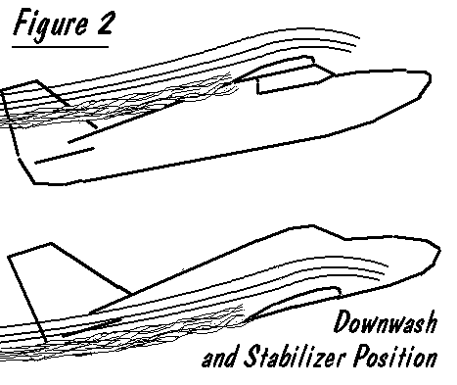
We finally master our high wing trainer -- or trash it, whichever comes first. Maybe then we build a shoulder wing plane.
Only after we are somewhat competent at flying do we try flying a low wing plane, and then with white knuckles and shaky knees. WHY? Just what is it about low wingers that make them "tougher" to fly?
Are they faster? No! All other things being equal, there's virtually no difference in drag, or therefore top speed. The illusion comes from designers' choice -- they tend to put faster airfoil sections and lower aspect ratios on low wing planes, making them speedier.
Low wing planes do have several characteristics, compared to high wingers that make them more suitable for higher performance aircraft.
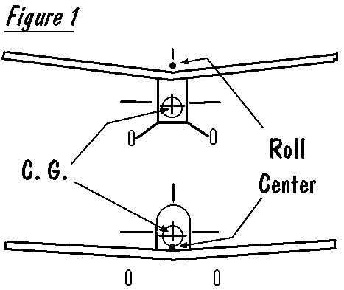
1. "Nicer" (and quicker) roll response. This comes from the relative placement of the Center of Gravity, being closer to the natural roll center of the wing. The CG will be at or only slightly above the roll center of a low wing, but well below that of a high wing. Assuming at least a little dihedral, the roll center of the wing will be slightly above the center of the wing. See figure 1.
In a roll, the wing (providing the "power") wants to roll about its own roll center. The rest of the plane (the "resistance") wants to roll about the CG. The wider the distance between roll center and CG, the funnier-looking is the roll (i.e., "non-axial").
2. The low wing lends itself to a less stable stabilizer position, leading to more pitch maneuverability.
With a high wing, it's simple, and natural, to have the stabilizer well below the wing. When the nose is pulled up, the stab drops down well below the wing's downwash, and becomes increasingly resistant to further AOA increases. This is great for stability, and makes stalls less likely.
The opposite is true for the low winger -- or a pull-up, the higher stab drops into the wing's downwash, making further AOA increases easier, and the plane more maneuverable.
3. The low wing reacts more neutrally to power changes.
Our old high wing trainer, with the thrust line very low, will respond by pitching nose up when power is added, nose down if power is reduced. This contributes to stability; with the nose going the way we want it to on a trainer.
On the other hand, the low winger will be more neutrally stable, without much pitch reaction to power changes. The low winger will also be more wind "resistant" on the ground, a function of wing height above the wheels. The high winger will naturally be more "tipsy," reacting to wind while taxiing and during takeoff and landing.
We must all understand that we're only talking of tendencies here. There are many other variables that have an impact on the characteristics involved -- the designer can juggle these around to get the desired handling. But wing placement is definitely one of the biggies when it comes to establishing how a plane is going to handle.

Seminole Radio Control Club

GENERAL FIELD RULES

All AMA safety rules shall be observed, including, but not limited to, the following:
1. No alcoholic beverages or illegal substances allowed on or about the flying field.
2. All food wrappers, bottles, trash, etc. are to be placed in the appropriate trash container. Broken aircraft should be taken home for disposal.
3. All persons shall remain behind the runway flight line safety barrier except when starting engines or retrieving aircraft.
4. Engines are to be started on the runway side of the flight line, and the pilot should be standing behind the crash barrier in a designated pilot box at takeoff. There are four such boxes at thirty-foot intervals,
limiting the total number of planes in the air at any one time to four. A helicopter practicing hovering maneuvers at the helipad shall not be counted in this total. However, any forward flight similar to a fixed
wing aircraft shall be treated as same, with the pilot occupying a flight box. Engine tests may only be conducted on the pit side of the barrier, and as close to it as possible, with the tail pointed towards
the barrier.
5. Each pilot must have a current AMA membership card and shall be a current Seminole Radio Control Club member or guest.
6. Novice pilots and guests shall not fly unassisted until they have demonstrated their ability to safely control their aircraft to a designated instructor.
7. Under no circumstances may a transmitter be operated without the proper frequency control pin (pins) attached to the antenna and AMA card in the frequency slot.
8. All engines larger than .10 cubic inch displacement shall be equipped with an effective muffler.
9. An AMA prop nut or spinner is strongly recommended.
10. The discharge of firearms is strictly forbidden.

FLYING RULES

1. Each new or rebuilt aircraft shall have a careful inspection and range check prior to flight.
2. Do not fly an aircraft having radio or structural trouble.
3. No flying behind the flight line.
4. Pilots shall operate their aircraft in a safe and courteous manner at all times.
5. HAVE FUN!

Classified Advertisements/ For Sale
FOR SALE-
HOBBICO NEXTAR- Plane is new, never flown. Futaba Skysport transmitter. No other radio equip. No engine. Plane and transmitter only (Chan 52) $150.00. Call Steve 509-0672 or e-mail ssw@nettally.com
Alpha Jet ducted fan profile jet from Hobby Lobby ($57 new)
Do you have a NEED FOR SPEED!!! Well, if you do, this aerobatic jet is the ticket. Add a dual conversion crystal on your frequency and this model is ready to fly!

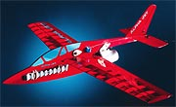

- Vasa VAS400 ducted fan unit ($120 new)
- Mega 16/15/3 brushless motor ($80 new)
- Castle Creations Phoenix35, 35 amp brushless speed controller w/ Deans ultra battery connector ($90 new)
- Hitec Electron 6, 6-channel dual conversion full range receiver (negative shift for Futaba) ($93 for flight pack w/ 3 servos new)
- 3 x Hitec HS-55 micro servos (incl. in flight pack)
- Deans whip antenna ($9 new)
- Thunder Power 2100mah lipo battery w/ Deans ultra connector (you'll need a lipo charger) ($75 new)
- 6-inch Deans ultra connector battery extension ($10)

Here is a video of an Alpha Jet in flight:
http://www.aff-cnc.de/aff/vid/aff_alpha_jet.avi

This model has been flown probably 10 times max, NEVER been crashed or even required repair since new.
Whole package cost over $534 new! You can have it for less than half the new price!
I will personally demo fly this model at the field for you before you buy it. It's a great model; I just don't fly it much any more due to my helicopter addiction. :-) Asking just $250 FIRM.
The price is firm because this is a great deal at less than half the new price and the quality is high. AND, you get to see it fly before you buy so this is not some Perry-table-gee-I-wonder-if-it-will-fly-gamble-buy! :-)
John Hall
john_hall@mindspring.com
(850) 893-6457
Wanted-
1. I would like a foam-cutting rig. I have seen hot wires that cut along templates attached to foam boards. Is there a way to see if someone has one of these rigs just gathering dust somewhere? Thanks - Don M. Coon
Integrated Science Teacher
Leon High School
850.488.1971 x2750 before 8:30 AM or after 3 PM
www.leon.leon.k12.fl.us/lion/dept/science/coon/
Seminole Radio Control Club
Tallahassee, FL

AMA Charter #216, 1969-2007

SRCC Officers

President – John Hall
Vice President – Brad Sharp
Secretary/ Newsletter Editor – Stephen Warmath
Treasurer - Sam Varn
Field Marshall – John Hall (New Appointment to be made in January)
Field Safety Officer- Gordie Meade (New Appointment to be made in January)

Field Hours

12 Noon till Dark- These hours apply to all aircraft, gas and electric.

Training Notes

To schedule a training time contact Mike Atkinson.

Flight Instructors
Mike Atkinson- Primary/ Advanced Fight Instructor (Coordinator) 926-4692
Geoff Lawrence- Primary/ Advanced Fight Instructor 942-9807
Mike Kinsey- Primary/ Advanced Fight Instructor 566-0144
John Hall- Primary/ Advanced Helicopter Flight Instructor 893-6457
Jay Leudecke- Primary/ Advanced Helicopter Flight Instructor 508-7135
Jeff Owens- Ground School/ Airworthiness Instructor (Fixed Wing) 894-2504
Steve Warmath- Ground School/ Airworthiness Instructor (Fixed Wing) 509-0672
Frank Bastos- Hobby Town Flight Demonstrator 671-2030
Don Coon- Leon High Aerospace Club Instructor 488-1971 x 1950

Club Meeting Location and Time
The regular club meetings are held on the first Thursday of each month at 7:30 PM at the Grace Lutheran Church on Miccosukee Rd. Head out Miccosukee Rd., cross Capital Circle NE, and the entrance will be the first one on your right. Once you park, follow the sidewalk around the left side of the building and go down the hill. We meet in a room on the first level.
Newsletter Submissions- Submissions are requested to be in M.S. Word format. Photos should be in .jpg or .tif format. Vector art accepted in Corel, Illustrator and AUTOCAD format. We will, however, accept anything to make it easier for those who wish to contribute. Submissions are due no later than the 23rd of the month. Send your submissions to ssw@nettally.com or by phone, Steve Warmath at 509-0672.
Hard Copy Printing of the SRCC Newsletter provided by Apogee Signs & Graphics.



