The Seminole Flyer www.seminolerc.com


A chartered member of the Academy of Model Aeronautics

AMA Charter #216, 1969-2007

“The Seminole Flyer” is a publication of the Seminole Radio Control Club of Tallahassee, Florida FEBRUARY 2007

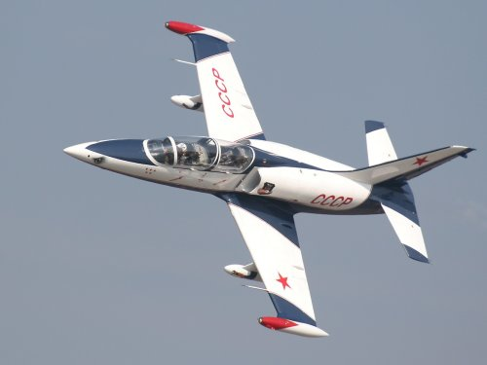
INDEX

Letter from the Editor
- Chief Pilot Report
- Chief Copilot Report
- Chief Treasurer Report
- Chief Scribe Report
- Regional Park Update
- Pilot Briefing
- Wing Tips
- Adhesives
- General Field Rules
- Flying Rules
- Classifieds/ For Sale
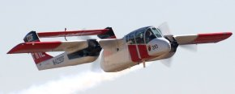

Russian L-39 Albatross on high-speed fly-by.

Letter from the Editor- Stephen Warmath
As you may know, this time of year is a little slow in the events department. But with the very unusual weather we are having, there is plenty of flying time to be had. John writes about our fortunate location. Mike has sent in an update on the Regional Park. We continue our new series “Pilot Briefing” featuring the other two Officers of the Club, Sam Varn and Steve Warmath. (Very strange writing about ones self in third person.) An aerodynamic primer is included on the effects of Wing Tips- What are they good for? And finally, a very sticky subject, Adhesives. How to glue yourself to just about anything. The Field and Flying Rules of the Club are included again this month for those that may have missed them last edition. The 3D/ Heli “Box” rule has been added. Happy Building and Flying- Steve

Chief Pilot- John Hall
We are truly fortunate to live in a part of the country that allows us to fly year-round. For many modelers, their fields lie dormant under several inches, if not feet, of snow. For these pilots, winter presents the opportunity for building/ repair work and getting radio gear serviced. But based on comments made by Northern pilots in the online forums, they are envious and wish they could fly year-round like us.

So far, this has been the mildest winter I've experienced as an RC enthusiast. This past month I've been out at our field standing on the flight line in a T-shirt. Even if the temperature does drop down to what some might consider "chilly", we now have the propane heater ready to warm up those stiff fingers before you wiggle the sticks. Also, I'm told that the cooler air tends to increase the power output of nitro engines. You might find that your nitro model is a little more "lively" than during the warmer months. So, come on out and give it a try!

The flyer for our May 5th, "Flying for a Cure", Walter Dodson Memorial event looks great! Thanks goes to Danny Goddard for his excellent work and all those who helped with their input and suggestions. Thanks also to Frank Bastos for making sure that the event announcement will be listed in the AMA magazine, and to Dr. Mike for the original idea and coordinating with the Dodson family. Please do your best to attend this event and spread the word as much as possible. We are hoping for strong attendance by both pilots and spectators in order to raise money for this worthy cause.

See ya at the field.

John Hall

Chief Copilot- Brad Sharp
Upcoming Club Events

February 1, 2007- Club Meeting at Grace Lutheran Church. 7:30 pm.
March 2-3, 2007- GAMA Show- Perry, Georgia

Upcoming AMA Regional Events
Pensacola Aerotow
FL
2/3/07-2/4/07 - Pensacola, FL (C) Pensacola Aerotow. Site: PACE OLF. Ruston Rood CD, 3506 Arizona Dr Pensacola FL 32504 PH:850-341-7310 email: rcrood@cox.net. Sponsor: NW FLORIDA AEROMODELERS

Mach Wintercoupe
FL
2/10/07-2/11/07 - Pensacola, FL (A) Mach Wintercoupe for 124, 140, 142, 153(JSO). Site: 8A. Robert Thoren CD, 10002 Bluff Dr Hunstville AL 35803 PH:256-880-8099 email: dthoren3@comcast.net. Commercial rubber, 36 in max span freewheel prop. Sponsor: MODEL AIRPLANE CLUB OF HUNSTVILLE
Amps Aerobatics Challenge
FL
2/10/07 - Miami, FL (AA) Amps Aerobatics Challenge for 411, 412, 413, 414, 415(JSO). Site: Silver Field. Anthony Fandino CD, 1099 E 27 St Hialeah FL 33013 PH:305-693-1374 email: tony@ajfnet.com. 180 box, no position scoring. Plaques and prizes. RV's welcome no hookups camping ok. Field open Friday for practice. Visit http://amps-rc.com. Sponsor: AERO MODELERS OF PERRINE
Ocala Electric Fly In
FL
2/16/07-2/18/07 - Ocala, FL (C) Ocala Electric Fly In. Site: Club Field. Dominick DiDomenico CD, 9071 SE 180th Ave Ocklawaha FL 32179 PH:352-288-4455 email: dom3157@aol.com. For additional info: Richard Dow PH:352-873-9225 email: dow@cfl.rr.com. All electrics welcome, no fees for vendors, swap or spectators. Landing fee $5 per day or $!0 for all 3 days. 48 x 600 foot paved runway and adjacent 150 x 900 grass runway. Campers welcome/no hookups. Food and beverages from cookshack by our Fly Girls. Visit www.ocalaflyingmodelclub.com. Sponsor: OCALA FLYING MODEL CLUB

Wings Over Venice
FL
2/16/07-2/18/07 - Venice, FL (C-Restricted to IMAA) Wings Over Venice. Site: Venice Field. Jack Butler CD, 211 Natures Way No Port FL 34287 PH:941-423-7037 email: jacknbutler@aol.com. Exit US 75 at Exit 195 (Laurel Rd) East. Go one block to Knights Trail and turn left (north). Follow RC flying signs - stay to the right and obey speed limits within the landfill. Sponsor: RC FLYERS OF VENICE

FSS #2
FL
2/17/07-2/18/07 - Oviedo, FL (A) FSS #2 for 444 (JSO). Site: Red Ember Rd. Thomas Galloway CD, 2173 Mohawk Trl Maitland FL 32751 PH: 407-628-5040 email: soarhead2@earthlink.net. Sponsor: ORLANDO BUZZARDS

Feb 2007 Indoor Event
GA
2/17/07 - Kennesaw, GA (A) FEB 2007 Indoor Event for 202, 206, 208, 209, 210, 212, 215, 217, 218, 219, 220 (JSO). Site: N Cobb High School. Dohrman Crawford CD, 1400 Mile Post Dr Dunwoody GA 30338 PH: 770-698-8737 email: tum25@bellsouth.net. Dime Scale, Phantom Flash, NO Cal, A-6, Hangar Rat. Sponsor: TTOMA

18th Annual Festival of Giants
FL
2/22/07-2/24/07 - Jacksonville, FL (C) 18th Annual Festival of Giants. Site: Lanny Road. Thomas Beckman CD, 104 Sycamore Lane Lake Helen FL 32744 PH:386-228-0700 email: brutuslt@worldshare.net. Under new club management and at a new site. We have a paved run way and a smooth mowed grass strip. This 80"/60" will apply, scale Turbines will be allowed if the meet the 80 inch wing span rule. There will be a pilots dinner on Friday. Pre registration $15 for the three days or $20 on site. For more info visit our website www.gatewayrcc.org or call Buford Howard PH:904-879-2834 or the CD. Sponsor: GATEWAY RC CLUB

Florida Jets
FL
2/28/07-3/04/07 - Lakeland, FL (C) Florida Jets. Site: Airport. Frank Tiano CD, 3607 Ventura Dr E Lakeland FL 33811 PH:863-370-1288 email: frank@franktiano.com. Visit www.franktiano.com. 200 Jet pilots, over 400 aircraft. 6 flight lines, 20 vendors, food court, manufactures demos. 9am-5pm. Go to website for more info, hotels, travel. Largest Jet Together in the World! Sponsor: IMPERIAL RC
Upcoming IMAA Regional Events
See “Wings over Venice” above.

Chief Treasurer- Sam Varn
Editor’s Note: The Treasurer’s report is published for Members only. The public version of the Newsletter does not include this information.
Here's the current Treasurer's report:

Cash - $ Checking - $ Savings - $ CD - $

We received our end of year statement and I was pleased to see that we had earned $563.80 in interest for the last six months of the year. We should earn in excess of $1100 by the time the CD matures. Otherwise all finances are pretty normal. No surprises one way or the other.

I have verified everyone's AMA status and a current "NO FLY" list should be posted at the field. I contacted all of those whose membership had expired and informed them of same. I have received some responses but not from everyone. I am hopeful that all will renew and our NO FLY list will be empty.

I believe it is important for everyone to understand that It is all club member’s responsibility to help us police this because it puts everyone at risk when someone is allowed to fly without AMA insurance. It is also a requirement of our lease and the county would likely not be too happy if an incident occurred. It could cost us our field! Look at the list and help us out. If a member tells you they have renewed they should be asked to provide evidence in the form of a new membership card or a fax or email from AMA stating they have renewed. If it is done online, you get confirmation pretty quickly. We'd appreciate everyone's help with this.

That's all I've got for now.
Sam

Chief Scribe- Steve Warmath

Visitor/ New member Introductions-
New Members Present- Danny Goodard, Curtis Wilson (Thomasville) Guests- Matt Dehaven

The Treasurer’s Report- Sam read off the current account amounts. This includes two new members and $24.00 from Frank for mug sales at the shop. Sam wanted to remind members that if they sign up new members, he needs complete information filled out such as phone numbers and e-mails, etc. Sam would post new applications at the field. Dues are prorated at $5.00 per month. A suggestion was made to have Club dues renewal coincide with AMA dues in December. No motion was made.
A motion to accept the treasurer’s report was made, seconded and passed.

Old Business-
- Badges and Frequency Pins- Sam Varn indicated the new prototype badges are not fuel proof and has an alternate source for printing but the cost would be $2.00 a piece. Other suggestions were made on how to fuel proof the pins. Sam is to test a clear coat to see if the problem can be resolved. Sam reiterated a previous position that the member badges would not be free if no one was going to wear them. If the Club elected to have them, Sam could do them for maybe for a couple of bucks each. Sam said if the fuel problem can be resolved, he was willing to still provide the frequency pins free to the Club. A series of discussions resulted in a motion by Mike Atkinson to make member badge wearing at the Field mandatory. The motion was seconded and discussed. The members present defeated the motion. It was agreed that we should not make a final decision on member badges and allow for time to think about options. The Frequency pins will be made pending a successful solution to fuel resistance or by going to another source Sam knows. A comment was made we did need to get the frequency pins made since there were some missing at the Field.
- The Field heater came up again. It turns out the Club does have a heater at the Field but the propane tank is empty. John said he would check on it the next time he was at the Field.
- At the last meeting the issue of flight safety was brought up concerning in-close helicopter and 3D flying. After a lengthy discussion among members a new flying area has been established at the Field and is painted on the ground. It will be called “The Box” where no flying Helis, high-speed fly-bys or 3D is allowed except for take-offs and landings. The “Box” extends 50’ outward from the pilot’s stations parallel to the runway and runs 50’ beyond each end of the pilot’s fence line, perpendicular to the runway. A motion was made to accept this Field rule, seconded and passed. Pilots were encouraged to use common sense, be courteous of others and speak up if there is a problem. One other suggestion regarding the field was to move the pilot’s station outward toward the runway and provided a larger pit area for pilots and planes. John noted there was a general lack of “announcements” regarding pilot’s intentions as required by AMA.
- The fence along the pavilion was rotting in places and needed some repair. John indicated the issue would be discussed with the new Field Marshall for resolution.
- Mike Atkinson announced the next Landfill Meeting was scheduled for Thursday night. The County was planning to interview 2 new Engineers to plan the park and thought the Park meeting would be cancelled until a selection was made.

New Business-
- Mike announced the idea for the “Relay for Life” event. Walter Dodson, a deceased member of the Club taken by cancer, has a grandson who solicited the Club for a contribution to the American Cancer Society in honor of his grandfather. Rather than the Club just make a donation, it was thought a Fly-In would be a fitting tribute to Mr. Dodson where the Club could make the money and at the same time, help raise awareness through advertising and spectator participation. Mike was suggesting the first weekend in May. It would be named “The Walter Dodson Memorial Fly-In” and 100% of the proceeds would be given to the ACS. A motion was made, seconded and passed for the Club to host the event.
- Johns Hall said that Richard Feezel had sent him an e-mail regarding the AMA’s new “TAG” program. (Take-off and Grow). There are support options from the AMA, but the Club would have to apply for. More information is available on the AMA website. John would look into it and discuss it again in the future.
- The next Float Fly will be March 31st at Lake Surovec. An advertisement will be made of the event and Frank would post it at the Perry show in early March.
- Theo Titus made a comment that we may experience some interference problems on certain channels due to pager frequencies and their clock sync. equipment. Generally, these are low power output in the 5-7 watt range and may be too weak to worry about. He wanted to let people know that if they start to encounter interference problems to let him know.
- Geoff Lawrence said he had met a local Scout Master at the Field who inquired how his troop might interface with the Club. It was mentioned the “TAG” program might be a good vehicle to consider once we have more information.

Announcements-
- New appointments include: Shannon Black- Safety Officer
Chris Bailey- Field Marshall
- Ken asked a question if the Club had insurance covering injury at the Field not flight related. Mike said the Club did not have this type of insurance but added he thought there was some level of coverage under the general AMA charter insurance. John will investigate with the AMA.
- Club Member of the Year- John noted that at the last meeting three members were nominated. They were Steve Warmath, Frank Bastos and Francis Surovec. After counting the votes the Club Member of the Year plaque was awarded to Steve Warmath.

With no additional business the meeting was adjourned at approximately 9:00 pm.

Apalachee Parkway Regional Park Update – Mike Atkinson
I had an opportunity to sit in on the interviews for the new Engineer/ Planner position on the park conversion. While both groups were quite impressive, the one chosen (I’ll withhold the name until official notification) had extensive experience in converting landfills into parks. What was really exciting is the fact that a large number of the projects included radio control airfields. The planning committee will pick up where we left off next month and try to move forward. I’ll keep everyone informed on progress.
7

Pilot Briefing
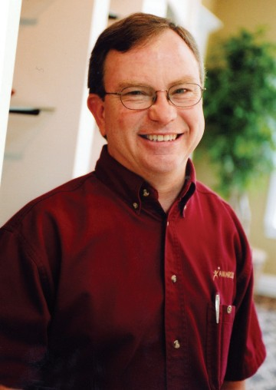
Sam Varn- Treasurer
Where are you from?
Born and raised in Brooksville, Florida (about 45 miles north of Tampa).
What do you do for a living?
As little as possible for as much as I can get…
President, CEO, CCBW (Chief Cook & Bottle Washer) of Awards4U. We are a manufacturer and retailer of awards and promotional products.
How did you get started in radio control?
Built my first plane in 1982 (Falcon 56). Got one flight and then found out my wife Nancy was pregnant with our first son. Sold everything.
In 2000 (I think), my son Justin and I went to the Big Boys Tech and Toy Show at the Civic Center. The club had a display there. I met a lot of the members (and still joined). Went to HobbyTown and dropped a serious amount of money for radio, trainer, etc. for Justin and me. After Justin discovered you can’t be a 3D pilot in three easy lessons, he lost interest. I didn’t.
What do you like best about the hobby?
I really enjoy the new friends I’ve made in the club. Unfortunately I don’t fly as often as I’d like but whenever I show up it just like I’d been there every day.
As to the hobby itself, I love to build airplanes. Kits are my favorites but ARF’s get in the air (and into the ground) quicker so I like building them too.
What models do you have or would like to have? What are your favorites and why?
I’m a big warbird fan and that’s mostly what I have. A P-47 that never gets flown is my favorite because it was my first kit and I put everything on it. I have really become a fan of float flying since Francis opened his lake to us. That’s the most fun of flying to me.
Other than just enjoying the hobby, are there any skills or maneuvers you are working on or want to master?
I’d like to take a shot at serious scale building one day. Trying to capture minute details appeals to me for some odd reason. I like to build as realistically (scale) as my talents will allow.
Is there anyone in particular who has influenced your participation in the hobby?
Just the general membership in the club. As an outsider with no real experience I didn’t know how I would be received. This club and the members in it make all the difference. I doubt that I would have stuck with it if not for the friendly and helpful attitude our members give to everyone.
Is there anything else you'd like to share?
I’m very hopeful that our plans for the landfill work out the way we want. If not, then I’d like to organize a clandestine organization of those that would like to have more trees around our current site “disappear”. I’d like to some day experience a real nice open flying site. The ground gets in my way enough without all those dang trees!

Pilot Briefing
Steve Warmath- Secretary/ Newsletter Editor

Where are you from?
I was born in Jackson, Tennessee. I lived in Birmingham Alabama for a few years and then moved to Orlando, Florida when I was 9. I lived there until I went to college. After college (Started at U.F. and later graduated from Clemson), I went into the military as a Navy pilot flying the P-3 Orion out of Barber’s Point, Hawaii. I was later a multi-engine flight instructor in Corpus Christi, Texas flying King Airs (T-44) and my final tour of duty was on the USS Independence as a Catapult and Arresting Gear Officer based out of Norfolk, Virginia. That cured me once and for all of the military and I got out in 1984. With all the deployments and moving around, my RC building and flying was put on hold for a number of years. I did manage some RC glider flying in Hawaii. My wife and I moved to Tallahassee in 1991 and after a few years I joined the Club. I did not become very active until a couple of years ago and now, I’m in deep, very deep.
What do you do for a living?
I currently work for Sperry & Associates, General Contractor, as Manager Design Services. (In-house Architect). I manage the services provided by the design professionals to our company in design-build work plus provide quality control, design, and permit coordination for the company.
How did you get started in radio control?
I was a student at University of Florida and I had a neighbor, also a student, who was an experienced RC flier. He got me started in flying RC and we would fly together at a local grass airstrip next to our neighborhood. I had been building model airplanes since I was 4 and did some control line flying in junior high. I have always loved airplanes as far back as I can remember. My mom said I was born with a propeller up my behind. My first radio was a Heathkit GD19 system I built and the darn thing actually worked.
What do you like best about the hobby?
I love building first and flying second. I’m pretty fussy when it comes to building and set-up. I enjoy the problem solving and creativity building affords me. I am a scale enthusiast. It is a real stress reliever from the pressures of the daily grind. I do fly more now. I’m hooked on float flying. I enjoy boating and flying. What better than combine the two? There is nothing prettier to me than watching a floatplane grease one in on the water or do a slow fly-by with those floats hanging out there. I also enjoy the association with fellow Club members.
What models do you have or would like to have? What are your favorites and why?
I have a number of planes in my hangar. Most notable are my Vmar Texan II, Great Planes J-3 on floats, Pulse XT, H9 AT-6 Texan, Funtana 40, H9 P-47 and a few electrics. My favorite is my J-3 on floats. It flies like a big docile trainer and very scale-like. My current project is a scratch built 1/5 scale Ziroli JU-87B Stuka (100” wingspan, gasser my wife calls “the thing”). I’ve been working on it for 2 ½ years. I recently completed the scratch-built, detailed cockpit and am about ready to start priming the plane. I hope to have it completed by the fall of this year. I also recently acquired a KMP Dehavilland Beaver on floats (96” wingspan). Very nice model. I think the Beaver is a beautiful aircraft with a rich history as a bush plane and in military service with the Army and Air Force. My wife and I went to Alaska last year and took a flight in a Turbo Beaver. These planes are everywhere up there. It’s the Alaska equivalent to the pick-up truck/ SUV. I was hooked on Beavers after that experience.
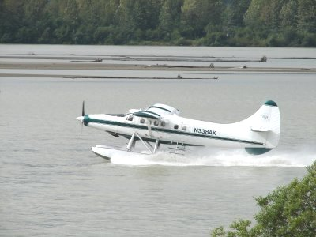
Other than just enjoying the hobby, are there any skills or maneuvers you are working on or want to master?
I want to become very proficient at flying off the water and continue to hone my basic RC flying skills. I’m more into flying in a scale like manner rather than 3D or what I call yankin’ and bankin’. I do enjoy basic aerobatic flying. I plan to build more scratch-built scale planes. On the horizon, a Ziroli Beechcraft D-18, a Dave Platt FW190, a Turbo Beaver and whatever else pops up of interest. Maybe even a helicopter down the road.
Is there anyone in particular who has influenced your participation in the hobby?
Kerry Roberson, the fellow student at University of Florida. He got me into this mess. Also fellow Club members Frank Bastos, Sam Varn, Geoff Lawrence and Dr. Mike.
Is there anything else you'd like to share?
Yes. Please contribute to the Newsletter.
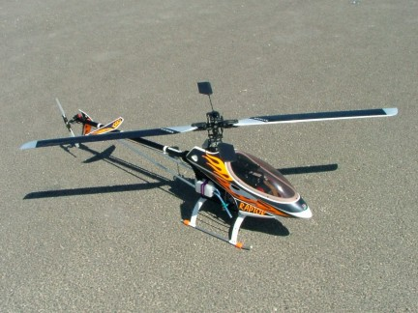

WINGTIPS -WHAT GOOD ARE THEY?? -by Clay Ramskill
There are just about as many types of wingtip treatments as there are plane designs - which is a whole bunch! Why?
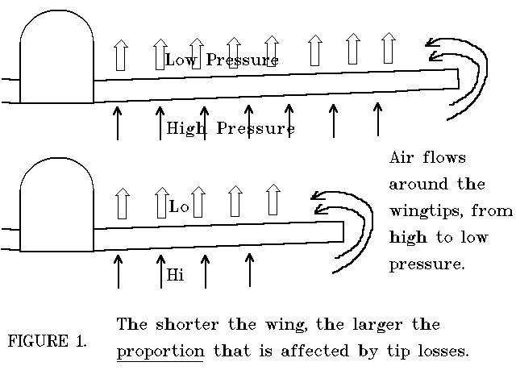
There are several lines of reason that can be applied to the tips designers put on their wings. Looks is one; a squared off tip looks a bit rough, like maybe the designer wasn't smart enough to come up with something better! However, that's the cheapest and easiest way to do it, so economics/ease of construction is a factor. Another reason for the wingtips might be efficiency. Just look at the winglets they're putting on some airliners these days; efficiency is what those birds are all about! And there are other areas that the wingtip can affect - like roll rates, stall characteristics, aileron flutter, and so on.
Let's take a look at the wingtip. In flight, a plane is supported by the air flowing over the wing; the airfoil shape is such that we get high pressure on the bottom of the wing, low pressure on the top. The difference between those pressures, spread over the area of the wing, gives us the lift we need. But the air will always want to flow from an area of high pressure to the lower pressure areas - at the wing tip, that's just what happens. (see fig. 1) That flow of air lessens the differential between the high and low pressure in that area, so we have less lift out at the tip. This lessening of the lift out at the wingtip (tip losses) gives us the possibility of increasing the efficiency of that wing by cutting down on those losses.
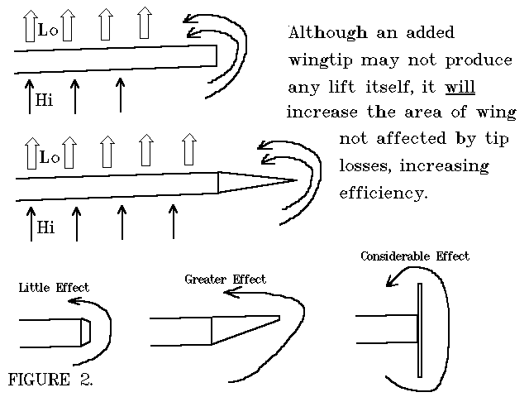
Tip losses vary considerably with different wing configurations; the losses increase in some proportion to the following: higher angle of attack, lower aspect ratio, higher wing loading, lower airspeed, higher sweep angles, and of course the design of the wingtips.
The first way to cut tip losses is by increasing the Aspect Ratio of the wing; that is, building the wing longer in proportion to its chord, or width. That’s why gliders have such long, narrow wings. All other things being equal, the longer wing has the same tip losses - BUT those losses will affect a lesser proportion of the total wing. Figure 1 illustrates this point.
And the point here is that ANY thing that lengthens the wing, even if the extra tip area is not lift producing itself, will help make that wing more efficient at producing lift. (see figure 2) NOTE; we can't get too wild with this concept - because anything we add to the wing will also produce drag!
Also note in figure 2 that not only the distance the air has to go from the bottom of the wing to the top has an effect, but also sharp corners will play a part. The sharper the corner the air must make, the less the flow. So a tip plate may be the most efficient of all, in that there is not only considerable distance "around the tip", but also two sharp corners!
The wingtips will also affect the planes roll rate, especially if there is a sharp corner out at the end. In general, a rounded tip will allow higher roll rates than will one with a sharp end.
Wing tips are an area where you can easily do (and undo) modifications to your plane, to alter some of its performance characteristics. You may not see much, if any, change to an already efficient wing, like a full span Cub wing. But on a plane with shorter, higher loaded wings, differences from the tips may be quite noticeable.
ADHESIVES
by Roger Layton
Cyanoacrylate adhesives: The history that abounds relative development of CA is this. It was developed as an alternative to sutures and bandages for treating open battlefield wounds during the Vietnam War. This seems to make sense in light of its ability to instantly weld the fingers together of any careless modeler. That little bottle of instant repairs that you buy is actually a chemical called cyanoacrylate monomer, which, except for an inhibitor, would instantly form a single plastic blob of polymer with accompanying heat and fury that would resemble the China Syndrome. CA was on the market for a number of years before it came to the construction hobbies. The adhesive was so fluid that it could only be used to mend nonporous materials like ceramic, plastic, and glass. It certainly did not work on balsa, which merely soaked it up like a sponge. Later, when viscosity modifiers were added, it became generally useful and ended up "in our hands" (pun intended). The advantages of CA are speed and hold. The disadvantages are cost, vapor, and brittleness. Please be your own judge but I will not use it for whole plane construction. It has a place and is excellent in certain applications. For many butt joints and T-joints, CA is too brittle, especially in large airplanes. Aliphatic glue is a much better choice. CA is specified as the adhesive of choice for wing skins. In this application, it is too hard and makes sanding to an invisible butt joint very difficult. Animal glue like Sigment is the quintessential choice since it is the sole truly sandable adhesive. Cyanoacrylates are excellent for tacking parts into place to speed up construction followed by re-gluing with an aliphatic adhesive. CA is unequalled for making repairs and piecing a crashed beauty back together. When you use CA, be careful not to draw debris such as sawdust or baking soda (incidentally a good inexpensive accelerant) into the bottle. It may cause the entire contents to harden.
Aliphatic glue: The parent for this type of glue is doubtlessly Borden's white glue. Borden's is very strong glue, which penetrates wood well. A second generation of such glues contains fillers, which render them somewhat "sandable." Regardless of the claims, none are truly sandable since their binder is rubbery. In my mind, more expensive is not better. The hobby store brands like Pica's "Gluit" and others are expensive and not very sandable. Borden's yellow woodworkers glue is strong, inexpensive, and as sandable as any I have found. On large built up fuses and wings, I recommend using Borden's woodworker’s glue for most of the "inside" construction including attachment of the skin. But I glue the skins together and other places to be subsequently sanded with Sigment. Firewalls, landing gear blocks, and hard points are attached with epoxy.
Silicon caulk or RTV: This is an excellent adhesive, which does not harden. This provides considerable shock absorption. This material is particularly good for attaching parts inside fiberglass fuselages. There must be ample gluing surface. Fiberglass flexes in a finished airplane during flight will cause brittle joints made with CA epoxy or other adhesives to fail. Many servo trays have broken loose during a hard landing. Certainly, you have noticed the vinegar-like smell of silicon adhesive when it cures. Do not use this adhesive around electrical components. Connect cells in a battery with hot melt adhesive.
Rubber cement: The next time you want to make little protective foam boxes for your receivers or batteries use rubber cement. It maintains its flexibility and will never let go once it is dry.
3M Spray Adhesive: Formula 77 is excellent for attaching paper rib and bulkhead patterns to balsa or plywood during scratch building. If you want to remove the pattern from the wood after cutting, allow the adhesive to dry on the paper for more than a minute before applying. The paper will not stick quite so tightly and the adhesive will not transfer to the wood. 3M can also be used to hold 6oz. fiberglass in position on the wing center while epoxy or polyester resin is applied. It is great to hold plans flat on building board.
[from Rock Valley RC Flyers, Rockford, IL.]

Seminole Radio Control Club- GENERAL FIELD RULES

All AMA safety rules shall be observed, including, but not limited to, the following:
1. No alcoholic beverages or illegal substances allowed on or about the flying field.
2. All food wrappers, bottles, trash, etc. are to be placed in the appropriate trash container. Broken aircraft should be taken home for disposal.
3. All persons shall remain behind the runway flight line safety barrier except when starting engines or retrieving aircraft.
4. Engines are to be started on the runway side of the flight line, and the pilot should be standing behind the crash barrier in a designated pilot box at takeoff. There are four such boxes at thirty-foot intervals,
limiting the total number of planes in the air at any one time to four. A helicopter practicing hovering maneuvers at the helipad shall not be counted in this total. However, any forward flight similar to a fixed
wing aircraft shall be treated as same, with the pilot occupying a flight box. Engine tests may only be conducted on the pit side of the barrier, and as close to it as possible, with the tail pointed towards
the barrier.
5. Each pilot must have a current AMA membership card and shall be a current Seminole Radio Control Club member or guest.
6. Novice pilots and guests shall not fly unassisted until they have demonstrated their ability to safely control their aircraft to a designated instructor.
7. Under no circumstances may a transmitter be operated without the proper frequency control pin (pins) attached to the antenna and AMA card in the frequency slot.
8. All engines larger than .10 cubic inch displacement shall be equipped with an effective muffler.
9. An AMA prop nut or spinner is strongly recommended.
10. The discharge of firearms is strictly forbidden.

FLYING RULES
1. Each new or rebuilt aircraft shall have a careful inspection and range check prior to flight.
2. Do not fly an aircraft having radio or structural trouble.
3. No flying behind the flight line.
4. Pilots shall operate their aircraft in a safe and courteous manner at all times.
5. No 3D, Helicopter or high-speed flyby’s allowed within the Field safety “Box”. (Painted lines on runway/ apron)
6. HAVE FUN!

Classified Advertisements/ For Sale
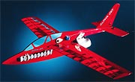
FOR SALE-
Alpha Jet ducted fan profile jet from Hobby Lobby ($57 new)
Do you have a NEED FOR SPEED!!! Well, if you do, this aerobatic jet is the ticket. Add a dual conversion crystal on your frequency and this model is ready to fly!

- Vasa VAS400 ducted fan unit ($120 new)
- Mega 16/15/3 brushless motor ($80 new)
- Castle Creations Phoenix35, 35 amp brushless speed controller w/ Deans ultra battery connector ($90 new)
- Hitec Electron 6, 6-channel dual conversion full range receiver (negative shift for Futaba) ($93 for flight pack w/ 3 servos new)
- 3 x Hitec HS-55 micro servos (incl. in flight pack)
- Deans whip antenna ($9 new)
- Thunder Power 2100mah lipo battery w/ Deans ultra connector (you'll need a lipo charger) ($75 new)
- 6-inch Deans ultra connector battery extension ($10)

Here is a video of an Alpha Jet in flight:
http://www.aff-cnc.de/aff/vid/aff_alpha_jet.avi

This model has been flown probably 10 times max, NEVER been crashed or even required repair since new.
Whole package cost over $534 new! You can have it for less than half the new price!
I will personally demo fly this model at the field for you before you buy it. It's a great model; I just don't fly it much any more due to my helicopter addiction. :-) Asking just $250 FIRM.
The price is firm because this is a great deal at less than half the new price and the quality is high. AND, you get to see it fly before you buy so this is not some Perry-table-gee-I-wonder-if-it-will-fly-gamble-buy! :-)
John Hall
john_hall@mindspring.com
(850) 893-6457

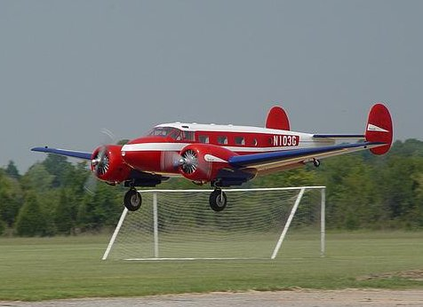

Seminole Radio Control Club
Tallahassee, FL

AMA Charter #216, 1969-2007

SRCC Officers

President – John Hall
Vice President – Brad Sharp
Secretary/ Newsletter Editor – Stephen Warmath
Treasurer - Sam Varn
Field Marshall – Chris Bailey
Field Safety Officer- Shannon Black

Field Hours

12 Noon till Dark- These hours apply to all aircraft, gas and electric.

Training Notes

To schedule a training time contact Mike Atkinson.

Flight Instructors
Mike Atkinson- Primary/ Advanced Fight Instructor (Coordinator) 926-4692
Geoff Lawrence- Primary/ Advanced Fight Instructor 942-9807
Mike Kinsey- Primary/ Advanced Fight Instructor 566-0144
John Hall- Primary/ Advanced Helicopter Flight Instructor 893-6457
Jay Leudecke- Primary/ Advanced Helicopter Flight Instructor 508-7135
Jeff Owens- Ground School/ Airworthiness Instructor (Fixed Wing) 894-2504
Steve Warmath- Ground School/ Airworthiness Instructor (Fixed Wing) 509-0672
Frank Bastos- Hobby Town Flight Demonstrator 671-2030
Don Coon- Leon High Aerospace Club Instructor 488-1971 x 1950

Club Meeting Location and Time
The regular club meetings are held on the first Thursday of each month at 7:30 PM at the Grace Lutheran Church on Miccosukee Rd. Head out Miccosukee Rd., cross Capital Circle NE, and the entrance will be the first one on your right. Once you park, follow the sidewalk around the left side of the building and go down the hill. We meet in a room on the first level.
Newsletter Submissions- Submissions are requested to be in M.S. Word format. Photos should be in .jpg or .tif format. Vector art accepted in Corel, Illustrator and AUTOCAD format. We will, however, accept anything to make it easier for those who wish to contribute. Submissions are due no later than the 23rd of the month. Send your submissions to ssw@nettally.com or by phone, Steve Warmath at 509-0672.
Hard Copy Printing of the SRCC Newsletter provided by Apogee Signs & Graphics.



