The Seminole Flyer www.seminolerc.com


A chartered member of the Academy of Model Aeronautics

AMA Charter #216, 1969-2008

“The Seminole Flyer” is a publication of the Seminole Radio Control Club of Tallahassee, Florida APRIL 2008

INDEX
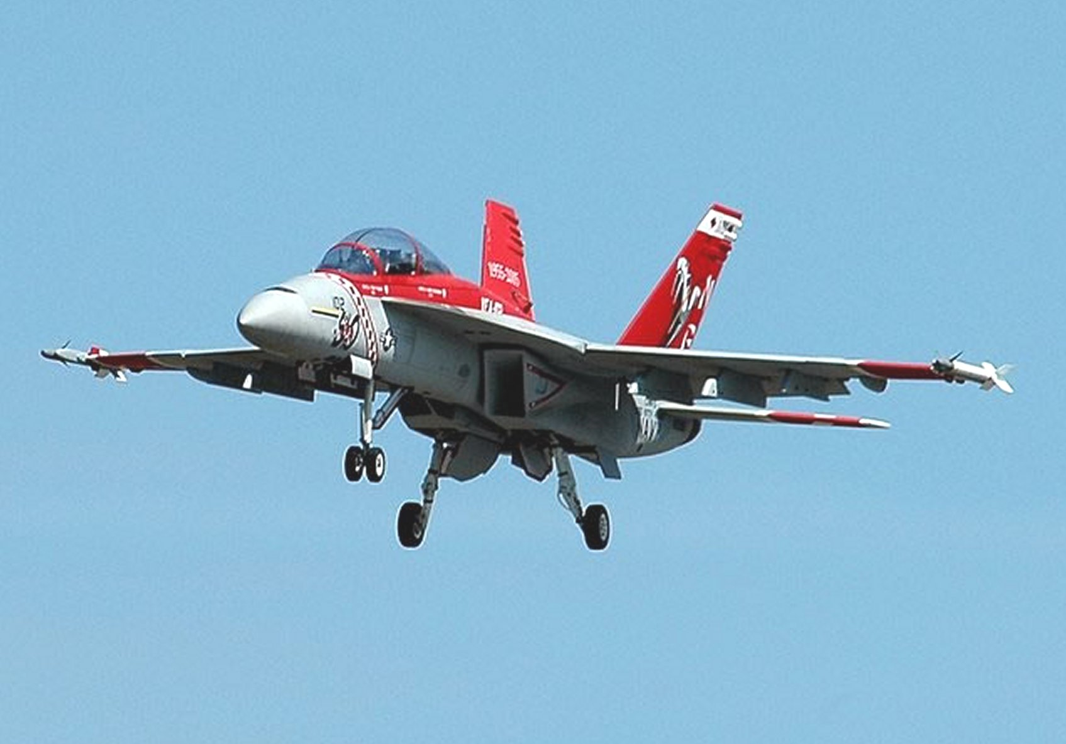

Letter from the Editor
- Float Fly Photo Gallery
- Chief Pilot Report
- Club Calendar
- Chief Copilot Report
- Chief Treasurer Report
- Chief Scribe Report
- Pilot Brief- Mike Levine
- Helicopter on Floats
- VTOL Concept
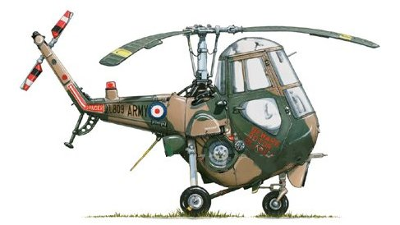

Letter from the Editor- Stephen Warmath
The flying season is developing full momentum. So far we have had the Open House, a great Float-Fly and soon the Fun Fly series will begin this month. There are lots of other events soon to take place, so check the Club Calendar every month for additions. Speaking of the Float Fly, we had a great turnout on Saturday the 22nd and the weather was perfect. A two page Photo Gallery is included. This month we feature in the Pilot Briefing, fellow Club member, Mike Levine. For the heli pilots who want to get their feet wet with float flying, this month’s Helicopter on Floats is included for some tips on making the plunge without getting wet. Geoff Lawrence sent in an interesting article on a futuristic VTOL concept whose description was written by his brother.

Remember, the April meeting is at the field and starts at 7:00 pm.

Happy Building and Flying- Steve

Photo Gallery- Float Fly March 22, 2008
Photos by Steve Warmath
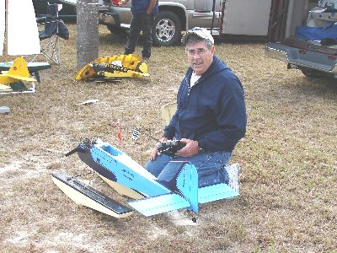
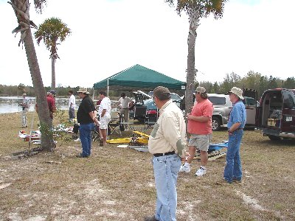

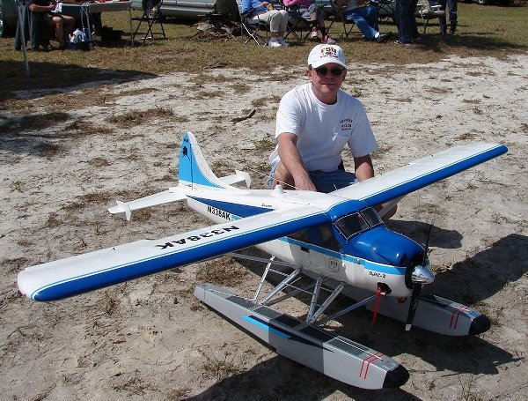
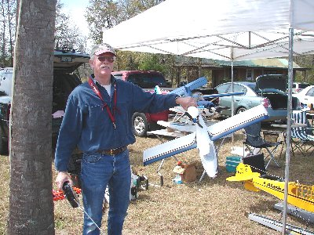

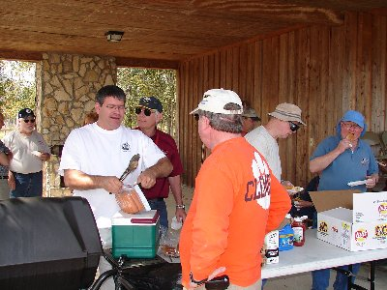


Photo Gallery 2- Float Fly March 22, 2008
Photos by Steve Warmath
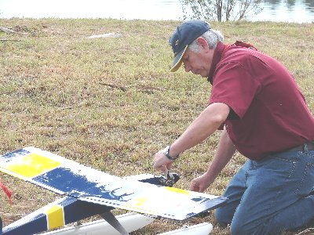
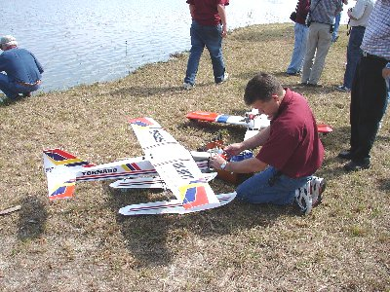

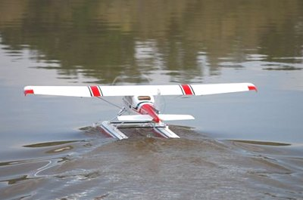
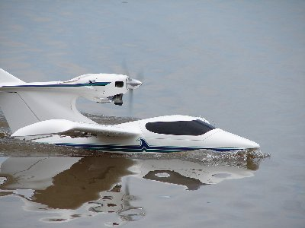

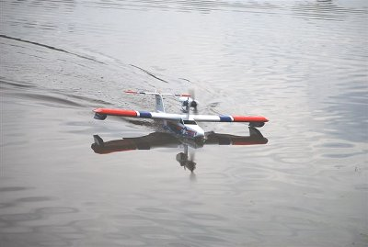
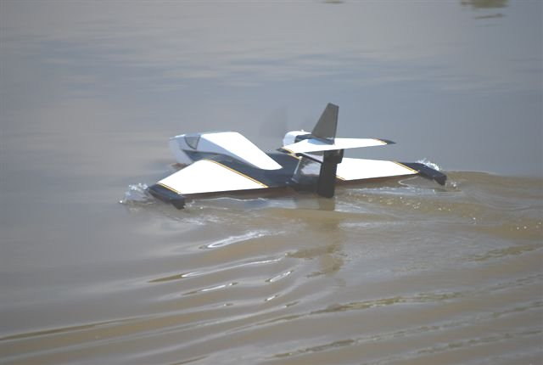

Chief Pilot- Shannon Black
Well everyone, spring is here. We now have longer days, warmer temperatures, and a little better flying weather. We are able to have our meetings at the field once again, and we can mix in some flying at the meetings. We had a wonderful turnout at the Float Fly, and I’d like to thank everyone who worked so hard to make that event a success.

Speaking of events, we’ll now begin preparing for our May “Flying for a Cure” event. This will take the support of all of our members to make this event a success and to raise some money for a wonderful cause.

As you are reading this, many of you may be thinking of our first Fun Fly Competition that will be taking place at 12:00 on Saturday, April 5th. The rest of you may be wishing that I’d quit bringing up this event. I hope that everyone is as excited about these events as I am, and I hope that every member of the club will come to the field and cheer on the contestants. This will be a great opportunity to display the support and brotherhood that this hobby, and our club, is known for.

See ya at the field.

Club Calendar
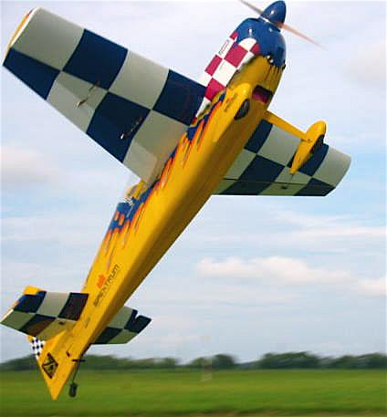

April
- 3- Club Meeting at the Field 7:00 pm
- 5- Fun Fly Series Begins- #1 See web site “Events” section for details.
- 22 Medart School Demo 12:00– 2:00 pm
- 26- SouthWoodstock 1:00 – 5:00 pm
- 29 Shadeville School Demo- 12:00– 2:00 pm

May
- 1- Club Meeting at the Field 7:00 pm
- 3- Fun Fly Series- #2
- 6- Crawfordville Demo- 12:30- 2:15 pm
- 17/ 18- Airfest 2008
- 24- Flying for a Cure Event

June
- 5- Club Meeting at the Field 7:00 pm
- 7- Fun Fly Series- #3

July
- 3- Club Meeting at the Field 7:00 pm
- 5- Fun Fly Series- #4
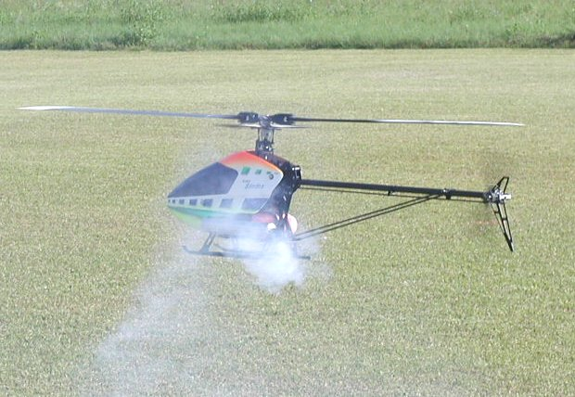

August
- 7- Club Meeting at the Field 7:00 pm
- 9- Fun Fly Series- #5

September
- 4- Club Meeting at the Field 7:00 pm
- 6- Fun Fly Series- #6

October
- 2- Club Meeting at Grace Lutheran Church. 7:30 pm.
- 4- Fun Fly Series- #7

November
- 6- Club Meeting at Grace Lutheran Church. 7:30 pm.
- 8- Fun Fly Series- #8

December
- 4- Club Meeting at Grace Lutheran Church. 7:30 pm.

Chief Copilot- Chris Bailey

Upcoming AMA Regional Events

Pensacola Aerotow 2008
FL
4/04/08-4/06/08 - Pensacola, FL (C) Pensacola Aerotow 2008. Site: Coastal Airport. Ruston Rood CD, PH:850-432-3743 email: rcrood@cox.net. Sponsor: NORTHWEST FLORIDA MODELERS
Gateway RC Club Spring Fling
FL
4/05/08 - Jacksonville, FL (C-Restricted to Gateway RC Club) Gateway RC Club Spring Fling. Site: Lannie Rd Flying Field. Patrick Lanfri CD, 4743 Sappho Ave Jacksonville FL 32205 PH:904-534-6661 email: lanpc@comcast.net. Visit www.gatewayrc.org. Gateway RC Club member only day. Membership $50, membership accepted at event. Sponsor: GATEWAY RC CLUB

Spring Heli 2
FL
4/11/08-4/13/08 - Boyette, FL (C) Spring Heli 2. Site: Club Field. Gene Sanchez CD, PH:815-310-6501 email: etsanchez@verizon.net. No contest just flying, fun and sun. Premier site. All helicopters welcome. Visit www.triplecreekrc.com. Sponsor: TRIPLE CREEK RC

Tri County RC Big Bird Fly In
FL
4/12/08 - Dunnellon, FL (C) Tri County RC Big Bird Fly In. Site: Rainbow Fld/Bridges Rd. Fred Backhaus CD, PH:352-746-4249 email: fremar3242@embargmail.com. Sponsor: TRI COUNTY RC CLUB

NMPRA Gold Cup Series
FL
04/18/08-04/20/08 - Sunrise, FL (A) NMPRA Gold Cup Series for 422 and 424(JSO). Site: Markham Park. James Perdue CD, 395 NW 89 Ln Coral Springs FL 33071 PH:954-683-2660 e-mail: jamesperdue@earthlink.net . Sponsor: MARKHAM PARK PILOTS

Spring Fling
FL
4/18/08-4/20/08 - Ocala, Fl (C) Spring Fling. Site: Club Field. Gary Doeren CD, PH:920-737-4852 email: grdoeren@aol.com. Visit www.ocalaflyingmodelclub.com. Food and drink on site, rustic camping, no hookups, great flying site, 50' x 600' paved runway, 12 acres of mowed grass. Sponsor: OCALA FLYING MODEL CLUB

Huntsville Heli Flyers Annual Fun Fly
AL
4/18/08-4/20/08 - Huntsville, AL (C) Huntsville Heli Flyers Annual Fun Fly. Site: Club Field. Troy Blackwell CD, PH:256-714-3881 email: teeroy@nehp.net. Lot of fun, food and fellowship to be had with pilots prizes and raffle. Visit www.huntsvilleheliflyers.org. Sponsor: HUNTSVILLE HELI FLYERS

Warbirds Over Bama
AL
4/19/08-4/20/08 - Tuscaloosa, AL (C) Warbirds Over Bama. Site: Club Field. Frank Baity CD, PH:205-553-7131 email: frank.baity@wim.falconjet.com. Giant Scale 80" mono plane, 60" biplane rule will apply. Join us at our new spacious flying site located near motels and restaurants. Camping available on site no hookups. Fun fly format with award for Best of Show. Landing fee $20 must have AMA to fly. Details and directions at www.waam.us. Sponsor: WAAM

Bay City Flyers 12th Annual Spring Classic
FL
4/19/08-4/20/08 - Land O Lakes, FL (AA) Bay City Flyers 12th Annual Spring Classic for 411-415 (O). Site: Club field. Montgomery Huff CD, PH:352-686-4136 email: planewrappers@tampabay.rr.com. All classes Basic, Sportsman, Intermediate, Advanced, Unlimited, Freestyle. Prizes for 1st-3rd each class, Freestyle winner and Grand Champion. Visit www.planewrappers.com. Sponsor: BAY CITY FLYERS

1st Annual Buddy Box Day
FL
4/19/08 - Jacksonville, FL (C) 1st Annual Buddy Box Day. Site: Club Field. John Lake Jr. CD, PH:912-673-6713 email: theranger545@tds.net. Introduction to Radio Control Aviation. No entry fees. Instructor Pilots and training aircraft available. On site restrooms. Visit www.gatewayrc.org. Sponsor: GATEWAY RADIO CONTROL CLUB

Air Fair 2008
FL
4/19/08-4/20/08 - Sarasota, FL (C-Restricted to IMAA) Air Fair 2008. Site: Club Field. Michael Winter CD, PH:941-966-7786 email: mikeandeva@comcast.net. Visit www.sarasotarc.com. Sound restrictions apply. 104dB(A) at nine feet. Sponsor: SARASOTA RC SQUADRON CLUB

Airmasters MAC Spring Fly In
GA
4/19/08 - Leesburg, GA (C) Airmasters MAC Spring Fly In. Site: Club Field. Dan Stevens CD, 2816 Somerset Dr Albany GA 31721 PH:229-439-8949 email: dan.stevens@mchsi.com. Sponsor: AIRMASTERS MAC

Perryman April Fools Annual
GA
4/20/08 - Whitesburg, GA (A) Perryman April Fools Annual for Cat III 101, 102-103, 104-105, 101C, 102-103C, 104-105C, 124, 140, 142, 160, 161, 162, 501, 503(JSO). Site: NG Turf Farm. Frank Hodson CD, 150 Hill Ave Fayetteville GA 30215 PH:770-461-9870 email: fhodson@bellsouth.net. Visit www.thermalthumbers.com. Sponsor: TTOMA

Top Gun
FL
4/23/08-4/27/08 - Lakeland, FL (B) Top Gun for 512, 515, 520, 522(JSO). Site: Lakeland Airport. Frank Tiano CD, PH:863-370-1288 email: frank@franktiano.com. 120 world class aircraft, flying rounds Wed - Sun, Static Judging Wed - Fri. Huge Manufacturers Area, Giant food station, bleachers, 20th Anniversary, noon time air show Fri - Sun. Visit www.franktiano.com. Sponsor: IMPERIAL RC CLUB

Annual HAM Fly In and Air Show
FL
04/26/08 - Brooksville, FL (C) Annual H.A.M. Fly In & Air Show. Site: Club Field. Ed Carpenter CD, 8974 S Filly Pt Inverness FL 34452 PH:352-344-1688 e-mail: k4gj@yahoo.com . See H.A.M. web site for map. Landing fee $5, pilots meeting at 9AM. Sponsor: HERNANDO AERO MODELERS

Spring Fun Fly
GA
04/26/08 - Gray, GA (C) Spring Fun Fly. Site Commissioners Field. James Harris CD, 712 N Briarclub Rd Warner Robins GA 31088 PH:478-957-5776 e-mail: jjharris@cox.net . Refreshments available. Free admission to the public, free parking, special events at mid day. Sponsor: DIXIE AEROMASTERS

Southeast Electric Flight Festival
GA
5/01/08-5/04/08 - Andersonville, GA (C) Southeast Electric Flight Festival. Site: Hodges Field. Ernie Schlumberger CD, PH:770-879-0890 email: eschlumber@aol.com. Visit www.fayetteflyers.com. The South's premier Electric fun fly open to all forms of E-powered flight. Primarily open flying, demo flights Friday/Saturday, BBQ Sat night, top Electric vendors and full line hobby shop on site. LMR Sailplane (class B & SEFF no excuses) on the 1st from 9am-3pm, open flying after 3pm and throughout weekend. Sponsor: FAYETTE FLYERS

Chief Treasurer- Sam Varn
Editor’s Note: The Treasurer’s report is published for Members only. The public version of the Newsletter does not include account balances.

Here's our current account balances.
Cash: $0.00 Checking (Premier): $0.00 Checking (Capital City): $0.00
CD: $0.00 Savings: $0.00
Total Funds: $0.00

Chief Scribe- Steve Warmath
Visitor/ New member Introductions- Curtis Wilson

A request for a motion to accept the Secretary’s February meeting minutes was made seconded and passed.

Treasurer’s Report- Sam read the current balances on our accounts and added we had 2 new members and 3 returning members pay their dues. No other news to report.

Old Business-
- There are new tables at the field with possibly more coming. They are being used and again a thank you to those involved.
- John Hall stated power has yet to be run out to the other tables and is still in the works.
- Joe Satterwhite mentioned the field needed to be fertilized soon.
- The bleachers needed to be repaired. It was thought the metal structure was sound, but needed stripping and painting. It was estimated the replacement cost for the lumber to replace the seats would run around $600.00. It was suggested that the bleachers be removed and replaced with tables or benches. Points of discussion:
- Picnic tables need some repair before using for spectators.
- The bleachers would require (16) 2 x 12 x 16’ pt lumber plus screw hardware.
- Sam noted we have not had any income generating events lately and cautioned about getting low on cash.
- Discussion of upcoming expenses.
- Motion was made to spend up to $750.00 to refurbish the bleachers, seconded and passed. It was also mentioned maybe we can get a sponsor like Home Depot to get a discount on the material.

- Steve asked how the decision will be implemented. Shannon said he would get an e-mail out to everyone and try to get a work party together for the upcoming Saturday at 10:00 am. Stage 1 would be to disassemble the wood seats from the frames.
- Shannon said the Open House turnout was good. We didn’t get any new members from it. The Rodeo turn out was about half what it was last year.

New Business-
- Shannon asked for some suggestions for revenue generating events. Items discussed:
- Concessions usually out pace landing fees at events.
- Collect landing fees from members for Fun Fly Events.
- Pay minor amount for food at Field meetings to help cover costs. It was suggested $2.00 for a hotdog, chips and a drink.

- March 22nd Float Fly. No answer on Porta- John. It was decided not to get one due to low expected turnout. There will be a short work party on Tuesday before the event. Mike Atkinson said that heli’s were welcome as well. Boats are welcome too.
- Bob Burke asked the field Porta-John get a thorough cleaning, as it was not being well maintained. Sam said he would contact the company for a service call.
- There are (3 ) school demo’s coming up in April. See Calendar in Newsletter.
- The orange barrier has been pulled down and needs repair. It was suggested that lattice be put up, as it would look nicer. No action decided upon.
- John Hall said the batteries for the charging system are being depleted faster than they can be recharged due to heavy usage. He felt like we needed solar panels with 10 times the capacity of what we have now. There is no damage to the batteries but we need to investigate an alternative. John said he may have a lead on a larger solar panel for around $100.00 he could get. A motion was made to research the problem (John) and if warranted, spend up to $100.00 on the solar panel if compatible with our current charger.
- Fun Fly competition- Shannon said he had received suggestions on a point system and event ideas. He said he would like any input. The idea was to have 8-10 events and drop lowest two scores. Mike and Gordie volunteered to run the events. They will also need help from volunteers from those participating. Jeff Owens suggested a 10-point system with a 10 for first place and a minimum of 3 points for participating with scores in between prorated based on the number of participants for a given event. Shannon said he would be putting out an e-mail with events list, rules and point system.
Announcements- Spektrum and JR were having a special on free second receivers when purchasing a complete system, running through April 15th. Check your local Hobby Shop for details.

With no additional business, the meeting was adjourned at 8:15 pm.

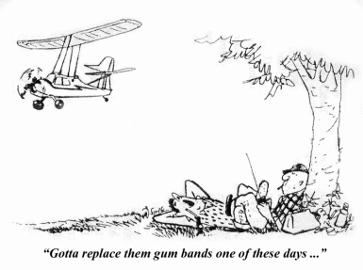

PILOT BRIEFING- Mike Levine

Where are you from?
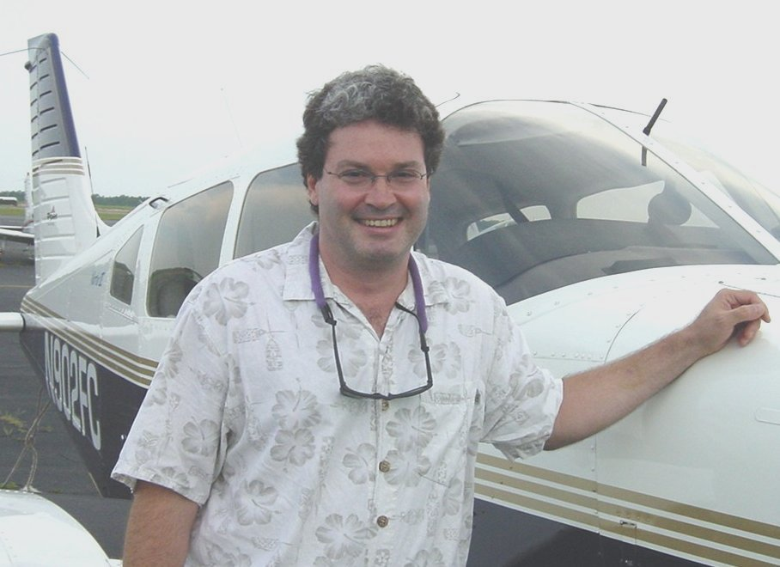
I grew up on Long Island, NY but lived in Connecticut for 14 years before moving to Tallahassee four years ago.

What do you do for a living?
I’m a Senior Database Consultant for CGI AMS, Inc.

How did you get started in radio control?
I have always been fascinated with flight of any kind. I started with the Cox .049 control line models and went through more than I can remember! I’ve always been interested in radio-controlled models, but it was my brother-in-law Mark who actually got me started with R/C airplanes about twelve years ago. I used to travel almost three hours every weekend from Connecticut to Long Island to go flying with him in the dead of winter. At times I had two pair of pants on! We flew at Heckscher State Park on the South Shore of Long Island off of a narrow paved runway that seemed to always have a cold, stiff cross wind. We had to sweep the runway often because seagulls would drop clams on the pavement to break them open and the broken shells did a number on wheels and covering. No buddy box back then! We would hand the transmitter back and forth letting our hands warm up. I learned to land when the engine went dead stick one time while Mark was busy in the “men’s room”. I yelled to him, “what should I do” and he yelled back, “land!!!”…so I did. And I’ve landed myself ever since.

What do you like best about the hobby?
I know a lot of people say it but it’s true, it really is the people you meet and the friends you make at the field and meetings (and at the hobby store). I also like the challenge of building and flying new models and that first flight is always the most exciting, interesting and nerve wracking! I also enjoy helping new people get into the hobby and be successful at it.

What models do you have or would like to have? What are your favorites and why?

I have always loved warbirds (as people who know me already know) and the P-38 and Spitfire are my favorites. I would also like to build a large Bearcat or Corsair one day. I do like Mustangs but everybody seems to have one! I’m also enjoying learning to fly 3-D with my ¼ Hanger 9 Cap 242. I also recently assembled an e-powered Cub, which I would like to take to club float fly events. The first R/C model I ever bought was a Royal P-38 Lightning kit. I recently re-powered it and still fly her today! I opened the box and as Gordy can attest to, it was like a mini lumberyard with lots of square balsa and not so good instructions! It took over 300 hours to complete. With no building experience I soon realized that I was not going to learn to fly on this airplane! So I bought several ARF trainers and learned to fly (and crash) on them while I was stumbling along building the P-38 and my flight box, which I was glad, would never have to go into the air. I also built an Ace R/C T34 “trainer” which was the first kit built airplane I successfully flew. It is now retired and hangs proudly in my garage. The second kit I built was the Pica 1/6 scale Spitfire that I also still fly today. I also bought a 1/5 scale G-38 powered Yellow Aircraft Spitfire, which was like a work of art. So much so that I had to sell it after just three flights because it was too nerve wracking to fly. Even though it was a very expensive ARF of sorts, I paid somebody to assemble it for me because I couldn’t bring myself to cut any holes in it!

Other than just enjoying the hobby, are there any skills or maneuvers you are working on or want to master?
Working on my 3-D so I can keep up with Bill!
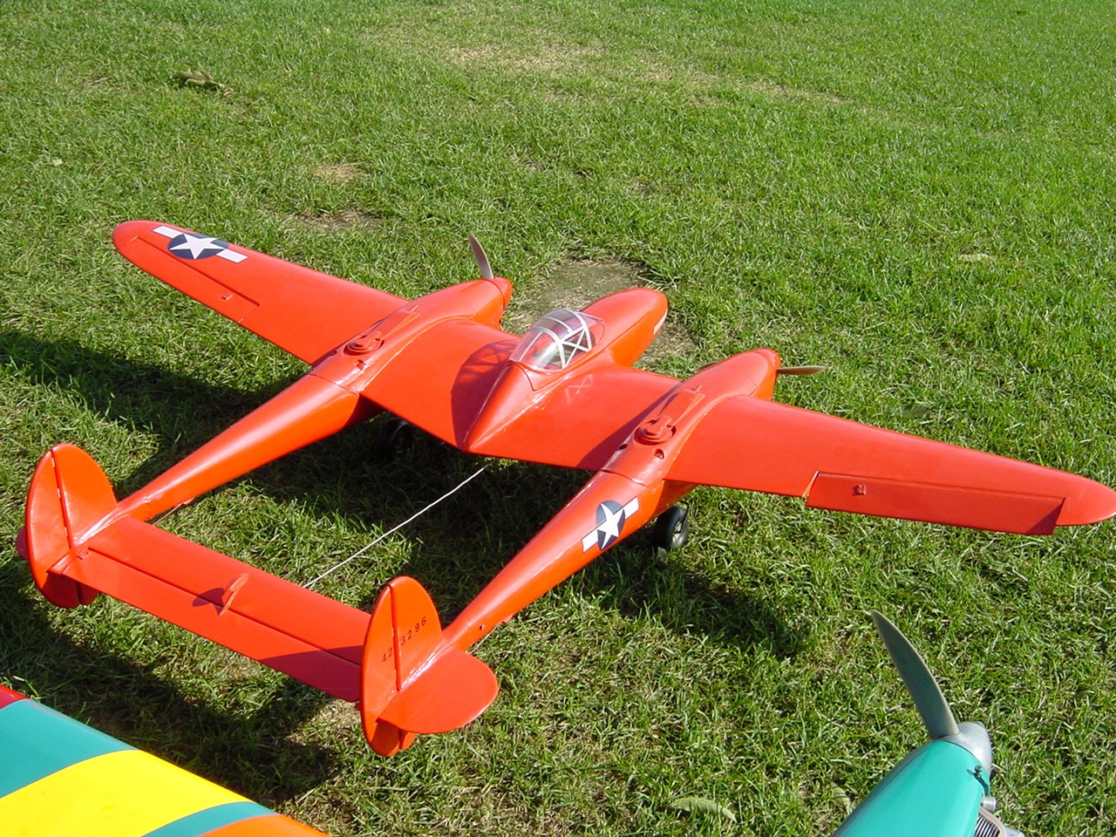

Is there anyone in particular who has influenced your participation in the hobby?
As I said earlier it was my brother in-law Mark who mentored me and got me into and hooked on the hobby. My stepfather was also an accomplished R/C pilot but passed away before we could fly together.

Is there anything else you'd like to share?
I have very much enjoyed flying here (year round flying is great!) and meeting everybody in the club. I am very happy that there is such a great flying site here in Tallahassee and a great group of guys to fly with as well. I recently got engaged to a great gal (Laurie) that I have been seeing for about a year now. She has two boys, Matthew (8) and Robby (12) who I am hoping to get into the hobby. We are all building a Sky Raider and will be participating in the fun fly competition series. If you see them at the
field please say hello and make them feel welcome! See you at the field soon.

Mike

Helicopter on Floats by Ironsides [with contribution from Patrick Jacobs]
Warning
Don't try flying a helicopter over water until you have some rotor time under your belt. Those who fly fixed wing aircraft off water have some protection. That is, the expensive parts like the radio and servos are inside the fuselage and are basically waterproof. Not so the helicopter, all the parts are hanging out in the breeze and if you go into the water, everything will get soaked, including your wallet. Additionally, fixed wing aircraft construction is such that there are floatation pockets all over the place. Not so with helicopters made of steel and plastic parts - they have no buoyancy at all.
Helicopter Floats
Heli floats come in four basic types. You can buy inflatable off-the-shelf, plastic floats that are intended for fixed wing but that work for helis, kid's beach "flotation noodles" that can be adapted, and foam cores that you build yourself.
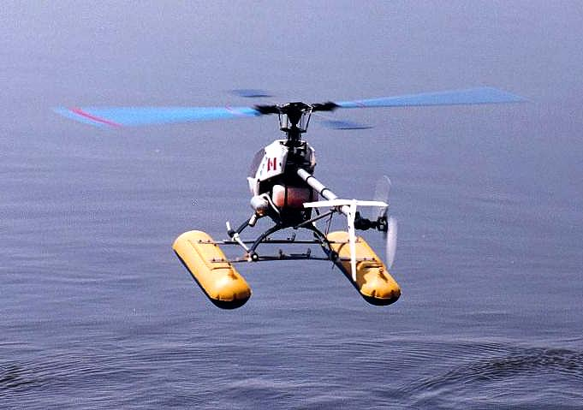 | 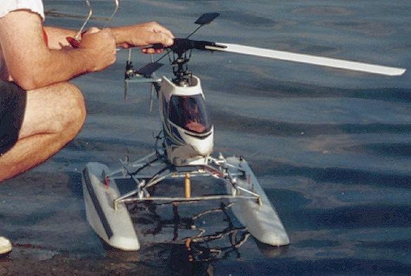
Inflatables | Plastics
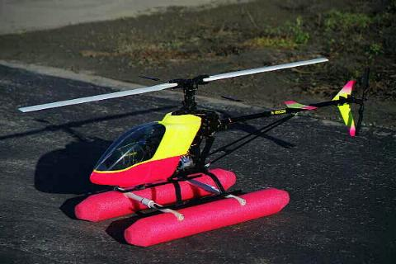 | 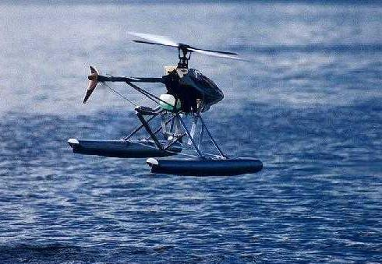
Noodles | Foam/Balsa/Fiberglass

Pendulum Effect
Adding relatively heavy floats to the bottom of a heli increases the stability of the aircraft. However, should that heavy weight start swinging too much, a pendulum effect can set up. Stay ahead of the heli and damp out any swings.
Tail Rotor Strike
On land the inflatables have a tendency to be a bit soft and to allow the heli to rock fore and aft. Watch the tail rotor, as there is more possibility that it will hit the ground than with normal fixed gear.
When landing on the water, ease on gently and keep a little forward pressure to make sure the craft does not settle back on its haunches.
Taxiing
In light breezes, when on the water you can taxi by tilting the rotor disk in the desired direction of travel. Be careful, if you drive the rotor over too hard, you will submerge a float and do damage.
Aerobatics
If you choose the light inflatables, aerobatics are still very achievable.

Crash Considerations
When a fixed wing model crashes into the water, it is better to have the floats rip off like a ski binding if too much force is encountered. Both the floats and the fixed wing wreckage will float 99.9% of the time.
However, when a heli augurs into the water, the last thing you want is for the life jacket to tear away. It is the only chance you have of the wreckage staying afloat long enough for you to recover it.
First rule: Make sure the floats stay on.
Flying Scenarios
You can take off from the beach and fly over water and then land back on terra firma. More advanced pilots can start the engine on land, put the model on the water, then take off and land on water. It is strongly suggested that you try the land-to-land profile until you get the feel of the effects that floats have on your heli.
Simulator
If you have a simulator, it is strongly suggested that you use it. Add some weight to your model set up and watch the sensitivity to collective change. Throw in some wind and turbulence to find out how the model reacts. Unfortunately, the simulator will not tell you much about the manner in which the increased drag of your floats will affect fast forward flight.
Wind
For all heli fliers, wind at the beach is a major factor. At the flying field, you can determine the wind and put the model down so that the canopy faces into wind. At the beach, if you have anything but an on-shore breeze, it is hard to do a tail-in take-off and landing.
If you try to do a water take-off with anything other than an on-shore breeze, your heli will immediately weather vane into the prevailing wind and start moving downwind. You might be good enough to perform a nose-in take-off, but most of us are not in that league. For those who don't know, in a nose-in hover the yaw, pitch and roll axes are reversed. The pilot has to turn his brain inside out and backwards. That's why heli pilots look weird!
Second Rule: You first attempts should be made on a very calm day.
Spool Up Torque
When you take off from land, the ground has enough friction to absorb the torque as the main rotor spools up for take-off. On water, as soon as you increase the throttle, the whole machine wants to rotate like an earth augur. It takes a fair amount of practice to balance the rudder input to that of the rotor torque.
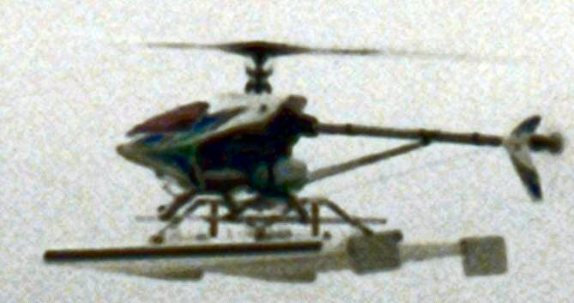 | You can add fixed water rudders to the backs of the floats (except inflatables) to minimize float rotation.
Third Rule: Watch out for spool up torque when taking off from water.
Rotor Negative Incidence
It is nice to have some negative incidence on the rotor at low throttle. When the engine dies, you can dump the collective, keep up the rotor speed and perform a graceful auto-rotation.
Taking off from water, negative incidence can sink your heli. If you increase the rotor speed and inadvertently dump the collective, tremendous downward pressure will be exerted on the floats. On land, the ground will press back and not much will happen. On water, a float will submerge and the rotor disk will hit the water. You don't want to know what happens when a rotor hits the water.
Fourth Rule: Have zero degrees incidence in the collective at the bottom until you know what you are doing.
Training Aid and Comments from Pat Jacobs
Quote:  I had been using a hula hoop to practise on land and found that it worked quite well. Not wanting to spend a whole lot more money on purchasing floats, the idea of using a pool noodle and wrapping it around the hula hoop came to me. | 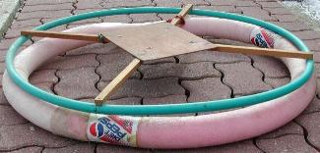
I attached the noodle to the hula hoop with plastic ties and used a plastic pop bottle (cut off at both ends) and inserted the 2 ends of the noodle into it. It was a fairly snug fit, so nothing further was needed.
As I was still fairly new to helicopter flight, I at this point could hover the helicopter quite successfully, nose out. I had not been able to perfect hovering nose in or sideways. Given this, I can say from experience that I should not have proceeded any further or higher until I was more experienced at doing the above. The present condition of my helicopter is evidence of this. Nonetheless, I took my helicopter up to the lake and was quite anxious to try it on water.
Having only spoken to a couple of people regarding flying over water, and only having had experience flying off land, I was not sure what I was in for. On doing the normal checks and setting the helicopter on the water and getting ready to lift it off the water, I was not prepared for what happened next. Due to the fact that the noodle faced little resistance on the water, it immediately started to rotate and drift towards the dock. I had visions of pressure-treated wood all over the place. After the initial shock, I countered with more tail rotor and successfully hovered off the water.
I would have to repeat to anyone that's considering helicopter flying that unless they perfect nose in/nose out left and right flight 12 inches above the ground they should not attempt to go any further. This, by the way, was repeated in information that I read and people I spoke to. But overconfidence got the better of me and that is why today the helicopter is resting in pieces. I am on the lookout for a used Nexus 30.
Unquote
Fast Forward Flight
The addition of such a large surface to the bottom of the heli induces a huge amount of drag. This drag has quite a moment arm. There is the tendency for the aircraft to "trip" due to this extra drag.
Move forward slowly on your first flights until you find out how severe this condition might be.
Search and Rescue
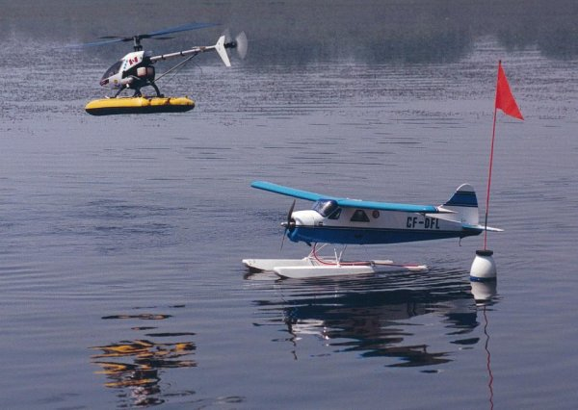 | In light wind, a heli can be used to great effect to blow back a dead stick fixed wing to shore.  In the photo, heli pilot Jim Moss aids Jack Mothersill's Beaver.  The photo was taken at Darlington Provincial Park during the Oshawa Club's Wednesday evening float flying.

NEWS SCAN
INVENTIONS
A Promising VTOL Concept – A Green Machine
How could an approach this straightforward have been overlooked by everyone?

A patent was applied for internationally on Feb. 28, which should have far reaching consequences. A VTOL (Vertical Take Off and Landing) aircraft concept has been found which promises more efficient cruise performance than fixed-wing aircraft.
The inventor John M. Lawrence of Palm Harbor, Florida points out that the basic limitation of a helicopter is that when it is advancing at high speed the rotor blade tips become transonic and the retreating blades operate in stall or near stall. The basic limitation of a fixed-wing aircraft is that the rather large wing area needed for a low speed takeoff is a liability at high cruise speeds because it produces aerodynamic drag. The new concept he has found has neither of these limitations.
The new rotorcraft has two counter-rotating rotors, which implement cyclic and collective pitch. The rotor blades are rigidly mounted in their hubs and are movable in pitch (feathering) only. Each rotor blade has its own fast response servo drive so the pitch angle of each rotor blade can be adjusted quickly by the on-board computer to produce whatever lift is needed from the blade.
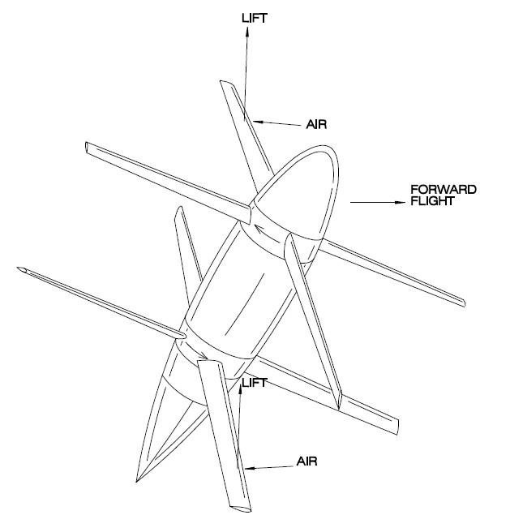
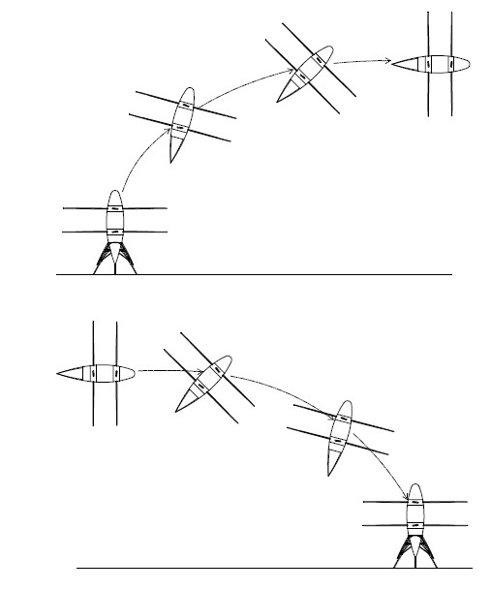
The craft takes off vertically, flies nose-high as it develops horizontal flight speed, and gradually noses over into horizontal flight. To land, it reverses the process: it slows, pulls its nose up and flies nose-high slowing further and arriving at its destination in a vertical orientation.
The total rotor blade area can be made significantly less than the wing area of a fixed wing aircraft because the airspeed of the rotor blades when hovering can be made much higher that the takeoff speed or a typical airplane. Because of this the “wing area” of the rotor blades can be significantly less than the wing area of a fixed-wing airplane. The airspeed of the rotor blades when flying horizontally is only about 10% higher than the craft’s speed. The result is that this new aircraft has less aerodynamic drag when cruising that an equivalent fixed-wing airplane. This advantage can be used to obtain a higher cruising speed or to reduce fuel consumption.
The craft also has excellent maneuverability when hovering and the ability to greatly smooth out the effects of air turbulence.
When the craft is flying horizontally it produces forward thrust to overcome drag by commanding more lift from the down-going rotor blades than the up-going rotor blades. Note the forward tilt to the lift vectors from the down-going blade and the backward tilt of the lift vectors from the up-going blade, so if the lift is greater on the down-going rotor blades the forward component from those blades will be greater than the aft component from the up-going rotor blade.
Are you wondering if the rotor blades can really produce lift in horizontal flight? If the rotor blades were not turning but were locked horizontally and vertically and were straight with the airflow but the nose of the craft were set to 3 degrees above horizontal, the horizontal rotor blades would produce lift, right? OK, now if the rotor blades all had a small amount of pitch and they turned as the air flowed over the craft, continuous lift would still be produced from each rotor as the rotors turn, right? Drag would, of course, also be produced. So the craft would need to apply power and use cyclic pitch to develop forward thrust as described above. Additional cyclic pitch can be added to permit the craft to obtain the same lift and forward thrust with the fuselage horizontal.
The problem of flying through the transition between hovering and horizontal flight must be given special consideration. One could say that all eight rotor blades support the craft in hover and that, in a snapshot in time, four rotor blades support the craft in horizontal flight but it can be shown that, in a snapshot in time, two rotor blades must support the craft at some point during transition. See the TRANSITION figure. This is necessary because of this fact: lift from all the rotor blades in hover is from the front or top side of the rotor blades but in horizontal flight the lift is from the front side of the down-going rotor blade and from the back side of the up-going rotor blade. So there must be a point during transition at which the lift from the up-going rotor blade is zero as it changes from one side of the rotor blade to the other side of the rotor blade.
Can the craft operate through transition? Yes, by (a) advancing with the nose only 20 to 30 degrees from vertical, “into the wind” at a reasonable speed, (b) having an adequate rotor speed, and (c) accepting a moderately high lift coefficient in the rotor blades of around 0.800. Transition has to be taken into account in the design just as do hover and horizontal flight.
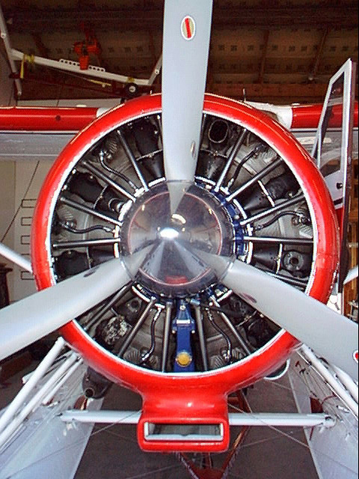

Seminole Radio Control Club
Tallahassee, FL

AMA Charter #216, 1969-2008

SRCC Officers

President – Shannon Black
Vice President – Chris Bailey
Secretary/ Newsletter Editor – Stephen Warmath
Treasurer - Sam Varn
Field Marshall – Joe Satterwhite
Field Safety Officer- Gordie Meade

Field Hours

12 Noon till Dark- These hours apply to all aircraft, gas and electric.

Training Notes

To schedule a training time contact Mike Atkinson.

Flight Instructors
Mike Atkinson- Primary/ Advanced Fight Instructor (Coordinator) 926-4692
Geoff Lawrence- Primary/ Advanced Fight Instructor 942-9807
Chris Bailey- Primary/ Advanced Flight Instructor 322-4047
John Hall- Primary/ Advanced Helicopter Flight Instructor 893-6457
Jay Leudecke- Primary/ Advanced Helicopter Flight Instructor 508-7135
Jeff Owens- Ground School/ Airworthiness Instructor (Fixed Wing) 894-2504
Frank Bastos- Hobby Town Flight Demonstrator 671-2030

Club Meeting Location and Time
October- March: The regular club meetings are held on the first Thursday of each month at 7:30 PM at the Grace Lutheran Church on Miccosukee Rd. Head out Miccosukee Rd., cross Capital Circle NE, and the entrance will be the first one on your right. Once you park, follow the sidewalk around the left side of the building and go down the hill. We meet in a room on the first level.
April- September: The regular club meetings are held on the first Thursday of each month at 7:00 PM at the Flying Field. The Club provides food and drinks.
Newsletter Submissions- Submissions are requested to be in M.S. Word format or via e-mail text. Photos should be in .jpg or .tif format. Vector art accepted in Corel, Illustrator and AUTOCAD format. We will, however, accept anything to make it easier for those who wish to contribute. Submissions are due no later than the 23rd of the month. Send your submissions to ssw@nettally.com or by phone, Steve Warmath at 509-0672.
Hard Copy Printing of the SRCC Newsletter provided by Apogee Signs & Graphics. 850-224-7446



