The Seminole Flyer www.seminolerc.com


A chartered member of the Academy of Model Aeronautics

AMA Charter #216, 1969-2007

“The Seminole Flyer” is a publication of the Seminole Radio Control Club of Tallahassee, Florida JUNE 2007

INDEX
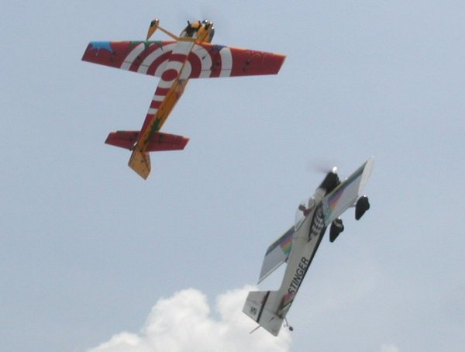

Letter from the Editor
- Flying for a Cure Photo Gallery
- Airfest 2007 Photo Gallery
- Float Fly Photo Gallery
- Chief Pilot Report
- Chief Copilot Report
- Chief Treasurer Report
- Chief Scribe Report
- Pilot Briefing- Jeff Owens
- Flying a Model Autogyro
- Principals of Helicopter Flight
- Classifieds/ For Sale
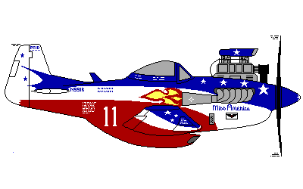

Aerial Ballet at Flying for a Cure Event May 5, 2007

Letter from the Editor- Stephen Warmath
This month we are loaded up with eye candy and multiple photo galleries from the back-to-back activities in May. We started off the month with our Flying for a Cure Event at our field followed by Airfest at the Tallahassee Airport and ending the month with an impromptu Float Fly at Lake Surovec. Our Pilot Briefing spotlights long time member, and general aviation enthusiast, Jeff Owens.
A primer on a little seen type of RC aircraft is offered in Flying a Model Autogyro. Also some basic aerodynamic incantations on the “dark arts” are included in Principals of Helicopter Flight.

In my usual surfing for those aero oddities that cause us to shake our heads and wonder, “Why would anyone do that?”, I found this video that gives Short Take Off and Landing new meaning.
http://www.wservernews.com/4HA6HM/070521-Landing
Who says you can’t go RV’ing and take your plane with you. Geeez………..

Happy Building and Flying- Steve

Photo Gallery- Flying for a Cure May 5, 2007
Photos by Steve Warmath
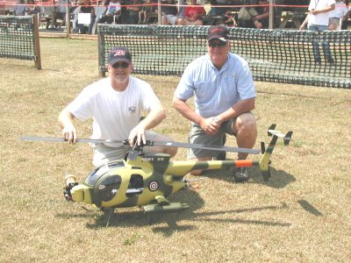
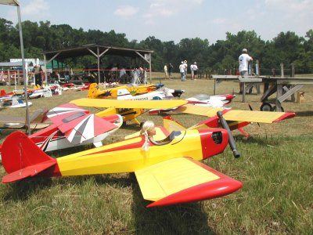

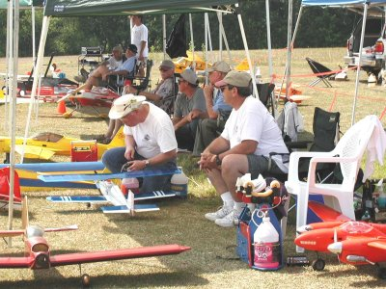
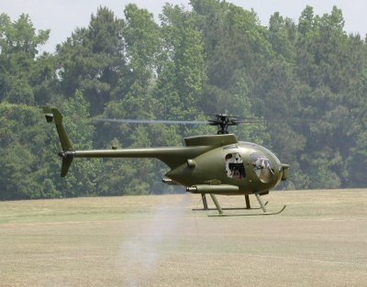

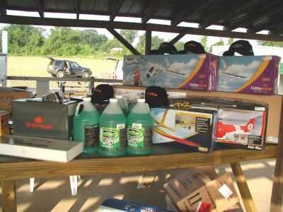
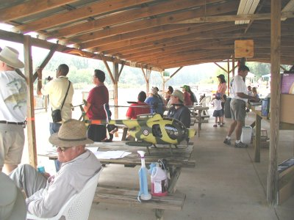

Photo Gallery- Airfest May 19-20, 2007

Photos by Steve Warmath & Democrat
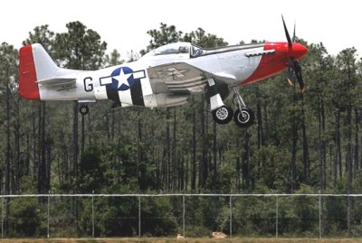
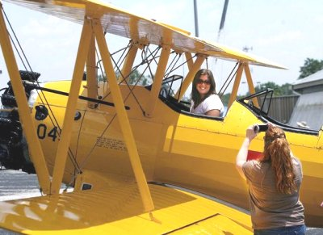

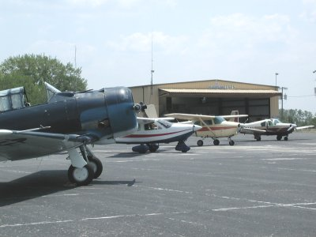
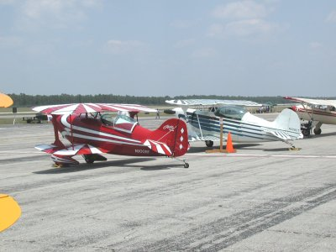

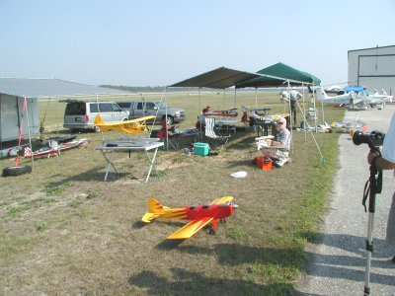
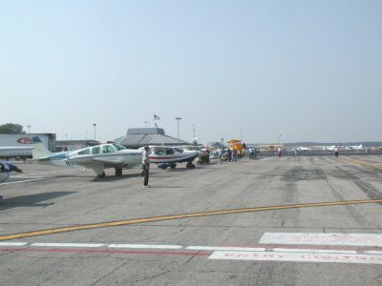

Photo Gallery- Float Fly May 26, 2007
Photos by Steve & Russ Warmath
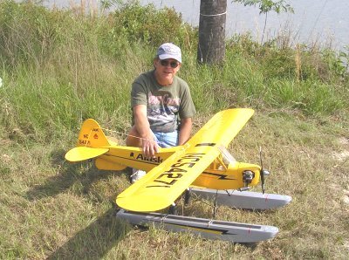
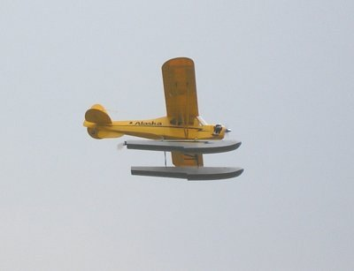

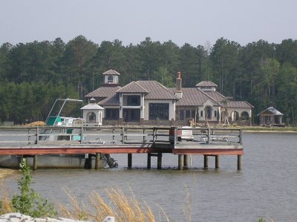
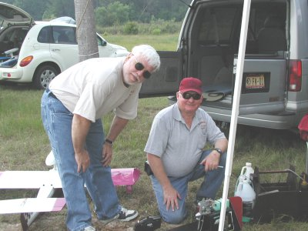

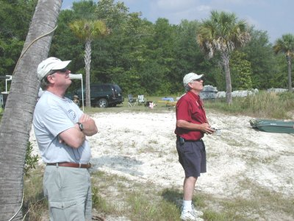
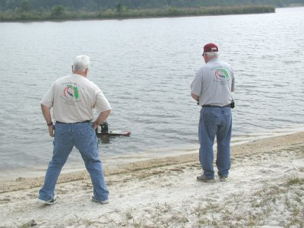

Chief Pilot- John Hall
With school out for the summer, there are a good number of young people looking for something fun to do with their summer free time. As a result, we've had an increase in new pilots showing up for flight training on Tuesday afternoons at the field. With only one or two instructors available this can be a difficult situation for both the instructors AND the students. We need more club members to volunteer as flight instructors.

Some of us, myself included, got off to a successful start in the hobby because another, more experienced pilot, took the time to be our instructor. Being an instructor can be rewarding in itself and gives one a chance to "pay it forward". You never know, you may be buddy-boxing the next Quique Somenzini or Curtis Youngblood! Or perhaps more likely, you are introducing a new pilot to what may become a life long interest for them. Not all student pilots stick with the hobby. But we should do our best to try to help those who are interested get off to a successful start.

Club members interested in being an instructor should contact Dr. Michael Atkinson at nexnbax1@comcast.net or H- 926-4692, W- 656-2200, C- 251-2694

See you at the field.

John

Chief Copilot- Brad Sharp
A special thanks is offered to Joe Satterwhite for his logistical help and participation in Airfest this year. He provided his tent and use of his trailer. He was there both days from beginning to close. He also volunteered to do all of the cooking at the Flying for a Cure event. Thanks Joe.

Upcoming Club Events
Club Meeting at the Field- June 7, 2007 at 7:00 pm.

Upcoming AMA Regional Events
King Orange Scale
FL
6/02/07-6/03/07 - Land O Lakes, FL (AA) King Orange Scale for 511, 512, 520, 522 (JSO). Site: Club Field. Wm J McCallie CD, 10501 Sago Rd Tampa FL 33618 PH:813-932-0622 email: wmccallie@tampabay.rr.com. Sponsor: BAY CITIES FLIERS

Peach Pattern Classic
GA
6/2/07-6/3/07 - Andersonville, GA (AA) Peach Pattern Classic for 401, 402, 403, 404, 406 (O). Site: Mac Hodges' Field. Emory Schroeter CD, 105 Summit Dr Griffin GA 30224 PH:770-67-0221 email: emorydmd@earthlink.net. FAI will fly on P06 schedule on Saturday and the F07 schedule on Sunday. Visit www.nsrca.org/d3/events.htm. Sponsor: FLYING GRIFFINS

Warbirds over GA
GA
6/08/07-6/09/07 - Andersonville, GA (C) Warbirds over GA. Site: Hodges Hobbies. Chris Joiner CD, PO Box 4469 Columbus GA 31914 PH:706-326-3505 email: giantwarbirds@hotmail.com. Restricted to giant scale warbirds only, 1911-1950 era. (Note: only those aircraft meeting era requirements may fly during event; all others may do so after hours). Entry fee $15. Only membership requirement is AMA. Friday evening dinner (extra fee). Go to www.giantwarbirds.org for more info. Co-sponsored by Hodges Hobbies. Sponsor: GIANT SCALE WARBIRDS ASSN

Northwest Florida Modelers 2nd IMAC
FL
6/09/07-6/10/07 - Pensacola, FL (AA) Northwest Florida Modelers 2nd IMAC for 411, 412, 413, 414, 415 (JSO). Site: Fritz Field. Ron Bullard CD, 3204 Copper Ridge Cir Cantonment FL 32533 PH:850-501-0358 email: bullardrm@cox.net. Visit www.nfmi.org. Sponsor: NFMI

Annual Spring Swap Meet/Fly In
FL
6/09/07 - Jacksonville, FL (C) Annual Spring Swap Meet/Fly In. Site; Lannie Rd Flying Field. Robert Davis CD, 7052 Arlet Dr Jacksonville FL 32211 PH:904-343-7116 email: bobdavis68@comcast.net. Spring Swap Meet Fly In. $5 landing fee. No charge for tables. Tables are limited so bring your or set up on tailgate. Drinks and food available. Contact CD for early access to field. Limited RV Parking, no hookups. Visit www.gatewayrc.org. Sponsor: GATEWAY RC
Fiesta of Five Flags
FL
6/16/07-6/17/07 - Pensacola, FL (AAA) Fiesta of Five Flags for CAT III 101, 102-103, 104-105, 101C, 102-103C, 104-105C, 122, 124, 128, 140, 142, 150, 151, 152, 153, 154, 155 (JSO). Site: Navy Spencer Field. George White CD, 5928 Hermitage Dr Pensacola FL 32504 PH:850-473-0866 email: white76@cox.net. Visit www.pensacolafreelfight.org. Sponsor: PENSACOLA FREE FLIGHT TEAM

Flying Griffins 3rd Annual Swap Meet and Fly In
GA
6/16/07 - Griffin, GA (C) Flying Griffins 3rd Annual Swap Meet & Fly In. Site: Allen Taylor Field. Emory Schroeter CD, 105 Summit Dr Griffin GA 30224 PH:770-467-0221 email: emorydmd@earthlink.net. Event begins at 9:00 a.m., $5 trader fee, onsite concessions. Bring your planes to fly, buy or sell. RV's welcome, but no hookups. Visit www.flyinggriffins.org. Sponsor: FLYING GRIFFINS

South Florida AMA Dist V Jamboree
FL
6/22/07-6/24/07 - Sunrise, FL (C) South Florida AMA Dist V Jamboree. Site: Markham Park. Douglas Jones CD, 3290 SW 2nd Ct Deerfield Bch FL 33442 PH:561-715-0173 email: shellback76@bellsouth.net. Visit www.mppaonline.net. Come to south FL and join in the fun. Open to all AMA members. All RC aircraft types welcome. 760'x55' asphalt runway with plenty of open space. Camping and RV spaces available. Hotels and beaches nearby. Make it a part of your family vacation! Sponsor: MARKHAM PARK PILOTS ASSOC

Rhoda Wing (Heli)
FL
6/23/07 - St Petersburg, FL (C) Rhoda Wing (Heli). Site: Club Field. Art Lavallee CD, 66146 Tudor Rd Pinellas Park FL 33782 PH:727-544-1939 email: alavallee@tampabay.rr.com. Sponsor: SPARKS

Chief Treasurer- Sam Varn
Editor’s Note: The Treasurer’s report is published for Members only. The public version of the Newsletter does not include this information.

Even though I missed it, the Fly for a Cure Fun Fly event was a good moneymaker for the American Cancer Society. We had 31 registered pilots, a good concession sales day and several individual contributions. Our total money collected for the day was $1,653.85. This included $270 in checks made payable directly to ACS. After paying for food and t-shirts (total of $936.38) we were left with a net of $717.47! I will be forwarding the three checks made payable directly to the ACS ($270) and a Seminole RC Club check for the balance of $447.47 to the American Cancer Society following our meeting and final club approval.

May was an expensive month! By club directive, I have reimbursed John Hall for the following: solar panel recharging station, weed-n-feed, chairs, trash cans, trash bags, landfill dumping fees and pressure treated wood for the bleachers and tables. Total of $887.65 in expenses but the field will be that much better for everyone. Please thank John and all concerned for the work they have done lately.

We had four new members join this month bringing our roster to 101 paid members! Wow! I think that's the highest I've ever seen it since I've been a member. When you see them at the field please welcome Fred Schmidt, Bryce Barbato, Christopher Smith and Butch Thigpen.

I think Vernon Brouse was the first to renew his dues this year, (thanks Vern!) which reminds me, DUES are DUE! Our membership term is from July 1 to June 30. I will be sending Dues Notices out around June 1. They will be due by June 30th. Your prompt payment is appreciated! If you don't get a notice or have any questions on your dues, please do not hesitate to contact me. Notices will be sent via PayPal again this year. If you don't want to pay electronically, you can mail a check (payable to Seminole RC Club) to my home:

Seminole RC Club
c/o Sam Varn, Treasurer
2668 Wharton Circle
Tallahassee, FL 32312

Or you can drop it by my office next to HobbyTown on Lafayette (Awards4U).

Here are our current balances:
Cash: $ Checking: $ Savings: $ CD: $
Total Funds: $

That's it for now. Safe flying and NO CRASHES!
Sam

Chief Scribe- Steve Warmath

The meeting called to order at 7:05 PM.

Steve read the Treasurer’s report in Sam’s absence. A motion was made to accept the report, it was seconded and passed.

Old Business:
- Frequency Pins- Brad is waiting to receive the pins from Sam.
- Field Update- The last meeting was in March. There were none in April. Three concepts are to be presented on the 17th, one week late. The new engineers have experience designing parks with RC fields associated with them. The preferred runway orientation is East-West facing north.
- Airfest 2007- Let John know if you can volunteer to fly and/ or participate in the event. Set-up will be Friday afternoon followed by an EAA appreciation BBQ dinner at 6:00 pm. It will also be Flightline’s 25th anniversary celebration. The set-up will be a little different this year. We will set up in the northern area of the ramp. They welcome static model display. No nitro flying this year, but electric flying OK. The event starts at 9:00. Set up at 8:00. Let John know of your participation so he can add you to the free entry list. Or you can just let them know at the gate you are with Seminole RC. We need to have Club information flyers at the event.
- A follow-on Field event after Airfest to promote the Club was not scheduled this year due to the number of events in May. Next year we will plan for one the week after Airfest.
- John said the road had been graded and was improved.
- Conditions of the field for the May 5th event were pretty good. There is to be a work party on Friday to set up. There is some lumber available for some minor repairs.
- The Crawfordville flight demo was coming up on the 1st and 2nd.
- A question was raised about getting nametags. John responded that the Club members had previously decided against having new ones made.

New Business:
- Mike noted that the new solar powered battery charging system provided and installed by John Hall was very impressive. The Club voted at the last meeting to reimburse John. Total cost for the solar panel and charger was $191.00. A discussion began on expanding the system. After discussion it was voted to purchase a second battery and extend the system to a waterproof junction box on the South end of the pavilion.
- Theo asked about the set up for Saturday “Flying for a Cure “ event. Frank Bastos gave an outline of how the field would be set up, logistics, pilot briefing, safety, etc. Flying with spotters will be required. There will be raffles throughout the day. No free lunch as this was a fundraiser. Permission had been obtained from the Sharps to start early.
- Gordie Meade wanted to address a safety issue concerning the location of the Pilot’s stations and the size of the pit area. He said he was starting to see more accidents occurring in the pit area and felt that the 15’ offset distance of the pilot stations from the edge of the runway should be reduced to have the pilots closer to the runway and make the pit area larger. Some members felt that it would theoretically reduce the size of the field and were opposed to the idea. After much debate and a visual inspection of what this proposal would look like from the pilot’s perspective, a motion was made to move the pilot’s station 15’, to the edge of the runway. There were 14 votes in favor and 3 opposed with several abstentions. The motion passed.
- Theo asked about the condition of the field wondering if it was getting too dry and needed watering. Frank said he thought the field was in pretty good condition and that the forecast called for scattered showers over the weekend.

Announcements
- Frank mentioned there would be a swap meet at HobbyTown on Saturday, May 12 at 10:00. He was hoping to expand the event by having another one in August to include the car and train guys.

With no additional business, the meeting adjourned at 7:55 PM.

Pilot Briefing
Jeff Owens
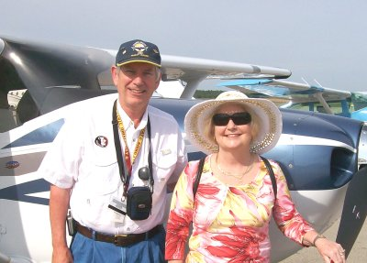
Where are you from? I was born in Syracuse, New York. After college in Worcester, Massachusetts and graduate school in Boston I took a post-doctoral position in Cleveland, Ohio. I moved to Tallahassee in 1976 for my second post-doc position.
What do you do for a living? I am a Physics Professor at Florida State University and also an Associate Dean of the College of Arts and Science. I have taught various courses such as Electricity and Magnetism, Quantum Mechanics, and Quantum Field Theory and I will be teaching Einstein’s General Theory of Relativity in fall 2007. My area of research is theoretical high-energy particle physics.
Jeff and Linda Owens
How did you get started in radio control? I flew U-Control while I was growing up and started again when I was a graduate student since I needed a hobby to give me a break from studying. I wanted more of a challenge and R/C had always fascinated me as I read about it in the model magazines. I learned to fly R/C in 1970 as part of an informal group who flew in an old hayfield north of Boston. I revisited the site in 2005 – it was deeded by the owner to the local community with the express intent of having it remain an R/C field! It is still in use with the same grass runways – and some of the same trees I hit!
What do you like best about the hobby? The challenge of performing maneuvers to the best of my ability, the engineering that goes into a well-built model and engine and radio installation, and the camaraderie of fellow aviation enthusiasts.
What models do you have or would like to have? What are your favorites and why? While I have flown helicopters (for the challenge), gliders (to learn about the dynamics of thermals and lift generation), sport planes (for the heck of it), my true love is flying pattern. That is what first inspired me when I was learning to fly and it has remained with me to this day. I currently have a HydeOut pattern plane with a Super Tigre 2300. I am nearly finished with a Cutlass Supreme – a pattern plane from the early 70’s and my next project is a Deception, also a pattern plane from the 70’s. I built a foam wing cutter and cut the cores with the aid of Rick Sunderland and my wife, Linda. I have the plans and a new set of retracts for it as well as the needed balsa wood.
Other than just enjoying the hobby, are there any skills or maneuvers you are working on or want to master? The incredible advances in engines, radios, and building techniques have resulted in aircraft that can perform maneuvers we never thought of 30 years ago. The pattern sequences are much tougher than they used to be when I was actively competing in contests. So, there are always new maneuvers to (attempt to) master. For me the most challenging are things like an inverted half snap roll on a 45 degree down line – getting the model to stop after exactly half a snap roll is tough.
Is there anyone in particular who has influenced your participation in the hobby? In the late 70’s and early 80’s there were quite a few active pattern flyers in the club. We had a ball competing all around North and Central Florida. Rick Sunderland, Al Weir, Gordy Meade, and John Cutrer all flew pattern. We coached each other and challenged each other to improve both our building and our flying. I miss that.
Is there anything else you'd like to share? I love all aspects of aviation and enjoy flying our Cessna 182 in addition to R/C activities. There are some pictures of it on my website at http://www.hep.fsu.edu/~owens. My love of pattern flying led me to try full-scale aerobatics in a CAP-10B and in a Super Decathlon. I even competed in one contest, taking 2nd place in Basic in the CAP. The Seminole R/C Club is a wonderful organization and I have learned much from the opportunities I have had serving in various positions including President, Vice-President, Secretary-Treasurer (twice), Newsletter editor (twice), and Webmaster. Things that I have learned while serving the Club have proven to be useful in other aspects of my career.

FLYING A MODEL AUTOGYRO... What’s so different about it?
By Jim Baxter

Most experienced, long-time modelers, would find an autogyro fairly easy to fly once they understand how it responds/behaves. An R/C helicopter flyer would adapt to an Autogyro fairly quick. A new R/C flyer, and even one with limited experience, could find it difficult and frustrating. However once you have experienced a successful flight the feeling is absolutely fantastic, and more often than not the modeler goes on to experience different and more advanced versions of the model Autogyro.
This page is posted here as an aid to those fledgling GyroNuts about to attempt their very first R/C Autogyro flight. Generally most of the comments pertain to models of the 'non-fixed-winged' design. Regardless of the design, the information will familiarize you with the flight characteristics of un-powered rotorcraft even though some models may have the assistance of a stubby wing.
GROUND HANDLING and LAUNCH
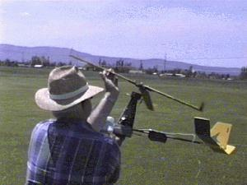
Before you fly, be sure your rotor freely rotates, and test it in a light breeze. Face into the wind, hold the model in one hand and pre-spin the rotor with the other hand. Raise the nose high (maybe 45-60 degrees) and while facing the wind, observe the rotation. How quickly the rotor spins up rapidly will depend on the strength of the wind. With very light breezes, it may not accelerate much at all until you increase the effectiveness (speed) of the breeze by walking directly into the breeze while continuing to hold the model nose high. You may even have to jog slowly.
If the rotor still does not spin up, you may have to slightly increase the negative incidence of the blades. By the same reasoning, if the rotor seems to spin-up almost too easily, you may want to remove some negative incidence. The more the negative incidence, the quicker the spin-up, but the rotor performance will suffer. Ideally, for maximum performance, you would like to have zero or possibly a little positive incidence in the blades.
Once you have noticed the rpm increasing, now you will be looking for it to accelerate into an "Autorotation” condition, which is necessary for the system to provide sufficient lift for flight. Autorotation will be noticeable in a few different ways. One, you can see the blades really accelerate rather suddenly. Two, you can generally audibly ‘hear’ the acceleration. Three, the increase in lift should remarkably increase. If you don’t feel the increase in lift, then the system may be inefficient and in-flight performance may be poor.
Flight (full) rpm must be present for launch or the model will normally roll into the retreating rotor blade, since the lift will be higher on the advancing side at low rpm. You cannot (should not) pull the model off the ground, as you might be able to do with an airplane. If the rotor is up to speed the model will want to lift off on its own. If it has not lifted off as you approach the end of the field, it is best to cut off the power and abort the attempt.
Caution: Do not rush the ground take-off. Apply power slowly and allow the model to accelerate slowly! Do not attempt a crosswind takeoff, unless you have a lateral tilting rotor and rudder control to assist. Generally, follow the rule of not taking off cross wind any time.
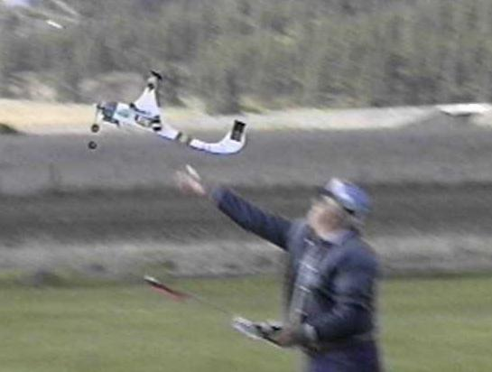
Actually hand launching of a small model (less than four feet of rotor) is almost preferable for the first few flights. One primary reason is that the model is closer to you at release and it is easier and quicker to see what correction is needed. With a ground launch (ROG) the model may be just far enough away that you may have difficulty reacting quickly enough for a correction. Small electric models are generally always hand launched, simply because of the excess energy necessary to complete the ground launch. If you are hand launching, wait for autorotation and then (and only then) push the model forward and slightly upward. If you release it too soon (prior to autorotation) it will most probably roll/turn in the direction of the retreating blades, and drop rapidly. If you throw or toss it too hard, it may nose up suddenly and/or sharply. Under normal conditions, the model should proceed forward in level flight, enter a slight climb, and possibly begin a slow right turn, giving you sufficient time to gain full control with your transmitter.
IN FLIGHT
Limit bank/tilt angles to 30 degrees. At bank angles between about 30 and 45 degrees, extreme caution must be exercised or you may lose control. If you exceed these angles, the model may simply slide out of control and enter the deadly spiral turn. The model will normally be flying in a one "g” condition, and only use just enough elevator (aft tilt) pressure to hold level flight. Do not attempt to push forward which will create a 'negative' g-force condition, unloading the rotor. These models are normally not sensitive in pitch/elevation, and elevation is easy to control through the use of power rather than transmitter elevation control. However they do generally react quickly to a roll/turn input.
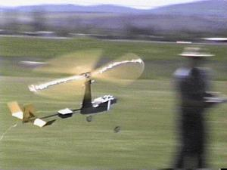
Orientation is far more difficult with the Autogyro than a standard fixed wing model airplane. One good flight technique is to -always- turn toward yourself whenever possible, especially when the model is very far away. With brightly colored rotor blade top surfaces, the blades will then become visible when it is banked -toward- yourself and you will know what it is happening. It is not uncommon for an R/C flyer to -relax- on the controls after initiating a turn. This technique can present a problem with many gyros, since the model will tend to -level out- with the lack of control pressure. Apply the control pressure to begin the turn, observe the attitude, and continue to hold a minimum of pressure to continue the turn. Notice that this does not mean -continue to increase, but simply hold what you have.
Picture a model airplane flying around with just the fuselage and tail showing, and this is somewhat like the Autogyro in flight. The limited profile of most autogyros will make it easy to become confused if you allow it to get very far away. If you become confused and lose control, reduce power (glow models) quickly and relax on the controls. With electric models, relax on the controls and use caution with power changes. The larger relative propellors on many electrics have a very pronounced torque effect with large power changes. Frequently, with a relaxation of controls, the model will attempt to level/right itself below the rotor. This will hopefully give you the opportunity to re-orientate on the model and regain control.
"To tilt or not to tilt"
DIRECT ROTOR CONTROL (DC) versus NON-DC CONTROLLED MODELS
DC models utilize full servo control; both lateral and pitch tilting of the rotor, and generally do not utilize a rudder or elevator for flight control. The advantage of DC is that control (except yaw) can be exercised at all airspeeds, right down to zero speed, including landing. A non-DC model is fully controllable, as long as it is above the minimum airspeed for rudder and elevator effectiveness. A zero ground roll landing for a non-dc model can only be accomplished if you have some wind to retain rudder/elevator effectiveness.
In flight a DC model may experience a horizontal (flat) rotation if permitted to slow to zero flight speed in light wind conditions without the aid of a rudder to counter the rotation. Usually this will only happen if the nose is raised somewhat excessively relative to the slow forward speed. Lateral DC tilting is highly effective. Very little tilting will cause the model to react. Pitch tilt, while effective, is not as 'sensitive' as lateral tilt.
Many of the non-pitch tilting models have the rotor placed high to clear the tail fin, and for an added bit of stability. However a higher placed rotor (vertically) than average may require the addition of rudder control to accomplish a turn. The lateral tilt simply "tilts" the model, but it won’t turn until you add rudder.
Another type model is the one with "Teeterbars", a blade system where the blades are rigidly connected together at the center and "teeter" at the center shaft. As one blade goes up, the other goes down. This configuration works, and has been employed successfully with the "Whistler". However, they just don’t seem to be nearly as efficient as the three or more bladed individually hinged rotors. My Whistler flies, but requires a much higher airspeed to maintain lift, even though it also has a supplemental wing to support the craft. It will not fly without the wing, nor will it fly without the rotor, at least mine won’t. It will not hover in anything less than a relatively strong wind of at least 10 knots.
Other teeters I have watched, and have been told about, seem to behave the same, and everyone I know of that has attempted the teeter system eventually abandoned it for the individually hinged system. I don’t know if this is a result of poor design on the part of the modeler or simply a fact of teetering models? Remember this is not to be compared with the teeter type rotor systems employing the helicopter/ flybar. They are converted helicopters, not the style of pure autogyro we are speaking of, and fly very different than the non-heli system.
Will a full sized autogyro perform aerobatics? Yes, to a degree. A Pitcairn craft was known to have performed loops during exhibition shows. Will the models perform aerobatics? Yes. Much better and easier than the full sized craft, but certainly not nearly as smooth. Depending on the type rotor system employed (which will dictate the amount of forward airspeed necessary) , loops and rolls can be flown. The same precautions as you would use with the average model airplanes are necessary. Just obtain a little additional altitude and airspeed to insure recovery if you fail to execute the maneuver properly. Caution: If you intend to practice aerobatics, it is advisable that you install slightly stronger servos, especially on the pitch control portion. There is more stress/load on the pitch axis/servo than the lateral /roll servo.
And what happens if the engine quits?
Will this type model simply fall and destroy itself, if so much depends on the engine to propel it forward (thus maintaining flight capable rotor rpm), and suddenly the engine fails?
Well not really.... However it is certainly not like a model airplane where the craft usually will assume a decent glide angle and float in for a typical "dead stick" landing. If your model has been properly balanced with the Center of Gravity just forward of the rotor shaft/spindle (or as prescribed for your particular model), it will (should) assume a slightly nose down attitude under light or no wind conditions and descend nearly vertical like a "soft rock". With D/C servo control you will have some degree of control over the general flying attitude and hopefully be able to "break" the rate of descent sufficiently to accomplish a soft landing. With a rudder/elevator controlled model, you will not have nearly as much direct control over the attitude, however you should be able to lower the nose enough to accelerate sufficiently to be able to use the rudder and elevator to "break" the descent just prior to touchdown. Again, this depends on the balance (hang angle) of the model. Little or no hang angle (relatively neutral CG), and you will have very little control over the descent. With between 5 to 10 degrees of down hang, the model should give you a forward glide, though rather steep, and the opportunity to have some control effectiveness.
It may sound stupid to lower the nose during the latter portion of the descent thus increasing the rate of descent, however this is one key to a successful soft landing. The object is to gain sufficient airspeed to allow the aft tilting of the rotor and / or "up" elevator to raise the nose and reduce the rate of descent immediately prior to touchdown. Timing of this is critical, obviously.. Break the descent too early, the model may drop the final foot or so tail first. Break too late, and crunch!
It is good idea to actually practice engine failure landings. Position the model with the nose pointed toward you, slightly upwind (but still over the landing field), at perhaps 200 to 300 feet of altitude. Reduce the power to idle (tick over), and notice the degree of control you have... Attempt to gain more control by lowering the nose (this is where D/C really come s in handy) and then break the descent for landing. With initially using idle power, you always have the opportunity to abort and try again. Once you feel comfortable, then actually stop the engine and prove to yourself that you can prevent a destructive landing.
IN SUMMARY
Most R/C modelers with some flying experience can fly a model autogyro, if a degree of common sense and caution is exercised. The rotor must be at full flying rpm (into autorotation) before the model will fly (non-fixed winged models). Orientation is difficult and tricky; keep the model within a few hundred feet (50-75 meters). Limit bank angles to prevent loss of control. Do not push down/negative control pressures (the model needs to fly at a slight positive 'g' pressure). Land before fuel is exhausted and with power applied with engine failure attempt to gain sufficient airspeed to allow a breaking of the descent. Please Note: The electric models I have experience with utilize a much larger propeller (geared motor) and with power failure (or a sudden closing of the throttle) the model may literally 'stop' flying and drop rapidly/unexpectedly due to the breaking effect of the large prop. With this in mind limit initial electric model flights to a simple one-minute circuit of the field and complete a landing, while noting any trim corrections required for the subsequent flight. Cautiously extend the flight time of each subsequent flight but always land before battery power expiration. A good idea is to ground test the system by timing the fully charged battery at full throttle and always land well before that time limit expires.

Principles Of Helicopter Flight

Welcome to the world of R/C Helicopters. The helicopter is probably the most challenging form of radio control model, being mechanically complex in nature, and requiring 100% concentration while operating.
Flying a model chopper is not unlike balancing a metal bearing or a marble on a piece of glass. If the mechanics of the chopper have been adjusted and aligned very well, it is similar to having a flat piece of glass. If the chopper is not set up just right, it is like having a convex piece of glass where the bearing wants to keep rolling off to one side.
The first thing the budding helicopter pilot must realize is that the model works on the very same principles as the full-size and controlling the chopper is just as difficult, if not more-so due to size and orientation. It is not simply a matter of pushing one button for up, and another for forward flight, etc.
Flying a helicopter, just like flying a model aircraft, is a skill that must be learned and that can only happen with practice .
Although building and flying a model chopper can be complex, it is also extremely satisfying. Being able to accurately control a vehicle, which you can hover, fly forward, backward, sideways, and do all kinds of interesting maneuvers and aerobatics, as well as land at your feet, is very exciting.
Unlike learning to fly a model airplane where flying with an instructor is a must, you basically learn to fly helicopters by yourself. Before you start flying, however, some time with an experienced helicopter pilot will be invaluable. He can help you set up your helicopter (it is extremely important to have the mechanics set up accurately for safe and easy flying) as well as give you some tips on flying; what to expect from your model and how to operate the controls.

How does a Chopper Work?
There are basically two different types of helicopters, those that have collective pitch and those that do not. Collective pitch is where the pitch of
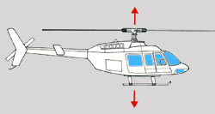
the main rotor blades may be simultaneously increased or decreased to change the amount of lift. This gives a quicker response to changes in vertical thrust as controlled by the pilot. On helicopters without collective pitch, the amount of lift is controlled entirely by the speed of the rotor blades or in other words the speed of the engine (throttle control).
The reaction time is longer and thus the control is less responsive.
There is a trade-off, however, and that is the cost and complexity of the rotor head. There are a great deal more moving parts in a collective pitch rotor head and thus, they are more expensive. Most current choppers are of the collective pitch variety.
On a standard, collective pitch helicopter there are four controls and these are operated by five channels of your radio system. These controls are the collective pitch, the fore and aft cyclic pitch, the side-to-side cyclic pitch, and the tail rotor pitch. The collective pitch must also be coupled with the throttle of the engine so that when more load is put on the main rotor blades by increasing the pitch, more throttle is applied to help overcome the additional drag.
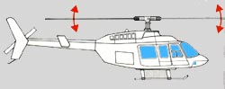
Helicopter flight is governed by the pitch, or angle, of its rotor blades as the sweep through the air. When climbing or descending, the pitch of each blade is changed simultaneously and to the same degree. To climb, the angle or pitch of the blades is increased. To descend, the pitch of the blade is decreased. Because all blades are acting simultaneously, or collectively, this is known as collective pitch. For forward, backward and sideways flight, an additional change of pitch is provided. By the means the pitch of each blade is increased at the same selected point in its circular pathway. This is known as cyclic pitch.
When a helicopter is started up and the rotors begin to turn they are maintained in flat pitch, with no angle, or bite on the air. As the engine warms up and the rotors turn faster, the collective pitch is increased and the helicopter lifts vertically. To make the aircraft fly forward, the collective pitch is retained, keeping the aircraft in the air, while the cyclic pitch is adjusted to enable each blade to have more bite as it passes over the tail.
To stop the helicopter and hover, the cyclic pitch is returned to neutral, causing the rotor blades to have the same pitch thought-out their cycle, allowing the collective pitch to retain the helicopter hovering in the air.
The left stick of your radio transmitter controls the collective and throttle in the vertical direction and the tail rotor pitch in the side to side direction. Your right stick controls both cyclic operations; up and down for fore and aft control and side to side for the cyclic side to side control. There are also mixing functions which mix the throttle and collective functions, and the throttle/collective and tail rotor functions.

Operation
The engine of a helicopter drives both the main rotor shaft and the tail rotor via a series of gears and a clutch. As the motor comes to speed, the clutch engages and begins to turn both rotor systems. Generally, at this point, there is no pitch on the main rotor blades and thus no lift. The throttle is increased until the main rotor blades are brought up to speed. To lift the helicopter collective pitch is applied.
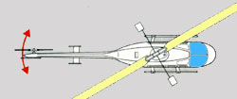
Because, for every action there is an equal and opposite reaction, when the engine is forcing the rotor blades to turn in one direction, the body of the helicopter will want to rotate in the opposite direction. The function of the tail rotor is to correct this tendency. The tail rotor blades provide enough thrust to the side to keep the helicopter pointing in one direction. By increasing or decreasing the pitch of the tail rotor blades the direction the helicopter is pointing can be changed.
The cyclic control permits the main rotor blades to be varied independently making the helicopter move in a horizontal direction. If one of the rotor blades increases pitch as it approaches the rear while the opposite blade decreases in pitch while approaching the front during its rotation, more lift will be produced in the rear, tilting the helicopter forward, and thus moving the helicopter in a forward direction.
The same principle applies for side to side and rearward, allowing the helicopter to fly in any direction.
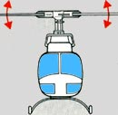
The control of the cyclic and collective pitch is transferred from the radio servos to the rotor blades via the swash plate. Part of the swash plate is stationary while the other part is allowed to rotate with the rotor head. Control linkage is connected from the servos to the stationary part of the swash plate as well as from the rotating part of the swash plate to the rotor head.
When flying a chopper, small control inputs are continually required by the pilot to correct for deviations in the flight path. That is why 100% concentration is required in chopper operation. The more accurately the chopper is set-up, the fewer the number of corrections that are required by the pilot.

What Happens if the Engine Stops?
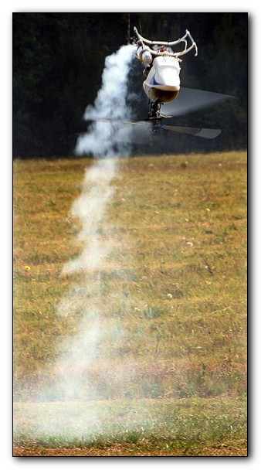
Auto-rotation is a way for helicopters to land successfully after a loss of power from the engine to the rotor drive systems.
This is accomplished with the aid of a special device known as an auto-rotation clutch which allows the rotor blades to free-wheel. As soon as power has been cut, the throttle/collective control is brought back all the way.

Classified Advertisements/ For Sale
FOR SALE- None this month

Seminole Radio Control Club
Tallahassee, FL

AMA Charter #216, 1969-2007

SRCC Officers

President – John Hall
Vice President – Brad Sharp
Secretary/ Newsletter Editor – Stephen Warmath
Treasurer - Sam Varn
Field Marshall – Chris Bailey
Field Safety Officer- Shannon Black

Field Hours

12 Noon till Dark- These hours apply to all aircraft, gas and electric.

Training Notes

To schedule a training time contact Mike Atkinson.

Flight Instructors
Mike Atkinson- Primary/ Advanced Fight Instructor (Coordinator) 926-4692
Geoff Lawrence- Primary/ Advanced Fight Instructor 942-9807
Mike Kinsey- Primary/ Advanced Fight Instructor 566-0144
John Hall- Primary/ Advanced Helicopter Flight Instructor 893-6457
Jay Leudecke- Primary/ Advanced Helicopter Flight Instructor 508-7135
Jeff Owens- Ground School/ Airworthiness Instructor (Fixed Wing) 894-2504
Steve Warmath- Ground School/ Airworthiness Instructor (Fixed Wing) 509-0672
Frank Bastos- Hobby Town Flight Demonstrator 671-2030
Don Coon- Leon High Aerospace Club Instructor 488-1971 x 1950

Club Meeting Location and Time –Meetings from April thru September are at the Field starting at 7:00.
The regular club meetings are held on the first Thursday of each month at 7:30 PM at the Grace Lutheran Church on Miccosukee Rd. Head out Miccosukee Rd., cross Capital Circle NE, and the entrance will be the first one on your right. Once you park, follow the sidewalk around the left side of the building and go down the hill. We meet in a room on the first level.
Newsletter Submissions- Submissions are requested to be in M.S. Word format. Photos should be in .jpg or .tif format. Vector art accepted in Corel, Illustrator and AUTOCAD format. We will, however, accept anything to make it easier for those who wish to contribute. Submissions are due no later than the 23rd of the month. Send your submissions to ssw@nettally.com or by phone, Steve Warmath at 509-0672.
Hard Copy Printing of the SRCC Newsletter provided by Apogee Signs & Graphics.



