This Issue is Dedicated to Good Friend and Fellow Pilot, James Cutrer

JAMES CUTRER

I don’t think I was ever formally introduced to James Cutrer. When I moved to Tallahassee in 1991, he was already a fixture in the Seminole Radio Control Club. I later learned that he was one of the charter members. In fact, the club had been formed just about the time I had previously lived in Tallahassee back in 1968, so our paths almost crossed back then. I suppose our paths must have crossed for real later when I was living in Atlanta and made trips to the Joe Nall fly-in up in Greenville, South Carolina in the late ‘80s. I am sure he must have been there since he was a real fan of “Greenville” as it was then known in the big plane circles. I have sometimes wondered whether we might have exchanged some small talk about planes and things on the sidelines at the Hartness field. In any case, it seems we were destined to cross paths in various ways until we finally just sort of bumped into each other.

I tried to recall when I finally recognized him as an individual rather than just one of the guys in the SRCC. Possibly, the first time I can remember was when he offered to pay the club dues for a young flier who had a difficult time coming up with enough money on his own. Or maybe it was at a club auction where I kept noticing the little man with the speech impediment (and the name I couldn’t pronounce) jumping on bargains like there was no tomorrow. James never met a bargain he didn’t fall in love with. And apparently, he met a whole lot of them.

Strangely enough, people like James don’t dive into your life, they just sort of slide in. I just know that we shared a love of airplanes, and not just models. Our interest in the large scale aspect of the model hobby meant we would eventually find ourselves as part of a traveling band of model airplane gypsies who roamed across the southeast hanging out in hot dusty fields and around other similarly minded folk, smelling like gasoline and nitro-methane. But James had one thing going that all the rest of us couldn’t match. He was generally the only guy to have the company of his wife. He and Shirley seemed inseparable. I know they traveled the entire country, sometimes just for the thrill of traveling and sometimes in support of other loves they shared.

You didn’t have to be around James very long to learn he was an avid FSU football fan. Model airplane events had to be passed up in order to bring the big motor home over to Tallahassee for every home game and frequently to pack up the well and churn and drive to those distant away games. Even when he sometimes chose to go flying during an away game, you could be sure the satellite dish would be bringing the game down to wherever he might be. I guess the only other thing he would allow to interfere with his flying fever was NASCAR racing (and motorcycles). I have been told he actually let the model airplanes simmer for a while when he and son John got involved in bike racing. But the airplane bug was under his skin and he couldn’t get away from it.

I have no idea how many events I was fortunate enough to share with James. It never crossed my mind to keep score. I do know that we frequently shared ideas as well as parts and support for each other when one of our toys was misbehaving. He could sometimes show a flash of temper and then just as quickly turn into a jolly, belly laughing clown on the sidelines at an event. And don’t put yourself in harms way if there was any barbeque around. The man could put down his share.

I have listened to him tell of his meager upbringing in the north Florida piney woods and of his exploits during his school years. There are probably many others who can better address the young James than me. I will always just be happy to remember him as my friend and someone who I could count on to be available if I needed him.

The road trip stops at the Dairy Queen won’t have quite the same flair when we trek to Ocala or to Mac’s on a Saturday. But I am sure we will all remember the smiling face slurping down that frozen stuff they sell. Like a lot of other folks, I am going to miss James.

James Cutrer passed away on Sunday, January 23, 2005, at the age of 74.

[Submitted by Theo Titus]
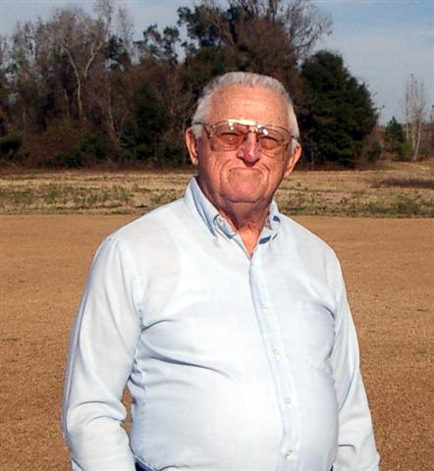

HAIL TO THE CHIEF
The Chief has gone fishing. He may return next month provided the whale decides to release him!

TREASURER’S REPORT
Hi Guys!
Not much activity this month. I need to get the net proceeds from the Float Fly from Mike. We netted about $12 on concessions but sold several t-shirts. Regardless of the income, the event was a gigantic success. It was great fun to see the water flying. I especially enjoyed Ed's "splash - n - goes". I hope we can do that event again.
See you Thursday,
Sam

SECRETARY’S REPORT
Business Meeting of January 6, 2005:

Richard began the meeting at approximately 7:30 PM.

Richard recognized new members Brit Corley, Dr. Mike’s Dad, and Rick Robins.

Sam read the treasurer’s report and it was approved. He provided for anyone interested the documents of last years funds and transactions. He also announced he has paid the corporate dues.

Richard read his annual “state of the club” address (interspersed with comments and discussion):

∙ He highlighted the rule to keep your person behind the flight line while flying. Also, he would like to see a designated 3-D flying area.

∙ Need an appointment for Field Marshal and Safety Officer.

∙ Noise is becoming an issue. He recommended the club purchase a sound pressure meter.

∙ He noted the club membership is growing in size and diversity of interest.

∙ There was a setback in the club financial balance due to last year’s theft. It is now about back to the pre-theft levels.

∙ Outside people are back to sneaking into the site to fish in the pond. He reiterated the need to report such activity.

∙ He made suggestions for updating the flying site such as removing the impound box and replacing with tables; paint our logo on the storage box; build new ramps for the storage container; creating more ventilation in the container; the field maintenance looks good thanks to Mike K. and company; and don’t neglect keeping up the maintenance on the mower.

∙ Last year was very active for events and he wants to keep that up this year.

∙ Revisited the idea of picture club ID cards.

Old Business:

Jeff Owens announced the next EAA Fly-In at the Tallahassee Airport may allow some R/C flying. Also, it is going to be bigger and better. It is scheduled for May 15th and 16th.

A question was asked about the status of the new site. Dr Mike said he’s waiting on a response from the County. Bob Burke mentioned potential problems of new site. A general discussion ensued.

Duane requested the exclusive use of the site April 2nd and 3rd for the annual soaring competition. Motion was approved.

Sam mentioned he created a standard form for event coordinators to use for recording finances etc.

Dr. Mike said Mike K. made an invitation for a Float Fly-In January 22nd at his home. He also asked for supplemental insurance. This was approved.

Dr. Mike also requested the field for February 5th for a Military Fly-In. This Was approved. He is asking for volunteers to help out.

Again, Dr. Mike mentioned a possible Fun-Fly in May.

Richard withdrew as candidate for member-of-the-year. Voting for other candidates Geoff L. and Gordy ended in a tie. It was agreed they would share the award.

Sam suggested the idea of the club providing some small compensation for future officers to possibly enhance the office’s appeal. This was discussed, and no decisions were made.

Bob B. made a presentation of an assortment of very old radio control equipment and old plane(s).

Theo made a solicitation for anyone interested in joining IMAA.

Meeting was adjourned.

EVENTS – PAST PRESENT FUTURE

January Float Fly-In:
The club tried its hand a hosting a float fly-in on January 22, 2005. Many thanks to Don and Linda Joiner, as well as their sons, for donating the use of their pond, in Monticello. Mike Kinsey presented the idea to the club at the January meeting. Because of upcoming events, we had to rush the organization. Despite this, the event was a great success. The Kinsey family (the Joiners are their cousins), went above and beyond to make us all feel at home. From the burgers and hot dogs to the homemade desserts, the “southern hospitality” was amazing.
There were 10 participating aircraft in the event, ranging from trainers on floats to delta wings, even including a helicopter on floats. Jay and his floating heli had to be the highlight of the day. However, a couple of spectacular crashes thanks to Mike Kinsey and Bob Donohue earn honorable mention. The flying began in the fog at 10:00 and continued until about 4:00. The event was well attended by others, as well. There were visitors from south Georgia, as well as many other club members and their families. All in all, a great time was had by everyone. Plans are already in the works for another one in late Spring or early Summer. Because we can fly early out there, the Summer heat won‘t be as bad.
- Michael Atkinson
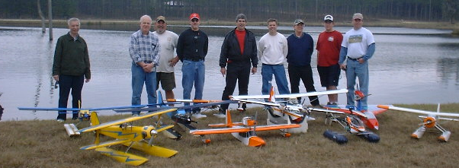

January 2005 Float Fly-In

Upcoming Military Madness:
The club will be hosting a Military Madness event on February 5, 2005, from 12:00 to 4:00. The field will be closed for open flying during this time. All pilots with military aircraft are encouraged to attend the event. Requirements: AMA insurance and $5 per pilot landing fee. Awards will be given for Best Static Display and Best Scale Flight. This year, our event honoree is Robert F. Burke. Bob served the country in WWII, stationed in the Pacific Theater, while in the U. S. Navy. Sam Varn and event organizer, Ken Detzner, have contacted 63 north Florida and south Georgia clubs to notify them of the event. Additionally, Ken has notified the newspaper and all television stations and expects great coverage. The Cub Scouts will be handling the concessions again. Hope to see you all there.
- Michael Atkinson
Upcoming Perry, Georgia, Swap Meet:
The club has reserved 4 tables at the upcoming swap meet in Perry, Georgia. The event is March 4, 5, 2005. Information can be found at http://gama.rcclubs.com/georgia.html . If you’ve never been to the show, do yourself a favor and plan to attend this one. You won’t regret it.
- Michael Atkinson

SWAP SHOP

For Sale: Gentle Lady 2 meter glider w/ 2 servos, 600 mah nicad battery, and hi-start.
All for $125.00. Call Vernon Brouse @ (850)297-0959.

Recommended Deals:
Servo City has their Hitec 4 channel micro receiver on sale. Check it out at http://www.servocity.com
Also, I got a great deal on a Lanier Mariner 120 from Ed Budzena (thanks, Ed). To power it, I chose the GMS 120 2C. For those of you who know me well, I love the GMS engines. With the muffler, Tower Hobbies carries this for $155. Plus, there is an online coupon for $25 off when spending $150. I should get it within the next few weeks and have everything ready to fly by the next float-fly. I’ll let you know how the engine does after tests.
Finally, Hobbytown has a Soarstar electric plane marked down to $99. I’ve had several of these and they are an excellent choice to begin your electric flight experience. At a regular price of $139, that’s quite a discount.
Any other recommendations, let me know.
- Michael Atkinson

Seminole Radio Control Club
Tallahassee, FL
AMA Charter #216, 1969-2004

SRCC Officers
President - Richard Wynn
Vice President - Dr. Mike Atkinson
Secretary - John Clark
Treasurer - Sam Varn
Field Marshall - ?
Field Safety Officer - ?

Field Hours
12 Noon till Dark

Training Notes
To schedule a training time contact Mike Atkinson.

Instructors
Mike Atkinson (Coordinator)
(h) 926-4692
Ed Budzyna
Jeff Owens
Sam Varn
Bob Burke
Geoff Lawrence
John Clark

