The Seminole Flyer www.seminolerc.com


A chartered member of the Academy of Model Aeronautics

AMA Charter #216, 1969-2008

“The Seminole Flyer” is a publication of the Seminole Radio Control Club of Tallahassee, Florida MARCH 2008

INDEX
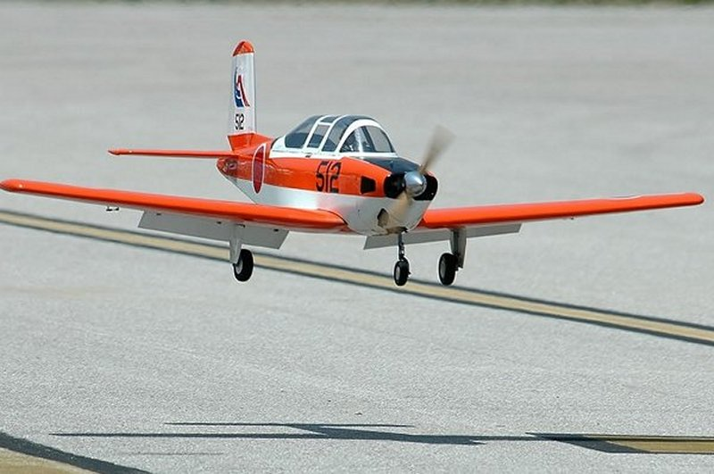

Letter from the Editor
- Chief Pilot Report
- Club Calendar
- Chief Copilot Report
- Chief Treasurer Report
- Chief Scribe Report
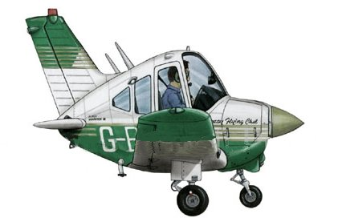
- Aerodynamics- Stalls and Spins

Beechcraft T-34 Mentor

Letter from the Editor- Stephen Warmath
With the weather starting to flip-flop between warm and cold with a few frog choker rainfalls in between, surely Spring is about to be upon us. I look forward to Club meetings at the Field with a little flight time before hand and a hot dog or slice of pizza to go with it. March will be the last meeting at the church until October. Remember, Field meetings start at 7:00.
There have been a few event additions to the master calendar this month, so check it out. Also included this month is a flyer for the Float Fly. Spread the word. Even if you don’t float-fly, come out and have a look. You’ll get hooked and it’s a lot of fun. This month we revisit a critical ground school subject-Aerodynamics. Stalls and spins are explained and behavior of air moving over a wing is graphically demonstrated. Did you know that stall speed increases when in an angle of bank? Approach turn stalls are bad Juju and can ruin your day. Just a quick follow-up on the Perry Show. For the second straight year in a row, it didn’t rain and the weather was perfect. There was a pretty good SRCC showing with about 7 members there. Some of the tables were a little thin this year, maybe due to economic conditions. There was certainly no lack of the amount of “challenged” aircraft for sale. One of the real ”lookers” in my opinion was Sig’s new Waco ARF. One was on display and it looked awesome. Got to have one. Frank, Joe and Sherman were there for HobbyTown and they had lots of stuff with them.
Happy Building and Flying- Steve

Chief Pilot- Shannon Black
I can't believe that it is already March. The building season (what little we have) for our hobby is almost past, leaving us with longer days and better flying weather. In preparation for this, we have continued to make upgrades at our field, including several new tables and benches. Please help me in thanking David Mills for all of the hard work that he has put in at the field making these improvements. The second charging station is now active and receiving much use. These have turned out to be a wonderful addition to our site.

I think that all who attended will agree that the Open House was a big success. Attendance at the Capital City Challenge was a bit below that of the past few years, but several new families joined us at the field on Sunday. Trainers flew for most of the day and everyone was rewarded with some great flying demonstrations from fellow club members. We have had several new members join within the past few weeks, so let’s all go out of our way to make them feel welcome. I look back on when I joined the club and recognize that the words of encouragement and assistance from club members are what gave me the incentive to return. Even after embarrassing myself with a heli crash on my first day, I felt welcomed and was encouraged to return. Let’s continue to offer this support to all members and interested parties.

At the February club meeting, we spent quite a bit of time discussing the upcoming Fun Fly Competition Series. Several members had good suggestions on how the events should be scored and the decision was made to take input from those involved, and then decide on a scoring method at the March meeting. I have not received any submissions or scoring suggestions. Remember guys, this is all of our event. If you have an idea, please send it to me. Also, I again want to encourage everyone to come to the next meeting on March 6th. We've had great participation during the past few meetings, and I'd like to continue this tradition. I'll see ya there.

Shannon

Club Calendar
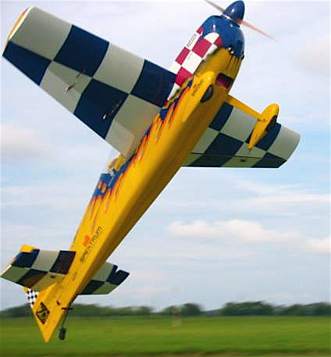

March
- 1- Perry Show 8:00 am – 5:00 pm
- 7- Club Meeting at Grace Lutheran Church 7:30 pm
- 22- Regional Float-Fly Lake Surovec

April
- 3- Club Meeting at the Field 7:00 pm
- 5- Fun Fly Series Begins- #1 See web site “Events” section for details.
- 22 Medart School Demo 12:00– 2:00 pm
- 26- SouthWoodstock 1:00 – 5:00 pm
- 29 Shadeville School Demo- 12:00– 2:00 pm

May
- 1- Club Meeting at the Field 7:00 pm
- 3- Fun Fly Series- #2
- 6- Crawfordville Demo- 12:30- 2:15 pm
- 17/ 18- Airfest 2008
- 24- Flying for a Cure Event

June
- 5- Club Meeting at the Field 7:00 pm
- 7- Fun Fly Series- #3
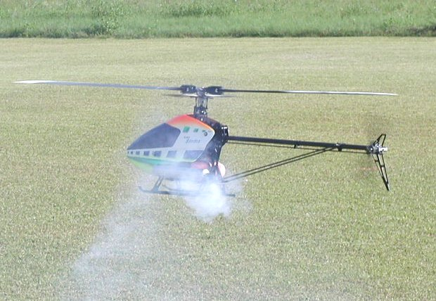

July
- 3- Club Meeting at the Field 7:00 pm
- 5- Fun Fly Series- #4

August
- 7- Club Meeting at the Field 7:00 pm
- 9- Fun Fly Series- #5

September
- 4- Club Meeting at the Field 7:00 pm
- 6- Fun Fly Series- #6

October
- 2- Club Meeting at Grace Lutheran Church. 7:30 pm.
- 4- Fun Fly Series- #7

November
- 6- Club Meeting at Grace Lutheran Church. 7:30 pm.
- 8- Fun Fly Series- #8

December
- 4- Club Meeting at Grace Lutheran Church. 7:30 pm.

Chief Copilot- Chris Bailey

Upcoming AMA Regional Events

Florida Extreme 3D Fly In
FL
2/29/08-3/02/08 - Jacksonville, FL (C) Florida Extreme 3D Fly In. Site: Lannie Road Flying Field. Peter Jackson CD, PH:954-205-5077 email: ppajacks@aol.com. Camping ok, no hookups, concession stand, restroom facilities, Saturday evening BBQ with $25 landing fee, electric night flying. For further info contact Jeff Carte email: jccarte@bellsouth.net. Pilot raffle prizes. Visit www.gatewayrc.org. Sponsor: GATEWAY RC CLUB

11th Annual Tlush/Kania Commeroative Contest
FL
3/04/08-3/05/08 - Cape Coral, FL (C) 11th Annual Tlush/Kania Commeorative Contest. Site: Club Field. Lloyd Underwood CD, 5917 Littlestone Ct #108 N Fort Myers FL 33903 PH:239-656-4009. C-LER Ign, O&R 60 SP-45 sec, O&R 23 SP 35 sec, ½ Tex Sm Tank, Electric LMR, Electric Wakefield - Wed: Brown Jr 90 sec, Texaxo Combined, Antique combined, Foxacoy 35 sec, AB ign LER combined. Sponsor: CAPE CORAL R SEA HAWKS

Florida Jets
FL
3/06/08-3/09/08 - Lakeland, FL (C) Florida Jets. Site: Lakeland Airport. Frank Tiano CD, PH:863-370-1288 email: frank@franktiano.com. Visit www.franktiano.com. Three hundred jets, demos, manufacturers area, 6 flight lines, awards, one of the most awesome flying sites on the planet. Sponsor: IMPERIAL RC CLUB

3rd Annual Tampa Bay Heli Classic
FL
3/07/08-3/09/08 - Zephyrhills, FL (AA) 3rd Annual Tampa Bay Heli Classic for 431, 432, 433, 434(O). Site: Club Field. Erich Freymann CD, 2109 Harcourt Place Odessa FL 33556 PH:813-926-8552 email: ejfreymann@verizon.net. Sponsor: CAN AM FLYERS

9th Annual Hal DeBolt Memorial
FL
EVENT LOCATION MOVED!!
3/07/08-3/09/08 -Dunnellon, FL (C) 9th Annual Hal DeBolt Memorial. Site: Rainbow Field. Donald Adkins CD, 5440 N Peppermint Dr Beverly Hills, FL 34465 PH:352-527-2047 email: dshobby@mindspring.com. Visit www.tricountyrcclub.homestead.com. East of Dunnellon on Co Rd 484 to Bridges Rd then follow the signs. Sponsor: TRI COUNTY RC CLUB
17th Annual Dick Cole Memorial Fly In
FL
3/07/08-3/09/08 - Palmetto, FL (C-Restricted to IMAA) 17th Annual Dick Cole Memorial Fly In. Site: Club Field. James Holloman CD, 3312 50th Ave East Bradenton FL 34203 PH:941-727-5670 email: jhollo6540@aol.com. Visit www.manateerc.com. 500' x 75' grass runway. RV parking - limited hookups, restrooms, food and beverages on site. Directions: I75 to exit 224, take US 301 North to Erie Road, turn left on Erie Road, follow Erie to 69th St, turn left onto 69th St. Follow signs approx 1 mile to entrance on your right. Sponsor: MANATEE COUNTY RADIO CONTROLLERS

FSS#2
FL
3/08/08-3/09/08 - Oviedo, FL (A) FSS#2 for 444(JSO). Site: Red Ember Road Club Field. Tom Galloway CD, PH:407-628-5040 email: soarhead2@embarqmail.com. Sponsor: ORLANDO BUZZARDS
Kingdom of the Sun Pattern
FL
DATE CHANGE
3/08/08-3/09/08 - Ocala, FL (AA) Kingdom of the Sun Pattern for 401, 402, 403, 404, 406(JSO). Site: Club Field. Ernest Meredith CD, PH:352-465-1739 email: e1meredith@aol.com. Visit www.ocalaflyingmodelclub.com. RV's and camping allowed, no hook ups. Sponsor: OCALA FLYING MODEL CLUB

SAM RC Contest
FL
3/12/08-3/13/08 - Palmetto, FL (C-Restricted to Society of Antique Modelers) SAM RC Contest. Site: 7100 69th St E. Paul Schmitz CD, 4918 14th St W K-2 Bradenton FL 34207 PH:941-224-5669. Wed: C-Ign, O&R SP, O&R 23SP, ½ A Texaco, Fox-a-coy, Nostalgia. Thur: Brown Jr, Texaco Comb, Antique, B/C Glo Ler, A/B Ign Ler. Sponsor: MCRC

Ocala Electric Fly In
FL
3/14/08-3/16/08 - Ocala, FL (C) Ocala Electric Fly In. Site: Club Field. Gary Doeren CD, 7284 SW 111th Lane Ocala FL 34476 PH:920-737-4852 email: grdoeren@aol.com. Visit www.ocalaflyingmodelclub.com. Food and drink on site, rustic camping, no hookups, great flying site, 50' x 600' paved runway, 12 acres of mowed grass. For additional info: Kyle Homberger PH:352-873-1980 email: rcdude51@aol.com. Sponsor: OCALA FLYING MODEL CLUB

Venice IMAC
FL
3/15/08-3/16/08 - Venice, FL (AA) Venice IMAC for 411, 412, 413, 414, 415(JSO). Site: Club Field. Paul Cormier CD, 688 Lakescene Drive Venice FL 34293 PH:941-497-0219 email: edge54033@yahoo.com. Visit www.venicerc.pages.web.com/id52.html. Breakfast/lunch. Rustic camping. Exit US 75 at Exit 195 (Laurel Rd) East 1 block to Knight Trail Rd. Turn left; follow RC flying signs. Obey speed limits strongly enforced. Sponsor: RC FLIERS OF VENICE

Gathering of Giants Fly In
FL
3/15/08-3/16/08 - Cape Coral, FL (C) Gathering of Giants Fly In. Site: Sea Hawk Park. John Niezelski CD, 4334 NW 34th Terr Cape Coral FL 33993 PH:239-282-0635 email: jniezelski4334@embarqmail.com. 14th Annual Gathering of Giants Fly In. LF $10 RV park free, no service, early arrivals Thursday please, paved runway 60' x 600', giant scale rules will apply, mono 80' biplane 60', free pilot raffle on Sunday. Visit www.rseahawks.org. Sponsor: CAPE CORAL RSEAHAWKS

Osceola Flyers Fun Fly
FL
3/15/08 - Kissimmee, FL (C-Restricted to Osceola Flyers Club members) Osceola Flyers Fun Fly. Site: Club Field. Howard Hosenbold CD, PH:407-856-2544 email: howardh@cybrstar.com. Visit www.osceolaflyers.com. Sponsor: OSCEOLA FLYERS

TTOMA Mar Indoor Contest
GA
3/15/08 - Kennesaw, GA (A) TTOMA Mar Indoor Contest for 202, 203, 206, 207, 208, 217, 220(JSO), 212, 218, 219(J)(SO). Site: N Cobb HS. William Gowen CD, 2105 Heritage Heights Decatur GA 30033 PH:404-634-6751 email: b.gowen@earthlink.net. Visit www.thermalthumbers.com. Sponsor: TTOMA

SAM
FL
3/18/08-3/19/08 - Nokomis, FL (C) SAM. Site: Landfill. Ed Gandorf CD, 373 Roseling Circle Venice FL 34293 PH:941-493-1614. Sponsor: RC FLIERS OF VENICE

Warbirds Over the Panhandle
FL
3/21/08-3/22/08 - Marianna, FL (C) Warbirds Over the Panhandle. Site: Marianna Model Airpark. Dale Cavin CD, 5098 Old Hickory Cir Marianna FL 32446 PH:850-482-7090 email: dcavin@earthlink.net. Visit www.chipolarcaviators.com. Giant Scale Warbirds Assoc event open to all Giant Scale Warbirds. No turbines. Friday night dinner. Drawings and raffles. 600 x 90 grass field. RV parking on site. No hookups. Sponsor: CHIPOLA RC AVIATORS

17th Annual Big Bird Fly In
FL
3/28/08-3/30/08 - Port St Lucie, FL (C-Restricted to IMAA) 17th Annual Big Bird Fly In. Site: Midway Field. Ken Bridges CD, 9639 Fairwood Court Port St Lucie FL 34986 PH:772-201-5509 email: docbridges2@aol.com. Visit www.sundancersrc.org. Sponsor: SUNDANCERS

Senior Pattern Contest
AL
3/29/08-3/30/08 - Alabaster, AL (C-Restricted to SPA) Senior Pattern Contest. Site: Club Field. Michael Wingo CD, PH:205-978-4938 email: mpwingo@bellsouth.net. Visit www.alabasterrc.com. I65 S of Birmingham, take exit 238, Hwy 31 go south 4.2 miles and flying field is on the right. GPS coordinates N33 11.109 W86 45.799. Sponsor: ALABASTER RC ASSOCIATION
Southern 500
FL
3/29/08-3/30/08 - Mulberry, FL (AA) Southern 500 for 422, 424, 428(JSO). Site: Newell Terry Field. Scott Smith CD, PH:863-670-5141 email: ssmith@hansonwalter.com. Field is located 2 miles east of mulberry on SR 60. Visit www.imperialrcclub.com for additional info. 424 must run APC 9 x 6 Prop with ground RMP limit of 16,5000 max. (SEMPRA region rules). Sponsor: IMPERIAL RC CLUB

Warbirds Over Tampa
FL
3/29/08-3/30/08 - Tampa, FL (C) Warbirds Over Tampa. Site: Club Field. Steven Noriega CD, PO Box 4536 Tampa FL 33677 PH:813-300-2662 email: ageironnevets@aol.com. Visit www.trac_tampa.homestead.com. Food concessions, overnight RV parking ok, no hookups, Warbirds of all sizes, no turbines, $10 landing fee for one or both days. Sponsor: TRAC

OTOW Big Bird Fly In
FL
3/29/08 - Ocala, FL (C-Restricted to IMAA) OTOW Big Bird Fly In. Site: Club Field. Charles Smith CD, 9746 SW 97 Ln Ocala FL 34481 PH:352-208-0923 csmith267@cfl.rr.com. No jets allowed - 125 x 600 ft runway grass. Sponsor: OTOW RC FLYERS

Chief Treasurer- Sam Varn
Editor’s Note: The Treasurer’s report is published for Members only. The public version of the Newsletter does not include account balances.

Here's our current account balances.
Cash: $00.00 Checking (Premier): $0.00 Checking (Capital City): $0.00
CD: $0.00 Savings: $0.00
Total Funds: $0.00

Chief Scribe- Steve Warmath
Visitor/ New member Introductions- David Mills (Helis), Hector Dueno, Bret Johnson (Airplanes& Helis), Joe Cortese, Joe Badgley, Dave Lusk.

A request for a motion to accept the Secretary’s January meeting minutes was made, seconded and passed.

Treasurer’s Report- Sam said there was a correction to the previous report. He said our interest on the CD was $500.00 vs. $1,000.00. Some AMA dues from members had not been paid. The No-Fly list has been updated. Sam read off the current account balances. He noted that the checking account was getting “a little thin”. Upcoming events will help replenish the account. We can transfer some money out of savings if we need to. We have had a few new members and have earned $2.93 interest on the checking account.

A request for a motion to accept the Secretary’s January meeting minutes was made, seconded and passed.

Old Business-
- Fun Fly- The planes have come in and were sold out very fast. Ten more were coming. Frank will order more if needed. Shannon asked if there was any discussion regarding modifications, questions, etc. The following were discussed and mentioned:
- Use only “out of the box” planes?
- The firewall could use reinforcing and linkages were average quality.
- The wing center section connection is weak and could use fiberglass reinforcing.
- Will repairs be allowed after a crash?
- Engine choices may be up to .46 (2S) and .72 (FS) with stock mufflers. No engine changes once set up.
- Prop selection- pilots choice.
- No dual aileron servo set-ups.
- Canopies to be installed per instructions.

Shannon gave a general explanation of the event for new members present. The events will be on Saturdays following the regular monthly meeting. They will be simple events picked randomly out of a hat. There will be 8-10 events. Members are asked to give suggestions. Awards4U will have awards at the end of the series. A pilot must complete a minimum number of events to be eligible for an award. A point system was discussed but not finalized. For the next Club meeting, a point system will be developed; rules and events will also be identified, discussed and adopted.
- Shannon announced a few upcoming events. The Motorcycle Rodeo on the 23rd and the Club’s Open House on the 24th. Brad Sharpe noted the Float-Fly scheduled for March 22nd was Easter weekend and wanted to remind everyone. The event was still on. There will be a need for a Porta-John. Joe Satterwhite said he would look into procuring one. We will need to renew our insurance for the site.
- Chris Bailey said that he had put together a promotional video and would play it at the end of the meeting and get input from members. We will have CD’s and Club display at HobbyTown. There would also be membership applications, information, flyers, etc. Chris suggested the web site be updated with some current pictures.

New Business-
- There are new tables at the field that have been donated by David Mills. They were built on site and are very nice. Thanks David. There is enough lumber left to build two more tables. Maybe one high, and one low height.
- Chris said he hopes to run power to the new tables.
- Shannon asked what other things needed to be done at the field. Joe Satterwhite said the field needed fertilizing. Marvin asked if the field could be leveled out. No action was decided upon. Joe thought the bleachers needed to be painted, possibly by the “Flying for a Cure” Event. A work party will be put together and some of these issues taken care of.

Announcements- None

With no additional business, the meeting was adjourned at 8:15 pm.
Aerodynamics

- Stalls and Spins
One of the first questions a pilot might ask, when converting to a new aircraft type, is "What's the stall speed?" The reason for the enquiry is that usually, but not always, the approach speed
chosen for landing is 1.3 times the stall speed. Stall is an undesirable phenomenon in which the aircraft wings produce an increased air resistance and decreased lift, which may cause an aircraft
to crash.
The stall of the wing occurs when the airflow no longer can go around the airfoil's nose (leading edge) and separates from the upper wing surface. It happens when a plane is under too great an Angle of Attack (AoA). For light aircraft, without high-lift devices, the critical angle is usually around 16°. The picture below shows a stalled airfoil:
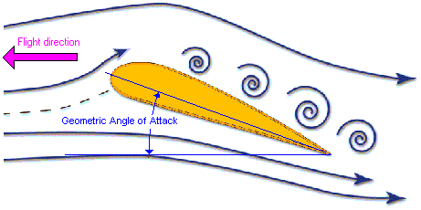
Geometric Angle of Attack is the angle between the airfoil chord line and the direction of flight.
The angle of attack measured relative to zero coefficient of lift is called the Absolute Angle of Attack (Absolute AoA). There's also the Pitch Angle, which measured with respect to the horizon.
For symmetric airfoils the Absolute AoA is equal to the Geometric AoA, whereas for cambered airfoils these two angles are different as shown below.
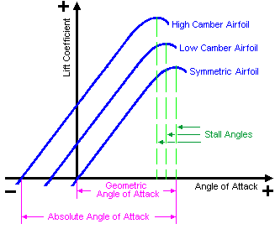
For airfoils of one family the symmetric airfoil stalls at a higher Geometric AoA compared with the cambered airfoil, however the cambered airfoil has higher lift coefficient and stalls at a higher Absolute AoA.
As mentioned in the chapter Forces in Flight, the lift force is proportional to the density of the air r, the square of the airspeed V, the type of airfoil and to the wing’s area according to the formula:
Lift force = 0.5 * r * V² * wing's lift coefficient * wing area. Since lift coefficient is proportional to the angle of attack, the lower airspeed is the higher the angle of attack has to be in order to produce the same lift. Thus, stall may occur during take-off or landing, just when the speed is low.
At low speed the aerodynamic forces are smaller and, if a non-experienced pilot tries to lift the aircraft at a too low speed, it may exceed the critical angle of attack and stall occurs. If you're flying near the stall speed and make a steep turn, the aircraft will stall. That's because, if the aircraft stalls for instance at 20 knots in straight level flight, it will stall at 28.2 knots in a 60 degree banked turn.
The rapid reduction in speed after passing the critical angle of attack means the wing is now unable to provide sufficient lift to totally balance weight and, in a normal stall, the aircraft starts to sink, but if one wing stalls before the other, that wing will drop, the plane falls out of the air. The ground waits below.
Stalls may also occur at high airspeeds. If at max airspeed and full throttle the pilot suddenly applies excessive up elevator, the aircraft will rotate upwards, however, due to aircraft's inertia, it may continue flying in the same direction but with the wings at an angle of attack that may exceed the stall angle.
Stalling at high-speed gives a more dramatic effect than at low speed. This because the strong propeller wash causes one of the wings to stall first that combined with the high speed produces a snap roll followed by a spiral dive. This happens very fast causing the aircraft to dive at full throttle and unless there's enough height for recovery, the crash will be inevitable.
An aircraft with relatively low wing loading has a lower stall speed. (wing loading is the aircraft's weight divided by the wing area) Since the airfoil also affects the stall speed and the max angle of attack, many aircraft are equipped with flaps (on the wing trailing edge), and some designs
use slats (on the wing leading edge). Flaps increase the wing's lift coefficient, but the simple ones may reduce the stall angle. Slats, on the other hand, increase the stall angle. Aircraft that are designed for Short Take-Off and Landing (STOL) use slots on the wing's leading edge together with flaps on the trailing edge, which gives high lift coefficient and remarkable slow flying capabilities by allowing greater angle of attack without stalling.
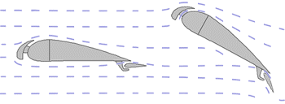
- Cruise Climb
The leading edge slots may prevent the stall up to approximately 30 degrees angle of attack by picking up a lot of air from below, accelerating the air in the funnel shaped slot (venturi effect) and forcing the air around the leading edge onto the upper wing surface. The disadvantage of the slots and flaps is that they produce higher drag. Since the high lift is only needed when flying slowly (take-off, initial climb, and final approach and landing) some designers use retractable devices, which closes at higher speeds to reduce drag.
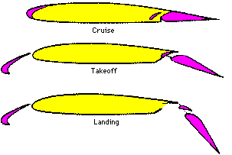
Such devices are seldom used in model aircraft (especially the smaller ones), mainly due to its complexity and also the increasing of wing loading, which may counter-act the increased lift obtained. The wing's aspect ratio (AR) also affects the overall lift coefficient of the wing. For give Re, the wing with higher AR (with long wingspan and small chord) reaches higher lift coefficient, but stalls at a lower angle of attack than the wing
with low AR as shown below:
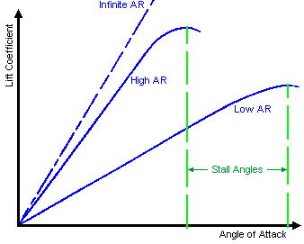
However, for a given wing area, increasing the aspect ratio may result in a too small wing chord with a too low Re number, which may significantly reduce the lift coefficient. This is likely to occur with small indoor planes.
Another method to improve an aircraft's stall characteristics is by using wing washout, which refers to wings designed so that the outboard sections have a lower angle of attack than the inboard sections in all flight conditions.
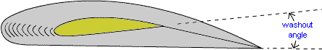
The outboard sections (toward the wing tips) will reach the stalling angle after the inboard sections, thus allowing effective aileron control as the stall progresses. This is usually achieved by building a twist into the wing structure or by using a different airfoil in the outboard section.
A similar effect is achieved by the use of flaps.
The aileron drag is a further factor that may cause an aircraft to stall.
When the pilot applies aileron to roll upright during low speed, the downward
movement of the aileron on the lower wing might take an angle on that part of the wing past the critical stall angle. Thus that section of wing, rather than
increasing lift and making the wing rise, will stall, lose lift and the aircraft
instead of straightening up, will roll into a steeper bank and descend quickly.
Also the wing with the down aileron often produces a larger drag, which may
create a yaw motion in the opposite direction of the roll.
This yaw motion partially counteracts the desired roll motion and is called
the adverse yaw.
Following configurations are often used to reduce aileron drag:
- Differential ailerons where the down-going aileron moves through a smaller
angle than the up-going. - Frise ailerons, where the leading edge of the up-going aileron protrudes below the wings under surface, increasing the drag on the down-going wing.
- And the wing washout.
Stall due to aileron drag is more likely to occur with flat bottom wings. Since differential ailerons will have the opposite effect when flying inverted, some aircraft with symmetrical airfoils designed for aerobatics don't use this system. The picture below illustrates an example of a Frise aileron combined with differential up/down movement.
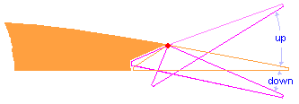
Another factor that affects the aircraft's stall characteristics is the location of its centre of gravity CG. A tail-heavy aircraft is likely to stall at higher airspeed than one with the CG
at the right location.
Recovering from a stall:
In order to recover from a stall, the pilot has to reduce the angle of attack back to a low value. Despite the aircraft is already falling toward the ground, the pilot has to push the stick forward to get the nose even further down. This reduces the angle of attack and the drag, which increases the speed.
After the aircraft gained speed and the airflow incidence on the wing becomes favorable, the pilot may pull back on his stick to increase the angle of attack again (within allowable range) restoring the lift. Since recovering from a stall involves some loss of height, the stall is most
dangerous at low altitudes.
Engine power can help reduce the loss of height, by increasing the velocity more quickly and also by helping to reattach the flow over the wing. How difficult it is to recover from a stall depends on the plane. Some full-size aircraft that are difficult to recover have stick shakers: the shaking stick alerts the pilot that a stall is imminent.
Spin
A worse version of a stall is called spin, in which the plane spirals down. A stall can develop into a spin through the exertion of a sidewise moment. Depending on the plane, (and where its CG is located) it may be more difficult or impossible to recover from a spin. Recovery requires good efficiency from the tail surfaces of the plane; typically recovery involves the use of the rudder to stop the spinning motion, in addition to the elevator to break the stall. However the wings might block the airflow to the tail. If the centre of gravity of the plane is too far back, it tends to make recovery much more difficult.
Another circumstance that may cause loss of control is when a hinged control surface starts to flutter.
Such flutter is harmless if it just vibrates slightly at certain airspeed (possibly giving a kind of buzzing sound), but ceases as soon as the airspeed drops. In some cases however, the flutter increases rapidly so that the model is no longer controllable. The pilot may not be aware of the cause and suspect radio interference instead. To reduce the flutter, the control linkages should not be loosely fitted and the push rods should be stiff. Long unbraced push rods can create flutter as vibration whips them around. In some difficult cases the control surface has to be balanced, so that its centre of mass (gravity) is ahead of the hinge line. It should be located at about 60-65% of the length of the control surface from its inner end:

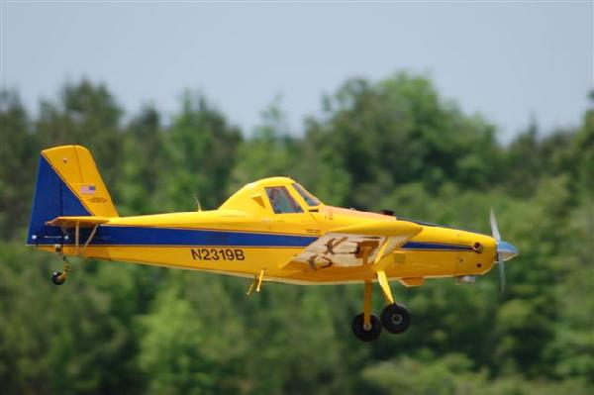

Seminole RC & HobbyTown
Regional Float- Fly




Contest Director: Frank Bastos 850-671-2030
AMA insurance required to fly
Concessions and Restroom. No Hook-ups
No landing fees
Pilot Briefing 9:30 am

March 22, 2008
9:00 am – 6:00 pm

Near Calvary, Georgia

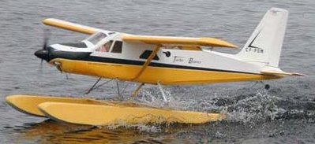

See attached directions to the lake

From Tallahassee- Drive North on Meridian Rd and cross the FL/GA state line. After passing the state line drive 2.8 miles to first road on left (Hadley Ferry Rd). Turn LEFT onto Hadley Ferry Rd. Drive over the Ochlocknee. River, 3.1 miles to first road on the left (Gainey Rd).
Turn LEFT onto Gainey Rd. Drive 1.5 miles to first road on the left (Lower Hawthorn Rd.) Turn LEFT onto Lower Hawthorn Rd. Drive .4 miles to first DIRT road on the left (Dickey Ferry Rd.) Drive .5 miles on Dickey Ferry Rd. to 311 Dickey Ferry Road.... entrance gate is on the LEFT. – Follow driveway to the lake and turn to the right to the cabin for parking.
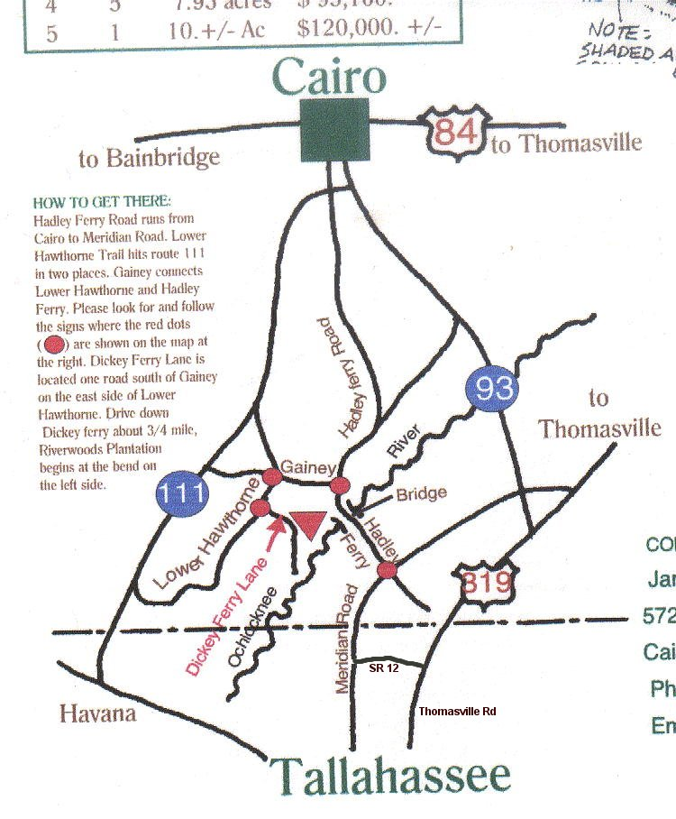

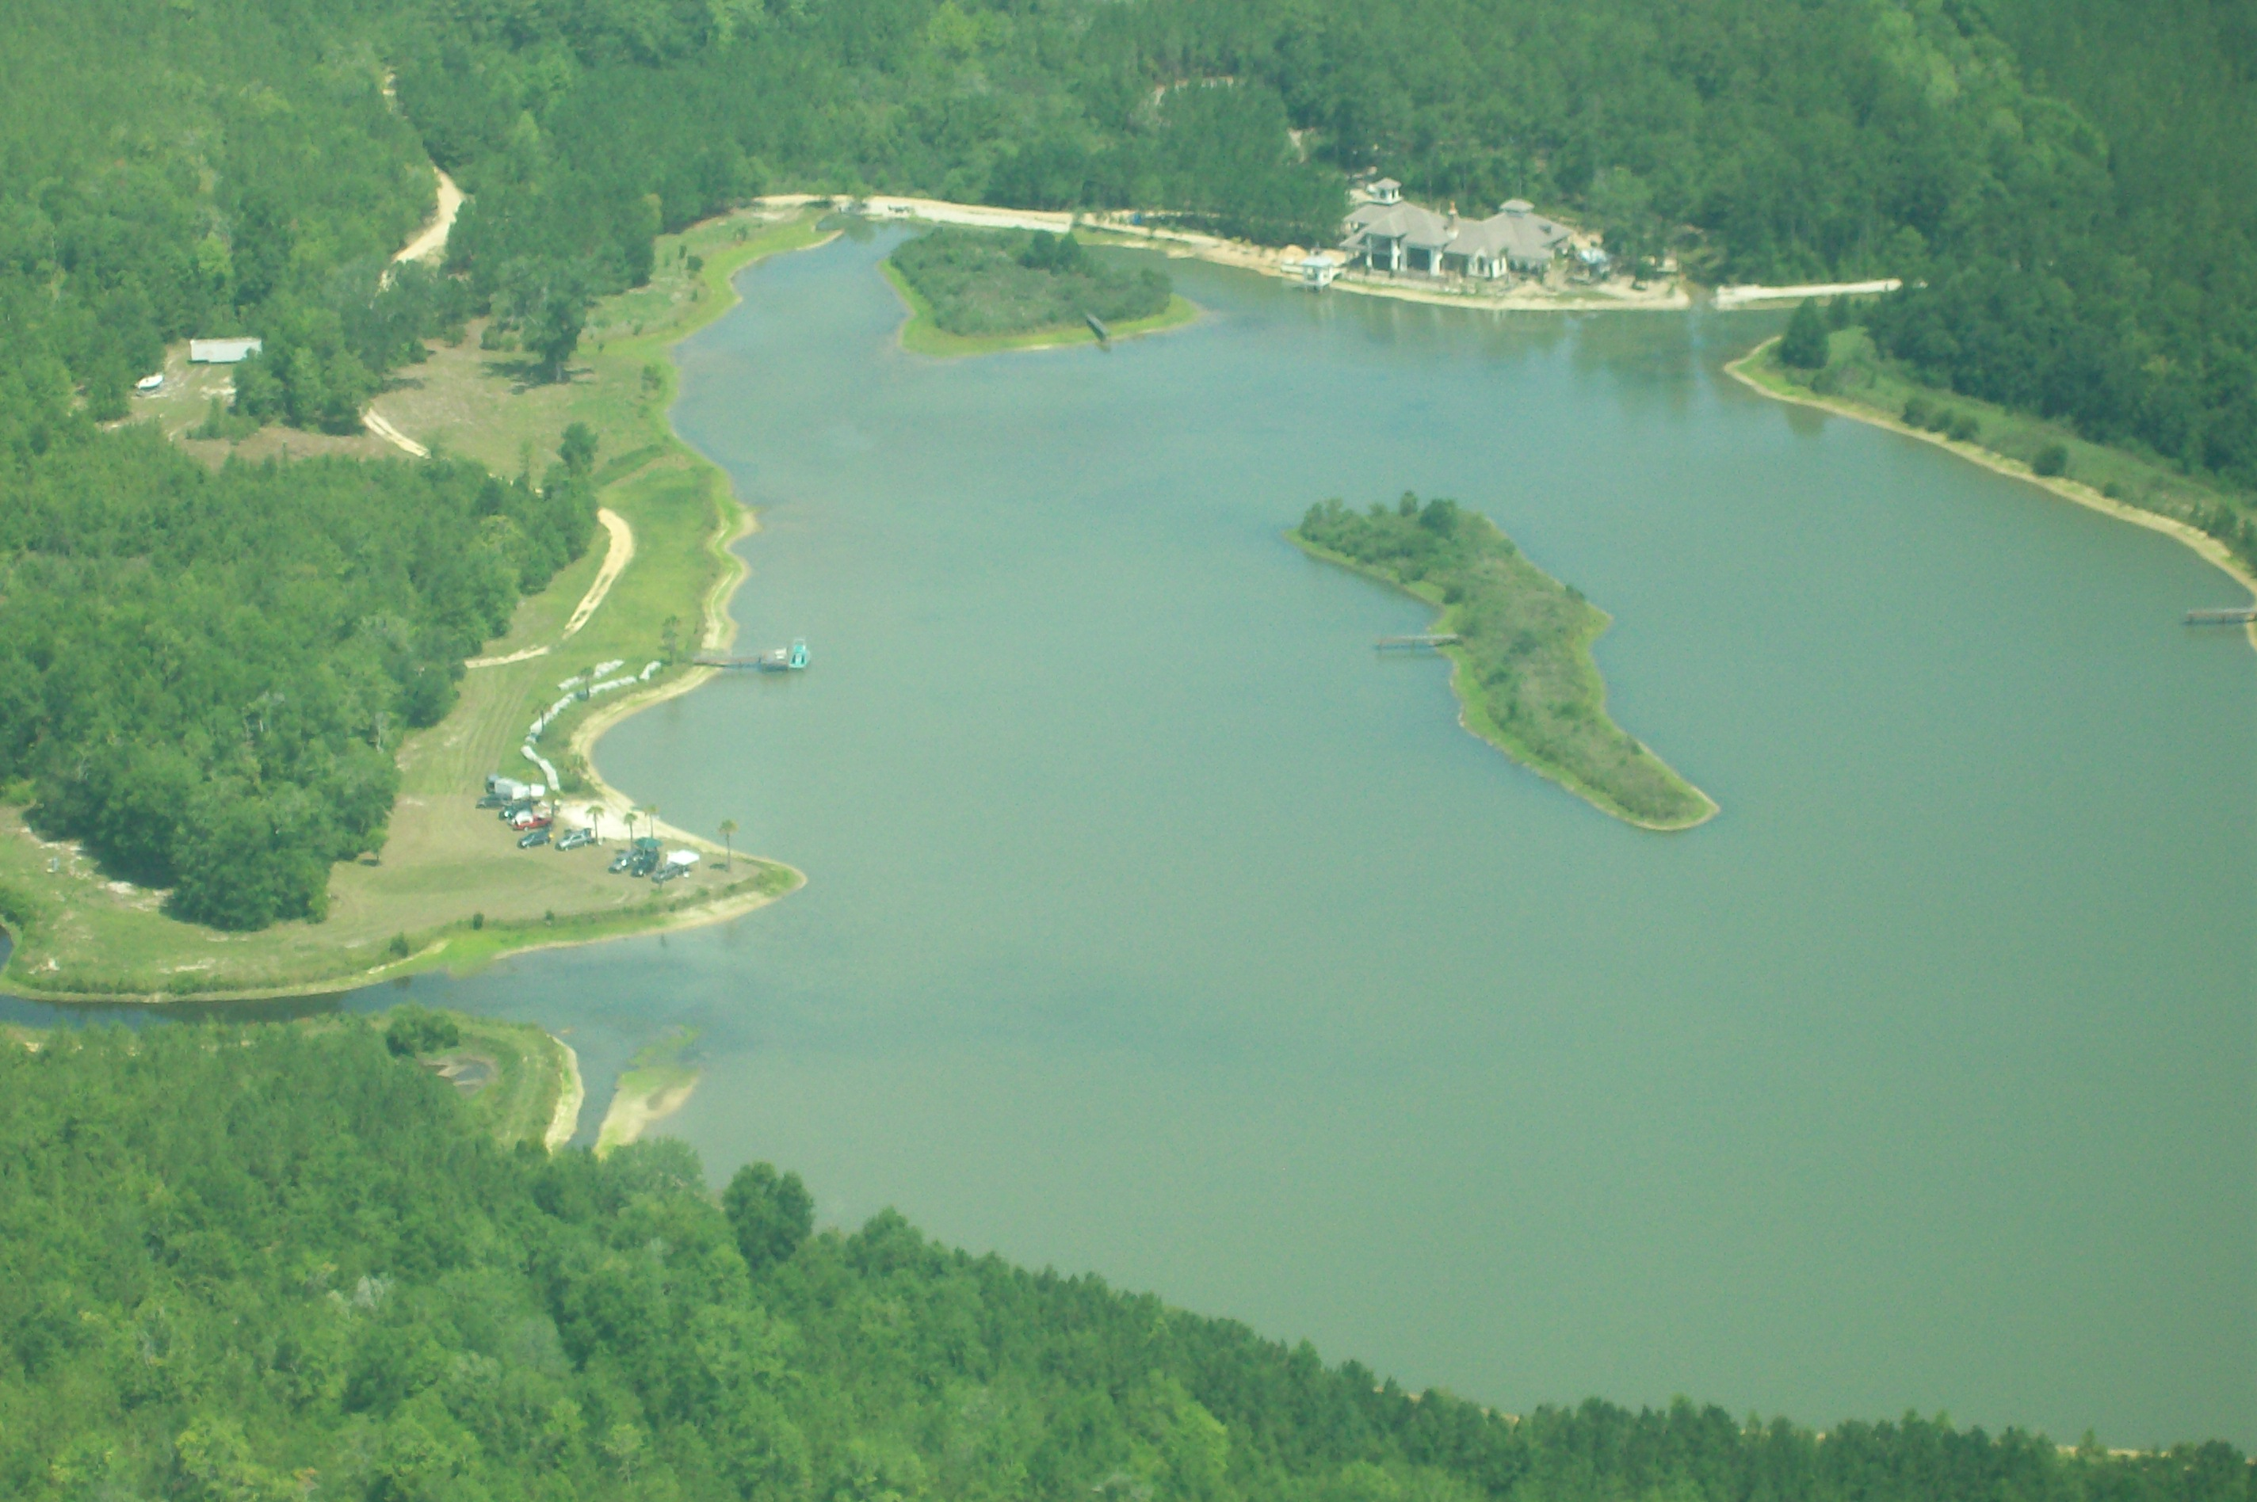

Seminole Radio Control Club
Tallahassee, FL

AMA Charter #216, 1969-2008

SRCC Officers

President – Shannon Black
Vice President – Chris Bailey
Secretary/ Newsletter Editor – Stephen Warmath
Treasurer - Sam Varn
Field Marshall – Joe Satterwhite
Field Safety Officer- Gordie Meade

Field Hours

12 Noon till Dark- These hours apply to all aircraft, gas and electric.

Training Notes

To schedule a training time contact Mike Atkinson.

Flight Instructors
Mike Atkinson- Primary/ Advanced Fight Instructor (Coordinator) 926-4692
Geoff Lawrence- Primary/ Advanced Fight Instructor 942-9807
Chris Bailey- Primary/ Advanced Flight Instructor 322-4047
John Hall- Primary/ Advanced Helicopter Flight Instructor 893-6457
Jay Leudecke- Primary/ Advanced Helicopter Flight Instructor 508-7135
Jeff Owens- Ground School/ Airworthiness Instructor (Fixed Wing) 894-2504
Frank Bastos- Hobby Town Flight Demonstrator 671-2030

Club Meeting Location and Time
October- March: The regular club meetings are held on the first Thursday of each month at 7:30 PM at the Grace Lutheran Church on Miccosukee Rd. Head out Miccosukee Rd., cross Capital Circle NE, and the entrance will be the first one on your right. Once you park, follow the sidewalk around the left side of the building and go down the hill. We meet in a room on the first level.
April- September: The regular club meetings are held on the first Thursday of each month at 7:00 PM at the Flying Field. The Club provides food and drinks.
Newsletter Submissions- Submissions are requested to be in M.S. Word format or via e-mail text. Photos should be in .jpg or .tif format. Vector art accepted in Corel, Illustrator and AUTOCAD format. We will, however, accept anything to make it easier for those who wish to contribute. Submissions are due no later than the 23rd of the month. Send your submissions to ssw@nettally.com or by phone, Steve Warmath at 509-0672.
Hard Copy Printing of the SRCC Newsletter provided by Apogee Signs & Graphics. 850-224-7446



