The Seminole Flyer www.seminolerc.com


A chartered member of the Academy of Model Aeronautics

AMA Charter #216, 1969-2007

“The Seminole Flyer” is a publication of the Seminole Radio Control Club of Tallahassee, Florida APRIL 2007

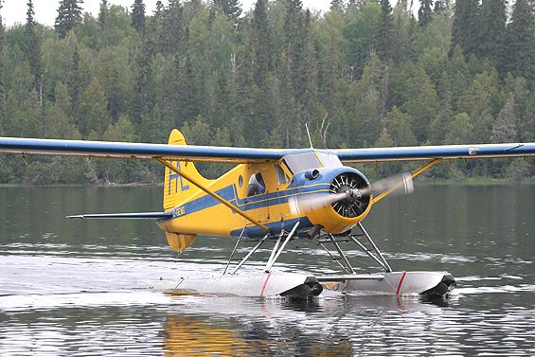
INDEX

Letter from the Editor
- Float Fly Photo Gallery
- Chief Pilot Report
- Chief Copilot Report
- Chief Treasurer Report
- Chief Scribe Report
- Pilot Briefing- Father & Son
- A Guide to Float Flying
- War Stories
- When Your Plane Tries to Tell to You
- Classifieds/ For Sale
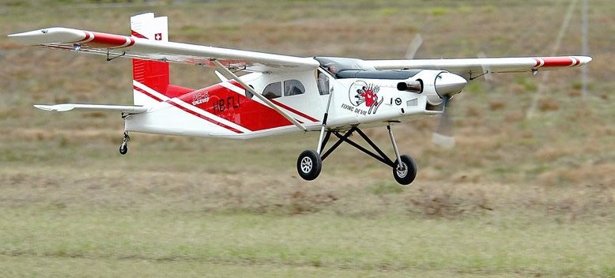
DHC-2 Dehavilland Beaver
Letter from the Editor- Stephen Warmath
Ah….. Ah- Choooo! Spring in Tallahassee is a lovely time of year. The trees are budding, the flowers are blooming and everything is yellow. I think it’s finally fading with all the pods now hitting the ground. So, what better way to spend a beautiful spring day than being at the pond flying floatplanes? The Float Fly Photo Gallery shows off some of these special birds and members having some fun March 31st. For those who are curious, this month, we have a primer on A Guide to Float Flying with general set up and flying principles. Be careful though, this stuff is addicting. Also included is a whimsical muse on being that “Top Gun” in War Stories. Did you ever fly an aircraft just didn’t seem in sync? Maybe it was trying to tell you something. When Your Plane Tries to Tell to You……. You might want to listen. How? Read up.

It is a special bond between father and son; especially when they both enjoy the same hobby for many years and actively participate together in the same Club. This month’s Pilot Briefing features one such pair of pilots. Father and son, Bill and Mike Atkinson share their stories. Anyone interested in participating in the “Pilot Briefing” please e-mail me or contact me and I’ll forward the format used. A picture is also requested. The idea is to put a face with a name so we can get to know each other better.
Club Meeting at the Field Thursday April 5th at 7:00 pm.
Note: Publishing of the Newsletter was delayed in order to include the Float Fly 3/31.
Happy Building and Flying- Steve

Photo Gallery- Float Fly March 31, 2007
Photos by Steve Warmath
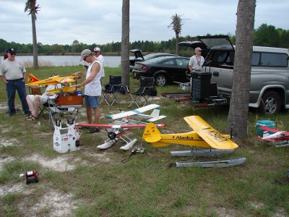
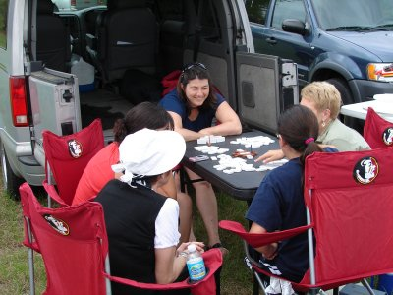

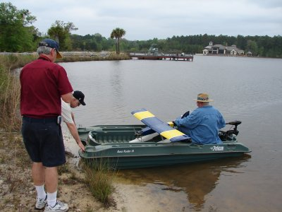
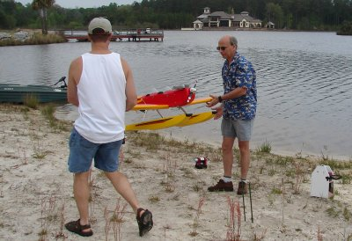

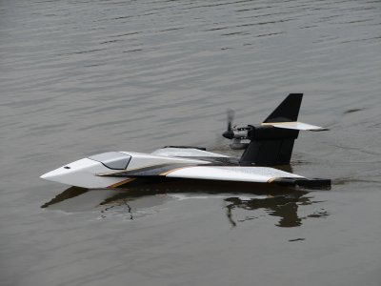
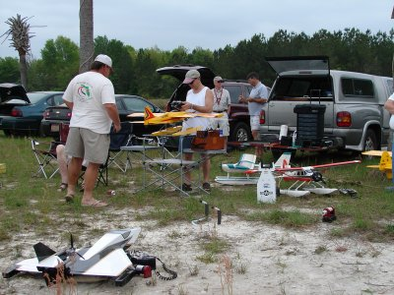

Chief Pilot- John Hall
Spring has sprung (feels more like summer) and the flight line is definitely heating up at the field. It's great to be out there flying with other club members and it seems like new faces are showing up just about every weekend. With the extended daylight hours, flying after work during the week has become a possibility again.

I'm looking forward to the next club meeting, which will be held at the flying field. Having the meetings at the field has definitely helped to increase attendance in the past and it's just more fun! I hope to see even more of the membership showing up at the field for the upcoming monthly meetings. Come out early and bring a model to fly.

See you at the field.
John

Chief Copilot- Brad Sharp
Upcoming Club Events

April 5, 2007- Club Meeting at the Field. 7:00 pm.
April 21, 2007- John Paul Southwood Flight Demo.
SouthWoodStock Festival

The members of Seminole RC Club have been invited to participate in Southwood’s first SouthWoodStock festival on April 21st. The administration at John Paul II School has agreed to allow us both the baseball and soccer/football fields for continuous flight demonstrations. Each field is surrounded by light poles. The baseball field may be better for helicopter and electric fixed wing flight, but I think the soccer field is best for glow powered fixed wing flight. We are scheduled to participate from 12:00 to 6:00. There is a charge to attend the festival, but any member and related family wishing to participate in the demonstration (either actually flying or coordinating the event) will be allowed to attend free of charge. If you are going to make it to the event, be sure and let me know and I’ll provide them with a list of names for entry. Be sure and include any family members you may be bringing.

Michael Atkinson
656-2200 – 926-4692
Nexnbax1@Comcast.net

April 24, 2007 - Shadeville Elementary Flight Demo

Upcoming AMA Regional Events
Southern 500
FL
3/30/07-4/01/07 - Mulberry, FL (A) Southern 500 for 424, 428(O). Site: Newell Terry Field. Scott Smith CD, 6308 Sherman Terrace Sebring FL 33876 PH:863-670-5141 email: ssmith@hansonwalter.com. SEMPRA rules apply. See www.imperialrcclub.com for additional information. Sponsor: IMPERIAL RC CLUB

King Orange International
FL
3/30/07-4/01/07 - Starke, FL (AA) King Orange International for 322, 323, 324, 325, 326(JSO). Site: Bradford Co Fairgrounds. William Hodges CD, 5060 US Hwy 1 N Bunnell FL 32110 PH:386-445-2238 email: clpahodges@aol.com. Will be flying all PAMPA events plus Basic Stunt, Old Time Stunt, Classic Stunt and Profile Stunt. Sponsor: X47 FLYERS

Gateway 40th Anniversary Fly In
FL
4/01/07 - Jacksonville, FL (C) Gateway 40th Anniversary Fly In. Site: Lannie Rd Airfield. Patrick Lanfri CD, 2305 Cedar Shores Circle Jacksonville FL 32210 PH:904-781-1146 email: lanpc@bellsouth.net. Celebrate Gateway RC Clubs 40th Anniversary. Pilots raffle, concessions, $5 landing fee, camping ok for Friday arrivals, no hookups. Visit www.gatewayrc.org. Sponsor: GATEWAY RC

8th Annual South Florida Jet Together Hosted by 332nd Red Tail RC Flyers
FL
3/31/07-4/1/07 - Sunrise, FL (C) 8th Annual South Florida Jet Together Hosted by 332nd Red Tail R/C Flyers. Site: Markham Park. Jack Goldfarb CD, 6611 NW 98th Ave Tamarac FL 33321 PH:954-724-8338 email: hapyjac2@aol.com. Sponsor: 332ND RED TAIL R/C FLYERS

Central Florida RC Airshow
FL
4/07/07 - Sorrento, FL (D) Central Florida RC Airshow. Site: Lake County. Rob Johnston CD, 1558 Cherry Lake Way Lake Mary FL 32746 PH:407-805-8845 email: rjohnst3@ford.com. Central Florida Sport Flyers Scale Aircraft Demonstration and Open House. Proceeds - a portion of the proceeds will be donated to Easter Seals Camp Challenge. Visit www.cfsportflyers.com. Sponsor: CENTRAL FLORIDA SPORT FLYERS

Spring Heli Fly In
FL
4/13/07-4/15/07 - Balm, FL (C) Spring Heli Fly In. Site: Club Field. Gene Sanchez CD, 411 Tomahawk Trl Brandon FL 33511 PH:813-310-6501 email: etsanchez@verizon.net. Open flying for all RC Helis. One round of FAI Aerobatics on Sunday. Come visit us at our new field. Large open area for flying, large covered pits area. Visit http://www.triplecreekrc.com. Sponsor: TRIPLE CREEK RC

Warbirds Over Bama
AL
CANCELLED
4/14/07-4/15/07 - Tuscaloosa, AL (C) Warbirds Over Bama. Site: Club Field. Frank Baity CD, 3805 Dearing Downs Dr Tuscaloosa AL 35405 PH:205-553-7131 email: fbaity88@comcast.net. 2nd Annual Warbirds over Bama. Giant scale warbird, 80" monoplane, 60" biplane only. Landing fee $20. Camping available at field. No hookups. Trophy for "Best of Show". Sponsor: WEST ALABAMA AERO MODELERS

FLA F2D Flying Frenzy
FL
4/14/07-4/15/07 - Jacksonville, FL (A) FLA F2D Flying Frenzy for 331 (JSO). Site: Herlong Airport. Dale Miller CD, 9380 Joloru Dr Jacksonville FL 32210 PH:904-371-4995 email: provector1@aol.com. Sponsor: FLYING REBELS

April Fools/Spring Opener
FL
4/14/07-4/15/07 - Palm Bay, FL (AA) April Fools/Spring Opener for CAT III 101, 102, 103, 104, 105, 101C, 102-103C, 104-105C, 107, 107, 120, 121,122, 124, 128, 140, 142, 150, 151, 152, 153, 154, 155, 160, 161 (JSO). Site: Palm Bay Field. Rex Hinson CD, 1141 S Waterview Dr Inverness FL 34450 PH:352-34-5931 email: rexh@tampabay.rr.com. Events may be flown on either day, FAI included. FAI Combined: Seven rounds. FAI Mini Events: Five rounds. All events will be conducted according to the latest edition of the appropriate rules. Sponsor: FMA

Tri County RC Big Bird Fly In
FL
4/14/07 - Dunnellon, FL (C) Tri County RC Big Bird Fly In. Site: Rainbow Field Bridges Rd. Fred Backhaus CD, 3624 N Laurelwood Loop Beverly Hills FL 34465 PH:352-746-4249 email: fremar@xtalwind.net. Sponsor: TRI COUNTY RC CLUB

Peach State Indoor Championship
GA
4/14/07 - Kennesaw, GA (AAA) Peach State Indoor Championship for 203, 206, 208, 212, 215, 217, 218, 219, 220 (JSO). Site: North Cobb High School. David Mills CD, PO Box 12306 Atlanta GA 30355 PH:404-509-4209 email: davidmillsatl@comcast.net. Sponsor: THERMAL THUMBERS OF METRO ATLANTA

NMPRA Championship Series
FL
4/20/07-4/22/07 - Sunrise, FL (A) NMPRA Championship Series for 422, 424 (JSO). Site: Markham Park. James Perdue CD, 395 NW 89 LN Coral Springs FL 33071 PH:954-683-2660 email: jamesperdue@earthlink.net. Sponsor: MPPA

Spring Fly-In
GA
Airmasters Model Airplane Club invites you to attend our annual Spring Fly-In. This event will be on April 21, 2007 from 9:00am – 4:00pm and will be held at our flying field. Our field is located north of Albany and east of Leesburg , GA on Hwy 32E. It’s just east of the Lee County Public Works Dept., at the intersection of Mossy Dell Rd. & Hwy. 32. www.geocities.com/clubamac222.

11th Annual Cullman SPA Championships
AL
4/21/07-4/22/07 - Cullman, AL (C-Restricted to Senior Pattern Association Members) 11th Annual Cullman SPA Championships. Site: Burdeshaw field. Steve Byrum CD, 1326 3rd St SE Cullman AL 35055 PH:256-737-9828 email: spbyrum@hiwaay.net. Sponsor: CULLMAN AEROMODELERS
Bushwhacked '07
FL
4/21/07-4/22/07 - West Palm Beach, FL (A) "Bushwhacked '07" for 755 (JSO). Site: Phil Wherry Field, Dyer Park. Chris Handegard CD, 2774 New York St West Palm Beach FL 33406 PH:561-832-1921 email: chandegard@peersonaudio.com. Sat. 8 rounds Open B, Sun. 8 rounds 2548 Scale Combat. Field open 8:00 a.m. Start Combat 10:00 a.m. Entry fee $20 one event $30 both. Trophies 1st to 5th place. Go to www.reccombat.com to sign up on line. Sponsor: RC BUSHPILOTS

FSS #4
FL
4/21/07-4/22/07 - Oviedo, FL (A) FSS #4 for 444 (JSO). Site: Red Ember Rd. R. Thomas Galloway CD, 2173 Mohawk Trl Maitland FL 32751 PH:407-628-5040 email: soarhead2@earthlink.net. Sponsor: ORLANDO BUZZARDS

Annual World Invitational Controlline Speed Competition
FL
4/21/07-4/22/07 - Ocklawaha, FL (AA) Annual World Invitational Controlline Speed Competition for 301, 302, 303, 305, 306, 307, 308(J)(S)(O), 304, 309(SO), 310(JSO). Site: Paradise Field. Brian Silversmith CD, 86 Kingsland Circle Monmouth Jct NJ 08852 PH:732-274-8945. This event is being hosted by the Young Marines and sponsored by Lowe's and Sam's Club. Food and drink will be provided. Sport Jet- NASS Rules, Perky Speed, All AMA Speed Safety Precautions will be adhered to especially fencing (safety netting). Sponsor: FLORIDA CIRCLE BURNERS
11th Annual Spring Classic
FL
4/21/07-4/22/07 - Land O Lakes, FL (AA) 11th Annual Spring Classic for 411, 412, 413, 414, 415(JSO). Site: Club Field. Dave Link CD, 4931 Kempton Woods Cir Wesley Chapel FL 33544 PH:813-843-3017 email: progolf99@yahoo.com. In addition to the class winners, we will crown a Grand Champion. A huge traveling trophy will be awarded to the winner to keep for the year. Must fly freestyle to qualify. Sponsor: BAY CITY FLYERS

Spring Fling
FL
4/21/07-4/22/07 - Ocala, FL (C) Spring Fling. Site: Club Field. Theodore Barker CD, 3710 SE 137th LN Summerfield FL 34491 PH:352-216-3879 email: bearnfuzz@aol.com. 80" plus. Go to model website for more info www.ocalaflyingmodelclub.com. Sponsor: OCALA FLYING MODEL CLUB

Spring Fly In
GA
4/21/07 - Leesburg, GA (C) Spring Fly In. Site: Club Field. Dan Stevens CD, 2816 Somerset Dr Albany GA 31721 PH:229-439-8949 email: dan.stevens@mchsi.com. 9 a.m. - 4 p.m. $10 landing fee. 80 x 500 grass runway + 30 acre flat grass over fly area. Raffle all day - big ticket item at 3 p.m. Mid-day demo featuring Mac Hodges/Dan Stevens with the B-29 and Bell X-1. Food and drink concessions. Visit www.geocities.com/clubamac222/. Sponsor: AIRMASTERS MAC

Fun Fly
FL
4/22/07- Wewahitchka The Emerald Coast Model Aviators would like to have a good old-fashioned fun fly complete with some competitive events and everything. We have Sunday, April 22 as the target date. You can show up at our Wewahitchka site as early as 8:00 AM to fly, but we won't have any events until later in the morning...say 10:00 AM or so. bdhaswell@hotmail.com

Southeast Electric Flight Festsival
GA
4/26/07-4/29/07 - Andersonville, GA (C) Southeast Electric Flight Festival. Site: Hodges Field. Ernie Schlumberger CD, 4993 Saxony Ct Stone Mountain GA 30083 PH: 770-879-0890 email: eschlumber@aol.com. The South's premier Electric Fun Fly open to all forms of e-powered flight. Primarily opening flying, demo flights, BBQ Saturday night, top electric flight vendors and full line Hobby Shop on site. LMR Sailplane (Class B and S.E.F.F. no excuses - new AMA battery rules) and F5B competition on the 26th from 9am - 3pm and throughout weekend. Visit www.fayetteflyers.com for details. Sponsor: FAYETTE FLYERS

Huntsville Heli Flyers Annual Fun Fly
AL
4/27/07-4/29/07 - Huntsville, AL (C) Huntsville Heli Flyers Annual Fun Fly. Site: Club Field. Troy Blackwell CD, 161 Wrightington Rd New Hope AL 35760 PH:256-723-5622 email: teeroy@nehp.net. Lots of food, fun and prizes with many of the top pilots attending. Visit www.huntsvilleheliflyers.org. Sponsor: HUNTSVILLE HELI FLYERS

Warbirds over Alabama
AL
4/27/07-4/28/07 - Opelika, AL (C) Warbirds over Alabama. Site: Club Field. Theodore Cowan CD, 85 Phillips Rd Opelika AL 36804 PH:334-480-0822 email: tc1917@hughes.net. Restricted to WWI & WWII aircraft to 1950 in military & civilian paint. Must be at least 80" monoplane/60" biplane to qualify. Further info at www.giantwarbirds.org. RV & camping; limited electrical; hanger storage; early birds welcome. Sponsor: FLYING C'S

1st Southern Alabama Warbird Fly In
AL
4/28/07-4/29/07 - Mobile, AL (C) 1st Southern Alabama Warbird Fly In. Site: ACMA -Irvington. Edward Frost CD, 6151 Brandy Run Rd Mobile AL 36608 PH:251-380-2905 email: billyfrost@gmail.com. Any type or size scale military aircraft. Choppers, jets. Any scale aircraft welcome. $5 landing fee. Visit www.alvinrc.com/warbird for more info. Sponsor: ACMA

Perryman's April Fools
GA
4/29/07 - Whitesburg, GA (A) Perryman's April Fools for Cat III 101, 102-103, 104-105, 101C, 102-103C, 104-105C, 124, 128, 140, 142, 150, 156, 160, 163, 164, 503(JSO). Site: North GA Turf Farm. Frank Hodson CD, 150 Hill Ave Fayetteville GA 30215 PH:770-461-9870 email: fhodson@bellsouth.net. Visit www.thermalthumbers.com. Sponsor: TTOMA

Upcoming IMAA Regional Events- None Scheduled in our area for April.
Chief Treasurer- Sam Varn
Editor’s Note: The Treasurer’s report is published for Members only. The public version of the Newsletter does not include this information.
Here's the current Treasurer's report:

Cash - $00.00 Checking - $0.00 Savings - $0.00 CD - $0.00

Total- $0.00

Chief Scribe- Steve Warmath

The meeting was held at Grace Lutheran Church on March 1st 2007 and called to order at 7:30 pm.
Visitor/ New member Introductions- New Members Present- None Guests- None
The Treasurer’s Report- Sam read off the current account amounts. He had received two checks from new members. Motion was made to accept and seconded. Motion passed to accept.

Old Business-
- Frequency Pins- Brad will be painting the clear coat on the pins when printed by Sam. Theo Titus requested the old pins be returned to him as he made them originally.
- Landfill/ Park meeting-John met with the planners/ engineer Post, Buckley, Shuh & Jernigan (PBS&J) and reported that they knew what they were doing regarding park design with airfields. Theo gave Mike Atkinson photos of various local fields as reference for the planners. Mike gave the planners a whole packet of information. Theo noted the Ocala Club Field was very nice with 2 parallel runways, one paved, one grass. He said they spent about $25,000.00 on the field. Steve wondered, if with the current discussions about the loss of budget dollars that may come about as a result of the state lowering property taxes, the Park would loose it’s funding for improvements and the new airfield. John noted that there was some state funding already identified for the project. How this would impact the new airfield was not clear. At any rate we would just stay where we were if the airfield was put on hold.
- Theo mentioned the clock setting radio systems again this month with specific frequency ranges. He identified 5 different frequencies being used. They fall between channels 15 & 16, 16 & 17, 23 & 24, 27 & 28 and 30 &31. They are relatively low power. FSU and Florida High were under 10 watts. We can expect up to 45 watts in the future with antenna heights up to 150’ maybe as early as June of this year. Motorist Aid call boxes use the same bands but are directional along the interstate. We should monitor for glitches, as it won’t show up on frequency checkers. Highflying aircraft, 100- 200 feet, will be more receptive to radio interference than an aircraft on the ground.
- EAA Airfest- May 19 & 20. Jeff Owens noted everyone involved with Airfest last year was happy with the way things ran. They will use the same “template” as last year. One exception to consider will be no northern flight area (gasser flying) due to the logistics of public control. Electrics were very popular, so we should maybe put emphasis on this type of flying. Jeff suggested that the club establish a committee for the event to help him so he could concentrate on other matters of the event. Areas of coordination included: Scheduling demos & pilots, set up and takedown, week before walk through, etc. John asked for volunteers. Steve, Brad and John volunteered. Others would be solicited. Jeff also noted that they expect more full-scale aircraft participation this year. There will be 5 war birds, Young Eagle flights and safety seminars.

New Business-
- John presented his current findings on the idea of a solar powered battery charger/ power stations. The issue was discussed at length as to type/ capacity of the charger, where the batteries would be located, who owned the batteries, how many batteries, security, where the solar panel was to be located, and if we even needed such a system. Jeff Owens made a motion to postpone any decision on the issue in light of question arising from battery ownership, need for system and other questions until such time John can provide a specific system recommendation and cost. Motion was seconded and passed.
- Daylight savings was going to happen on March 11th. Club meetings would be moved back to the field at 7:00 starting in April. Cookout at 6:30.
- Bob Burke said he thought there needed to be some grading on the access road into the field. John said he would talk to Mike and find out the contact person for the County.
- Brad Sharp suggested that a field inspection be done, as there are some issues with the bleachers. They need painting and there may be some structural issues that may need to be addresses. John said he would contact the Field Marshall to look into the issue.

Announcements-
- Perry Model Show starts tomorrow. A show of hands on who’s going.
- Some demos coming up: 4/21, Southwood; 4/24 Shadeville; 5/4 Crawfordville. Pilots include John (electrics), Geoff (foamies), Frank (helicopters) and Mike with his strange flying machines.
- March 31st Float Fly at lake Surovec. We will be notifying other Clubs in the area.
- A new band of flyers has started in Madison “Madison Flyers”.

With no additional business the meeting was adjourned at approximately 7:45 pm.

Pilot Briefing
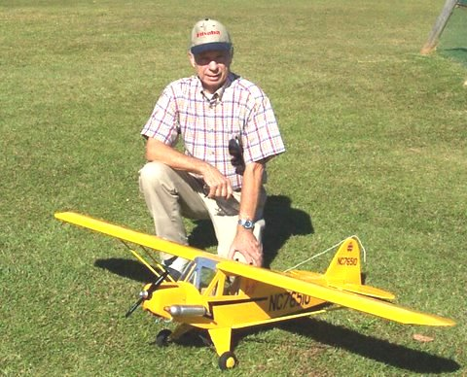
Bill Atkinson
Where are you from: I was born and raised in Jacksonville. We lived in Tallahassee for 2 years in the 60’s but went back to Jacksonville. We moved to Crawfordville in 2001.

What do you do for a living: I am retired after selling my school supply business of 42 years. I do, however, work part-time as a national sales manager for Seacoast Manufacturing and vending here in Tallahassee.

How did you get started in radio control: I got tired of going around in circles with U-control. I had a very good friend who flew radio control and he taught me how.

What do you like best about the hobby: I really like the camaraderie with club members. I like to give advice about repairing ARF’s after crashes. Most flyers today do not know how to repair an ARF after a crash. I like being outside at the flying field and meeting visitors and discussing the hobby with them. I especially like it when we plan a fly-in at our local school. The excitement on the students’ faces makes for a great day. Some of these kids have never seen model airplanes fly, let alone a “tank” or a “witch” or a “lawn mower” or a “race car”. On a personal note, I really enjoy the one-on-one time I get to spend with my son, Mike.

What models do you have or would like to have? What are your favorites and why? I have several models. Between Mike and me I have most all I will ever need. I would however, like to have a SE5-A ARF model that is currently available. My most favorite would have to be the Morane-Saulnier. It was my first airplane. My Saulnier is over 35 years old and still flying. Also, one of my favorites is a Top Flite Contender, a gift from my kids, several Christmas’s ago. I flew several Contenders in the 60’s and 70’s.

Other than just enjoying the hobby, are there any skills or maneuvers you are working on: Just trying to re-develop my flying skills. Before coming here, I quit flying for about 20 years, due to health problems.

Is there anyone in particular who has influenced your participation in the hobby? Frank McCormick from Jacksonville took the time and patience to teach me to fly and also to repair my crashes. In like manner, my son Mike took the time and patience to teach me all the things I had forgotten.

Is there anything else you would like to share? I have been flying for almost 45 years. I started flying in the late 60’s and in the 70’s. I was an active member of the Gateway RC Club in Jacksonville. I later became President and was Chairman of the NE Florida Flying Model Council. I was part of the group that promoted the Rebel Rally, which involved RC, UC, and FF competition. Also, I was part of the District V Championship, which included the above and the Snoopy Fun Fly Decathlon competition held the following Monday after District V. Flying, in a nut shell, is fun, time consuming, can be expensive, relaxing, exciting and a great way to get away from the stress of everyday life.

Pilot Briefing
Michael Atkinson
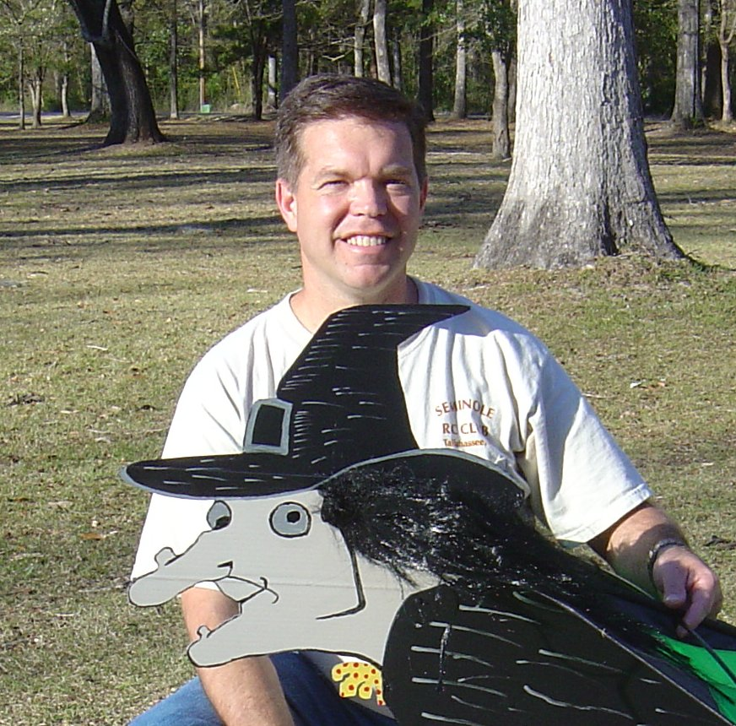
Where are you from? I was born and raised in Jacksonville, Florida. My grandfather was in land development and created Oyster Bay Estates, near Shell Point, in Wakulla County. We began visiting in the early 1970’s and moved to this area the end of 1993.
What do you do for a living? I am a chiropractor, practicing at Fiorini Chiropractic Center, on Blair Stone Road. I began practicing in Jacksonville, in 1990. After 3 ½ years as an associate, I moved to Tallahassee to join the practice with my sister and her husband. I have been married to my wife, Donna, for nearly 16 years. We have two children, Cora (12) and Mitchell (10).
How did you get started in radio control? When I was about 5 years old, my dad became heavily involved in RC flight in Jacksonville. I joined the club as a junior member. At age 6, I completed my first solo flight.
What do you like best about the hobby? I enjoy coming out to the field and visiting with other members, as well as the excitement I get when I fly a plane (or other flying device) for the first time. But, I get the most enjoyment from teaching others basic flight. I’ve been the airplane flight training coordinator for several years now. It’s a great feeling to see the extraordinary flight capabilities of some of the pilots you originally helped train.
What models do you have or would like to have? What are your favorites and why? My current favorite airplane I have is the Blackhorse Models P-51 Mustang. It’s equipped with flaps and retracts, and powered by a Saito 1.00. Probably my favorite of all my aircraft, however, is the Flying Thingz Sky Cutter flying lawnmower. I also have their flying doghouse in the box ready to build. I hope to have it finished by our May fly-in.
Other than just enjoying the hobby, are there any skills or maneuvers you are working on or want to master? By nature, I’m a sport pilot. I’m not really interested in 3D flight or helicopters. I would, however, like to get more proficient at basic aerobatic moves, keeping my entry and exit lines more “crisp”.
Is there anyone in particular who has influenced your participation in the hobby? My dad, Bill Atkinson, got me involved in RC flight when I was very young. He was president of Gateway RC Club, in Jacksonville, for 2 terms. He also served as a contest director for several years. When I moved to Tallahassee and began flying again, long time club members like Gordie Meade, Ed Budzena, Ron Whichel, Ory Weil, and Bob Burke really made me feel welcome.
Is there anything else you'd like to share? I’m very happy to be part of Seminole RC Club. Some days, I’ll drive out to the field just to sit around and chat. With life as fast paced as it is, it’s nice to be able to sit back and relax once in a while.

A guide to flying with floats Model Airplane News Sept. 2000- Onorato, Jim

Get your feet wet and start having fun on the water. One of my most memorable RC moments (second only to my first solo flight) was the first time I flew off water. The plane was a Sig clipped-wing Cub powered by an Enya .46 4-stroke and outfitted with a pair of 30-inch Balsa USA floats. To say I was nervous would be a gross understatement. Fortunately, all went well, and apprehension proved to be for naught. That was 13 years ago, and I still look forward to springtime when my boat goes back into the water and the floatplanes get dusted off for another enjoyable season on the lake. As a matter of fact, 1 don't think I've ever taken the floats off of that Cub! It's usually the first one out each spring, and the exhilaration I get from that first water liftoff never seems to fade. I hope this article will inspire other RC'ers to try this exciting aspect of our hobby.
So just which kinds of airplanes can you put on floats?just about any, I suspect, but some are better candidates than others. My favorite is the high-wing cabin-type such as a Cub or another tail-dragger. But hey; I've even seen a DC 3 on floats! The possibilities are endless. Compared with low-- wing types, high-wing models look realistic on floats and they are much less susceptible to water getting in at the wing saddle. They are also easier to adapt to floats because their main landing gear can often serve as the front strut for the floats.

FLOAT TYPES
A variety of commercially available floats are available in several sizes, and at least four different construction materials are used in their manufacture.
These include:
Conventional wooden kits that are built with lite-ply and balsa.
Precut foam-cores that must be covered with L64-inch ply or a somewhat thicker sheet balsa.
Ready-made molded-plastic floats.
Ready-made fiberglass floats.

Wooden floats can be covered with heat-shrink film or with fiberglass cloth and resin and then painted. The ready-made plastic or fiberglass floats are usually painted but can be left as is. The choice of floats really depends on how much work you want to do and how much you want to spend on floats.
A typical balsa-and-ply float is built upside-down on the building board in much the same way as you'd build a fuselage. Lite-ply formers and stringers make up the framework that is then sheeted with balsa or thin plywood. Lite-ply doublers are usually installed at the strut mounting points. In some cases, a hardwood spine runs the length of the float and allows the strut mounts to be located anywhere along the length of the float. This really simplifies matters when it comes to "hanging" the floats on your model.
Floats may have flat bottoms or vee bottoms. Vee-bottom floats track better but are less maneuverable and also produce more spray than flat-bottom floats. Flat-bottom floats are easier to build, but they don't look nearly as good as the more scale vee types.

INSTALLATION
When outfitting a plane with floats, the biggest challenge is in the placement and attachment of the floats to the fuselage. On many planes, the forward strut is attached to the fuselage just forward of the wing's LE, and the rear strut is attached to the fuselage just aft of the wing's TE. In any event, the fuselage must be reinforced at these attachment points. A piece of '-inch aircraft plywood installed under a former and strengthened with gussets will usually be sufficient. Unless you buy a kit that comes with floats specifically designed for your plane or you buy floats designed for a specific airplane, you are pretty much on your own when it comes to attaching them. For most models, float struts have to be custom made, and on all but scale models, they are usually made with steel music wire of various sizes.
On smaller planes-up to .40 size-formed-aluminum or molded-fiberglass landing gear can be used for the struts. This works best if the bottom of the fuselage is parallel to the model's datum line so the struts are the same length. If the struts have to be different, the chance of finding the exact size for the rear strut is usually pretty slim. If you use formed gear, they will usually be rigid enough to eliminate the need for diagonal bracing. Of course, you could make the rear strut out of steel wire, but that would look a little odd.
If all this seems confusing, not to worry: there is a relatively straightforward procedure that gives good results every time. But first, I'll cover a few basics to make this a little easier to follow.
In Figure 1, the point where the front strut is attached to the fuselage is point A. Point B is where the rear strut is attached to the fuselage. Points C and D are where the front and rear struts (respectively) are attached to the floats. The wire between points A and D is the diagonal brace. The members that go between the floats at points C and D are the crossbars (Figure 2).
The struts are formed in the shape of a trapezoid with the length of the top side equal to the width of the fuselage at the attachment points and the bottom side equal to the spread between the float centerlines. The crossbars that form the bottom of the trapezoid actually extend beyond the edges of the trapezoid to provide attachment points for the floats.
I have found that the easiest way to make float attachments is to use a flat board to represent the top of the floats and then to block up the fuselage in the appropriate position above the board. I then draw two parallel lines on the board making the distance between them equal to the spread between the float centerlines, and then I draw a centerline between them. Next, I draw two lines across and perpendicular to the first lines with the distance between them being equal to the distance between points C and D. The points of which these lines intersect the first two parallel lines are the locations of the four mounting points on the struts. Attach the strut-mounting blocks to these points with the crossbars installed in the mounting blocks. Now, on the float, I carefully measure the distance from the step to the attachment point for the front strut, and I use this measurement to position and draw another perpendicular line on the board-the "step" line. Last, I draw one more line 1/2 inch in front of the step line and mark it "CG." Now I block up the fuselage over the centerline at the height needed to keep the propeller 2 inches above the board. The plane's CG should be directly above the "CG" line, and the plane's datum line should be at 1 1/2 degrees positive angle relative to the top surface of the board. I generally make saddles out of 2-inch-thick Styrofoam to support the fuselage in the proper position. These are free-standing and can easily be cut to shape.
Once all this has been done, determine the height of the forward strut by measuring the perpendicular distance from point A on the fuselage to the forward crossbar. (This is not the distance between A and C.)
I then draw the front strut to use as a pattern to make the front music-- wire strut. The strut should be bound to the crossbar with copper wire and silver-soldered. Next, attach the strut to the fuselage and the building board and reblock the fuselage over the board. If the strut didn't come out exactly according to the pattern, just reposition the fuselage to get things lined up properly, and remeasure to obtain the correct height of the rear strut. After making the rear strut, attach it to the fuselage and board, and make sure everything is positioned properly. If necessary, use shims to make minor adjustments.
Finally, measure the length of the diagonal braces, bend them and silver-solder them between the top of the forward strut and the bottom of the rear strut. By now, it should be obvious that this process would be much easier if the positions of the strutmounting points on the float were adjustable.
The thickness of the wire used for the struts depends on the size of the airplane. The smallest plane I have on floats is that .40size Sig Cub; that one has 1/8-inch wire for all of the support structure. The largest is a 1/4-scale Cub (I told you I like Cubs), and that one has 3/16-inch crossbars and 5/32-inch struts and diagonal bracing. It also has 1/4x1-inch plywood crossbars under the wire ones for additional rigidity.

STEERING
Very few planes can maneuver on water with just the standard air rudder, so unless you plan to fly only on perfectly calm days, you will have to install a water rudder on one or both floats. Again, the size depends on the size of the plane. I like to use oval rudders with the long axis running horizontally. The two Cubs mentioned each have rudders on both floats. These measure 1 1/4x2 1/2 inches and 2 1/4x5 inches, respectively.
There are several ways to operate water rudders and, as with almost everything else, it depends on the plane. If the plane's air rudder extends to the bottom of its fuselage, the simplest linkage is to attach a separate control horn to the bottom of the rudder and run a flexible pushrod under the fuselage, down one strut and back to the water rudder.
If the rudder does not extend to the bottom of the fuselage, as on a Cessna, for example, you can run the pushrod from the rudder servo and out through the bottom of the fuselage and back to the water rudder. Or simply insert a rod with a steering arm into the nosewheel bracket and run a pushrod to the water rudder. My favorite setup is to use thin flexible steel cable (U-control cable works well) and set up a "pull/pull" system to two water rudders. To do this, I use a double control horn at the bottom of the plane's air rudder and run three cables as follows:
first, from the right side of the air rudder horn to the left side of the right float's rudder tiller arm;
second, from the left side of the air rudder horn to the right side of the left float's rudder tiller arm:
third, from the right float to the left one.
The first two cables run under the fuselage, down the strut and along the top of the floats. The third cable runs along the top of the floats and up and over the rear strut. I run the cables through small-diameter plastic tubes that I heat and bend 90 degrees. I attach these to the rear strut with thread and CA.

WATERPROOFING
Do a few things to the plane to make things waterproof. Wrap the battery and RX in a plastic bag and then in foam rubber. Mount the switch internally and operate it via a thin push/pull wire that exits the side or top of the fuselage. It is a good idea to avoid having exposed servos.
Use "hooded" pushrod exits wherever water is likely to enter (like everywhere!), and pay special attention to getting a good seal at the wing saddle. If you can, coat the framework with Balsarite before you cover it, and waterproof the radio and tank areas with thinned epoxy.
There are a few more things to consider before we actually fly:
The engine must have a very reliable idle because water taxiing is best done at slow speed, and it is much better to be able to taxi back than to have to retrieve the plane from the middle of the lake.
You must have a retrieval method, or you'll have to swim for your plane (or wait a long time for it to drift back to shore).
If you do have a spill (and you certainly will,) you should service the plane immediately. Lift it out of the water gently so the water doesn't slosh all over. Let the water drain out, then wring out the foam packing. Remove the glow plug to get the water out of the engine, then flush the engine with fresh fuel and run it for a few minutes. If the receiver or servos get wet, open them up and blow them dry. If you fly off salt water, just throw everything away!-only half kidding! If you act quickly, flushing everything with fresh water and then blow drying will usually salvage the electronic parts. Flying off salt water is not recommended!
One last thought: water spray can eat up a wooden prop in no time at all. Use reinforced-fiberglass props on the water.

FLYING WITH FLOATS
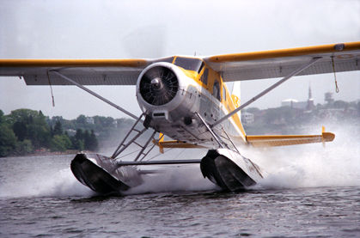
A floatplane takes off differently from a land plane in that its tail doesn't lift before the rest of it as speed increases. Instead, the floats gradually rise until they are "on step," at which point the plane really accelerates. The main thing to watch for during takeoff is that the plane doesn't bounce into the air before it's ready to fly. Make sure the plane has reached flying speed before you apply any up-elevator. The initial liftoff with water streaming off the edges of the floats is a sight to behold!
Because of the added drag and weight of the floats, the plane won't fly as fast as it did without floats, and its vertical performance will be somewhat diminished, but other than that, it should fly pretty much as it did before you added the floats.
The main difference I notice when flying a floatplane is the "pendulum effect" they experience at the last half of a roll. They really whip around! Also, landings have to be made a little faster to compensate for the higher wing loading. A perfect landing is made when the float's step and transom "kiss" the surface of the water at the same time. It just doesn't get any better than that!

FINAL THOUGHTS
I'm told that most planes will benefit from additional air rudder/fin area when equipped with floats. Up to a maximum of a 25-percent increase is usually recommended. The additional area is needed primarily for stability, and it's easily added in the form of a fixed fin under the fuselage. I suppose it helps during takeoff, but I have flown most of my floatplanes without additional air-rudder area and have not encountered any real problems.
Float flying is a blast. Try it; you'll like it!
(Editors Note: The referenced figures were not part of the downloaded article.)

WAR STORIES -by Clay Ramskill
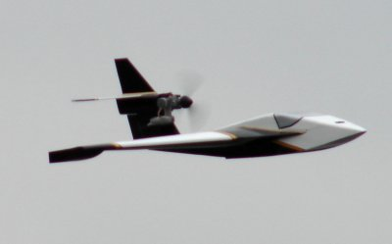
Although he knew that any fight could turn into a combat situation, Rock was just having fun. His lightweight little delta-winged fighter was fast, maneuverable, and would do a roll in a heartbeat. Just messing around over his home field, he was nearing the bottom of the second of a three loop series when it happened; a slight flicker of a shadow interrupted the constancy of the blazing sun.
It could only mean one thing -- the enemy! Rock immediately added full power to the already straining engine, resulting in a satisfying howl. Full back stick until the nose was high, then neutralize. As the little fighter zoomed upward, he scanned the sky near the sun, using his cap bill as a shade.
There! The enemy was high, cruising in toward the field, already in friendly airspace!
Adjusting course so he would pass directly below and towards the rear of the intruder, Rock continued the climb; he resisted the temptation to climb steeper -- that would just bleed off airspeed he may need for maneuvering. Passing well below the enemy, he started a wide left turn. Keep the airspeed high -- that's your main advantage. You know you can't turn with him.
In the turn, Rock looked back, picked up his adversary visually, and saw the altitude gap narrowing. Seemingly unconcerned, the enemy plowed on toward the field -- Rock turned tightly straight toward him, intending to attack from slightly below and behind. But as he neared firing range, the wily intruder banked steeply into a 3/4 roll and dived, causing Rock's plane to overshoot high and to the side. An immediate 90 degree "Bank and yank" brought Rock back around to behind and above the still-turning enemy. As he relaxed the stick, his nose dropped and he bored in for a firing run.
But again his adversary was able to turn inside him -- as he overshot, Rock could see that the other guy had had enough and was in a long fast dive toward his own airspace. Rock pulled up and watched, then cut power and glided back toward his own field - his R/C model should have enough fuel left to do a couple of touch and goes.
The hawk flattened his glide, slowed to a more fitting hunting speed, and headed for less crowded skies.
WHEN YOUR PLANE TRIES TO TELL YOU –Author Unknown
Once upon a time your author had a new pattern plane. On the first few days of flying it, everything was fine. But one day, on the first flight, it required several clicks of down trim (odd...) after take off -- and after each turn or maneuver, the pitch trim would be off again (VERY odd...). Only when it took full down stick to fly inverted (JEEPERS!) was your author smart enough to realize something was wrong. After landing, the problem was obvious: I had not bolted the wing to the fuselage!
But the plane DID "try to tell me"; I just wasn't listening. Only new, tight-fitting wing dowels had saved the plane from destruction -- it certainly wasn't the pilot! Recapping later, I thought of a number of things that would have caused similar symptoms: servo or servo tray loose, bad servo centering, broken elevator hinges, loose control horn, et cetera. The point is, ALL of those things are BAD! And with the plane not behaving properly, WHY did I keep flying??
Just suppose you're getting an occasional glitch from your radio; something that doesn't normally happen. This could be an antenna problem; it could be metal-to-metal vibration causing homegrown interference, or a loose crystal. Will any of these get better while you keep flying? And speaking of vibration, what if you start hearing it in the air? It's your plane talking to you -- loose muffler, engine mount, worn wing dowel holes, loose cowl mounting. Again, such problems don't get better, only worse.
One more example -- this has happened to all but the most careful pilots. Your engine goes lean and sags at the top of a loop. It's TELLING you that the mixture is too lean. But you don't listen and keep flying; a minute later, while doing another loop, you're suddenly dead stick!
The sky gods know -- we have enough problems that pop up suddenly, and we don't have any opportunity to prevent them. Other times the plane "tells you" that there is, or will be, a problem. Unless you really enjoy repairing or rebuilding -- LISTEN! Cutting a hop short to check out a possible problem is much quicker (and vastly cheaper) than building another plane!
Classified Advertisements/ For Sale
FOR SALE- None reported

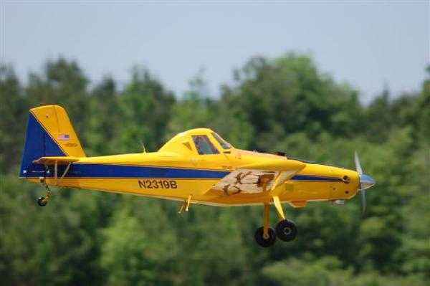

Seminole Radio Control Club
Tallahassee, FL

AMA Charter #216, 1969-2007

SRCC Officers

President – John Hall
Vice President – Brad Sharp
Secretary/ Newsletter Editor – Stephen Warmath
Treasurer - Sam Varn
Field Marshall – Chris Bailey
Field Safety Officer- Shannon Black

Field Hours

12 Noon till Dark- These hours apply to all aircraft, gas and electric.

Training Notes

To schedule a training time contact Mike Atkinson.

Flight Instructors
Mike Atkinson- Primary/ Advanced Fight Instructor (Coordinator) 926-4692
Geoff Lawrence- Primary/ Advanced Fight Instructor 942-9807
Mike Kinsey- Primary/ Advanced Fight Instructor 566-0144
John Hall- Primary/ Advanced Helicopter Flight Instructor 893-6457
Jay Leudecke- Primary/ Advanced Helicopter Flight Instructor 508-7135
Jeff Owens- Ground School/ Airworthiness Instructor (Fixed Wing) 894-2504
Steve Warmath- Ground School/ Airworthiness Instructor (Fixed Wing) 509-0672
Frank Bastos- Hobby Town Flight Demonstrator 671-2030
Don Coon- Leon High Aerospace Club Instructor 488-1971 x 1950

Club Meeting Location and Time –Meetings from April thru September are at the Field starting at 7:00.
The regular club meetings are held on the first Thursday of each month at 7:30 PM at the Grace Lutheran Church on Miccosukee Rd. Head out Miccosukee Rd., cross Capital Circle NE, and the entrance will be the first one on your right. Once you park, follow the sidewalk around the left side of the building and go down the hill. We meet in a room on the first level.
Newsletter Submissions- Submissions are requested to be in M.S. Word format. Photos should be in .jpg or .tif format. Vector art accepted in Corel, Illustrator and AUTOCAD format. We will, however, accept anything to make it easier for those who wish to contribute. Submissions are due no later than the 23rd of the month. Send your submissions to ssw@nettally.com or by phone, Steve Warmath at 509-0672.
Hard Copy Printing of the SRCC Newsletter provided by Apogee Signs & Graphics.



