The Seminole Flyer www.seminolerc.com
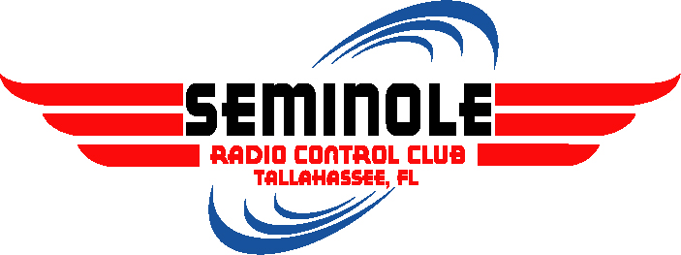
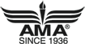
A chartered member of the Academy of Model Aeronautics

AMA Charter #216, 1969-2007

“The Seminole Flyer” is a publication of the Seminole Radio Control Club of Tallahassee, Florida MAY 2007

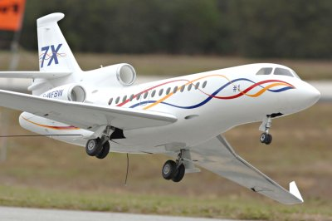
INDEX

Letter from the Editor
- Chief Pilot Report
- Chief Copilot Report
- Chief Treasurer Report
- Chief Scribe Report
- Pilot Briefing- Bob Burke
- Prop Effects
- Metals for Modelers
- Classifieds/ For Sale
Florida Jets 2007- Falcon Jet by Eric Rantet
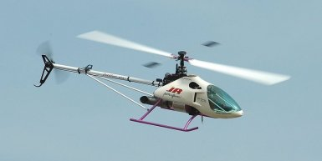

Letter from the Editor- Stephen Warmath
Looking at the calendar, May is shaping up to be a busy month with several Club activities scheduled. Our two big events are the Flying for a Cure Fun Fly and Airfest 2007. Please spread the word on both events and let’s see a record turnout for each one. See “Upcoming Events” for the details.
This month in our Pilot Briefing, we feature one of our most lovable, active members and long time supporter of the Club, Bob Burke.
How does that big fan on the front of your plane affect its flight characteristics? Read about it in Prop Effects. Taking the mystery out of the metals we work with is offered in this primer, Metals for Modelers.

A recent note in a tech magazine notes there is a new computer trouble-shooting term for Fight Sims going around. It’s “PICNIC”. It stands for: (Problem In Chair, Not In Computer). See our video advertisement for the “Flying for a Cure” event on RCUniverse. http://www.rcuvideos.com/item/HC84HTVBYC44JW59

Happy Building and Flying- Steve

Chief Pilot- John Hall
This past month the Club has had the opportunity to put on several flight demonstrations. Because the size and layout of each venue is different for each demo, the flight pattern and safety concerns vary. So far, the Club has had an excellent record for performing safe and entertaining demonstrations at schools and other public events. The Southwoodstock event provided a wide open baseball field with plenty of low woods for over fly. Large, nitro planes and helicopters were safely demonstrated along with small electrics for the enthusiastic festival crowd. The Shadeville Elementary school demo proved to be an exercise in flying in high winds! 20 - 25 mph winds never let up, blowing for most of the show. The kids didn't seem to mind though and were cheering for every loop and roll.

The demonstrations are a great opportunity to expose people to our hobby who might otherwise never get to see model aircraft fly in person. And one never knows, attending one of our demonstrations might be the beginning of a life-long hobby for someone who likes what they see and decides they want to give it a try.

See ya at the field.

John Hall

Chief Copilot- Brad Sharp
Upcoming Club Events

May 3, 2007- Club Meeting at the Field
May 4, 2007- Work Day at the Field
May 5, 2007- Flying For a Cure Fun Fly
May 12, 2007- Swap Meet at HobbyTown
May 19-20, 2007- Airfest 2007 Tallahassee Regional Airport

Upcoming AMA Regional Events
Top Gun
FL
5/02/07-5/06/07 - Lakeland, FL (B) Top Gun. Site: Airport. Bill Holland CD, 42911 Crimson Lane Shawnee OK 74804 PH:863-370-1288 email: wtholand@hughes.net. Over 130 of the World's finest scale modelers compete for the coveted "Mr. Top Gun" award. Huge manufactures area, food court, bleachers. Static judging Wed-Fri. Flying Thurs-Sun. Largest Scale event on the planet! Visit www.franktiano.com. Sponsor: IMPERIAL RC

Shadetree Spring Fling
FL
5/3/07-5/4/07 - Glen St Mary, FL (C) Shadetree Spring Fling. Site: Club Field. Billy Cannon CD, 102 Eloise St Macclenny FL 32063 PH:904-613-5522 email: bjcannon@nefcom.net. RV parking, food & beverages, 2 motels close by Econolodge 904-259-3000 Travel Lodge 904-259-6408. IMAA - AMA rules apply. Visit bjcannon@jefcom.net for further info. Sponsor: SHADETREE

1st Annual First Coast IMAC Contest
FL
5/4/07-5/6/07 - Jacksonville, FL (AA) 1st Annual First Coast IMAC Contest for 411, 412, 413, 414, 415 (JSO). Site: Club Field. Peter Jackson CD, 1908 Stillwind Ct Orange Park FL 32003 PH:954-205-5077 email: ppajck@aol.com. Club field open on Friday for practice flying and early registration. See club website and www.mini-iac.com for details. Sponsor: GATEWAY R/C

31st OJ Stillman Memorial
FL
5/5/07-5/6/07 - Pensacola, FL (AA) 31st OJ Stillman Memorial for 401, 402, 403, 404, 406 (JSO). Site: Escambia County Model Park. Tony Stillman CD, 2142 White Pines Dr Pensacola FL 32526 PH:850-941-4351 email: tony@radiosouthrc.com. Sponsor: NORTHWEST FLA MODELERS

Flying for a Cure
FL
5/05/07 - Tallahassee, FL (C) Flying for a Cure. Site: Club Field. Franklin Bastos CD, 3513 Castlebar Cir Tallahassee FL 32309 PH:850-264-0122 email: fbastos@comcast.net. 4.1 miles E. of Capital Circle SE use main entrance to landfill. Open to all pilots AA membership and $10 landing fee. Visit www.seminolerc.com. Sponsor: SEMINOLE RC

Warbirds Over the Glades
FL
5/12/07 - Delray Beach, FL (C) Warbirds over the Glades. Site: Club Field. Alexander Acuti CD, 8204 SW 11th Ct N Lauderdale FL 33068 PH:954-724-5031 email: spitfireluckyb@yahoo.com. Warbird brethren - come gather and join us for the first Warbird Fly In at our new field located one mile west of State Rd 7 in Delray Beach (see website for map). The flying site will feature a 600' paved runway. Event is limited to true Warbirds dressed in war paint. Heli's are welcome as are electrics with functioning landing gear and a minimum of 48" wingspan. Sorry, no turbines but ducted fans are ok. Join us for a great day of flying and fellowship, free lunch for pilots and crews. For more information go to our website www.palmbeachrc.com. Sponsor: PALM BEACH COUNTY RC ASSN

Joe Nall
SSC
5/16/07-5/19/07 - Woodruff, SC (C-Restricted to IMAA) Joe Nall. Site: Triple Tree Aerodrome. Mike Gregory CD, 28 Rocky Point Way Greenville SC 29615 PH:864-297-1201 email: mikegregory@charter.net. All spectator $5 per day must be AMA member or guest of AMA member. Float Flyers must be on channel 22, 23, or 24. No Channel 20. See website for more info www.joenall.com. Sponsor: CONFEDERATE AIR FARCE

Jets Over the Swamp 10
GA
5/18/07-5/20/07 - Waycross, GA (C) Jets Over the Swamp 10. Site: Waycross/Ware County Airport. Allen Smith CD, PO Box 36 Waresboro GA 31564 PH:912-614-0210 email: lasuga56@hotmail.com. For additional info: Keith Douglas PH:912-285-3110 email: dougglo@wayxcable.com. Join us for our annual jet rally on a 5000' runway at our airport. Motor homes welcome and tents available. Email us for event flyer with lodging and all the details. Please register in advance. Book and pay for tent rental by April 30th. Ducted fan and turbines only. Sponsor: OKEEFENOKEE RC CLUB

Gentle Lady "Plus" Soaring Competition
FL
5/19/07 - Oviedo, FL (A) Gentle Lady "Plus" Soaring Competition for 442 (O). Site: Red Ember Rd. Raed Elazzawi CD, 855 Bloomingdale Dr Orlando FL 32828 PH:407-277-9719 email: raed5@yahoo.com. Contest open to any 2 meter rudder/elevator glider. A special award for top score gentle lady pilot. Visit www.orlandobuzzards.org. Sponsor: ORLANDO BUZZARDS

2007 Heart of Dixie FF Championships
FL
5/19/07-5/20/07 - Pensacola, FL (AA) 2007 Heart of Dixie FF Championships for Cat III 101, 102, 103, 104, 105, 101C, 102-103C, 104-105C, 120, 124, 128, 140, 142, 153, 154(JSO). Site: 8A. Tom Hepler CD, 808 Rigel Drive SW Decatur AL 35603 PH:256-350-9263 email: buzzardbombshell@aol.com. Nos ¼ A, ½ A, A, B, C; Early ½ A Nos; OTR(L); OTR(S), Gollywocks Galore; OT Gas Pylon/Cabin; .020 Replica, Commercial Rubber; Classic Towline, FAC Dime Scale, FAC Jimmy Allen; FAC Jet Cat Scale; FAC OT Replica Gas; GAC Embryo; FAC Thomson/Cireve Races. Sponsor: MODEL AIRPLANE CLUB OF HUNTSVILLE

First Coast Helicopter Fly In and Clinic
FL
5/19/07 - Jacksonville, FL (C) First Coast Helicopter Fly In & Clinic. Site: Lannie RD Flying Field. Andrew Griffith CD, 1600Chain Fern Way Orange Park FL 32003 PH:904-993-4956 email: barracudahockey@aol.com. Rotary wing only. Turbines and autogyros welcome. Campers welcome no hookups. Modern kitchen and restroom facilities. No nitro flying before 9 a.m. $20 landing fee includes BBQ lunch. Visit www.gatewayrc.org. Sponsor: GATEWAY R/C

Air Fair 2007
FL
5/19/07-5/20/07 - Sarasota, FL (C-Restricted to IMAA) Air Fair 2007. Site: Club Field. Michael Winter CD, 4287 Hearthstone Dr Sarasota FL 34238 PH:941-966-7786 email: mikeandeva@comcast.net. Sound restrictions apply: 104dB(A) at nine feet. Sponsor: SARASOTA R/C SQUADRON

Rebel Rally
FL
5/26/07-5/27/07 - Palm Bay, FL (AA) Rebel Rally for 101, 102, 103, 104, 105, 101C, 102-103C, 104-105C, 120, 124, 128, 140, 142, 150, 151, 152, 153, 154, 155 (JSO). Site: Club Field. Joe Clawson CD, 401 Almansa St NE Palm Bay FL 32907 PH:321-984-8718. All National Cup events. Sponsor: FLORIDA MODELERS ASSOC

Electric Fly In
FL
5/26/07-5/27/07 - Morriston, FL (C) Electric Fly In. Site: 17150 SE 60th St. Richard Hinton CD, 851 SE 148th Terrace Williston FL 32696 PH:352-528-9229 email: rhinton1@peoplepc.com. Sponsor: THE OWLS - ONE WING LOW SQUADRON

Chief Treasurer- Sam Varn
Editor’s Note: The Treasurer’s report is published for Members only. The public version of the Newsletter does not include this information.
Here's the current Treasurer's report:

Cash - $0.00 Checking - $0.00 Savings - $0.00 CD - $0.00

Total- $0.00

The most important thing I want to let members know is that dues notices will be going out next month (June). All memberships expire on June 30 so it would be great if everyone renewed before that date. Some members that joined recently paid more than their pro-rated dues should have been. I will be adjusting all dues to reflect that. Everyone that has an email will be getting an invoice via PayPal like we did last year. For those that don't want to use PayPal, they can just mail a check to me. The postal system still works!
We have picked up a couple of new members in April...Bryce Barbato and "Butch" Thigpen. Welcome to both of them!
I will not be at this upcoming meeting due to a business conflict. If anyone needs reimbursement for anything, please bring the receipts by my store on Lafayette Street.
Sam

Chief Scribe- Steve Warmath
(Minutes by Brad Sharp)

At our first field meeting of the year, the weather was windy, somewhat overcast and on the cool side. Hot dogs solved part of the problem, and there was still acceptable, if slightly more challenging flying to be had. The meeting called to order at 7:05 PM.

Sam read the Treasurer’s report. A motion was made to accept, seconded and passed.

Old Business:
- Frequency pins: Brad awaiting delivery of pins from Sam.
- Landfill Update: Three plans are to be presented for review 5/10. Alignment of runway is critical to our flying and close attention will be given to this.
- Airfest 5/19-5/20: Members are needed. To volunteer, contact John Hall. Help is needed for setup on Friday 5/18, and for various activities on Saturday and Sunday. There will be no fuel-powered model aircraft flying this year. Models representing various aircraft & helos are needed for static display.
- Discussed having an Open House at Seminole Field the weekend following Airfest. However, this made three scheduled events for the month of May. In the future we should consider using Airfest to promote a following Fly-in/Open House.
- Road grading was committed to by the County but not yet completed or started. John will follow up. Field condition report from Chris disclosed that conditions are generally acceptable. The bleachers look pretty shabby, but more importantly, they need to be 'stress-tested' for safety. Most picnic tables are in need of replacement and it was suggested and agreed upon that two tables and several chairs (and types of chairs) were unstable, unsafe and may present liability issues.

New Business:
- Field Power- A Solar panel and 12v. system was designed, purchased, installed and donated to the Club by John Hall at his own expense. It is operational for all to use. Frank Bastos motioned that the Club reimburse John, and this was immediately and enthusiastically seconded by all, with no objections. This is not a charging system - it is a 12v source of power for our chargers. The power is from a battery, and the solar part of the system recharges the battery.
- Tables and Chairs- Following more discussion about the safety of the tables and chairs, Frank Bastos motioned that the Club fund replacement. Motion was seconded with no objections. $200.00 was set as the figure to fund replacements.
- A scale to weigh the models is being donated by Pat Murray and will be kept at the field. It will likely be stored in the small shed, to which all members have the lock combo. Thanks Pat!
- Tristan proposed a 'house cleaning' of the small shed, and several members volunteered to help.
- In his role as Contest Director of the May 5 Fly-In, Frank Bastos asked for volunteers to clean-up and prepare the field on Friday, May 4th. Frank mentioned the potential need for more space for models and parking that may be required as a result of the success of our events. We should be addressing this in advance of the need, at least to the extent of knowing our options and how much time, effort, and funds will be necessary to implement any changes.
- Flying Safety at the Fly-In was mentioned. Frank reaffirmed that a pilot’s meeting will be held as usual to explain the field rules. It was also mentioned that all club members present are expected to observe and act as safety officials. Any questionable activities not requiring immediate action should be referred to Frank.

The meeting adjourned at 7:55 PM.

Pilot Briefing
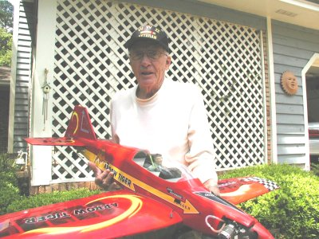
Bob Burke
Where are you from?
I was born and brought up in Detroit, Michigan. During World War II, I served in the Marshall Islands. Upon my return to the states, I moved to Palm Beach. I later moved to Tallahassee. I met my wife here and we recently celebrated our 50th anniversary.
What do you do for a living?
My wife and I went into the ladies fashion shoe business and worked together for over 40 years and retired in 1988. After retirement, we purchased several different RV’s and traveled over the entire United States and Canada. We would spend months away at a time. We spent most of the time in the Northeast during the summers. Life has been very good!
How did you get started in radio control?
I have been interested in model planes since I was very young. My father would take me to the flying field when I was a pre-schooler. I began with rubber-powered models and progressed to RC models and everything in between.
What do you like best about the hobby?
I enjoy the fellowship and seeing the new models that club members bring to the field.
What models do you have or would like to have? What are your favorites and why? I have and fly about four models most of the time. I sell or trade the ones I get tired of flying.
Other than just enjoying the hobby, are there any skills or maneuvers you are working on or want to master?
What skills I may have for building and flying are usually what I settle on. I don’t believe I will fly any better a year from now that I do presently. ☺
Is there anyone in particular who has influenced your participation in the hobby?
In the mid fifties, we had a small club consisting of four guys. Most are gone now, but we learned much from each other. I think we have a great group of guys and a great hobby shop. Thanks to Frank Bastos who is always helpful and there when you need advice.
Prop Effects -by Clay Ramskill
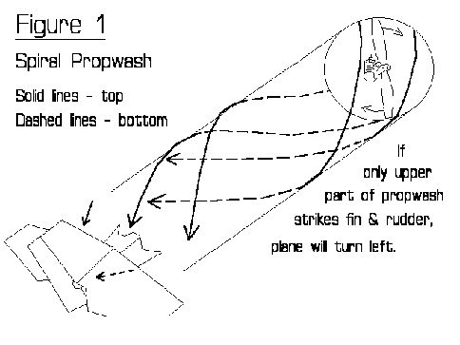
Often as not, when our plane does something really weird, like a ground loop on takeoff, we say, "the torque got hold of it; there just wasn't anything I could do!". Even in magazine columns we see something like: "the engines torque was pulling me to the left, so I had to jab in some right rudder".
These folks are right in that the actions of the prop were the cause of the problem - and wrong about the culprit being torque.
There are basically four "effects" from the action of the propeller; well, five if you count the thrust! They are: spiral prop wash, asymmetric loading (p-factor), torque, and gyroscopic effects. We'll look at each of these in turn.
Spiral Prop wash. The prop does not throw the prop wash straight back - there's some drag on the prop, and that tends to make the wash behind it come off in a spiral fashion. And the problem comes when that spiral flow meets the rudder. If the rudder/fin is mounted high, the plane will turn (yaw) left because only the top part of the spiral hits it. See fig. 1. On a tail dragger at rest, tail down, this may not be the case, and even the reverse may be true because the prop wash must be mostly parallel to the ground. See fig. 2.
P-Factor. Asymmetrical thrust is most apparent with tail draggers because it's mostly a function of the prop not being perpendicular to the oncoming airflow - but that can also happen with any plane when at a high angle of attack, like right AFTER takeoff. When the air is coming into the prop at an angle instead of square to it, one side of the prop operates at a higher angle of attack than the other, and the resultant thrust is no longer acting on the planes' centerline, but off to one side. And that makes the plane want to turn. See fig. 3. The usual case, nose high, gives us a left turn.
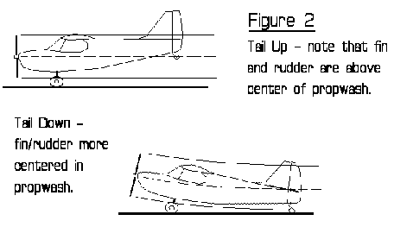
Torque. Our props have a certain amount of drag - and the torque (twisting force) the engine exerts on the air is, in opposite fashion, also exerted through the engine mount to the airplane. Since all our props turn to the right, that means there is a force trying to twist (roll) the airplane to the left. Note that this force is about the ROLL axis - the torque forces do not by themselves TURN or yaw the plane as do the previous two effects. We automatically take care of this with ailerons in keeping the wings level, and it really doesn't take much force from the ailerons to do it. On the ground, the wheels counter all torque forces.
Gyroscopic effect. The weight of the fast-turning prop creates a gyroscope, which will resist any change in the direction of its rotating axis. This is easily overcome by the planes controls - but the more detectable gyroscopic effect comes AS THE DIRECTION IS CHANGING. As the planes direction is changing, as in a sudden pull-up, gyroscopic forces try to rotate the plane about an axis 90 degrees to the axis you're forcing it. In the example of a sudden pitch up, the gyro action from the prop will try to force the plane to turn (YAW) to the right. Don't believe it? Try it - the next time you're holding your plane nose up at full power to check your mixture, rotate the plane sharply nose up and down. You'll feel the sideways pressure from this force. In flight, its almost negligible, except perhaps at near zero airspeed if you do a VERY quick stall turn or flop over.
So what is one to do? Answer- know what your planes characteristics are, and compensate - with THE RUDDER! Let's take an example; the Piper Cub, well known for its tendency to ground loop on take off. Here's what happens: you gas the engine, and immediately have to put in some right rudder to keep it from turning to the left, from the p-factor on the prop. With the tail down, the tailwheel gets more effective as you begin to roll, and you have to let up on the rudder. But then the tail comes up - and the fin and rudder, which were low and were getting equal right and left yaw from the spiral effect, now pop up into only the top portion of the spiral prop wash. The Cub will now sharply turn left unless you are quick to shove on the right rudder. As the Cub accelerates, the fin/rudder get more straight airflow and again you must let up on the right rudder to keep it straight! Whoo! And we're not even airborne yet!
One method to tame the initial gyrations is to hold the tail down for part or all of the take off run - this keeps the tailwheel firmly in contact with the runway, stabilizing directional control considerably. A touch of up elevator does wonders here; just remember to slack off the elevator at lift off to keep from climbing too steeply.
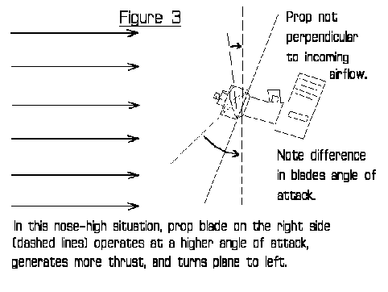
Suppose you pull the plane off early, while very slow. You are at a high angle of attack, and the p-factor (and maybe some spiral effect, too) will try to turn you to the left again. Assuming that you keep the wings level with aileron, RUDDER is the proper way to correct the left drift. If you only correct with right aileron, the plane will be in a skid, in unbalanced flight, and you're setting yourself up for a stall/snap/crash, big-time!
Just how much prop effects affect your planes behavior depends on the plane. A pattern-type plane is affected very little. A front-engine delta, which can operate at very high angles of attack (lots of p-factor) and has a very high tail (spiral prop wash), is affected considerably - you get a sore thumb from standing on the right rudder. And your planes probably fall somewhere in between those two extremes.
Understand what is happening with your plane - and learn to make the PROPER corrections (quite often with right rudder). You'll be a better, smoother pilot, and you may just save a plane or two!

Metals for Modelers by Roy Vaillancourt
This article discusses the classification and properties of the metals most often used by modelers.
ALUMINUM
One of the most abundant metallic elements, aluminum is also one of the most versatile engineering and construction materials available today. Its wide range of alloys can satisfy many diverse requirements, including high strength, light weight, good corrosion and tarnish resistance, and good electrical and thermal conductivity. And aluminum's attractive silvery luster makes it easy on the eye.
Although pure aluminum has a relatively high melting point -- 1220 degrees Fahrenheit -- most of its alloys can be easily fabricated, machined and joined. Aluminum is available cast, forged or wrought, such as in plates, bars or rods. It is non-toxic and can be attractively finished by many common methods including painting and anodizing -- a chemical etching process. The three alloys most commonly used for modeling are 2024-T4, 5052-H32 and 6061-T6.
2024-T4
T4 is a well-known aluminum-copper alloy that has been heat-treated in solution and then naturally aged to a stable condition. It is available in sheet, strip, plate, block, rod and tube form. A very rigid metal, it is easily machined. Its mechanical properties include high strength and excellent resistance to fatigue under tensile or compressive loads. However, because it doesn't bend easily under load, it is not easily formed by bending, as in a brake. In fact, T4 fractures readily at the bend line and is likely to crack at stress concentration points under vibration. Although it is not good for engine mounts it is commonly used to make pistons and connecting rods in engines, pivot blocks, scissors or air cylinders on retracts. It should not be used to make bending brackets of any type.
5052-H32
A strain-hardened and stabilized aluminum-manganese alloy, H32 has moderate to high strength properties but is not heat-treatable. However, it exhibits good welding and brazing characteristics with a high resistance to corrosion. Most commonly supplied in sheet metal form, it is generally not available in thickness over 3/16 of an inch. H32 is excellent for bending into brackets and similar hardware. When bending, keep the internal radius of the bend equal to 1.5 times the thickness of the material or greater.
6061-T6
T6 is an aluminum-silicon-magnesium alloy that has been heat-treated in solution and artificially aged. Of all the aluminum alloys, T6 machines the best and has excellent brazing and welding qualities. It demonstrates very high resistance to cracking under stress and is easily formed by bending or pressure. A medium strength alloy with high corrosion resistance, it is used in many heavy-duty structures such as engine mounts and landing gear components.
For machining aluminum, the best cutting agent and lubricant is kerosene. Next best is light machine oil like Marvel Mystery Oil, but even candle wax can be used without difficulty.
One thing to remember when finishing aluminum is that for the common man getting paint to stick to it is very tough. Not because we can't paint right, It's because our finishing method does not agree with what aluminum wants to see. Aluminum naturally forms a thin surface layer of oxidation. (This is that black stuff you get on your hands when handling untreated aluminum.) This layer forms rapidly on fresh cut material and prevents the rest of the material underneath from oxidizing or corroding. Even if the part looks shinny, this layer may have already formed. This is why aluminum is considered very corrosion resistant. However, this very same layer is what makes it very hard for paint to stick. Well some of you may say, "I'll out smart this material and use some epoxy paint". Truth is, no matter what paint you use if the surface isn't prepared right the paint will peal right off.
The best way to prepare aluminum is to dip the part in a chromic acid etching bath just prior to priming. This bath removes all oxidation and applies a thin protective top layer that adheres to the aluminum and accepts any paints very well. Painting should begin as soon as possible after the part is dried off but it is possible to wait up to 24 hrs. With out too much harm. Once the primer is on all other painting can proceed at a normal rate. Well most of us don't have a chromic acid bath at home so how do we handle this problem.? The best way is to sand the entire part with 320 or 400 wet - dry sandpaper used wet. Dry the part off by use of a heat gun or forced air. Wash right away with Acetone or thinners compatible with the paint you will be using. Again dry off and commence applying primer. Once the primer is on you can relax. If you had to stop anywhere in the process before you got primer on the part you'll have to start all over with the sand paper etc. The point here being that you have to get primer on an oxidation free surface.
LEAD
Probably the second most used metal used by modelers. When was the last time you built a nose heavy plane? Lead is most commonly used by modelers as ballast. This bluish-gray metallic element is very dense with a specific gravity of 11.35. This means it is very heavy for a given volume. Lead is a soft, malleable and ductile material. Its melting point is quite low at 625 degrees F. Lead is also useful for generating electric current in electrochemical applications such as batteries. It can be readily and inexpensively fabricated into many forms. It is used as an additive to some metals to make them easier to machine and it is also a major alloy in most solders. Lead is sometimes added to "plain" bearings to aid in lubrication and ease of fabrication.

COPPER
Probably the first metal to be smelted from its ore, Copper is a very useful material that has a number of desirable properties. It resists corrosion, provides outstanding electrical and thermal conductivity, and has good ductility. While its strength-to-weight ratio is relatively low, Copper is considered a heavy metal. Pure Copper melts at 1981 degrees F. It can be polished to a high luster. It is non-magnetic and combines well with other metals to form a wide variety of useful alloys. It is easy to fabricate and can be joined mechanically by soldering or brazing very easily. Copper and its alloys tend to work harden and can be either hot or cold worked to increase its strength. What this means is that as you bend Copper, if you were to bend the same area back and forth repeatedly the material actually gets stronger at the bend. The down side is that as the strength and stiffness goes up so does its stress cracking probability. So the trick here is to know just when to stop working it before you start to fatigue it. For most of our uses today there are two basic forms of Copper.
C110
This is 99.9 percent pure Copper. It can be bent, riveted, drilled, milled, filed, soldered, brazed and welded to most any configuration. Most common use is electrical connections and ground straps etc.
C112
A harder version of the C110 that can also be easily brazed and soldered. It is harder then the C110 so it may require annealing prior to bending and /or shaping. Annealing is a softening process that is accomplished by heating the part to a burgundy red color and letting it cool naturally. The annealing process can be applied to an entire part or it may be done locally (only to certain areas).
Like aluminum, Copper also likes Kerosene as a cutting agent when machining it. Also like aluminum; Copper forms a thin oxidation layer that helps it become very corrosion resistant. This oxidation layer, however, does not form as fast as aluminum's so painting Copper is not as big a chore. The do-it-at-home modeler should follow similar techniques as used on aluminum when it comes to painting Copper.
BRASS
Brass is really an alloy of 70 percent Copper and 30 percent Zinc. Brass is an excellent metal for cold working and shares many of the same properties of Copper but Brass is stronger. Increasing the Zinc content increases strength and ductility. Brass can also be annealed the same way Copper is. Brass is considered a "self lubricating" metal and very rarely requires a lubricant in either machining or in use. Brass sometimes has Lead added to aid in machining and forming. There are many special alloys available but the three basic forms of Brass in use today are:
C260
Known as "cartridge brass" C260 has a high Zinc content that gives it optimum strength and ductility yet still retains the high formability of Copper. It has excellent cold workability and is used extensively in the automotive field. It is also the most common form of Brass used for plumbing goods, builder's hardware, and ammunition components.
C330
Most widely used for the fabrication of tubing. A low Lead content of .5 percent gives this alloy good machinability and excellent cold working properties. It can be fabricated by forming, bending, machining, piercing and punching. It can also be brazed, soldered and welded similar to Copper. Of all the Brass alloys this is the one that is used most widely for brazing steels and dissimilar metals together.
C360
Considered a "Leaded" Brass, this alloy also has a high Zinc content of up to 37 percent. The inclusion of lead gives this high strength alloy a "free-cutting" quality making it easier to machine. Often called "Leaded Brass" or "Free machining Brass" it finishes well and is the most easily plated, soldered and brazed Brass alloy.
STEELS
For our purposes there are basically two types of steels that could be found in the average shop, Carbon Steel and Stainless Steel.
Carbon Steels
Carbon Steels come in a variety of alloys. Too many to list here. The predominant elements in Carbon Steels are Iron and Carbon. The Carbon content can range from a few hundredths to just over 1 percent. Doesn't sound like big numbers , does it?
(Low Carbon Steels 0 - .30 %, Medium Carbon Steel .31-.70 %, High Carbon Steel .71-1.3 %). Carbon Steel in its various forms represents more than three-quarters of the steels in production today. Carbon Steel is generally fine grained, and has little to no alloying agents. Most Carbon Steels are classified as hot rolled, cold drawn or cold rolled and are available in bar, sheet, wire, tubing, and structural shapes. They can also be forged and casted. Carbon Steels are heat treatable to a degree. The carbon content is what gives these steels their heat treatable strength properties. For example; the higher the carbon content, the stronger the material can be heat treated to. The music wire we use for landing gear is one of the medium Carbon Steels heat-treated to a tough condition. One draw back to these steels is that they contain high amounts of Iron. This means they rust easily. They should not be left bare, as they will form an oxidation layer of rust. Unlike aluminum, this oxidation layer keeps on going until it has taken over the whole part. Eventually the part will deteriorate and disappear. Leaving you with a pile of rust....... The best cutting agent for carbon steels is plain old motor oil. 30W works the best. Straight out of the can or bottle. Finishing steel is very easy. Clean off all oils and sand off all rust followed by a wipe down with thinner. Apply a coat of primer as soon as possible and finish off with the color of your choice.
Stainless Steel
Stainless Steels are high-alloy steels well known for their outstanding corrosion resistance. Valued for tough mechanical properties such as high strength and extreme thermal capacities they provide low maintenance and long service life. Typically Stainless Steels are iron-nickel-chromium alloys with a generally high percentage of nickel. There are two classes of Stainless Steels, Non-Ferric (300 series) and Ferric (400 series). The Ferric class (400 series) contains a higher percentage of iron and approximately 12 % chrome and even though these steels are classified as "stainless" they do rust. The 400 series is magnetic and is heat treatable while the 300 series is not magnetic (generally) and is not heat-treatable. The 300 series contains a higher percentage of nickel and approximately 17 % chrome. It is the higher contents of nickel and chrome that give the 300 series their corrosion resistance. Most fasteners such as nuts, bolts and washers are of the 300 series. In cases where extreme high strength is required nuts and bolts would be made from heat-treated 400 series and then coated to prevent corrosion. The best cutting agent for most Stainless is USED motor oil thinned with a little Kerosene. The older the motor oil the better. You know, the stuff you drain out of your car after 70000 miles. Don't mix it with rocks or sand, just add a little Kerosene and your good to go.
Finishing any Stainless is just like finishing any Carbon Steel with one exception. The non-ferric series does not rust and therefore does not require any finishing at all if you don't need it painted. It can be left bare and will hold its luster for a very long time. Much longer than most of our models survive. The ferric series does rust so it should be given the prep and prime and paint treatment.

Classified Advertisements/ For Sale
FOR SALE-
New last year...Hitec Eclipse 7 FM - 7 channel radio with receiver and servos (installed in model) and a SIG Kadet LT 40 trainer with engine - all in new condition. Was flown twice by an experienced pilot. Other equipment and supplies - call for details. New cost was well over $400. & will sell for $300.00 OBO.
Ray Alexander, 294-6354 & email address rjalex2000@yahoo.com
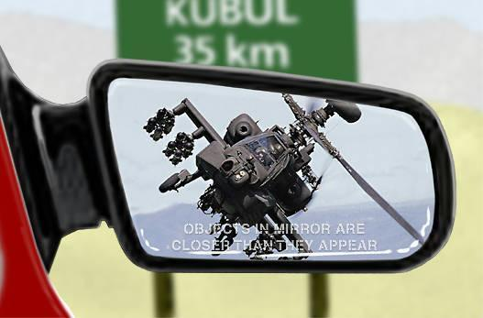

Highway Patrol of the Future

Seminole Radio Control Club
Tallahassee, FL

AMA Charter #216, 1969-2007

SRCC Officers

President – John Hall
Vice President – Brad Sharp
Secretary/ Newsletter Editor – Stephen Warmath
Treasurer - Sam Varn
Field Marshall – Chris Bailey
Field Safety Officer- Shannon Black

Field Hours

12 Noon till Dark- These hours apply to all aircraft, gas and electric.

Training Notes

To schedule a training time contact Mike Atkinson.

Flight Instructors
Mike Atkinson- Primary/ Advanced Fight Instructor (Coordinator) 926-4692
Geoff Lawrence- Primary/ Advanced Fight Instructor 942-9807
Mike Kinsey- Primary/ Advanced Fight Instructor 566-0144
John Hall- Primary/ Advanced Helicopter Flight Instructor 893-6457
Jay Leudecke- Primary/ Advanced Helicopter Flight Instructor 508-7135
Jeff Owens- Ground School/ Airworthiness Instructor (Fixed Wing) 894-2504
Steve Warmath- Ground School/ Airworthiness Instructor (Fixed Wing) 509-0672
Frank Bastos- Hobby Town Flight Demonstrator 671-2030
Don Coon- Leon High Aerospace Club Instructor 488-1971 x 1950

Club Meeting Location and Time –Meetings from April thru September are at the Field starting at 7:00.
The regular club meetings are held on the first Thursday of each month at 7:30 PM at the Grace Lutheran Church on Miccosukee Rd. Head out Miccosukee Rd., cross Capital Circle NE, and the entrance will be the first one on your right. Once you park, follow the sidewalk around the left side of the building and go down the hill. We meet in a room on the first level.
Newsletter Submissions- Submissions are requested to be in M.S. Word format. Photos should be in .jpg or .tif format. Vector art accepted in Corel, Illustrator and AUTOCAD format. We will, however, accept anything to make it easier for those who wish to contribute. Submissions are due no later than the 23rd of the month. Send your submissions to ssw@nettally.com or by phone, Steve Warmath at 509-0672.
Hard Copy Printing of the SRCC Newsletter provided by Apogee Signs & Graphics.

