The Seminole Flyer www.seminolerc.com


A chartered member of the Academy of Model Aeronautics

AMA Charter #216, 1969-2007

“The Seminole Flyer” is a publication of the Seminole Radio Control Club of Tallahassee, Florida SEPTEMBER 2007

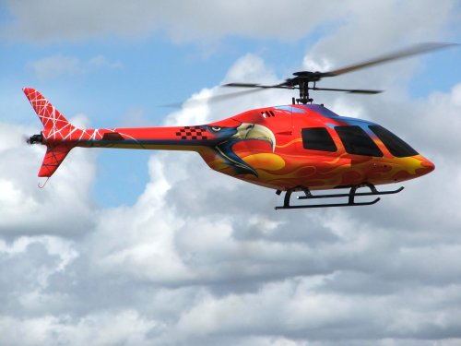
INDEX

Letter from the Editor
- Chief Pilot Report
- Chief Copilot Report
- Chief Treasurer Report
- Chief Scribe Report
- Pilot Briefing- Jay Luedecke
- Learning the Art of Model Building
- Flybar Control Systems
- Thoughts for the Month
- Tips & Reader Feedback
- Reducing Drag

Letter from the Editor- Stephen Warmath
Last month I said it was hot. This month, I’ll say it’s hotter! Even the fans in the shop don’t help. They just pound me with hot air. No fun. Another reminder here to drink lots of water and stay cool. With football season kicking off this month, the thought of fall and cooler weather comes to mind. Ah….cooler seasons coming around again.
For our Beginner’s Corner some general guidance on The Art of Model Building is offered this month. In this issue, our Pilot Briefing features Jay Luedecke, serious rotor head extraordinaire. Also for you dark side flyers, Jay sent in an article of the technical mechanics of helicopter Fly Bar Control Systems. Off on the usual unrelated tangent is a short list of things to ponder in Thoughts for the Month.
Also, a few more Tips to have handy in the shop as well as some feedback from Dave Sellars on how to improve last month’s recipe of homegrown cleaner is offered. Reducing Drag is not about work or your last date. It’s all about factors affecting how our aircraft slide through the medium of air. Remember as a kid how we would fly our hand out of the car window at 50 mph and then turn it up sideways and about rip our arm off? It’s all about drag. We had a Cocker Spaniel named “Cisco” who liked to put his head out the window with his mouth open. The air, I swear, passed right through him and out the exhaust pipe. Whew!……….. But that’s another law of aerodynamics.

Happy Building and Flying- Steve

Chief Pilot- John Hall
This month I would like to make the membership aware of some housekeeping issues that the club needs to address.
Club Field Maintenance - As some of you are aware, the club mower has been having problems with burning oil. The problem has been diagnosed and the cost of repair has been specified. The club officers are in the process of gathering information so that the available options can be presented to the membership at the next Club meeting. I strongly encourage all members to make an effort to attend this meeting as there is likely to be vote to determine what direction the club will take to resolve this issue.
Field Security - Monday night an empty car was found parked at the South end of the runway just before dark. The gate was locked and there was no obvious evidence of forced entry. The Sheriff was called and arrived on scene to investigate. At that time, two subjects both non-members, emerged from the woods around the pond, got into their vehicle and attempted to quickly leave the field. The Sheriff stopped the subjects and questioned them as to how they obtained access to the field and their reason for being on the property. The two subjects claimed that they were fishing and that somebody fitting the description of a club member had given them the gate lock code. Fortunately, nothing was stolen or vandalized. Even though matted grass indicated that the subjects had driven their car down the runway, there was no apparent, permanent damage to the grass.
At a minimum, we will need to change the code for the lock. This serves as a reminder about the importance of keeping the code confidential. Telling non-members the code or leaving the lock hanging open without scrambling the combination defeats the purpose of having a lock in the first place. Using a code as opposed to a physical key is a convenience I'm sure we would all like to continue. But if that convenience means that we cannot secure the field and our assets, we may want to reconsider if it's worth it.
Once again, I strongly encourage all members to attend the next club meeting to share your thoughts and help decide on resolutions to these issues.
See you at the field.
John Hall

Chief Copilot- Brad Sharp

Upcoming Club Events
Club Meeting at the Field- September 6, 2007 at 7:00 pm.

Upcoming AMA Regional Events
Florida State Championships
FL
9/01/07-9/02/07 - Palm Bay, FL (AA) Florida State Championships for Cat III 101, 102-103, 105\4-105, 101C, 102-103C, 104-105C, 120, 124, 128, 140, 142, 150, 151, 152, 153, 160, 161 (JSO). Site: Club field. Bill (William R) Barr CD, 2235 Chinaberry Cir SE Palm Bay FL 32909 PH:321-725-5063 email: bdbarr@strato.net. Sponsor: FLORIDA MODELERS ASSOCIATION

SUmmers End Fun Fly
FL
9/01/07 - Lake City, FL (C) Summers End Fun Fly. Site: Club Field. Chalres "Bill" Howe CD, 209 Bannerfarm Road Mills River NC 28759 PH:352-262-6348 email: howecw@aol.com. Sponsor: LAKE CITY RC

Bushwhacked 07 - 1/2
FL
9/08/07-9/09/07 - West Palm Beach, FL (A) Bushwhacked 07- ½ for 755(JSO). Site: Phil Wherry Field, Dyer Park. Chris Handegard CD, 2774 New York St West Palm Beach FL 33406 PH:561-832-1921 email: chandegard@peersonaudio.com. Sat 8 rounds Open B, Sun 8 rounds 2548 Scale Combat. Field open 8am Start Combat 10am. Entry fee $20 one event $30 both. Trophies 1st to 5th place. Go to www.rccombata.com to sign up online. Visit www.rcbushpilots.com. Sponsor: RC BUSHPILOTS

Allen Taylor Fly In
GA
9/08/07 - Griffin, GA (C) Allen Taylor Fly In. Site: Allen Taylor Field. Emory Schroeter CD, 105 Summit Dr Griffin GA 30224 PH:770-467-0221 email: emorydmd@earthlink.net. Pilot's meeting begins at 10 am; $10 landing fee; on site concessions; RV's welcome, but no hookups; rain date will be Sept. 9, 2007. Visit www.flyinggriffins.org. Sponsor: FLYING GRIFFINS

2007 Gulf States Annual
FL
9/15/07-9/16/07 - Pensacola, FL (AA) 2007 Gulf States Annual for Cat III 102-103C, 104-105C, 124, 153(JSO). Site: Helicopter Field 8A Navy Site. Carl Bakay CD, 118 Gentry Circle Lafayette LA 70508 PH:337-504-4363 email: carlbakay@scientificdrilling.com. Sponsor: CLOUD CLIMBERS OF SE LOUISIANA

Summers End Fly In
FL
9/15/07-9/16/07 - Ocala, FL (C) Summers End Fly In. Site: Club Field. Thomas Thacker CD, 15702 SW 16th Avenue Road Ocala FL 34473 PH:352-553-2627 email: tthacker6@cfl.rr.com. All Giant Scale - AMA Rules apply. No 3D acro or hovering allowed at this event. Short noontime demo's. RV's welcome Friday 9-14-07-Sunday 9/16/07 no hookups. Come join us for one of Florida's best events at one of Florida's best flying sites. Visit www.omfc.com. $10 landing fee per day or $15 for the weekend. Refreshments provided by the Ocala Fly Girls. Sponsor: OCALA MODEL FLYING CLUB

Bud McMillan Big Bird Fly In
FL
9/21/07-9/22/07 - Jacksonville, FL (C) Bud McMillan Big Bird Fly In. Site: Club Field. Ewell Howard CD, PO Box 892 Callahan FL 32011 PH:904-879-2834 email: bhoward32011@aol.com. 60/80 rule. On site camping, BBQ Fri night for all pilots, landing fee $20 includes BBQ, Food and drink available, Pre Reg $15 contact CD forms available at www.gatewayrc.org. Sponsor: GATEWAY RC CLUB

AMA District V Jamboree
AL
9/22/07-9/23/07 - Harvest, AL (C) AMA District V Jamboree. Site: Epps Field. Ernie Duffey CD, 679 Kelly Spring Rd Harvest AL 35749 PH:256-859-5786 email: eduffey@knology.net. Visit www.narca.net. Sponsor: NORTH ALABAMA RADIO CONTROL ASSOCIATION

Hush Up FF Gathering
FL
9/22/07-9/23/07 - Palm Bay, FL (A) Hush-Up FF Gathering for CAT III 124, 140, 142, 153 (JSO). Site: Club Field. R Ray Combs CD, 6747 Sugarbush Dr Orlando FL 32819 PH:407-351-2209 email: rcombsjr@cfl.rr.com. Come on down for fun in the sun and see who is best at picking air. Bring a junior and he/she could win a first place plaque. See you there. Sponsor: FL MODELERS ASSOC

Northwest FL Soar In
FL
9/22/07 - Pensacola, FL (A) Northwest FL Soar In for 444, 460(JSO). Site: Harold OFL. Rae Fritz CD, 5980 Pawnee Dr Pensacola FL 32526 PH:850-944-5121 email: raewfritz@bellsouth.net. Res Launches via High start, Unlimited launches via 12v winch. Visit www.nfmi.org. Sponsor: NORTHWEST FL MODELERS INC

Cubbie Fly In
FL
9/22/07 - St Petersburg, FL (C) Cubbie Fly In. Site: Club Field. Art Lavallee CD, 10716 1st Lane N St Petersburg FL 33716 PH:727-544-1939 email: alavallee@tampabay.rr.com. Sponsor: SPARKS

Super Jet South Jet Event
GA
9/27/07-9/30/07 - Gay, GA (C) Super Jet South Jet Event. Site: Club field. Joe Rafalowski CD, 125 Ellenwood Ct Fayetteville GA 30215-2920 PH:770-719-1726 email: joeraf@georgiajets.org. Visit www.georgiajets.org. Sponsor: GEORGIA JETS

Warbids Over Montgomery
AL
9/28/07-9/29/07 - Montgomery, AL (C-Restricted to Giant Scale Warbirds Association) Warbirds over Montgomery. Site: Club field. Gene Hannah CD, 9324 Bristol Way Montgomery AL 36117 PH:334-215-7450 email: gmhannah2@charter.net. Sponsor: RAMMS

Jacksonville 17th Annual Pattern Meet
FL
9/28/07-9/30/07 - Jacksonville, FL (AA) Jacksonville 17th Annual Pattern Meet for 401, 402, 403, 404, 406(O). Site: Club Field. Billy Meadows CD, 3023 Shady Dr Jacksonville FL 32257 PH:904-737-0172 email: billy.j.meadows@comcast.net. On site RV/camping/no hookups/modern bathroom. Concession stand, sat nite dinner, Friday practice only. Event fee $30. Visit www.gatewayrc.org. Sponsor: GATEWAY RC

Chuck Yeager Fly In
FL
9/29/07 - Dunnellon, FL (C) Chuck Yeager Fly In. Site: Rainbow Field. Donald Adkins CD, 5440 N Peppermint Dr Beverly Hills FL 34465 PH:352-527-2047 email: dshobby@mindspring.com. With the permission of WWII Ace Gen. Chuck Yeager for the use of his name, this annual fly in is dedicated to al past and present military pilots. RV parking available - no hookups. 600' x 100' grass runway. Rainbow café will be open. $5 landing fee. Visit www.tricountyrcclub.homestead. Sponsor: TRI COUNTY R/C CLUB

Chief Treasurer- Sam Varn
Editor’s Note: The Treasurer’s report is published for Members only. The public version of the Newsletter does not include this information.
It’s been a slow month in dues collections and we still have a rather large contingent of unpaid members. Please review the NO FLY list that is posted at the field and remind anyone you may know to please renew TODAY! We want to be sure that all members that want to enjoy our great facilities have paid equally like all others. Please help us police this! Thanks!

Per the member’s instructions at the last meeting, I have re-invested the club’s money in a new CD. After the last CD matured we were able to add to it for a total of $----------. This has been invested at SunTrust in an 11 month CD with a 5.25% APY. That was the best deal available that did not require you to open another type of account (checking, savings, etc.) which was a “condition” in a couple of places that had very slightly higher interest.
Here’s our current cash position:
Checking: $ Cash: $ Savings: $ CD: $

Total funds $

That’s all I’ve got for now. See you at the field!
Sam

Chief Scribe- Steve Warmath

The August meeting at the field was called to order at 7:00 PM.

Treasurer's report
Sam presented the monthly report, reminded members that yearly dues were due on July 1st, and that a significant number of members have not yet paid. He also briefed the members on the new IRS forms that were to be submitted for Non-profit “Social Clubs”. It was not a big deal, it’s just that every year we had to file the paperwork with the IRS.

Old Business
- Park & Recreation Update- Due to anticipated budget cuts for the County, our field relocation plans have been put on hold possibly 5 - 8 years. Other planned County projects are fizzling out as well. We are expecting to stay where we are until the time of relocation. There will be no recall of the committee until further notice. If the County asks us to move, they will do it for us. Access to the new field is a problem with no money to start a new access road.
- Air Fest 2008- No update at this time. Club participation is again most welcome. The Club will go through an informal qualification plan to identify members that will fly at the event.
- The new fencing and lattice are up. There was discussion about removing the two end posts and three center posts from the old line because they were ugly. One idea was to repair them with new lattice. Three motions were put forth and approved. They were:
- Remove three-center posts from old line.
- Bring existing fence line up to quality of the new pilot line fencing.
- Place 3 signs in the pavilion that read “Pilots only beyond this point”.

- Saturday is a Float Fly. It should be a perfect day and a good time.

New Business
- Gordie Meade said the lawnmower is really burning a lot of oil. In 1-1/2 hours of mowing, it burned ½ qt. of oil and is getting worse. It needs to go back to the shop. It was motioned and approved to take the mower back in and get an estimate to repair it or replace the engine. The Officers would then discuss our options and make a recommendation to the members.
- Sam is going to move $25,000.000 back into a 5-1/4%, 11 month CD.
- Mike Atkinson said an un-named lady had donated a Cadet Sr. Trainer to the Club.

Announcements
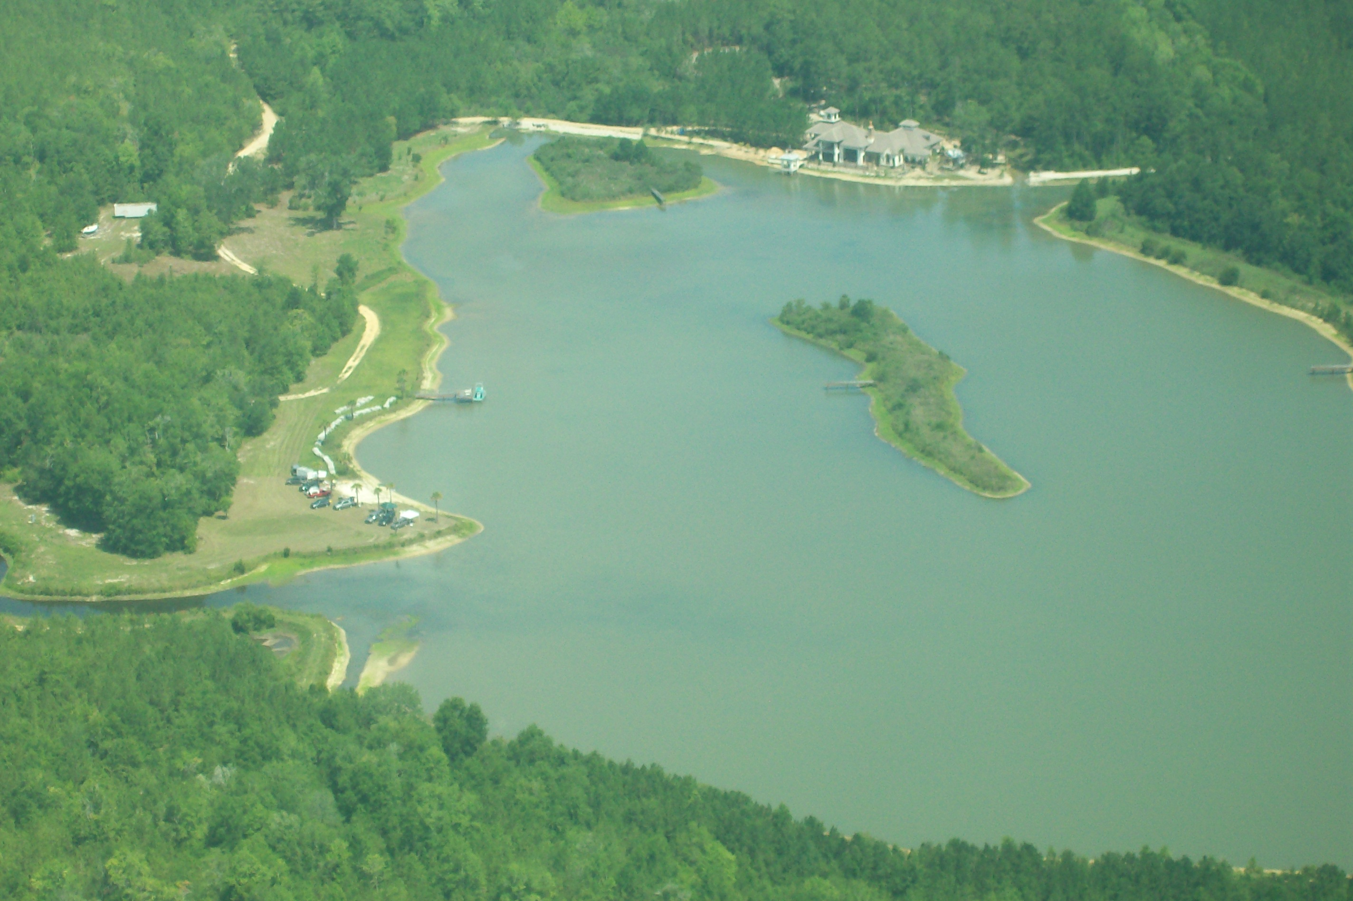
Frank Bastos of HobbyTown announced he was organizing a Hobby Expo for next summer and is looking for ideas. He was thinking of a “swap meet” format to include the train and RC car people. Since the train guys already have a building at the fairground reserved for July 26, 2008, he could get the building next door. Frank asked everyone to think about it and give him your input.
With no additional business, the meeting was adjourned at 7:33 PM.

Lake Serovec- Home of the Float Fly. Photo by Jeff Owens

Pilot Briefing- Jay Luedecke
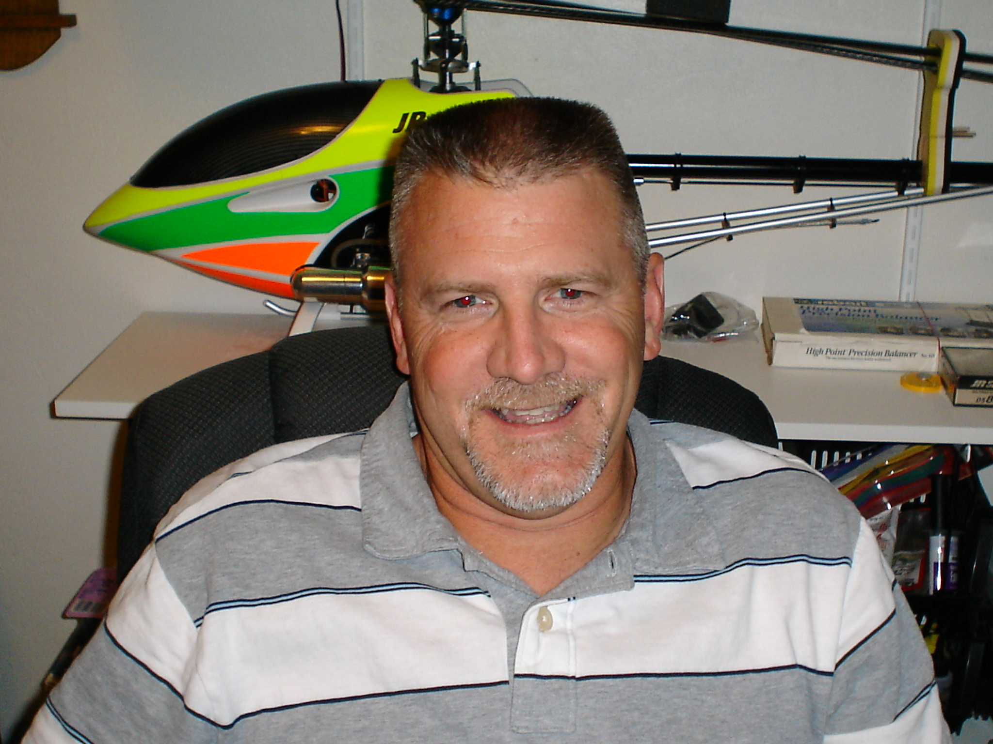
Where are you from? I was born in San Antonio Texas and was raised in Sealy, Texas where most of my family still lives.
What do you do for a living? After many years of printing, I eventually discovered a new career passion working with AutoCad. I am currently using my AutoCad and Mapping skills as an Engineering Technician/Designer at Florida State University.
How did you get started in radio control? Richard Lovern introduced me to the hobby in 1997. After visiting the club airfield several times, Gordie Meade, Dave Sellars, Dave Harding, and Buck Harris sparked my interest in RC Helicopters and I have been learning to set up and fly them ever since.
What do you like best about the hobby? The good friends I have made throughout the years. I also like the never ending challenge of mastering these things.
What models do you have or would like to have? I currently have a Raptor 50, and hope to acquire an Avant Aurora Ultimate 90 (Phantom Helicopter) real soon. I would love to have a Vario Bell 412 Turbine with 4-bladed head.
What are your favorites and why? Any helicopter! I enjoy the mechanical marvels of rotary wing flight. The scale models are what really peaked my interest in starting the hobby years back. I enjoy trying to make the models fly just like the real thing. Unfortunately, I have not ventured into it yet. I think that time may be getting closer.
Other than just enjoying the hobby, are there any skills or maneuvers you are working on or want to master? Not really. I always try to work on different orientations each time I go fly and that usually results in getting comfortable with different maneuvers. Some of which are planned and some not!
Is there anyone in particular who has influenced your participation in the hobby? The guys I mentioned above influenced me the most when I was getting started. Without their (Gordie’s) set up help I would not be where I am today. Thanks guys! I am influenced by everyone now because we all have our own unique style that we share every flight.
Is there anything else you'd like to share? It’s all about having fun. Freak on!

From the Westlake RC Club, Inc., North Olmstead, Ohio

Learning the Art of Model Building
Building model airplanes, like any other artistic medium such as sculpture, landscape, painting, or flower arranging, is an art form in its own right. And like any other art form, it's a learned skill that takes time and dedication to master.
I try to bring a new model to the meetings every chance I get, and I always hear many who look at them say, “I could never do that,” or “it would take me 10 years to build that.” For the less experienced modelers among us, I can certainly understand how that could come to mind. However, those models are a culmination of more than 45 years at the drawing board and work bench, with the last 12 years having been “full time.” It’s safe to say that I have been fortunate enough to have packed a dozen average modelers’ lifetime achievements into my last five years of modeling!
With that being said, we all must understand that mastering the art of modeling will span a lifetime, and we can’t expect to start out where those who have been doing it for many years have aspired to. The good news is that modeling skills are not difficult to learn, it just takes practice. The main thing is that someone new to modeling must begin with a project simple enough to complete successfully—after all, there's no better motivator than success!
So where does one begin? Most of us in the club are RC fliers that fly Almost-Ready-to-Fly (ARFs) models; so naturally, the first thought would be to build an RC model. There are those among us who could accomplish this task just fine. However, that depends on many factors, such as wood-working skills, plans reading ability and so forth. For most, all of those skills will have to be learned right from the start, which might seem like a monumental undertaking! So here’s how I’d suggest going about it.
First: Keep the main objective in mind—learning to build models!
Second: Start simple!! The fact that your primary interest is flying RC models doesn’t mean your limited to building only RC models. Remember, the goal is learning to build. If you’re flying ARF's now, you can still hone your flying skills while you’re learning to build. Then when you do build your first RC model, your flying skills will be in good shape too.
Third: Don’t get in a hurry, and don’t get discouraged. There are no time limits on any project that are not self induced! And remember, this is a hobby and hobbies are about filling our time with enjoyable activities.
Here’s a suggestion for, shall we say, testing the water! Start out with a simple stick-and-tissue type Free Flight kit. The investment is minimal—$15.00 will go a long way in that realm, and the skills required to complete the model are really pretty minimal, but will go a long way toward building your skills. Then when you get it done, take it out and fly it. Learning to trim these models will also go a very long way in understanding RC models and what makes them tick. Then with each step, move up to something a bit more complex, and through just a few small steps, you will have learned the basic building and plans reading skills required to build an RC model.
Now, don’t expect the first try to produce a world-class model. Keep in mind that this is a series of small steps toward the larger goal of mastering the art of modeling, and with each step, work toward improving something, not everything, on your next model. Give special attention to the areas that were the most difficult on the first one, and before you know it, your basic skills will be forming nicely.
And finally, if you find yourself in a little over your head, ask questions of those of us who do build. Modelers by nature are a pretty good bunch of folks, and I haven’t met many who are not willing to help someone who is truly interested in learning the art of modeling.

The Flybar and Control Systems
Last time I touched on the question of the cyclic response of a model helicopter. We saw that the natural tendency is for the main blades to respond too quickly to cyclic commands. This happens because the aerodynamic forces acting on the blades are large compared to the weight of the blades. We can't do much about this because the lift on the blades has to be big enough to support the weight of the helicopter and so we can reduce the forces on the blades only at the expense of not having the helicopter fly at all!
The control systems employed on model helicopters almost without exception employ a flybar to overcome these difficulties.
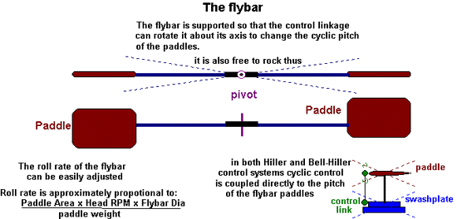
The flybar as illustrated here consists of a rod carrying small aero foils (paddles) and is pivoted so that it may rock. The angle of attack of the paddles is set by the cyclic control and they respond in much the way outlined for the main blades last time. Again, to roll the flybar to the right the angle of attack of the paddles is increased on going round the rear half of the rotor and reduced on going round the front half of the rotor. This is simply done by rotating the whole bar around its axis. Because the flybar is not responsible for lifting the helicopter the aerodynamic forces acting on the paddles can be tailored to give the required speed of response. It is best to think of the flybar as a gyroscope that can be steered by the cyclic controls but when not being steered tends to maintain its axis of rotation relative to the ground rather than the helicopter body or the air. The speed of response of the flybar to commands can be adjusted as follows:
      - Increasing the weight of the paddles slows it down.
      - Increasing the area of the paddles speeds it up
      - Increasing the rotor RPM speeds it up
      - Increasing the aspect ratio (span/chord) of the paddles speeds it up.
      - Increasing the length of the flybar speeds it up.
This last point was something that Ken Rudd touched on in W3MH some time ago. However it’s not obvious why this should be the case so let me just give my reasoning for it. If we take one size and weight of paddles and fit them to a flybar that has been lengthened by say 10%. We :
      - 1) increase the moment of inertia (the flywheel effect) of the flybar. This means that the flybar will need a greater torque to impose a given rolling or pitching rate on it.
      - 2) However, in putting the paddles further out we have increased the leverage that they have so that, for a given aerodynamic force on the paddles, we have a bigger torque.
      - 3) In addition, by putting the paddles further out we have, for a given head speed, increased the airspeed of the paddles and thus increase the aerodynamic forces they produce.
Now effect 1) acts to slow down the response of the flybar, and it involves a square law so a 10% increase in flybar length increases the torque needed for a given roll rate by about 20%. However, effect 3) also involves a square law so, with the paddles 10% further out they produce 20% more force for a given cyclic pitch. So effects 1) and 3) cancel one another out. This leaves effect 2) which is linear and so a 10% increase in flybar length speeds the flybar up by 10%.
The Hiller control system
This is the simpler of the two systems seen on models. In this case the cyclic controls are transmitted from the servos to the flybar only. The cyclic pitch variations of the main blades are then controlled entirely by the tilting of the flybar. The sequence of events that follows the application of a cyclic roll control go like this:
      - 1) Cyclic pitch acting on the flybar paddles causes the flybar to start tilting in the desired direction.
      - 2) As the flybar tilts cyclic pitch starts to be applied to the main blades and they start to follow the flybar.
      - 3) Torque from the main blades acting on the body accelerates it into the roll.
      - 4) The rate of roll of the helicopter settles down to that determined by the flybar.
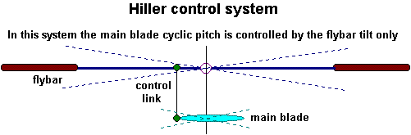
The amount of cyclic control applied to the main blades is automatically adjusted so that the correct roll rate is maintained. The more the main rotor lag behind the flybar the greater the cyclic control applied to the main blades and vice versa.
Bell-Hiller Control
The problem with the basic Hiller control system is the delay it introduces in the response of the helicopter. The pilot must wait for the flybar to respond before his cyclic commands get through to the main rotor. This means that a degree of anticipation is required by the pilot to get the control inputs in slightly ahead of their being required.
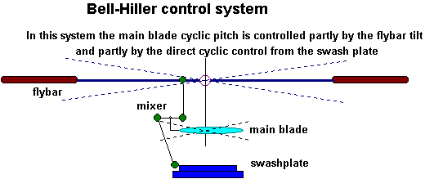
The Bell-Hiller system of control addresses this problem and has become almost universal in modern model helicopter designs. In this system the cyclic controls go to the flybar as before. A proportion of the cyclic control is also taken directly to the main blades and mixed with the cyclic control from the tilt of the flybar. The Bell-Hiller mixing ratio determines the proportion of the main blades cyclic control comes directly from the swashplate and how much comes from the flybar. When a cyclic control input is made the main blades now respond immediately to the command. Any tendency for the main rotor to roll too far or too fast is resisted. If the main rotor overtakes the flybar in the roll the control fed from the flybar to the main blades will reduce the cyclic control on the main blades and slow their progress. The beauty of the Bell-Hiller system is the degree to which the response of the helicopter can be adjusted to suit various requirements. For a beginner, the helicopter can be set up so that the flybar roll rate is very slow by using heavy paddles. The resulting machine can still have a quick response to cyclic commands because of the direct element of the main blade control that allows the main rotor to tilt before the flybar has moved. The slowly responding flybar helps in two ways. It limits the initial rotor tilt and acts to help return the rotor level after the command has been released.
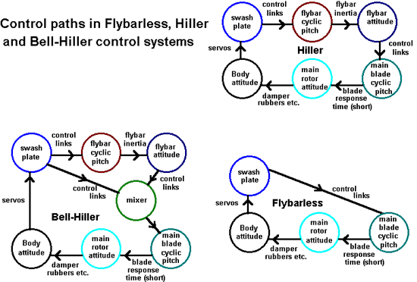
The flybar in forward flight
So far we have only considered the action of the flybar in the hover but it is interesting to see what happens to the flybar in forward flight.
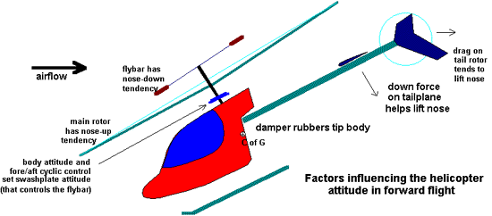
Normally the paddles of the flybar are set with no collective pitch. In forward flight the helicopter is tilted nose down and there is a net down flow through the main rotor. This means that the flybar paddles are at a negative angle of attack. As a consequence the paddles are pushing downwards. However, when the paddles are on the advancing side they have a higher airspeed and the down force is greater than on the retreating side. The paddles fall on the advancing side and rise on the retreating side resulting in a nose down tilting of the flybar. If this effect was not opposed the helicopter would take on a steadily increasing nose down attitude and dive into the ground. What opposes the nose down tendency? Previously we saw that in forward flight the greater lift of the blades on the advancing side causes the main rotor to have a nose-up tendency and this requires some forward cyclic control to be used if a constant attitude is to be maintained. The natural nose-down tendency of the flybar will go some way to provide this. A correct balance between the two opposing effects depends on many factors: Flybar length influences the advance ratio of the paddles. Bell-Hiller mixing ratio determines how much the main blade cyclic pitch is changed by the nose-down attitude of the flybar. The stiffness of the damper rubbers, etc. determines how closely the body follows the main rotor attitude. The attitude of the body determines the plane of the swashplate that in turn influences the cyclic pitch of the flybar etc, etc. Down force on the tail plane and drag on the tail rotor and the boom all provide a stabilizing influence on the nose-up nose-down attitude of the helicopter. Certainly, this seems to be one aspect of the helicopter where almost every component has some influence.

From the Windom Eagles, Windom, Minnesota

Thoughts for the Month
1. The easiest way to find something lost around the house is to buy a replacement.
2. Never take life seriously. No one gets out alive anyway.
3. Gardening Rule: When weeding, the best way to make sure you are removing a weed and not a valuable plant is to pull on it. If it comes out of the ground easily, it is a valuable plant.
4. An unbreakable toy is useful for breaking other toys.
5. If quitters never win, and winners never quit, then who is the fool who said, “Quit while you’re ahead?”
6. Get the last word in: Apologize.
7. All of us could take a lesson from the weather. It pays no attention to criticism.
8. Health is merely the slowest possible rate at which one can die.
9. Health nuts are going to feel stupid someday, lying in hospitals dying of nothing.
10. Whenever I feel blue, I start breathing again.


Tips & Tricks

Recycling Masking Tape
I use the clear backing on the MonoKote film to recycle my masking tape if it is still in fairly good condition. It keeps the adhesive from going bad. When I need the tape, I just peel it off.

Protecting Hinges
Petroleum jelly often has been used on pinned hinges to prevent epoxy glue from sticking to the hinge joint; however, it is difficult to get just the right amount on the hinge and to make sure the hinge is completely coated. A very cool way is to melt the petroleum jelly in a small dish such as a dessert dish (an oven safe type, of course). Use only enough to melt to a depth of about 1/6 of an inch. Fold the hinge and dip the pinned end into the melted jelly. Remove and touch the hinge and dip the pinned end into the melted jelly. Remove and touch the hinge to a paper towel to remove excess. In a couple seconds, the petroleum jelly cools and has penetrated the hinge. You now have a completely coated hinge joint that epoxy will not stick to.
—both from Schoolcraft Skyhawks R/C Airplane Club, Schoolcraft, Michigan.

Stir Sticks (Popsicle sticks)
Next time you are in the craft shop, pick up some Popsicle sticks. They come in boxes of 100, 500, or 1,000 and they are cheap. You will be able to use these for all kinds of things like servo rails, reinforcing splices, skids, fuel tank stops, mixing epoxy—any place where you are going to put in screws. You will find all kinds of uses for them.
—From the Niagara County Radio Controlled Model Flying Club, Lockport, New York.
I would like to comment on the following "TIP" contained in the latest SRCC Newsletter.

Home Brewed Model Cleaner Revisited
I don't remember where I read this but it was in one of the modeling mags. The formula below makes one gallon of cleaner. It works good just watch out for the fumes from the ammonia when you mix it.
• 10 Parts Water (90oz) (11 1/3cups)
• 2 Parts Denatured Alcohol (18oz) (2cups)
• 1 Part Ammonia (9oz) (1cup)
• 1/4 Part Dish Detergent (2oz)"
Dave Sellars writes- “There's no doubt that the above formula will work extremely well as a cleaning solution. However, the use of any cleaning solution containing ammonia is NOT recommended for R/C models. Ammonia is highly corrosive and servo connectors, gyro connectors, receiver contacts, etc. that are exposed to ammonia will eventually corrode and will result in a disconnect. Think about that green crud that shows up on the battery terminals in a flashlight over time. BTW, Simple Green is great, but it too has also been reported to be highly corrosive when used on aluminum.
If one wanted to use the above formula to "mix your own", an additional cup of alcohol could be substituted in the place of the cup of ammonia.
If one chooses to use a commercial product to clear an R/C aircraft, it is recommended that one use a product that does NOT contain ammonia. Check the contents before purchasing the product. For example, use Glass Plus NOT Windex, etc. One of the best solutions is regular isopropyl alcohol that you can buy at Wal-Mart for about $.40/per bottle. It cleans well, is not corrosive, and the residue will quickly evaporate.” Thanks Dave, Ed.

REDUCING DRAG -by Clay Ramskill
This subject is tough, assuming we want to stay clear of complexity. To get into the nitty-gritty of drag reduction, we need a wind tunnel, some heavy computations, and a whole bunch of witchcraft!
So we'll stick to some more basic principles, and leave the name-dropping and number crunching to someone more learned than we are!! We do, however, have to make one distinction -- drag due to lift. That is pretty much separate from the rest, because it's strictly a function of lift -- the more lift we need, the higher the angle of attack our wing must operate at, the more lift drag we have. And once our wing area, shape, and airfoil are established, there's really only one control we have, and that is the weight of the plane.
Put simply, the heavier the plane, the more this form of drag will degrade performance, throughout the speed range!
Having gotten past that, there are several other drag components to look at -- skin friction, form drag, and interference drag, as well as cross-sectional area.
Cross-sectional area is easy. The more air you have to push aside as you go through it, the more drag. So we need to keep fuselages reasonably slender, airfoils reasonably thin. But the size is not nearly as important as shape.
Form Drag: Good "streamlining" is an area where we can really see some results. What we'd like to see is every component of the plane shaped like a good symmetrical airfoil -- or like a drop tank as seen on jet aircraft. At the speeds we're interested in, a really sharp point in the front is not necessary (that's what you see on supersonic planes!). What is desirable is a nice smooth curvature.
Where we DO want the "pointiness" is at the rear. A good, smooth, continually tapering curve ending at a relatively sharp trailing edge or point. The main thing to avoid is abrupt or angular changes in the airflow.
Retracts: Easily the worst contributor to drag is the landing gear. Fixed gear drag can be reduced by wheel pants and cuffs on struts -- but retracting gear is the obvious solution. There is, however, weight, complexity and expense penalties.
Now, let's look at skin friction. First, the less skin, the less friction! Rounding corners not only cuts form drag, it cuts the skin area. Round forms enclose the most interior volume with the least skin area. A smooth skin cuts drag -- dirt, rough covering overlaps, and covering wrinkles all increase drag. You won't do much better than good sanding and Monocote! We should point out that sharp corners, even when aligned with the airflow, will tend to increase turbulence and produce more drag. A rounded fuselage is less draggy than square -- the same goes for wingtips.
Interference Drag: We did a nice little wind tunnel experiment in school: we measured the drag of a fuselage, and then the wing. Then we put in the wing and fuselage attached together. The combination had extra drag beyond the sum of the components!
The interference caused by projecting objects (like wings, landing gear, gear struts, stabs, etc.) can be reduced, usually by the use of fillets. These were quite pronounced on WWII fighter wings, as on the Spitfire and P-40, and just rounded off the interior square corners, carrying the rounding well aft of the wing. You'll see these on pattern and racing planes.
Projections: The best solution to projections is -- get rid of them! Retract the landing gear, hide the control horns, enclose the radio antenna, countersink the bolt heads, etc. Cowl in the engine, use an enclosed muffler. Look at a competitive pattern plane -- you'll see all of these features.
Like most things aerodynamic, drag reduction involves many details, all of which add up in achieving your goal. "If you want to go fast, get out, the sandpaper"? Yep, but remember, we need both a smooth skin AND a smooth form!
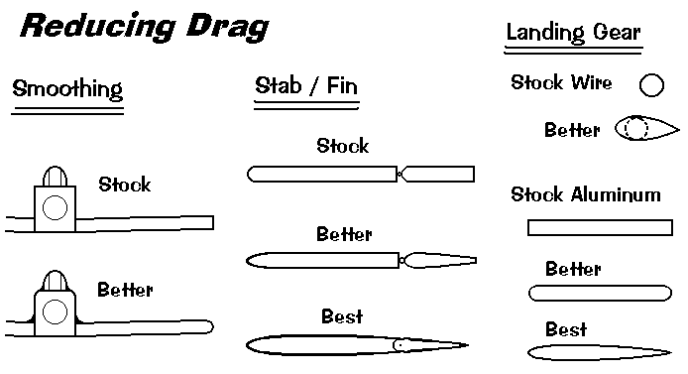

Seminole Radio Control Club
Tallahassee, FL

AMA Charter #216, 1969-2007

SRCC Officers

President – John Hall
Vice President – Brad Sharp
Secretary/ Newsletter Editor – Stephen Warmath
Treasurer - Sam Varn
Field Marshall – Chris Bailey
Field Safety Officer- Shannon Black

Field Hours

12 Noon till Dark- These hours apply to all aircraft, gas and electric.

Training Notes

To schedule a training time contact Mike Atkinson.

Flight Instructors
Mike Atkinson- Primary/ Advanced Fight Instructor (Coordinator) 926-4692
Geoff Lawrence- Primary/ Advanced Fight Instructor 942-9807
Mike Kinsey- Primary/ Advanced Fight Instructor 566-0144
John Hall- Primary/ Advanced Helicopter Flight Instructor 893-6457
Jay Leudecke- Primary/ Advanced Helicopter Flight Instructor 508-7135
Jeff Owens- Ground School/ Airworthiness Instructor (Fixed Wing) 894-2504
Steve Warmath- Ground School/ Airworthiness Instructor (Fixed Wing) 509-0672
Frank Bastos- Hobby Town Flight Demonstrator 671-2030
Don Coon- Leon High Aerospace Club Instructor 488-1971 x 1950

Club Meeting Location and Time –Meetings from April thru September are at the Field starting at 7:00.
The regular club meetings are held on the first Thursday of each month at 7:30 PM at the Grace Lutheran Church on Miccosukee Rd. Head out Miccosukee Rd., cross Capital Circle NE, and the entrance will be the first one on your right. Once you park, follow the sidewalk around the left side of the building and go down the hill. We meet in a room on the first level.
Newsletter Submissions- Submissions are requested to be in M.S. Word format. Photos should be in .jpg or .tif format. Vector art accepted in Corel, Illustrator and AUTOCAD format. We will, however, accept anything to make it easier for those who wish to contribute. Submissions are due no later than the 23rd of the month. Send your submissions to ssw@nettally.com or by phone, Steve Warmath at 509-0672.
Hard Copy Printing of the SRCC Newsletter provided by Apogee Signs & Graphics.



