The Seminole Flyer www.seminolerc.com


A chartered member of the Academy of Model Aeronautics

AMA Charter #216, 1969-2007

“The Seminole Flyer” is a publication of the Seminole Radio Control Club of Tallahassee, Florida DECEMBER 2007

INDEX
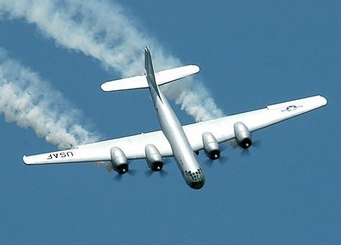

Letter from the Editor
- Chief Pilot Report
- Chief Copilot Report
- Chief Treasurer Report
- Chief Scribe Report
- Pilot Briefing- Geoff Lawrence
- Beginner’s Corner
- Take More Chances
- The Model Jet Engine
- A Christmas Poem
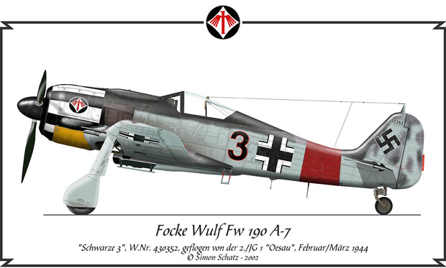

Letter from the Editor- Stephen Warmath


“All I want for Christmas is my two front teeth”………
Oh, wait a minute; I have my two front teeth. So maybe a G4 Flight sim…. or a Top Flight B-25… or another monster floatplane? Mmmmmmmm…so many possibilities. This is the time of year that really brings out the kid in me. I’m sure it does for others who enjoy this great hobby. Having said that, may all of you enjoy a very happy holiday season and a prosperous new year. And, as it has been said before, “support your local hobby shop”.
This month we feature in the Pilot Briefing one of our solid members, past Club Member of the year and 2006 Vice President, Geoff Lawrence.
This month’s video link fits into the “Someone was bound to do it” category; a vectored thrust, twin turbine Mig-29. This thing is amazing in what it can do. http://www.wservernews.com/4HA6HM/071119-RC-Mig29

With our beginners in mind, who may get their first airplane for Christmas or just want some general information, a Beginner’s Corner is featured this month. Following this naturally, is the emotional side of those occasional mishaps that addresses the notion that it might actually be ok to Take More Chances- Enjoy More Crashes. Curious about Model Jet Engines? A short intro; The Model Jet Engine is included.

On a personal note, I am ex-military and I have experienced the emotional stress of being away from home and family during the holidays. But deep down, one feels a sense of purpose and service to one’s country. In my perusal of information on the web, I ran across this Christmas poem I would like to pass on to the members. (It is neither a political statement nor an endorsement of any particular military action, but recognition of those who serve our country and cannot be home this time of year to enjoy the holidays with friends and family.)

And finally, one more piece of business. We will be electing the 2008 Club Officers at the December meeting. As of this publishing, the following slate of candidates is proffered:

President- Shannon Black

Vice President- Chris Bailey
Secretary- Steve Warmath- incumbent
Treasurer- Sam Varn- incumbent

Any additional nominations may be made at the meeting and prior to the official voting. As prescribed in the Club Constitution, Officers for the new year shall assume the duties of their office at the conclusion of the regular December meeting.

Happy Holidays and a Prosperous New Year- Steve

Chief Pilot- John Hall

Since this will be my last entry as "Chief Pilot", I would like to take this opportunity to thank everybody who helped make this a good year for the Seminole RC Club. Special thanks to those club members who volunteered their time to help maintain the field or promote our club at the various events we participated in this year. And thank you to the other club officers who also give of their time to help keep the club functioning.

Please try to attend the December meeting (Thursday, Dec. 6th, 7:30pm at the church) where we will be electing club officers for 2008.

Thanks for a good year and see you at the field,
John

Chief Copilot- Brad Sharp
Upcoming Club Events

December 6, 2007- Club Meeting at Grace Lutheran Church. 7:30 pm. Annual Officer Elections.

Upcoming AMA Regional Events

Chili Cook-Out
FL
12/01/07-12/02/07 - Palm Bay, FL (AA) Chili Cook-Out for Cat III 101, 140, 142(J)(SO), 102-120, 122-124, 128, 150-156, 157-160, 162, 163(JSO). Site: Palm Bay. Jerry Wagner CD, 1767 New Pt Comfort Rd Englewood FL 34223 PH:941-474-4959. Sponsor: FL MODELERS ASSOC

Santa Fly In
FL
12/01/07 - Dunnellon, FL (C) Santa Fly In. Site: Rainbow Field. Donald Adkins CD, 5440 N Peppermint Dr Beverly Hills FL 34465 PH:352-527-2047 email: dshobby@mindspring.com. Landing fee is new unwrapped toy(s) with a value of at least $10. This event is held in conjunction with local Fire Department Toys for Tots Drive. Catch the spirit and help a poor kid. On site RV parking, no hookups. Great food at our on site rainbow café. 100' x 600' grass runway. Visit www.tricountyrcclub.homestead.com. Sponsor: TRI COUNTY R/C CLUB

4th Annual Toys for Tots Fly In
FL
12/01/07 - Jacksonville, FL (C) 4th Annual Toys for Tots Fly In. Site: Lannie Rd Flying Field. Robert Davis CD, 7052 Arlet Dr Jacksonville FL 32211 PH:904-343-7116 email: bobdavis68@comcast.net. Bring a new unwrapped toy for a boy or girl as your landing fee, or $10 cash. All toys and landing fees will go to Toys for Tots. Prizes and raffle. Hot and cold drinks, food. Modern restrooms facilities on property. Visit www.gatewayrc.org. Sponsor: GATEWAY RC
IRCC Winter IMAA Fly In
FL
12/01/07-12/02/07 - Mulberry, FL (C-Restricted to IMAA) IRCC Winter IMAA Fly In. Site: Newell Terry Field. David DeWitt CD, 1810 Staunton Ave Lakeland FL 33803 PH:863-838-4459 email: benz425@aol.com. IMAA size and safety rules apply to all aircraft. 3D flying will be permitted on designated times. No turbine powered models. $10 weekend landing fee. Visit www.imperialrcclub.com. Sponsor: IMPERIAL RC CLUB

Fall Electric Classic
FL
12/01/07-12/02/07 - Venice, FL (C) Fall Electric Classic. Site: Memorial Field. George Faketty CD, 219 Coral Rd Venice FL 34293 PH:941-223-0855 email: g.faketty@juno.com. Breakfast/lunch/rustic camping. Exit US 75 East at Exit 195 (Laurel Rd) go 1 block to Knights Trail Rd turn lft (North) follow RC Flying signs. Obey all speed limits. Sponsor: RC FLYERS OF VENICE

3rd Annual Battle for BOCA
FL
12/08/07 - Delray Beach, FL (A) 3rd Annual Battle for BOCA for 755(JSO). Site: RC Flying Site in Palm Beach Downs Park. Chris Handegard CD, 2774 New York St West Palm Beach FL 33406 PH:561-832-1921 email: chandegard@peersonaudio.com. RC Combat contest, AMA rules for Open B Combat apply. Field open 8am, Start combat 10am, entry fee $20 includes lunch. Trophies 1st to 5th place. Visit www.rccombat.com to sign up on line. Sponsor: PALM BEACH RC ASSOCIATION

2007 Winter Tangerine Pattern Classic
FL
12/08/07-12/09/07 - Apopka, FL (AA) 2007 Winter Tangerine Pattern Classic for 401-406 (JSO). Site: Club field. Steven Homenda CD, 1829 Sparkling Water Cir Ocoee FL 34761 PH:407-294-1436 email: homenda2@yahoo.com. FAI "P" on Saturday, "F" on Sunday, $30 entry fee, includes lunch on Saturday; field open for practice Friday before contest @ noon; campers welcome - no hookups; lodging nearby; Orlando Frets - co-contest direction. Visit www.rcacf.com. Sponsor: RCACF

Warbird Fly In
FL
12/08/07-12/09/07 - Sarasota, FL (C) Warbird Fly In. Site: Club Field. Dave Hasler CD, 12117 Clubhouse Dr Bradenton FL 34202 PH:941-727-4137 email: haslers@hotmail.com. Club field located 2 miles east of I75 on Bee Ridge Rd. Warbirds of all sizes welcome. Food concessions, overnight RV parking, no hookups, $10 landing fee for one or both days. Visit www.sarasotarc.com. Sponsor: SARASOTA RC SQUADRON
Big Bird Fly In 80+
FL
12/08/07 - St Petersburg FL (C) Big Bird Fly In 80+. Site: Club Field. Arthur Lavallee CD, 66146 Tudor Rd Pinellas Park FL 33782 PH:727-544-1939 email: asylval@tampabay.rr.com. Sponsor: SPARKS

Gateway RC Winter Swap Meet
FL
12/08/07 - Jacksonville, FL (C) Gateway RC Winter Swap Meet. Site: Lannie Rd Field. Kevin Wilson CD, 10527 Old Plank Rd Jax FL 32220 PH:904-693-3806 email: kwilson@deximaging.com. Free admission, no charge to set up, tables limited, 1st come 1st serve. $5 landing fee. Concession stand and restrooms. Visit www.gatewayrc.org. Sponsor: GATEWAY RC CLUB
Warbirds Over Ft Valley, GA
GA
12/14/07-12/15/07 - Fort Valley, GA (C) Warbirds Over Ft Valley, GA. Site: Duckworth Field. Norman Deputy CD, 117 Devonshire Rd Warner Robins GA 31099 PH:478-328-2689 email: ndeputy@bellsouth.net. Giant scale warbirds fly in, 80" + mono, 60" + multiwing, in military or civilian colors, must be a warbird replica. Registration and flying 9am-5pm both days, concessions on field. Co-sponsored by The Giant Scale Warbird Assn. Visit www.giantwarbirds.org or www.gamarc.com. Sponsor: GEORGIA AIRCRAFT MODELERS

54th King Orange Internationals
FL
12/29/07-12/31/07 - Palm Bay, FL (AAA) 54th King Orange Internationals for CAT III 101-105, 101C-105C, 106, 120, 122, 124, 128, 140, 142, 150-155, 158, 160-162 (JSO). Site: Club field. Bill Barr CD, 2235 Chinaberry Cir SE Palm Bay FL 32909 PH:321-725-5063 email: bdbarr@strate.net. FAC events: R/C 1/2A Texaco, A Texaco; Nostalgia & Rubber Gas events; Open Towline Glider; E-36; Bounty Hunter; F1Q. Sponsor: FLORIDA MODELERS ASSOCIATION
Chief Treasurer- Sam Varn
Editor’s Note: The Treasurer’s report is published for Members only. The public version of the Newsletter does not include this information.

The big message I want to get out is to remind everyone to renew his or her AMA. I will be checking their status after the first of the year and a new NO FLY list will be issued.
Our numbers haven’t really changed except for the addition of three new members. The only change would be to the checking account by a little less than a couple hundred dollars.

Here are our numbers:

Cash - $0.00 Checking (CCBG) - $0.00 Checking (Premier) - $0.00
CD - $0.00 Savings - $0.00
Total Funds - $0.00

That's all folks!
Sam

Chief Scribe- Steve Warmath
The November Club meeting was called to order at approximately 7:35 pm.

Visitor/ New member Introductions- None

The Treasurer’s Report- Sam read off the current account amounts. He said the good news was we had earned $3.36 in interest on our new checking account at Premier Bank. There had been no activity for the month except for one new member sign up the day of the meeting. Motion was made to accept the report, seconded and passed.

Old Business-
- Joe Satterwhite wanted to correct the last meeting minutes to reflect that the new lawn mower engine was being stored at the field vs. at his house, as reported.
- John wanted to talk about the fencing that was removed from the field. He said that after sending e-mails to the members and talking with members, no one has stepped forward to take responsibility. He did not pursue it at the last meeting. Whoever took it down went against members vote to keep it up. He stated he was worried that this action could set a precedent. This action cannot be tolerated. Acting unilaterally against decisions voted by club members is not acceptable. All fence material was hauled off and the holes in the ground were left open. John did not believe outsiders did it. He felt he got the word out to everyone, and felt somebody should know who did it and should step forward. When he asked for discussion, there was none.
- Frank Bastos reported the Boy Scout event was fun along with a few crashes. The format was a Float Fly. He felt it was a nice alternate site to fly. He spoke with one of the Rangers and he said we could fly there any time. Canoes are available for retrieving planes. We may need to get one-day insurance coverage to fly there on a regular basis. Geoff Lawrence also agreed it was a good site. There was not a lot of space at the lakefront, but there are two docks. Mike Atkinson also agreed it was a good alternate site. Lots of flying room. Scout participation was low due to late getting the word out. We should do it again next year and plan better for it. Frank said maybe 100 people looked in with over 1,000 in attendance.
- John said he had received e-mail from Fred Schmidt about the Killearn Lakes Community Event. A soccer field will be used for casting event but could share with small planes/ helicopters. There will also be a ball field but it will have inflatable structures on it. We would need to be able to fly in a small vertical space. It is scheduled for November 10th with a 12:00-2:00 window for flying. If interested in participating, let John Know.
- Joe Satterwhite noted the new first aid kit was $21.00 and at the field. The fire extinguisher was on the way.
- Vernon Brouse noted he had given the gate lock code to the County mowing crew.
- John noted that someone was riding a motorcycle on the field. It appeared to be a father training a young person. There was no damage to the field.

New Business-
- Jeff Owens- May 21, 2008 is the posted EAA AIRFEST Event
- No Fall Fly-In this year. Too late to schedule and a lot of conflicts.
- Marvin McRae noted there hadn’t been many young, new members at the field lately and was wondering about Club roster. Sam noted that for the year, we lost 40 members through attrition. He said it was not uncommon to see cycles where membership increases in the Spring and then taper off in late Summer and Fall. There was a question about the Leon Aerospace Club’s lack of activity with the Club. Mike Atkinson thought it was a problem for them to afford AMA insurance. Frank Bastos noted his airplane business at the shop was down 30%. There were other comments discussion relating to trend in the hobby and are paraphrased as follows:
- Shift in market to easy planes to fly not requiring RC fields or AMA.
- Cost of Club and AMA dues.
- Possible recruiting of new members.
- The need for more Club activities that involve the public, particularly young people.
- Incentives for new first year members
- New flyers needing flight training having to wait around or just show up expecting help. We don’t have enough flight instructors at the Field on a regular basis.
- Possible activities for recruiting new members through Mall Shows, Airfest, Motorcycle Rodeo, Boy Scout Jamboree.
- Flying or not flying not a big deal to the public. Display is very important.

- Frank Bastos mentioned he was pursuing a joint hobby show along with the regular train show in July or August. It would include aircraft and RC cars and call it a “Hobby Expo”
- We want to schedule at least 3 main events for ’08. It was too late to plan any events this year, but now was the time to start planning.
- Jeff Owens reported on the status of the new Pattern Association. He had attended a meeting in Orlando and found they wanted to schedule 4-6 events in Florida. The first will be December 1-2 in Apopka. Jeff had mentioned the possibility of our Club hosting an event. He was asked about logistical requirements. Most needed are scorekeepers, runners, concessions, TX impound and a Contest Director. General Club flying would be limited for two days. There would be 4 rounds on Saturday and 2 rounds on Sunday. Jeff said he would be competing in the December event and would note how the event was run.
- The floor was opened to nominations for Officer elections.
- Mike Atkinson was nominated for Vice President.
- Shannon Black was nominated as President
- Chris Bailey was nominated for Vice President
- Mike Atkinson withdrew his nomination in favor of Chris
- No new nominations for Secretary or Treasurer. Steve Warmath and Sam Varn will be on the ballot as incumbents.
- Additional nominations may be heard at the December meeting prior to the official election.

- Members were reminded to consider their choice for 2007 Member of the Year. Vote will be cast at the December meeting and announced at the January meeting. Appointments to Safety Officer and Field Marshall will also be made in January.
- New Field/ Park plans closed for 5-8 years. No meetings are scheduled.
- Meeting Venues were mentioned. Public places don’t work well unless we can get a private room. Jeff said catered in meetings work great for EAA. No additional discussion about changing meeting location.

With no additional business, the meeting was adjourned at 8:40 pm.

Secretary Note- The following Club Members are on the ballot for 2008 Club Officer elections in December.

SRCC Officers

President – Shannon Black
Vice President- Chris Bailey
Secretary - Stephen Warmath (incumbent)
Treasurer - Sam Varn (incumbent)

Pilot Briefing-Geoff Lawrence
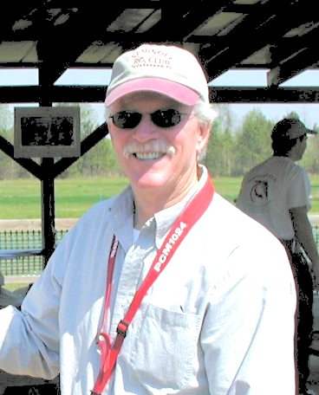

Where are you from? I was born in Tallahassee at the old Dale Mabry Field hospital the year prior to TMH being established. Maybe that has something to do with my interest in airplanes. I spent a year in Memphis and three in California in the Navy.

What do you do for a living? I'm retired from IBM. Former Service Representative and Service Manager.

How did you get started in radio control? I suppose my older brother was my original spark in aviation and models. He helped my build and fly .049 control line profile planes as a kid. Returning to Tallahassee in 1970, I joined the newly formed Seminole RC Club and after one unsuccessful attempt to learn to fly on my own, I received help and learned to fly on a Dave Robolon Pronto. I've since scratch built and occasionally fly that same plane.

What do you like best about the hobby? I love the proliferation and diversity of really cool airplanes on the market. I enjoy "assembling" the new generation of ARF's. I think they represent tremendous value for the planes we get nowadays and the competition just keeps driving the quality up.
Mostly I enjoy the camaraderie at the flying field, especially the group of regulars on Tuesday afternoons. You can have airplane and motor conversations at the field you can't have any place else.

What models do you have or would you like to have? What are your favorites and why? - My favorite is always the last one I've completed and flown. Right now it's a GP Skybolt biplane with a Saito 100. It may be my all time favorite airplane. I enjoy seaplanes and float planes a lot. I've found you don't always have to wait for a float fly to fly seaplanes. My SeaMaster and Cessna 182 on floats fly just fine off grass. I really love the warbirds. I have a KMP Hellcat with a Saito 120 and retracts. The history of the various military aircraft is fascinating to me and I always try and learn all I can about the various planes I have models of. Would you believe the PBY Catalina sunk more tons of enemy shipping than any other plane of WWII?

Other than just enjoying the hobby are there any skills or maneuvers you are working on or trying to master? Spin recovery. I've lost more airplanes from spins than any other single cause.

Beginner’s Corner

Simple Park Flyers are a great introduction to radio control flying and you can fly them straight out the box without too much trouble, even if you've never flown an rc airplane before.
But before you do, always read the manufacturer's instruction manual before you do anything!
The information that follows on this page should only be taken as a general rule of thumb - refer to the proper manual for setting-up and flying tips for your particular airplane, this is very important. It is also very helpful to seek out experienced flyers at the local RC field. Check at your local Hobby Shop for information.

Weight and balance
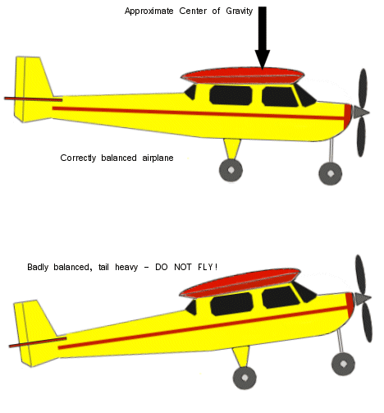
If you've purchased an RTF kit and followed the manufacturer's instructions, the weight and balance should be OK but it is always necessary to check the balance before flying any model airplane, as an incorrect balance will cause the plane to crash immediately.
All flying model airplanes, just like real ones, have a center of gravity (CG) that effects the plane's balance and thus its flying characteristics.
This CG, as a general rule, will be approximately 1/3rd of the way back from the leading edge (front edge) of the wing.
To test your airplane's balance, place the tips of each index finger under each wingtip 1/3rd of the way back. Gently lift the model up so it balances on your fingertips.
If the balance is correct, the model should be either level or with its nose pointing slightly downwards.
If the tail is pointing downwards do not fly it yet! Instead you need to add weight to the nose of the model. Modeling clay or fishing shots are ideal. Add only enough to make the plane balance correctly.
Getting the balance correct is of paramount importance if you want to keep your airplane in one piece.

Pre-flight checks
Pre-flight checks are essential for any flying model airplane. Even obvious things can be missed if you're too eager to get the model in the air, and such mistakes normally result in a crash!
Your model's instruction manual should outline the pre-flight checks needed for that specific airplane, but as a general guideline basic checks include:
- Wing securely fastened
- Control surfaces moving freely and correctly
- Motor operation correct
- Radio control gear (batteries) OK
To test the radio gear properly, here's what you should do - switch on the transmitter, then the receiver, and with the transmitter antenna fully collapsed, walk away from the model backwards to a distance of 30 feet or so. As you walk, keep moving the rudder stick left and right and watch the rudder of the airplane. If you only get a few feet away and the rudder starts 'twitching' or not responding to the stick movements, do not fly. Check the batteries of the radio gear, they may need replacing.
If they are new but the rudder still doesn't respond properly, then other people may be flying model airplanes nearby on your frequency. Again, do not fly if this is the case as the interference may cause the plane to crash.

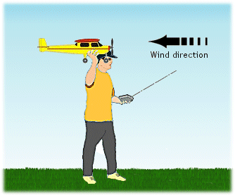
The test glide
While not necessary, you might want to test glide your model before flying it. The purpose of this is to assess its glide characteristics and to give you an idea of what to expect if the motor runs down unexpectedly.
A test glide is best done over long grass if possible - if something is wrong then the model will have a soft landing.
Do the pre-flight checks as per the manual and when ready, turn on the transmitter first, then the receiver switch on the model. Extend the transmitter antenna fully.
Make sure that all controls respond correctly and that control surfaces move in the correct sense ie moving the stick on the transmitter left moves the rudder left etc.
Holding the airplane at face-level and facing into the wind (important: flying any rc airplane is best done in a gentle breeze or no wind at all - if it's a windy day, wait for another!), gently launch the model from your hand. Don't throw it like a dart, a smooth but firm push is all that's needed.
Be sure that the plane is level, or pointing slightly downwards when you launch. If it is launched pointing upwards, it may stall and crash.
All being well, it should glide gently to the ground after a smooth, even flight (use rudder to control the glide direction).

The powered flight
Assuming that all is well with the model and radio control gear, and you've maybe performed a successful test glide, you're ready for your first powered flight!
There are 2 ways of launching; you can hand launch, as described above for the test glide or you can take off from the ground.
We'll focus on a hand launch as this is sometimes the only option with some rc airplanes, and take-offs are covered a bit further down the page.
With all checks complete and radio gear on (don't forget to turn on the receiver in the plane too - I have seen a model plane launched, only to smash into the ground seconds later because the operator only turned on the transmitter!) fully extend the transmitter antenna and hold the model at face-height, pointing level or slightly downwards and into wind.
Switch on the engine to full power and give the airplane a firm push out of your hand, but not too hard.

As soon as it has left your hand, hold the transmitter with both hands, thumbs on sticks.
Always hold the transmitter so that the antenna is pointing upwards at least 45 degrees - this maximizes the signal strength.
Important: use small stick movements to start with - over compensating is the biggest cause of first flight mishaps!
Once the airplane flying, use elevator to control the climb - you don't want it to disappear into the clouds, and you don't want it too close to the ground, either.
A safe height is around tree-top height, say, 40 feet or so.
Once you've settled at about that height, gently turn the plane and get used to its characteristics, remembering not to make sharp turns!
Don't move the sticks to their maximum positions - keep the moves soft, smooth and small.
Use common sense; don't fly close to people or objects and keep the model at a sensible height and distance from yourself, but not too far away that you can't see it properly - although the radio control gear has a range of hundreds of feet, you don't have to fly your airplane far before it gets too small to see what it's doing.

Trimming the airplane
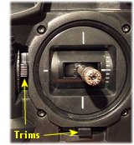
'Trimming' is the term used to describe the action of adjusting the airplane controls while in flight, so that it flies in a straight and level line on its own - or, at least, is as stable as possible without any input from your thumbs on the tx sticks.
You may find that the model has a tendency to turn one way or another when you aren't steering it (particularly to the left) due to the torque from the motor.
Use the small trim tabs on the transmitter to fine-tune the controls, but these may vary from model to model.
After you move a trim tab, let the model fly on its own for a few seconds, then re-adjust accordingly. The aim is to get the model flying straight and level with the tx sticks in their neutral positions.

The take off
If your plane has an undercarriage and you are flying from a smooth, flat surface such as tarmac you might prefer to take off from the ground rather than hand launch.
With all checks complete, place the airplane on the ground facing into wind, and stand immediately behind it. Turn the engine on to full power and let the model accelerate along the ground.
You may need to use the rudder to keep the plane going in a straight line. Soon it will take off from the ground and you can fly it around.
If you are flying the airplane in an area of grass, the plane may not be able to get enough speed up for take off so you'll have to hand launch it instead.

The landing
What goes up, must come down!
All airplanes must be landed into wind whenever possible, this is very important. A crosswind landing is acceptable and sometimes unavoidable, but never try and land with the wind, it doesn't work well!
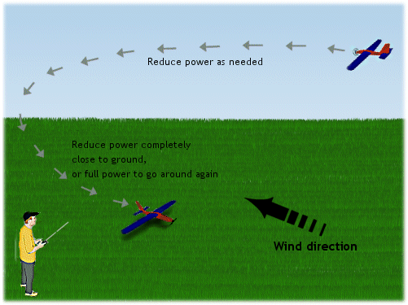
Fly a downwind leg a safe distance in front of you, either right to left or left to right, and turn the model back towards you when it is safely to your side (not directly in front).
Line the model up to where you want to land and reduce power or turn the engine off completely if there is no proportional speed control. Keeping it in a straight line using the rudder, let the model glide down in a smooth approach until it touches the ground.
Use the motor power softly to try and control the rate of descent of the plane - using elevators will obviously have the same effect, but will also effect the speed of the plane ie too much down elevator will increase the approach speed and vice versa.
If at anytime you are unsure about your final approach, turn the engine back on to full power and do another circle before lining it up for another landing.

Above, final approach and nicely set up for a greaser!
Alternatively you can of course go for the 'straight in' approach if you've been flying further out to your side - just bring the airplane in from the side and commence the descent as above.
There's no shame in missed approaches! It's better to try 5 times and go home with your model intact, than to rush a landing and take the model home in pieces! The landing is the most nerve-racking part of flying when you're new to the hobby, so remember not to panic if you're finding it hard to begin with.
Having said that though, always try and land well before the motor battery dies or you might be landing somewhere that you didn't want to!

Important tips to remember:
- When the model is coming towards you, the turns will be back to front. This is something that will catch you out in the early days, but you'll quickly get used to this 'reverse co-ordination'.
- If you get into trouble and your model isn't doing what you want it to do, cut the motor! 9 out of 10 times this will greatly decrease the chances of any serious damage, but of course this depends on the situation.
- Always make sure that the radio gear batteries have lots of charge before you fly; even just one dead battery will result in a dead model airplane, guaranteed! I know, because I've been there...!
- Be sensible and responsible.

Remember also that flying model airplanes for the first time is usually a nerve-racking experience so don't be too concerned if you find your heart in your mouth!
Just keep things smooth and practice at your own pace (and the model's).
With time you'll gain much confidence and will soon be able to move on to bigger and better rc airplanes, and impressive aerobatic stunts.
The most important point to remember when flying your model is this.... Enjoy it!

Take More Chances—Enjoy More Crashes
by Bob Karaseiwicz

As you gain in skills, you will take more chances. For instance, an outside loop with a trainer! Well, you just learned that the typical trainer will not do an outside loop (outside loop—from straight and level flight, push down; go down and around to straight, and level flight again.)
When your trainer has reached the inverted position and is trying to go up while inverted, it either won’t climb or falls off to the side. The likely result is a crash. The definite result is a learning experience.
Don’t give in to the temptation to blame your airplane, radio, the wind, the sun, or anything else external. The fault lies with your urge to try something new. Congratulations! You are well on your way to becoming an excellent flier.
Now, how does a beginning flier get out of a difficult situation? The answer, my friend—it depends. In the above outside loop situation, the experienced flier would stay in inverted flight and level off. Then either give up to do a half-inverted inside loop, or do a half roll to level flight. This comes with experience—experience in getting out of tight situations. The flier who never gets into a difficult situation—that is, never takes a chance—never progresses.
Is there a general method for getting out of trouble? Yes, only one. Before you try it, think about it and think about things that can go wrong. Remember the “three mistakes high” rule. You might want to discuss your attempts with an instructor beforehand. You definitely want to discuss your new maneuvers with someone more experienced afterward. If only to brag or find out what went wrong.
Oh, one more thing. Please make sure your attempts are safely out over the field, never near the pits.

The Model Jet Engine (gas turbine)
A model jet engine nowadays can be purchased from many places and this particular side of rc flying is becoming more and more popular as these miniature gas turbines become more readily available, as well as falling in price.
Having said that though, this aspect of rc flying is not for the novice! Many hours of experience and an impressive budget is still needed to actively partake in flying models with gas turbines.
These jet engines do, however, make rc jets completely realistic, enabling the model to fly and sound just like the real thing!
Even more recently, the engines are being used in rc helicopters too - again, making the scale jet-turbine helicopters much more realistic.
Shown below is a 'JetCat' turbine that is readily available to buy for an rc jet. This particular brand is one of the most popular and is available from JetCat USA:

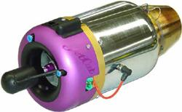

Model rc jets have traditionally lacked the authenticity of having a true jet engine until recent years; previously jets needed to be powered by either gas or electric motors with a propeller (thus spoiling the look of the aircraft), noisy ducted fan or 'pulse jets' (which are more rocket motors than anything else), but now they can be powered by a fully functional jet turbine.
A model jet engine can vary in design from one model to another, but they all work on the same principle: at the front of the engine is a spinning compressor - much the same as one to be found in a car supercharger. This draws the airflow into the chamber, slowing the air down and cooling it at the same time.
The fuel, which is nearly always kerosene, is introduced into the chamber as a very fine spray and so mixes with the air easily. This fuel/air mixture is then ignited by a small glow plug, much the same as the one found on a 2 or 4 cycle model airplane engine.
As the mixture ignites and explodes within the chamber, the temperature rises quickly and air expands greatly in volume. This hot air is then forced out of the rear of the combustion chamber, as it has nowhere else to go. It is forced out at great speed, thus generating a large amount of thrust to power the model jet through the air.
At the rear of the model jet engine is a turbine, which is also connected to the front compressor by way of a shaft running through the center of the combustion chamber.
As the hot air is forced out the back of the engine, it passes through this turbine and causes it to spin at high speed; this in turn causes the front compressor to spin, sucking in more air for the whole process to continue.
The drawing below shows the basic principle of a model jet engine:

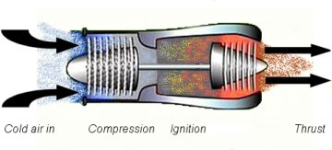

A model jet engine needs to be started with compressed air to initially power-up the turbine. This is commonly supplied from a diver's oxygen tank or something similar.
Only when the compressor has reached the necessary revolutions per minute (RPM), can the fuel be introduced into the chamber and the engine can then operate normally.

A Christmas Poem
The embers glowed softly, and in their dim light,
I gazed round the room and I cherished the sight.
My wife was asleep, her head on my chest,
My daughter beside me, angelic in rest.
Outside the snow fell, a blanket of white,
transforming the yard to a winter delight.
The sparkling lights in the tree I believe,
Completed the magic that was Christmas Eve.
My eyelids were heavy, my breathing was deep,
Secure and surrounded by love I would sleep.
In perfect contentment, or so it would seem,
so I slumbered, perhaps I started to dream.
The sound wasn't loud, and it wasn't too near,
but I opened my eyes when it tickled my ear.
Perhaps just a cough, I didn't quite know, then the
sure sound of footsteps outside in the snow.
My soul gave a tremble, I struggled to hear,
and I crept to the door just to see who was near.
Standing out in the cold and the dark of the night
A lone figure stood, his face weary and tight.
A soldier, I puzzled, some twenty years old,
Perhaps a Marine huddled here in the cold.
Alone in the dark, he looked up and smiled,
Standing watch over me, and my wife and my child.
"What are you doing?" I asked without fear,
"Come in this moment, it's freezing out here!
Put down your pack; brush the snow from your sleeve,
you should be at home on a cold Christmas Eve!"
For barely a moment I saw his eyes shift,
Away from the cold and the snow blown in drifts.
To the window that danced with a warm fire's light
then he sighed and he said "Its really all right,
I'm out here by choice. I'm here every night."
"It's my duty to stand at the front of the line, that separates you from the darkest of times.
No one had to ask or beg or implore me,
I'm proud to stand here like my fathers before me.
My Gramps died at ' Pearl on a day in December,"
Then he sighed, "That's a Christmas that 'Gram always remembers."
My dad stood his watch in the jungles of ' Nam
and now it is my turn and so, here I am.
I've not seen my own son in more than a while,
but my wife sends me pictures; he's sure got her smile.
Then he bent and he carefully pulled from his bag,
The red, white, and blue... an American flag.
I can live through the cold and the being alone,
Away from my family, my house and my home.
I can stand at my post through the rain and the sleet;
I can sleep in a foxhole with little to eat.
I can carry the weight of killing another,
or lay down my life with my sister and brother.
Who stand at the front against any and all,
to ensure for all time that this flag will not fall."
"So go back inside," he said, "harbor no fright,
your family is waiting and I’ll be all right."
"But isn't there something I can do, at the least,
"Give you money," I asked, "or prepare you a feast?
It seems all too little for all that you've done,
for being away from your wife and your son."
Then his eye welled a tear that held no regret,
"Just tell us you love us, and never forget.
To fight for our rights back at home while we're gone,
to stand your own watch, no matter how long.
For when we come home, either standing or dead,
to know you remember we fought and we bled.
Is payment enough, and with that we will trust,
that we mattered to you as you mattered to us."

Seminole Radio Control Club
Tallahassee, FL

AMA Charter #216, 1969-2007

SRCC Officers

President – John Hall
Vice President – Brad Sharp
Secretary/ Newsletter Editor – Stephen Warmath
Treasurer - Sam Varn
Field Marshall – Chris Bailey
Field Safety Officer- Shannon Black

Field Hours

12 Noon till Dark- These hours apply to all aircraft, gas and electric.

Training Notes

To schedule a training time contact Mike Atkinson.

Flight Instructors
Mike Atkinson- Primary/ Advanced Fight Instructor (Coordinator) 926-4692
Geoff Lawrence- Primary/ Advanced Fight Instructor 942-9807
Mike Kinsey- Primary/ Advanced Fight Instructor 566-0144
John Hall- Primary/ Advanced Helicopter Flight Instructor 893-6457
Jay Leudecke- Primary/ Advanced Helicopter Flight Instructor 508-7135
Jeff Owens- Ground School/ Airworthiness Instructor (Fixed Wing) 894-2504
Frank Bastos- Hobby Town Flight Demonstrator 671-2030

Club Meeting Location and Time
The regular club meetings are held on the first Thursday of each month at 7:30 PM at the Grace Lutheran Church on Miccosukee Rd. Head out Miccosukee Rd., cross Capital Circle NE, and the entrance will be the first one on your right. Once you park, follow the sidewalk around the left side of the building and go down the hill. We meet in a room on the first level.
Newsletter Submissions- Submissions are requested to be in M.S. Word format. Photos should be in .jpg or .tif format. Vector art accepted in Corel, Illustrator and AUTOCAD format. We will, however, accept anything to make it easier for those who wish to contribute. Submissions are due no later than the 23rd of the month. Send your submissions to ssw@nettally.com or by phone, Steve Warmath at 509-0672.
Hard Copy Printing of the SRCC Newsletter provided by Apogee Signs & Graphics.



